Mississippi University for Women Annual Security & Fire Safety Report


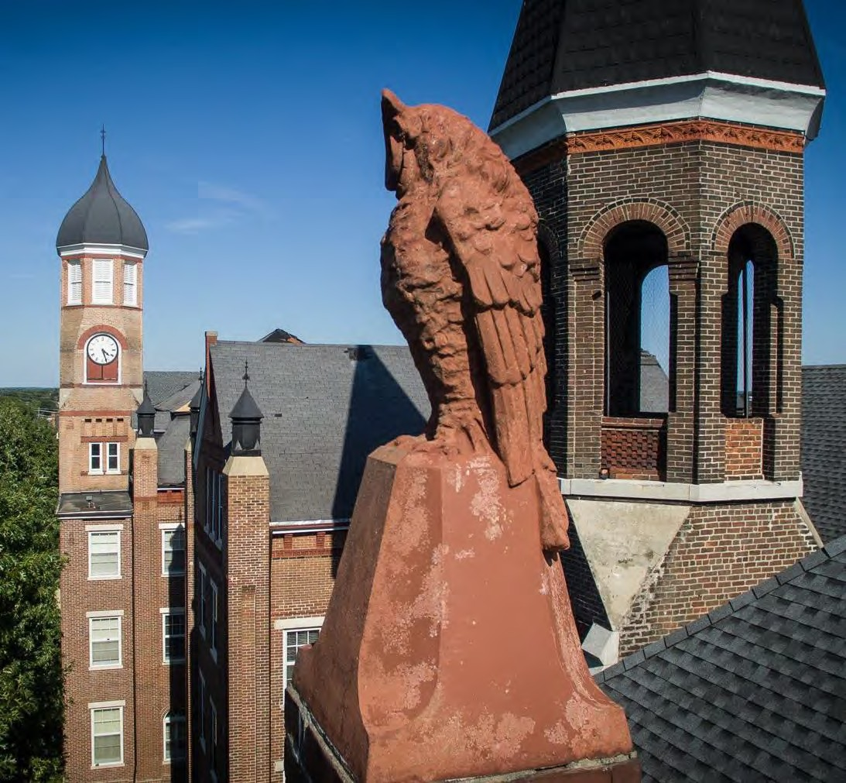
The W Police Department | 2025 Annual Security Report 1

Table of Contents
From the President…………………………………………………………………………………………...4 From the Chief of the MUW Police Department…………………………………………………………….5 Brief History of Campus Crime Reporting……………………………………………………………………6

ANNUAL SECURITY REPORT
PREPARATION OF THE ANNUAL SECURITY REPORT
AND DISCLOSURE OF CRIME STATISTICS……………………………………………………………7 ABOUT THE MUW POLICE DEPARTMENT…………………………………………………………9 Mission and Core Values.……………………………………………………………………………9
Role and Authority…………………………………………………………………………………..9 Working Relationship with Local Agencies………………………………………………………...9 Crimes Involving Students and Student Organizations Off-Campus……………………………... 10
REPORTING CRIMES AND OTHER EMERGENCIES……………………………………………..10 Voluntary, Confidential Reporting….……………………………………………………………...10 Reporting to University Police…….……………………………………………………………….11 Reporting to Other Campus Security Authorities….……………………………………………….11 TIMELY WARNING……………..………………………………………………………………………13 EMERGENCY NOTIFICATION………………………………………………………………………..15 COMMUNITY SAFETY BULLETINS………………………………………………………………. 16
EMERGENCY RESPONSE AND EVACUATION PROCEDURES....………………………………16
Emergency Management at MUW………………………………………………………………...16 Drills, Exercises, and Training.……………………………………………………………………17 SECURITY OF AND ACCESS TO MUW FACILITIES……………………………………………...18 Special Considerations for Residence Hall Access.………………………………………………..18
Security Considerations for the Maintenance of Campus Facilities………………………………..18

MUW’S RESPONSE TO DOMESTIC VIOLENCE, DATING VIOLENCE,
SEXUAL ASSUALT, AND STALKING………………………………………………………………....18 Commitment to Addressing Sexual Assault/Rape, Domestic
Violence, Dating Violence, and Stalking..…………………………………………………………18 What is consent…………………………………………………………………………………….20 Defining Sexual Assault/Rape, Domestic Violence, Dating Violence, and
Stalking……….…………………………………………………...………………………………..21
What to do if you have been the victim of sexual assault/rape, dating violence, or
stalking?…………………………………………………………………………………………….22
University Procedures for Responding to Reports of Sexual Assault, Domestic Violence, Dating
Violence, and Stalking………………………………………………………………………22 Internal Disciplinary Procedures that will be followed once an incident of
Domestic Violence, Dating Violence, Sexual Assault, or Stalking has
been reported……………………………………………………………………………………….23 Live Grievance Hearing…………………………………………………………………..25 Appeals………………………………...…………………………………………………………...27 How to be an Active Bystander and Risk
Reduction……………………………………………………………………………………….….28
Programs to Educate and Prevent Domestic Violence, Dating Violence, Sexual Assault, and
Stalking…………………………………………………………………………………………….29
Sex Offender Registration-Campus Sex Crimes Act……………………………………………….29

CAMPUS SECURITY POLICIES, CRIME PREVENTION, AND
SAFETY AWARENESS PROGRAMS………………………………………………………………...30

The W Police Department | 2025 Annual Security Report 2

Behavioral Intervention Team…………………………………………………………………..…30 Weapons Policy……………………………………………………………………………………30 Student Conduct……………………………………………………………………………………31 Parental Notification Policy………………………………………………………………………..38 Missing Student Policy…………………………………………………………………………….38 Daily Crime and Fire Log………………………………………………………………………….38 Crime Prevention and Safety Awareness Programs…………………………………………………38
MUW POLICIES GOVERNING ALCOHOL AND OTHER DRUGS……………………………...39
MUW’s Alcohol and Drug Policy…………………………………………………………………39 MUW Alcohol-Related Offenses…………………………………………………………………..40 MUW Drug-Related Offenses……………………………………………………………………..41 Drugs Risks and Consequences……………………………………………………………………41 Drug and Alcohol Educational Programs…………………………………………………………...42
ANNUAL DISCLOSURE OF CRIME STATISTICS………………………………………………...43 Clery Act Crimes.…………………………………………………………………………………..43 Violence Against Women Act (VAWA) Crimes….………………………………………………..44 CRIME STATISTICS – LOWNDES COUNTY SHERIFF DEPARTMENT………………………45 CRIME STATISTICS – CITY OF COLUMBUS POLICE DEPARTMENT………………………65

HOUSING REPORT
Types of student housing available………………………………………………………………...69 Policies on housing assignments and requested assignment changes……………………………...69 Policy on admission of visitors in student housing facilities………………………………………70 Measures to secure entrances to student housing facilities………………………………………...71 Type, number, and description of security training provided to student housing employees……..71 Type and frequency of programs designed to inform student housing residents
about housing security and enforcement procedures………………………………………………..72

ANNUAL FIRE SAFETY REPORT
Fire Safety………………………………………………………………………………………….72 Fire Statistics for On-Campus Student Housing Facilities………………………………………...72 Description of On-Campus Student Housing Fire Safety Systems………………………………..72 Residence Hall Fire Drills………………………………………………………………………….72 Annual Disclosure of Fire Statistics for Each On-Campus Housing Facility……………………...73 Prohibitions on Portable Electrical Appliances, Smoking and Open Flames……………………...74 Student Housing Fire Evacuation Procedures……………………………………………………..75 Campus Building Fire Evacuation Procedures…………………………………………………….75 Fire Safety Education and Training Programs for Students, Staff, and Faculty…………………...76 Fire Incident Reporting…………………………………………………………………………….76 Plans for Future Improvements in Fire Safety………………………………………………………76
IMPORTANT PHONE NUMBERS……………………………………………………………………77



From the President-

To the University Community:

Mississippi University for Women is committed to providing a safe, welcoming and respectful environment in which to learn, work, live and visit. Maintaining that environment is a responsibility we share as a university community.

I encourage you to review the information contained in this report, including campus safety measures, procedures for reporting crimes and emergencies, and the policies and resources designed to protect and support our students, faculty, staff and visitors. Knowing how to respond, where to seek assistance and how to report a concern are important parts of keeping our campus safe.

The W will continue to evaluate and strengthen our efforts to promote campus safety and well-being. Just as importantly, each of us has a role to play by remaining attentive, reporting concerns and looking out for one another.

Thank you for doing your part to help make The W a safe and supportive community.

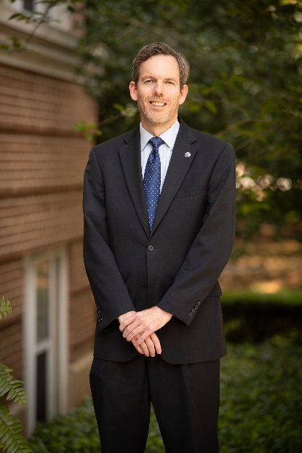
With W Pride,

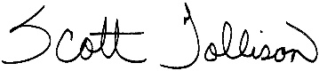

Scott Tollison
Interim President

From the Chief of MUW Police Department-

On behalf of our faculty and staff, it is my pleasure to welcome you to Mississippi University for Women. I want to thank you for your interest in our Annual Security and Fire Report. We publish this report because it contains valuable information on our campus community. Mississippi University for Women (MUW) works to maintain a safe and secure campus and to protect your property by providing full police safety services through the Police Department. We also share information you can use to reduce your chances of becoming a crime or accident victim. An informed community is a safer community.

Each year, MUW publishes the Annual Security and Fire Report which includes crime statistics and the fire safety report. This report also outlines MUW security policies and procedures. Please take the time to familiarize yourself with this report in order to become an informed member of our community and contribute to the University’s effort to create and maintain a safe environment.

The MUW Police Department is committed to making our campus a safe place in which to live, work, and study.


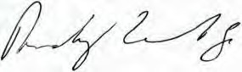
Randy Vibrock
Chief of Police
MUW Police Department

BRIEF HISTORY OF CAMPUS CRIME REPORTING


Jeanne Clery 1966-1986
The Jeanne Clery Act, a consumer protection law, requires all colleges and universities who receive federal funding to share information about crime on campus and their efforts to improve campus safety as well as inform the public of crime in or around university facilities. This information is made publicly accessible through the University’s website and Annual Security and Fire Safety Report.

The Clery Act was named in memory of a student, Jeanne Clery, who was murdered and raped in her dorm room at Lehigh University in 1986. Her attacker was also a student at the University whom Jeanne did not know prior to the attack. Her parents championed laws requiring the disclosure of campus crime information, and the federal law that now bears their daughter’s name was enacted in 1990.

The Clery Act requires colleges and universities to keep records and report on the nature, date, time, and place of crimes occurring on campus, including hate crimes. It also prescribes a number of security- related protocols for emergency response procedures, timely notifications for on-campus crimes and missing students, fire incident reporting, and the like. It is one of the most frequently modified sections of the Higher Education Act and has been amended many times since it was signed into law in 1990.

The Act is intended to provide current and future students, their families and staff, as higher education consumers, with accurate, complete and timely information about safety on campus so they can make informed decisions. Choosing a college or university is a major decision for students and their families. The issue of campus safety is a vital concern, which drives the nationwide law. In essence, the law requires colleges and universities to collect, report, and disseminate crime information to the campus community with the goal of maintaining a safe environment for students to learn, faculty to teach, and staff and administrators to work by increasing the awareness of crimes committed on campus.

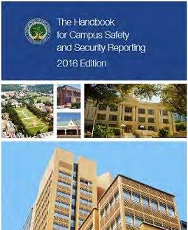
Questions about The Clery Act:

The Handbook for Campus Crime Reporting assists universities and colleges in meeting the regulatory requirements of the Jeanne Clery Disclosure of Campus Security Policy and Campus Crime Statistics Act, or the Clery Act. The handbook covers such topics as Classifying and Defining Clery Crimes, Timely Warnings, the Daily Crime Log and Annual Disclosure Requirements. It can be
found at U. S. Department of Education, Campus Security webpage, “The Handbook for Campus Safety and Security Reporting”. http://www2.ed.gov/admins/lead/safety/handbook.pdf

2025 ANNUAL SECURITY & FIRE SAFETY REPORT

PREPARATION OF ANNUAL SECURITY REPORT & DISCLOSURE OF CRIME STATISTICS

In accordance with the federal regulations The W prepares this report to comply with the Jeanne Clery Disclosure of Campus Security Policy and Crime Statistics Act. Within this report you will find crime, fire and security-related policies and procedures for the three most recent calendar years. This process includes collecting statistics obtained from multiple reporting sources and then reporting this information to the Mississippi University for Women community by October 1st of each year. The report is compiled using information maintained by the MUW PD, by other University offices such as Housing and Residence Life, Student Conduct, Campus Security Authorities (CSAs) and also information provided by local law enforcement agencies surrounding the University’s campus.

The annual security and fire safety report is prepared by the MUW PD. On an annual basis enrolled students and current employees of the University are notified via email by the MUW PD of the Annual Campus Security and Fire Safety Report. This email message provides an overview of the Annual Campus Security and Fire Safety Report, the address for the University Police Department website where the report can be obtained on-line and also how a hard copy “printed version” can be obtained. This information is also made available through multiple campus sources, such as speaking presentations and other venues. This information is also made available to prospective employees and students. The University’s Student Handbook, which includes policies and procedures, informs our prospective and current students, faculty and staff about the general procedures for reporting crimes both on and off campus.

The Annual Campus Security and Fire Safety Report contains information regarding campus security and personal safety including topics such as: crime prevention, public safety authority, crime reporting policies, fire safety, disciplinary procedures and other matters of importance related to security on campus. The report also contains information about fire statistics in University residential facilities and crime statistics for the three previous calendar years concerning reported crimes that occurred on campus; in certain off- campus buildings or property owned or controlled by the University; and on public property within, or immediately adjacent to and accessible from the campus.

In compliance with the 1998 amendments to the Campus Security Act (now known as the Jeanne Clery Disclosure of Campus Security Policy and Campus Crime Statistics Act) and Department of Education regulations, the crime and fire statistics published in this report illustrate the reporting of crime categories as specified below:
- Reporting of specified hate crimes by category of prejudice against the victim (race, gender, religion, sexual orientation, ethnicity, disability)
- Reporting of violation arrests and referrals to campus disciplinary action
- Reporting of fires, death/injuries and property damage

Each of these statistical categories is further broken down by geographic area:
- On-Campus (includes On-Campus Residential facilities)
- Non-Campus property
- Public Property (includes property within campus or immediately adjacent to it)

Clery Act reporting is based on where the incident occurred. The Clery geography map color codes properties based on the reportable location definitions classified by the U.S. Department of Education. MUW’s Clery geography map can be found at http://www.muw.edu/images/sa/police/2019CLERY_MAP_web.pdf

The MUW PD makes annual requests to the City of Columbus Police Department and Lowndes County Sheriff’s Department for crime statistics taken from the public areas within campus or immediately adjacent to the campus to be included in the Annual Campus Security and Fire Safety Report.
The Annual Campus Security and Fire Safety Report includes crime statistics for the following categories of crimes, reported to campus security authorities and local law enforcement:
- murder/non-negligent manslaughter
- Manslaughter by negligence
- rape
- fondling
- incest
- statutory rape
- robbery
- aggravated assault
- burglary
- motor vehicle theft
- arson

Within the Annual Campus Security and Fire Safety Report the Violence Against Women Act offenses that are reported to campus security authorities and local law enforcement include:
- domestic violence
- dating violence
- stalking

Also included are statistics for the following categories of violations arrests and referrals for campus disciplinary action:
- liquor law violations
- drug law violations
- weapons (carrying, possessing, etc.)

The University distributes a notice of the availability of this Annual Security and Fire Safety Report by October 1 of each year to every member of the University community. Anyone, including prospective students and employees, may obtain a paper copy of this report by contacting the MUW PD at 662.241.7777 or by visiting the MUW PD Office located in McDevitt Hall on campus.

Additional Sources of Statistical Information


Consistent with the U.S. Department of Education federal regulations, the MUW PD has developed, and periodically reviews, procedures to include on-campus statistics, and reports of required crimes made to the following campus security authorities: Office of the Vice President for Student Affairs, Dean of Students, student organization advisors, and the Office of Housing and Residence Life (including residence directors and residence advisors).

ABOUT THE MUW POLICE DEPARTMENT

Mission and Core Values

It is the mission of the MUW Police Department to safeguard persons and property through preparedness and vigilance. The department holds true to the customer-service policing philosophy. Its members shall continually strive for excellence in service, training and professional development. Core Values are: accountability, honesty, integrity, dependability, service to others before self and a genuine desire to pursue what is right, good and fair.

Role and Authority

The MUW PD protects and serves the MUW campus twenty-four hours a day, 365 days a year. The University Police department is responsible to the Vice President for Student Affairs and employs eight full-time sworn officers (which includes Chief of Police and Assistant Chief of Police), four full-time dispatchers, and one full-time office manager. MUW PD utilizes part-time officers who serve during special events and coverage on regular shifts. The department has two field training officers and one department training coordinator. Field training officers will ensure that all new officers will be properly trained and knowledgeable of department policies and procedures. The new officers will work with a field training officer for a designated period of time. The department training coordinator will seek out training opportunities for the department and maintain training records for all officers.

The MUW PD has complete police authority to apprehend and arrest anyone involved in illegal acts on- campus and areas immediately adjacent to the campus. If minor offenses involving University rules and regulations are committed by a University student, the campus police may also refer the individual to the disciplinary area of Student Affairs.

Major offenses such as rape, murder, aggravated assault, robbery and auto theft are reported to the police. Investigators from MUW PD, the city police, and/or the county may be deployed to solve these serious felony crimes. The prosecution of all felony offenses and some misdemeanors are conducted at the Lowndes County Circuit Court. The prosecution of most misdemeanors is conducted at the Lowndes County Justice Court.

MUW PD provides full police and environmental safety services to the campus community. The MUW PD force consists of sworn officers with full arrest powers who are on duty 24 hours a day, 7 days a week and are certified by the state of Mississippi. These officers are vested with all the powers, authority and responsibilities of any officer of the state on property owned or operated by the University and property immediately adjacent to campus. There are dispatchers for every shift that officers are working.

Working Relationship with Local Agencies

The MUW PD maintains a cooperative relationship with the City of Columbus Police Department, Lowndes County Sheriff’s Department, and other surrounding police agencies. The University maintains a memorandum of understanding with the City of Columbus Police Department and Lowndes County Sheriff’s Department. The MUW PD cooperates fully with other law enforcement agencies in cases that involve both on-campus and off-campus jurisdictions or when resources of an agency other than the MUW PD can be used to facilitate the resolution of an investigation. Local police agencies and MUW PD exchange information on a regular basis and work together during campus and community events.

Crimes Involving Students and Student Organizations Off-Campus

The MUW PD relies on a close working relationship with the local law enforcement agencies to receive information about incidents that involve students and recognized student organizations.

When a student is involved in an off-campus offense, police officers may assist with the investigation in cooperation with local, state or federal law enforcement. City of Columbus Police and Lowndes County Sheriff’s Department routinely work and communicate with campus officers on any serious incidents occurring on-campus or in the immediate neighborhood and business areas surrounding campus. MUW operates no off-campus student housing, but has one facility, Plymouth Bluff that can be rented by students and student organizations. However, some students live in the neighborhoods surrounding MUW. While the Columbus Police Department has primary jurisdiction in all areas off campus, MUW officers can and do respond to student-related incidents that occur in close proximity to campus. MUW officers have direct communication with the city police, fire department and 911 to facilitate rapid response to any emergency situation. MUW does not have any off-campus student organizations with off-campus housing.

REPORTING CRIMES AND OTHER EMERGENCIES

The University has a number of ways for the campus community members and visitors to report crimes, serious incidents, and other emergencies to the appropriate University officials. Regardless of how incidents are reported, it is critical for the safety of the entire MUW community that incidents are reported immediately so that the MUW PD can investigate and determine if follow-up actions are required.

Voluntary, Confidential Reporting

If you are the victim of a crime and do not want to pursue action within the University system or the criminal justice system, you may still want to consider making a confidential report. The purpose of the confidential report is to comply with your wish to keep the matter confidential, while taking steps to ensure future safety of yourself and others. With such information, the University can keep an accurate record of the number of incidents involving students, determine where there is a pattern of crime with regard to a particular location, method, or assailant, and alert the campus community to potential danger. Reports filed in this manner are counted and disclosed in the annual crime’s statistics for the institution.

Under the law, campus pastoral and professional counselors, when acting as such, are not considered to be a campus security authority and are not required to report crimes for inclusion in the annual disclosure of campus crime statistics. As a matter of policy, however, MUW encourages its counselors, if and when they
deem it appropriate, to inform the persons they are counseling of procedures to report crimes on a voluntary, confidential basis for inclusion in the annual disclosure of crime statistics.

All verified and unverified confidential reports of sexual offenses that meet reporting criteria as determined by MUW PD and that are made to University staff are included in MUW campus crime statistics (see Prevention and Reporting of Sexual Assaults for more information about MUW policies and procedures concerning sexual offenses).

Crimes reported to counselors or MUW Health Center are not included unless the victim chooses to report to one of the other campus security authorities.

Reporting to University Police

To maximize the safety of campus, the MUW PD strongly encourages anyone with knowledge about any crime, suspicious activity or unsafe actions/conditions on campus (either as a witness or as a victim) to make an immediate report to the MUW PD in person or by phone. Reporting does not mean legal action but it may help police officers stop further incidents as well as help them keep the community informed about criminal activity.

To make a report in person, go to the MUW PD, located in McDevitt Hall. To make a report by phone, call 662-241-7777 and describe the situation to the dispatcher. In emergency situations, including fires and medical emergencies, call 911. All 911 calls made from campus will go to the Lowndes County 911 Dispatch Center and the dispatcher on duty will contact the MUW PD dispatcher. It is best to contact 911 first and then, call 662-241-7777 in the event of an emergency.

University students requiring non-emergency medical care may contact the Student Health Center at 662- 329-7289. Students seeking counseling services may contact the Counseling Center at 662-329-7748.

MUW employees requiring non-emergency medical care may contact the Student Health Center at 662- 329-7289 or Baptist Memorial Hospital at 662-244-1000.

Students, faculty and staff members who are victims of interpersonal relationship violence may contact the National Domestic Violence Hotline at 1-800-799-7233 or www.thehotline.org for counseling and advocacy and file a report with the university’s Title IX Coordinator located in 300 – Cochran Hall and contact number is 662-370-1035.

Reporting to a Campus Security Authority (CSA)

What is a CSA?
A CSA is a person referred to as a campus security authority by the Clery Act. CSA's are a vital part of data collection for the annual safety and security report.
The Clery Act requires MUW to provide an annual campus safety and fire report. In addition to input from law enforcement, certain positions are designated as Campus Security Authorities (CSA) for the purpose of providing information for this report. CSAs are usually found in departments responsible for, but not limited to, student and campus activities. The W has identified that all faculty and staff members are Campus Security Authorities.

How Are CSAs Identified?
The law defines the following four categories of CSAs:
- MUW PD sworn law enforcement personnel and department administrators.
- Non-police people or offices responsible for campus security—community service officers, campus contract security personnel, parking enforcement staff, personnel providing access control and/or security at campus facilities, athletic events or other special events, safety escort staff, residential community assistants and other similar positions.
- Officials with significant responsibility for student and campus activities—an Official is defined as any person who has the authority and the duty to take action or respond to particular issues
on behalf of the University. To determine which individuals of organizations are CSAs, consider job functions that involve relationships with students. Look for Officials (i.e., not support staff) whose functions involve relationships with students. If someone has significant responsibility for student and campus activities, then they would be considered a CSA. Some examples of CSAs in this category include, but are not limited to: academic deans; student affairs / residential life
officials; coordinator of Greek Affairs (or related positions); athletic administrators, including directors, assistant directors and coaches; student activities coordinators and staff; student judicial officials; faculty and staff advisors to student organizations; student center building staff; student peer education advisors; and administrators at branch campuses.
- Any individual or organization specified in an institution's statement of campus security policy as an individual or organization to which students and employees should report criminal offenses.

Campus Security Authority Reporting
It is imperative that we maintain an effective way to manage reports that Campus Security Authorities receive. The university requires CSA’s to notify the MUW PD about crime information as soon as they become aware of it by completing this CSA Incident Report form. CSAs should not investigate crimes or attempt to determine whether in fact a crime occurred. Rather, a CSA’s obligation is to simply report the information as soon as possible.

If you are in doubt as to whether a crime is reportable, please err on the side or reporting the matter. If you have any questions, please contact MUW PD at 662-241-7777.

MUW Response to a Crime Report

When you report a crime to the MUW PD, a MUW police officer will meet with you, listen to what happened and if necessary, make a preliminary report. Next, an investigator will review the report and conduct a follow-up investigation. If a suspect is found and you decide to press charges, information will be presented to the District Attorney, who decides if there is a legal basis to arrest the suspect. If there is an arrest to be made, you will be asked to sign an affidavit and a warrant will be issued. Any law enforcement officer can serve the warrant. If the subject lives on campus, it will be best if the warrant is served by MUW police officers. A court date will be set and you will have to be present to testify.

MUW encourages you to report criminal activity even if you do not want to take legal action in order to help us maintain accurate statistical records. The MUW PD is responsible for preparing the University’s Annual Campus Security and Fire Safety Report and for compiling the crime and fire statistics included in the report. We like to keep the community informed as much as possible. The information you report may
require the MUW PD to issue a W-Alert if they determine that the circumstances warrant such action. Also, see information below regarding another way in which to make a voluntary confidential reporting of forcible and non-forcible sexual offenses.

Anonymous Reporting

If you are interested in reporting a crime or incident anonymously, you can utilize the University’s online reporting website, which can be accessed at www.muw.edu/reporting.

TIMELY WARNINGS

Under the Clery Act, colleges and universities must use timely warnings and emergency notifications to inform the campus community of potential threats against which they can take preventive measures. These ongoing disclosure requirements, when implemented, can help to create and promote a safe campus environment.

The purpose of a timely warning is to notify the campus community of the incident and to provide information that may enable the community to take steps to protect themselves from similar incidents. The Chief of Police will issue timely warnings whenever there is a substantial risk to the safety of other members of the campus community. For incidents involving off-campus crimes, the MUW PD may issue a timely warning if the crime occurred adjacent to the campus or in a location frequented by the University population.

Timely warnings have a narrow focus with a concentration on the Clery Act specific crimes. A timely warning must be issued for Clery Act crimes that occur in the University’s Clery Act geography. The warning must reach the entire campus.
Timely warnings are considered for the following classifications of Clery Act crimes: Criminal Homicide
- murder/non-negligent manslaughter
- Manslaughter by negligence

Sex Offenses
- rape
- fondling
- incest
- statutory rape

- robbery
- aggravated assault
- burglary
- motor vehicle theft
- arson

Timely warnings may also be issued for other reported crimes as determined necessary by the Chief of Police or designee. The decision will be made in compliance with the Clery Act and in an effort to prevent similar crimes from occurring.

Decisions to disseminate a timely warning will be decided on a case-by-case basis in light of all the facts surrounding the crime and the continuing danger to the campus community. The purpose of the warning is to aid in the prevention of similar crimes by alerting the community about the incident and providing information on the actions the campus community can take to diminish their chances of being victimized.

A timely warning will be issued as soon as pertinent information is available. The amount and type of information presented in the timely warning will vary depending on the circumstances of the crime. If there is certain information that could compromise law enforcement efforts, it may be withheld form the timely warning notice. An effort will always be made to distribute a warning as soon as pertinent information is available so that the warning is a preventive tool, not solely a description of the incident.

Timely warning will include some or all of the following information:
- Date, time and location of the reported crime
- Summary of the incident
- Description of the suspect and/or vehicle, if available
- Special instructions or incident specific safety tips

In the event that a situation arises, either on-campus or off-campus, that constitutes an ongoing or continuing threat, a campus wide “timely warning” will be issued. The Chief of Police or designee will issue a timely warning notice for the University community to notify members of the community about incidents that occur on campus, where it is determined that the incident may pose an ongoing threat to members of the University community. The warning will be issued through the University’s messaging system called W- Alert to students, faculty and staff.

The W-Alert may encompass the following modes of communication:
- Text (SMS) message
- Email university email addresses
- Broadcast automated calling
- Social Media (Facebook and Twitter)
- University’s homepage website
- Electronic display boards

In the event of inclement weather, the MUW PD will be in constant contact with Emergency Management and will keep the University updated regarding inclement weather. Depending on the particular circumstances, especially in all situations that could pose an immediate threat to the community and individuals, a notice may be posted on the main page (www.muw.edu) of the University Website providing the community with immediate notification.

Anyone with information warranting a timely warning should report the circumstances to the MUW PD (662-241-7777) or in person to the dispatcher at the front gate.

EMERGENCY NOTIFICATIONS

MUW is committed to ensuring the campus community receives timely and accurate information in the event of a confirmation of a significant emergency or dangerous situation occurring on the campus involving an immediate threat to the health and safety of the students and employees. The MUW PD is the department who will confirm the existence of a credible emergency event or threat. The University will use the emergency notification system through ReGroup to provide alerts via W-Alert. This is the MUW emergency notification service available to all students, faculty and staff. It can be used to send emergency messages within minutes of the occurrence of an incident. Once the emergency notification has been made, more detailed follow-up information will be released to the campus community.

The Chief of Police or designee has the authorization to send emergency notifications. Once confirmation of an emergency event or threat, an emergency notification will be sent to the University community to notify members about the incident that occurred on campus, where it is determined that the incident may pose an ongoing threat to members of the University community. An emergency notification will be sent without delay and unless a notification will compromise efforts to assist a victim or contain, respond to, or otherwise mitigate emergency.

The emergency notification will be issued through the University’s messaging system called W-Alert to students, faculty and staff.

The W-Alert may encompass the following modes of communication:
- Text (SMS) message
- Email university email addresses
- Broadcast automated calling
- Social Media (Facebook and Twitter)
- University’s homepage website
- Electronic display boards

Emergency notifications have a broad focus and may be issued without delay for the following list of emergencies, but not limited to:
- Natural disaster
- Weather
- Environmental
- Terrorist attack
- String of larcenies
- Power outage

Emergency notification will include some or all of the following information:
- Date, time and location of the reported crime
- Summary of the incident
- Description of the suspect and/or vehicle, if available
- Special instructions or incident specific safety tips
- Statement as to where additional information may be obtained

COMMUNITY SAFETY BULLETIN

MUW Police Department provides information on crimes that have recently occurred in the campus area so that you may take the appropriate precautions. MUW Community Safety Bulletins are based on information that was reported to MUW Police Department. The reported information may not have been investigated or confirmed at the time the Community Safety Bulletin was issued.

All crimes reported to the MUW Police Department are recorded in the daily crime log. This crime log can be viewed at the MUW Police Department, located in McDevitt Hall.

Community Safety Bulletins will be issued via e-mail and posted to our website after an incident occurs that should be brought to the attention of the University community. Physical descriptions of the person(s) of interest may be included in Community Safety Bulletins only when they provide several details that might help distinguish the suspect's appearance from the general population.

Community Safety Bulletins are located and archived at www.muw.edu/police/bulletins

EMERGENCY RESPONSE AND EVACUATION PROCEDURES

Emergency Management at MUW

The MUW PD assists all departments and campus with developing, maintaining, and implementing emergency operations plans, developing and conducting exercises, and building partnerships with external response agencies. An emergency procedures flipchart is provided to the campus community. This document contains emergency response information for a wide range of events that could potentially occur on campus.

The University uses the emergency notification system through ReGroup to provide alerts via W-Alert. This is the MUW mass emergency notification service available to all students, faculty and staff. It can be used to send emergency messages within minutes of the occurrence of an incident. Once the emergency notification has been made, more detailed follow-up information will be released to the campus community via additional W-Alerts or Community Safety Bulletin.

Steps to enroll to receive W-Alerts or to update information:
- Go to MUW’s home page, www.muw.edu.
- Click on the Banner Web icon on the top right hand side of the home page.
- Enter your Banner ID (user ID) and pin then click the “Login” button
- Click the “Personal Information” tab on the left hand side of the page.
- Click on “W Alert Text Messaging Opt In/Out.
- Enter your phone number +area code then select “Opt-In.”
- Then click the “Submit” button.

Additionally, the campus community is encouraged to download the SchoolDude Crisis Manager application to their phones. Crisis Manager is a mobile safety platform that provides emergency plans specific to the MUW campus.

The University maintains a Crisis Action Team (CAT), which may be activated by senior university officials for response to emergencies on the MUW campus. Team members and MUW PD have received training in Incident Command System (ICS), which is utilized when responding to these incidents.

Drills, Exercises, and Training

To ensure the campus’s emergency management plans remain current and actionable, the campus conducts at least one large scale exercise annually. The exercise includes a full-scale scenario that involves coordination with local and state agencies. In conjunction with the annual exercise, the campus will notify the campus community of the exercise and remind the campus community of the W-Alert system and emergency response procedures. In additional to the large-scale university-wide exercise, various
departments and colleges practice lockdown procedures throughout the year.

2025
Disaster Drill
MUW nursing students participated in a disaster drill on September 18, 2025that involved a simulated active shooter in Columbus, MS. The university administration convened in Welty Hall during the drill and conducted a table top training exercise based on how an active shooter would impact the campus.

2024

Disaster Drill
MUW nursing students participated in a disaster drill on September 12th that involved a simulated tornado response at Cromwell Communications Building on The W’s Campus in Columbus, MS. The university administration convened in Welty Hall during the drill and conducted a table top training exercise based on how a tornado would impact the campus.

2023

Disaster Drill
MUW nursing students participated in a disaster drill on September 7th that involved a simulated tornado response at Cromwell Communications Building on The W’s Campus in Columbus, MS. The university administration convened in Welty Hall during the drill and conducted a table top training exercise based on how a tornado would impact the campus.

SECURITY OF AND ACCESS TO MUW FACILITIES

On the MUW campus, academic and administrative buildings are open from 8:00am until 5:00pm, Monday through Friday. Academic and administrative buildings close at 5:00pm. Academic buildings are scheduled to be open at night and on weekends only as needed. MUW PD officers routinely check all building entrances and exits to ensure the security of each building.

Special Considerations for Residence Hall Access

On the MUW campus, all residence halls operate under a computerized Access Control System. All exterior doors are locked twenty-four hours a day. Identification cards are coded so that only students who are residents in a particular hall have authorized electronic access entry to that hall. The system will deny entry to all unauthorized persons and log that denied entrance. When a door is malfunctioning, personnel are summoned for immediate repair. Residents should always lock doors and windows.

Each on-campus resident receives the MUW Student Handbook each fall semester upon moving in to the residence halls, which includes information on safety and security. Only residents and their invited guests are permitted in the residence halls. It is the resident’s responsibility to ensure that their guests are aware of the University and residence hall policies which can be found in the MUW Student Handbook. The MUW Student Handbook is also located online at http:www.muw.edu/deanof students/resources and is updated as needed throughout the year. Please refer to the online version of the MUW Student Handbook for the most up to date version.

Security Considerations for the Maintenance of Campus Facilities

MUW is committed to campus safety and security. At MUW, locks, landscaping, and outdoor lighting are designed for safety and security. Outdoor lighting is inspected once a semester to ensure adequate lighting. Grounds-keeping personnel trim shrubs and trees in order to provide well-lighted routes on campus.

We encourage campus community members to promptly report any security concerns, including concerns about locking mechanisms, lighting, or landscaping, to the MUW PD at 662-241-7777.

MUW’S RESPONSE TO DOMESTIC VIOLENCE, DATING VIOLENCE, SEXUAL ASSAULT, AND STALKING

Commitment to Addressing Sexual Assault/Rape, Domestic Violence, Dating Violence, and Stalking
Mississippi University for Women seeks to foster an atmosphere of respect for all members of the University community. To this end, the University is committed to maintaining a working and learning environment free of sexual harassment and discrimination. Members of the Mississippi University for Women (“The W/the university”) community, guests and visitors have the right to be free from all forms of sex/gender harassment, discrimination and misconduct, examples of which can include acts of sexual violence, sexual harassment, domestic violence, dating violence, and stalking. All members of the campus community are expected to conduct themselves in a manner that does not infringe upon the rights of others. When an allegation of misconduct is brought to an appropriate official’s attention, supportive and other remedial measures will be offered and may be used to reasonably ensure that such conduct ends, is not repeated, and the harm on the individual affected and community are remedied, including serious sanctions when a responding party is found to have violated this policy.
This policy has been developed to reaffirm these principles and to provide recourse for those individuals whose rights have been violated. The W’s Title IX Policy (“Policy”) is not meant to inhibit or prohibit educational content or discussions inside or outside of the classroom that include controversial or sensitive subject matters protected by academic freedom. Academic freedom extends to topics that are pedagogically appropriate and germane to the subject matter of courses or that touch on academic exploration of matters of public concern.
The policy addresses all forms of discrimination on the basis of sex, including sexual harassment. Mississippi University for Women does not discriminate on the basis of sex in its educational, extracurricular, athletic, or other programs or in the context of admissions or employment in accordance with Title IX of the Education Amendments of 1972 and the regulations found in Part 106 of Title 34 of the Code of Federal Regulations (Title IX).
Title IX is a federal law that provides that, “No person in the United States shall, on the basis of sex, be excluded from participation in, be denied the benefits of, or be subjected to discrimination under any education program or activity receiving Federal financial assistance.”
The W, as an educational community, will promptly and equitably respond to all reports of sex discrimination in order to eliminate the misconduct and/or harassment, prevent its recurrence, and address its effects on any individual or the community. The Policy applies to all members of the University community including: students, employees, volunteers, independent contractors, visitors, and any individuals regularly or temporarily employed, studying, living, visiting, conducting business, or having any official capacity at the University.

What is consent?

Consent: An informed, freely given affirmative agreement, communicated by clearly understandable words or actions, to participate in each form of sexual activity. The person giving the consent must act freely, voluntarily, and with an understanding of their actions when giving consent.
Effective Consent is:
Effective Consent is the basis of this policy because effective consent maintains the value that all persons have the right to feel respected, acknowledged, and safe during sexual activity. The use of force to obtain sexual access or to induce consent violates this policy whether the force is physical in nature, violent, or involves threats, intimidation or coercion.
Lack of protest or resistance does not constitute consent, nor does silence mean consent has been given. Relying solely on non-verbal communication can lead to misunderstanding. Persons who want to engage in sexual activity are responsible for obtaining consent- it should never be assumed. Clear communication from the outset is strongly encouraged.
Effective Consent is NOT:
Consent is not effective if it is obtained from force, threat of force, fraud or intimidation. Additionally, it is not consent if the initiator has sex with someone they know, or reasonably should know, to be incapacitated by alcohol, drugs, sleep or illness. A person who is unconscious, unaware, or otherwise physically helpless cannot give consent to sexual activity.
General guidance for consent:
- Any form of sexual activity requires consent.
- Consent cannot be inferred from silence, passivity, or lack of active resistance.
- A current or previous dating or sexual relationship is not sufficient to constitute consent, and consent to one form of sexual activity does not imply consent to other forms of sexual activity.
- When consent is requested verbally, absence of any explicit verbal response constitutes lack of consent. A verbal “no” constitutes lack of consent, even if it sounds insincere or indecisive.
- By definition, there is not consent when there is a threat of force or violence or any other form of coercion or intimidation, physical or psychological.
- Either person may withdraw consent at any time. Withdrawal of consent should be outwardly demonstrated by words or actions that clearly indicate a desire to end sexual activity. Once withdrawal of consent has been expressed, sexual activity must cease.
- A person who is the object of sexual aggression is not required to physically or otherwise resist the aggressor; the lack of informed, freely given consent to sexual contact constitutes sexual misconduct. Intoxication is not an excuse for failure to obtain consent.
- A person who is the object of sexual aggression is not required to physically or otherwise resist the aggressor; the lack of informed, freely given consent to sexual contact constitutes sexual misconduct. Intoxication is not an excuse for failure to obtain consent.
- A person who is below the legal age of consent is incapable of giving consent.

Incapacitation:
A person cannot consent if they are unable to understand what is happening or is disoriented, helpless, asleep, or unconscious, for any reason, including by alcohol or other drugs. As stated above, a Respondent violates this policy if they engage in sexual activity with someone who is incapable of giving consent.
Incapacitation occurs when someone cannot make rational, reasonable decisions because they lack the capacity to give knowing/informed consent (e.g., to understand the “who, what, when, where, why, or how” of their sexual interaction).
This policy also covers a person whose incapacity results from a temporary or permanent physical or mental health condition, involuntary physical restraint, and/or the consumption of incapacitating drugs or alcohol.
Age of Consent: According to Mississippi Code Annotated § 97-3-65, an individual who is 17 years or older cannot receive consent from a child who is between the ages of 14 and 16, if the child is thirty-six
- or more months younger than the person.

Defining Sexual Assault/Rape, Domestic Violence, Dating Violence, and Stalking

Title IX Sexual Harassment: Conduct on the basis of sex that satisfies one or more of the following:
- Quid Pro Quo – An employee of the recipient conditioning the provision of an aid, benefit, or service of the recipient on an individual’s participation in unwelcome sexual conduct;
- Hostile Environment – Unwelcome conduct determined by a reasonable person to be so severe, pervasive, and objectively offensive that it effectively denies a person equal access to the recipient’s education program or activity; or
- Sexual assault[i] – An offense that meets the definition of rape, fondling, incest or statutory rape as used in the FBI’s Crime Reporting system. A sex offense is any sexual act directed against another person, without the consent of the victim, including instances where the victim is incapable of giving consent.
  - Rape – The penetration, no matter how slight, of the vagina or anus with any body part or object, or oral penetration by a sex organ of another person, without the consent of the victim.
  - Sodomy – Oral or anal sexual intercourse with another person, without the consent of the victim, including instances where the victim is incapable of giving consent because of his/her age or because of his/her temporary or permanent mental or physical incapacity.
  - Sexual Assault with An Object – To use an object or instrument to unlawfully penetrate, however slightly, the genital or anal opening of the body of another person, without the consent of the victim, including instances where the victim is incapable of giving consent because of his/her age or because of his/her temporary or permanent mental or physical incapacity. An object or instrument is anything used by the offender other than the offender’s genitalia, e.g., a finger, bottle, handgun, stick.
  - Fondling – The touching of the private body parts of another person for the purpose of sexual gratification, without the consent of the victim, including instances where the victim is incapable of giving consent because of his/her age or because of his/her temporary or permanent mental or physical incapacity.
  - Incest – Sexual intercourse between persons who are related to each other within the degrees wherein marriage is prohibited by law.
  - Statutory Rape – Sexual intercourse with a person who is under the statutory age of consent.
- Dating violence – Violence committed by a person who is or has been in a social relationship of a romantic or intimate nature with the victim. Dating violence includes, but is not limited to, sexual or physical abuse or the threat of such abuse. The existence of such a relationship shall be based upon the reporting party’s statement with consideration of the following factors:
  - Length of the relationship
  - Type of relationship
  - Frequency of interaction between the persons involved in the relationship
- Domestic Violence is any crime of violence, to include misdemeanors or felonies committed by current or former spouse or intimate partner, or anyone else protected under domestic or family violence laws in Mississippi.
- Stalking – Engaging in a course of conduct directed at a specific person that would cause a reasonable person to:
  - Fear for the person’s safety or the safety of others; or
  - Suffer substantial emotional distress
  - Course of conduct: two or more acts, including, but not limited to, acts in which the stalker directly, indirectly, or through third parties, by any action, method device, or means follows, monitors, observes, surveils, threatens, or communicates to or about a person, or interferes with a person’s property
  - Substantial emotional distress: significant mental suffering or anguish that may, but does not necessarily require medical or other professional treatment or counseling
  - Reasonable person: a reasonable person under similar circumstances and with similar identities to the victim

What to do if you have been the victim of sexual assault/rape, dating violence, domestic violence, or stalking?

The Title IX Coordinator is the employee at the University, designated and authorized to coordinate the institution’s efforts to comply with Title IX. The Title IX Coordinator and the Title IX Deputies (“Title IX Team”) oversee the implementation of grievance procedures, which includes notification, investigation and disposition of complaints of sex discrimination and sexual harassment. The Title IX Coordinator will coordinate the provision of educational materials and training for the campus community. Additionally, the Title IX Team will ensure a fair and neutral process for all parties and monitor all other aspects of the University’s Title IX compliance.
Reports of sex discrimination or sexual harassment to the University Title IX Coordinator can be made in person, by mail, by telephone, or by electronic mail, or through the institution’s website using the contact information listed for the Title IX Coordinator, or by any other means that results in the Title IX Coordinator receiving the person’s verbal or written report. A report may be submitted at any time by using the telephone number or electronic mail address, or by mail to the office address listed for the Title IX Coordinator or through the institution’s website. The Title IX Coordinator can be contacted by telephone, email, or in person at:

Title IX Coordinator Office of Civil Rights
Christina Chunn U.S. Dept. of Health and Human Services
Cochran Hall, Room 300 Health and Human Services 61 Forsyth Street, S.W.
Email:titleix@muw.edu Atlanta, GA 30303-8909 Office: (662) 370-1035 Phone: (404) 562-7886

Fax: (404) 331-2867

University Procedures for Responding to Reports of Sexual Assault, Domestic Violence, Dating Violence, and Stalking

The W strongly supports and encourages prompt reporting of sex discrimination and harassment so that resources can be provided to the parties and the community can remain safe. All university community members (students, faculty, and staff) should help ensure that violations of the Policy are promptly reported. University employees are mandatory reporters unless designated as a confidential resource. Normally, this means reporting any witnessed violations or violations learned about through the disclosure of a reporting party. Reporting is not the same as the filing a formal complaint.

The university will attempt to complete most investigations within sixty (60) business days. The timeframe for formal investigations will begin upon filing of a formal complaint and will conclude upon submittal for adjudication. Investigations may be delayed and timeframes for investigations may be extended for good cause and with written notice provided by the university to reporting parties and responding parties including the reason for the delay or extension. Good cause may include but are not limited to considerations such as the absence of a party, a party’s advisor, or a witness; concurrent law enforcement activity; or the need for language assistance or accommodation of disabilities. Delays caused solely by administrative needs are not considered good cause. The university will attempt to accommodate the schedules of parties and witnesses; however, grievance resolution must be completed in a reasonably prompt timeframe, and must proceed to conclusion even in the absence of a party or witness.

A person filing a report will be provided with information regarding the university’s Title IX policy and procedures as well as confidential resources and information for reporting criminal offenses to campus and local law enforcement. Instances of sexual harassment may violate both the university’s Title IX policy and the law. As a result, the university encourages complainants to pursue their complaints through both the University’s Title IX process and through the criminal justice system. The Columbus Police Department, which can be reached at (662) 244-3500, can explain the procedures for pursuing a criminal investigation of sexual harassment. University grievance procedures are not the same as a criminal investigation.

Internal Disciplinary Procedures that will be followed once an incident of Domestic Violence, Dating Violence, Sexual Assault, or Stalking has been reported

Formal Complaint

A document submitted and signed, by either the complainant or the University Title IX Coordinator, alleging sexual harassment against a responding party and requesting that the University investigate the allegation(s) of sexual harassment. At the time of filing a formal complaint, a complainant must be participating in or attempting to participate in the institution’s education program or activity of the institution in which the formal complaint is filed. A formal complaint may be filed with the Title IX Coordinator in person, by mail, or by electronic mail, by using the contact information required to be listed for the Title IX Coordinator or any additional method designated by the institution. Additionally, the document may be in the form of an electronic submission (such as by e-mail) that contains the reporting party’s physical or digital signature.

Informal Resolution
With the agreement of both parties, a formal complaint under Title IX may be resolved using an informal resolution process (mediation) overseen by one or more members of the Title IX Team or its designee if (i) the university determines, in its discretion, that such a process would be appropriate; and (ii) all parties voluntarily agree and provide written consent to participate. An informal resolution process is available at any time prior to reaching a determination regarding responsibility in the grievance process. Informal resolution is not available in cases of sexual harassment of a student by a university employee.
Before initiating informal resolution, the university will provide written notice to the parties disclosing the allegations, the requirements of the informal resolution process, and any consequences resulting from participating in the informal resolution process, including the records that will be maintained or could be shared.
The parties to any such informal process will not be required to deal directly with one another. Instead, after a preliminary review of the reported incident the Title IX Coordinator or other official selected by the Title IX Team will commence coordinated discussions with both the reporting party and the responding party in order to seek a mutually agreed upon resolution. At any time, if either party is dissatisfied with the proceedings of the informal resolution process, that party may request the informal resolution process be terminated, in which case the formal resolution procedure (described below) would commence. In addition, any party can pursue formal resolution if dissatisfied with a proposed informal resolution. The parties may not request formal resolution after the parties fully complete the informal resolution process. Finally, as described above, the university may elect to pursue a formal resolution procedure even if the reporting party does not wish a formal resolution. During informal resolution, the parties have the right to be assisted by an advisor of their choice. The parties, however, are responsible for presenting their own information and, therefore, advisors are not permitted to cross-examine or question any party or to participate directly in the informal resolution process.

Formal Resolution
For allegations of sexual discrimination that cannot be resolved informally, a Title IX Hearing Panel, comprised of three Title IX Deputies who have not been involved in advising or investigating the parties, shall be convened. One member of the panel will serve as the Hearing Chair. The purpose of the hearing panel is to determine responsibility and make recommendations for sanctioning, if applicable. The obligation of the hearing panel is to objectively evaluate all relevant evidence both inculpatory and exculpatory, and must therefore independently reach a determination regarding responsibility without giving deference to the investigative report.
The Title IX Hearing Panel has the right and responsibility to ask questions and elicit information from parties and witnesses on their own initiative to aid the Hearing Panel in obtaining relevant evidence. The parties also have equal rights to present evidence in front of the Hearing Panel so that the Hearing Panel has the benefit of perceiving each party’s unique perspectives about the evidence. The Title IX Coordinator may also appoint a hearing officer to oversee and/or conduct the hearing.
Investigative Report: The University will prepare and finalize an investigative report that fairly summarizes relevant evidence. Prior to completion of the investigative report, the University will send to each party and the party’s advisor, if any, the evidence subject to inspection and review in an electronic format or a hard copy, and the parties will have the (10) business days to submit a written response, which the investigators will consider prior to completion of the investigative report. After completion of the investigative report, the parties will all receive a copy of the report and will have ten (10) business days to submit a written response, before the report is finalized and provided to the decision-making panel.
All evidence subject to the parties’ inspection and review will be available at any hearing to give each party equal opportunity to refer to such evidence during the hearing, including for purposes of cross-examination. If a party disagrees with an investigator’s determination about relevance, the party may argue relevance in their written response and/or to the Hearing Panel at the live hearing.
The investigative report may include recommended findings and conclusions, however, the Hearing Panel will objectively evaluate relevant evidence and will not defer to recommendations made by the investigator. The investigative report may include a credibility analysis, but such analysis cannot result in a determination regarding responsibility. If the report involves multiple reporting parties, multiple responding parties, or both, the university may issue a single investigative report.
Standard of Proof: The standard of proof for review of formal complaints under this policy against students and employees, including faculty, is preponderance of the evidence. Preponderance of the evidence is a determination based on facts that are more likely true. The decision-making panel will be making a determination if the evidence supports that it is more likely than not that the university’s policy has been violated. The standard of evidence reflects the “degree of confidence” that the Hearing Panel has in correctness of the factual conclusions reached.
The university will apply the same standard of evidence for formal complaints against students as for formal complaints against employees, including faculty, and apply the same standard of evidence to all formal complaints of sexual harassment.
Live Grievance Hearing
The parties will be provided with the final investigative report not less than then (10) business days prior to the live grievance hearing and will also be provided with an informational packet including, but not limited to: a final investigative report, hearing rules and procedures (including procedural time limitations), and the list of Title IX Hearing Panel officers.
The following are general guidelines for the hearing:
- The hearing is of an educational nature and is not subject to the rules of criminal proceedings.
- The hearing normally shall be conducted in private.
- The hearing shall be conducted live. Separate rooms, with technology enabling the Hearing Panel and the parties to simultaneously see and hear all proceedings may be arranged at the request of either party.
- The complainant, respondent, and their advisors, shall be allowed to attend the entire portion of the live grievance hearing at which information is received.
- The complainant and respondent will receive the name(s) of the Hearing Panel officers prior to the live hearing. Either party may challenge any Hearing Panel Officer prior to the live hearing if they believe they have a conflict of interest. The Title IX Coordinator will review the concern and will have sole discretion to make a change in Hearing Panel Officers, including reducing the number on the panel.
- In hearings involving more than one respondent, the Title IX Coordinator, in his or her discretion, may permit the live hearing concerning each person to be conducted either separately or jointly.
- The parties have the right to be assisted by an advisor that they select. In the event a party does not select an advisor, the university will provide, without fee or charge to that party, an advisor who will conduct cross-examination on behalf of that party at the live hearing. Parties will not be permitted to conduct cross examination on their own. The university may require parties to acknowledge whether they intend to have an advisor present during the hearing.
- The complainant, respondent, and the Hearing Panel may arrange for witnesses to present pertinent information to the Hearing Panel. Witnesses will provide information to and answer questions from the Hearing Panel and answer questions during cross examination by either party’s advisor.
- The Hearing Panel Chair will make all determinations of relevance and procedure for the conference.
- At the conclusion of the hearing, after which all pertinent information has been received, the Hearing Panel shall determine, by private deliberation and through majority vote, whether the respondent has violated the Title IX policy. In the event of a two-member panel, the decision must be unanimous.
- The Hearing Panel’s determination shall be made on the basis of whether it is more likely than not (a preponderance of evidence) that the respondent violated the university’s Title IX policy.
- There shall be a single verbatim record, such as a tape recording of the live grievance hearing. The record shall be the property of the university but, upon request, will be made available to the parties for inspection or review. No other recording is to be made during the hearing.
- After the hearing, the Hearing Panel will issue a written notice of outcome (determination of responsibility). The notice will include:
  - Identification of the allegations potentially constituting sexual harassment
  - A description of the procedural steps taken from the receipt of the formal complaint through the determination, including any notifications to the parties, interviews with parties and witnesses, site visits, methods used to gather other evidence, and hearings held;
  - Findings of fact supporting the determination;
  - Conclusions regarding the application of the Policy to the facts;
  - A statement of, and rationale for, the result as to each allegation, including a determination regarding responsibility, recommendations for disciplinary sanctions the university may impose, and whether remedies will be provided by the university to the complainant, and;
  - The university’s procedures and permissible bases for the reporting party and responding party to appeal.
The determination will lay out the evidentiary basis for conclusions reached in the case. Hearing panels will attempt to complete their determinations within ten (10) business days after completion of the live hearing. The hearing panel’s determination will be submitted simultaneously to the parties and their advisors by the Title IX Coordinator. The determination of responsibility becomes final either on the date that the Title IX Coordinator provides the parties with the written determination of the result of the appeal, if an appeal is filed, or if an appeal is not filed, the date on which an appeal would no longer be considered timely.
At the live hearing, the Hearing Panel will permit each party’s advisor to ask the other party and any witnesses all relevant questions and follow-up questions, including those challenging credibility. Cross examination at the live hearing will be conducted directly, orally, and in real time by the party’s advisor of choice and never by a party personally. All questioning will be relevant, respectful, and non-abusive. No party or witness will be questioned in an abusive or intimidating manner.
The Hearing Panel may determine a question is irrelevant, however, parties are not permitted to waive a question.
Video evidence showing the conduct alleged within a complaint may be considered, even if the party does not submit to cross-examination.
A respondent’s alleged verbal conduct, that itself constitutes the sexual harassment at issue, is not considered the respondent’s statement, and constitutes part or all of the underlying allegation of sexual harassment itself.
Notice:
The University will provide to all known parties, written notice of:
- The University’s Title IX grievance process;
- Allegations of sexual harassment, including sufficient details known at the time and with sufficient time to prepare a response before any initial interview;
- The University’s position that the responding party is presumed not responsible for the alleged conduct and that a determination regarding responsibility is made at the conclusion of the grievance process;
- The parties right to have an advisor of their choice, who may be an attorney;
- The parties right to inspect and review evidence;
- The University’s prohibition on knowingly making false statements or knowingly submitting false information during the grievance process;
- The date, time, location, participants, and purpose of all hearings, investigative interviews, or other meetings, with sufficient time for the party to prepare to participate; and
- Additional allegations not included in the original notice.

Appeals
Parties may appeal the dismissal of a formal complaint by notifying the Title IX Coordinator in writing of their appeal within five (5) business days of the dismissal of the complaint. The other party will be notified of the appeal of the dismissal decision if the party has received a Notice of Allegations. Appeals of a dismissal decision will be reviewed by the three-member Appellate Panel. Parties will be notified of the outcome of the appeal in writing. The outcome of a dismissal decision appeal can either uphold or reverse the dismissal decision. If the appeal upholds the dismissal, the basis of the dismissal decision will be implemented. If the dismissal decision is reversed, either an investigative or informal resolution process will resume. Any dismissal decision appeal outcome is final.
A decision reached by the Title IX Hearing Panel may be appealed by either party to the Title IX Coordinator within five (5) business days of receiving the written determination. Such appeals shall be in writing and shall be delivered to the Title IX Coordinator.
The university will notify the other party in writing when an appeal is filed and implement appeal procedures equally for both parties. Both parties will have a reasonable, equal opportunity to submit a written statement in support of, or challenging, the outcome.
The appeal will be assigned to a three-member Appellate Panel who will issue a written decision describing the result of the appeal and the rationale for the result and provide the written decision simultaneously to both parties.
Except as required to explain the basis of new information, an appeal shall be limited to a review of the verbatim record of the Title IX Hearing and supporting documents for one or more of the following purposes:
- A procedural irregularity that affected the outcome of the matter.[ii]
- To consider new information, sufficient to alter a decision, or other relevant facts not reasonably available at the time of the determination that could affect the outcome. Failure to appear at a hearing and prepare and to present information, when appropriate notice was provided, will not be an acceptable reason for appeal.
- The Title IX Coordinator, investigator(s), or decision-maker(s) had a conflict of interest or bias for or against complainants or respondents or the individual complainant or respondent that affected the outcome of the matter.
All grounds for appeal will be available to all parties.
The Appellate Panel will not have served as the advisor, investigator, or hearing panel officer in the case.
If an appeal is upheld by a majority decision of the Appellate Panel the matter shall be returned to the original Title IX Hearing Panel for re-opening of the grievance hearing to allow reconsideration of the original determination and/or sanction(s). If an appeal is not upheld by a majority decision, the matter shall be considered final and binding upon all involved

How to Be an Active Bystander

Bystander intervention means safe and positive options that may be carried out by an individual or individuals to prevent harm or intervene when there is a risk of dating violence, domestic violence, sexual assault or stalking. Bystander intervention includes recognizing situations of potential harm, understanding institutional structures and cultural conditions that facilitate violence, overcoming barriers to intervene, identifying safe and effective intervention options, and taking action to intervene.

Bystanders play a critical role in the prevention of sexual and relationship violence. They are “individuals who observe violence or witness the conditions that perpetuate violence. They are not directly involved but have the choice to intervene, speak up or do something about it.” We want to promote a culture of community accountability where bystanders are actively engaged in the prevention of violence without causing further harm. We may not always know what to do even if we want to help. If you or someone else is in immediate danger, dial 911. This could be when a person is yelling at or being physically abusive toward another and it is not safe for you to interrupt.

Below is a list of some ways to be an active bystander
- Watch out for your friends and fellow students/employees. If you see someone who looks like they could be in trouble or need help, ask if they are okay.
- Confront people who seclude, hit on, try to make out with, or have sex with people who are incapacitated.
- Speak up when someone discusses plans to take sexual advantage of another person.
- Believe someone who discloses sexual assault, abusive behavior or experience with stalking.
- Refer people to on- or off-campus resources listed in this document for support in health, counseling or with legal assistance.

Risk Reduction

Risk reduction means options designed to decrease perpetration and bystander inaction, and to increase empowerment for victims in order to promote safety and to help individuals and communities address conditions that facilitate violence. With no intent of victim blame and recognizing that only abusers are responsible for their abuse, the following are some strategies to reduce one’s risk of sexual assault or harassment (taken from Rape, Abuse & Incest National Network, www.rainn.org):
- Be aware of your surroundings. Knowing where you are and who is around you may help you to find a way to get out of a bad situation.
- Try to avoid isolated areas. It is more difficult to get help if no one is around.
- Walk with purpose. Even if you don’t know where you are going, act like you do.
- Trust your instincts. If a situation or location feels unsafe or uncomfortable, it probably isn’t the best place to be.
- Try not to load yourself down with packages or bags as this can make you appear more vulnerable.
- Make sure your cell phone is with you and charged.
- Don’t allow yourself to be isolated with someone you don’t trust or someone you don’t know.
- Avoid putting music headphones in both ears so that you can be more aware of your surroundings, especially if you are walking alone.
- When you go to a social gathering, go with a group of friends. Arrive together, check in with each other throughout the evening and leave together. Knowing where you are and who is around you may help you to find a way out of a bad situation.
- Trust your instincts. If you feel unsafe in any situation, go with your gut. If you see something suspicious, contact law enforcement immediately (local authorities can be reached by calling 911 in most areas of the U.S.).

- Don’t leave your drink unattended while talking, dancing, using the restroom or making a phone call. If you’ve left your drink alone, just get a new one.
- Don’t accept drinks from people you don’t know or trust. If you choose to accept a drink, go with the person to the bar to order it, watch it being poured, and carry it yourself. At parties, don’t drink from the punch bowls or other large, common open containers.
- Watch out for your friends, and vice versa. If a friend seems out of it, is way too intoxicated for the amount of alcohol they’ve had or is acting out of character, get them to a safe place immediately.
- If you suspect you or a friend has been drugged, contact law enforcement immediately (local authorities can be reached by calling 911 in most areas of the U.S.). Be explicit with doctors so they can give you the correct tests (you will need a urine test and possibly others).
- If you need to get out of an uncomfortable or scary situation here are some things that you can try:
  - Remember that being in this situation is not your fault. You did not do anything wrong; it is the person who is making you uncomfortable who is to blame.
  - Be true to yourself. Don’t feel obligated to do anything you don’t want to do. “I don’t want to” is always a good enough reason. Do what feels right to you and what you are comfortable with.
  - Have a code word with your friends or family so that if you don’t feel comfortable you can call them and communicate your discomfort without the person you are with knowing. Your friends or family can then come to get you or make up an excuse for you to leave.
  - Lie. If you don’t want to hurt the person’s feelings it is better to lie and make up a reason to leave than to stay and be uncomfortable, scared or worse. Some excuses you could use are: needing to take care of a friend or family member, not feeling well, having somewhere else that you need to be, etc.
- Try to think of an escape route. How would you try to get out of the room? Where are the doors? Windows? Are there people around who might be able to help you? Is there an emergency phone nearby?
- If you and/or the other person have been drinking, you can say that you would rather wait until you both have your full judgment before doing anything you regret later.

Programs to Educate and Prevent Domestic Violence, Dating Violence, Sexual Assault and Stalking

Individuals who have been victims of either sexual assault or sexual violence are encouraged to immediately contact the MUW PD at 662-241-7777 or by dialing 911 and seeking immediate medical
attention. Keep in mind that medical examinations are time-sensitive and are critical in preserving evidence of sexual assault.

Campus and community services are available, even if University or criminal reports are not made. The University strongly encourages anyone who feels they have been the victim of sexual misconduct to seek emotional and physical support through confidential crisis intervention, healthcare, and counseling.

The University is also committed to providing preventive, informative and supportive programming for all members of the University community throughout the year. Campus-wide programs are designed to increase safety awareness, develop self-defense techniques, improve communication skills between all
persons, and help prevent acquaintance and stranger rape, build self-esteem, and provide information related to bystander intervention and steps to take in the event of a sexual assault.

The university has an ongoing Title IX campaign which is known as "Be Wise. Be Heard. Be Supported." This campaign included the creation of bathroom stall stickers in all residence halls and academic buildings and various information sessions for students, faculty and staff throughout the year.
Sex Offender Registration-Campus Sex Crimes Prevention Act

Upon release from prison, individuals convicted of sex crimes may be required to register with law enforcement agencies (under laws referred to as “Megan’s Law”). If registered sex offenders are enrolled at or employed at a postsecondary institution, the offenders must also provide this information to the state.
The information is then provided by the state to campus police departments or to other law enforcement authorities in the jurisdiction where the institution is located.

The State of Mississippi maintains a statewide sex offender registry. This web address allows you to search by county for sex offenders in the MUW and surrounding areas. The Mississippi sex offender registry statute requires all sex offenders to register. To obtain Mississippi Sex Offender information, please go to the following web address: http://state.sor.dps.ms.gov

CAMPUS SECURITY POLICIES; CRIME PREVENTION AND SAFETY AWARENESS PROGRAMS

Behavioral Intervention Team

The University utilizes a Behavioral Intervention Team which is a select group of trained staff and faculty across campus. The objective of the team is to identify, evaluate, and manage potentially threatening situations, including persons of concern, at the University.

This team uses the National Behavioral Intervention Team Association practices. NaBITA is committed to providing education, resources and support to professionals in schools and in the workplace who endeavor every day to make their campuses and workplaces safer through caring prevention and intervention.

MUW’s Behavioral Intervention Team Mission Statement
“To proactively build and sustain community with a comprehensive, collaborative team that identifies behaviors that are a risk of harm to self or others. To promote campus safety by fostering a culture of reporting. To help and support via educational, rather than punitive means, according to an established protocol and transparent procedures. To provide training and education as we work together to promote student and community success and development. To assess, evaluate and evolve team function and protocols over time as best practices are identified and refined.”

Weapons Policy

Institutions of Higher Learning, State of Mississippi Policy 1106

“The Board recognizes that the possession of pistols, firearms or other weapons on any of its institutional premises or at its institutions or student functions off-campus by persons other than duly authorized law enforcement officials, institutional security officials, other authorized persons and the institutional approved programs creates an unreasonable and unwarranted risk of injury or death to its institutions’ employees, students, visitors and guests and further creates an unreasonable and unwarranted risk of damage to properties of the institutions, employees, students, visitors, guests and properties of others. Because of such dangers, the Board hereby prohibits the possession of pistols, firearms or other weapons in any form by any person other than duly authorized law enforcement officials, institutional security officials and other authorized persons regardless of whether such person possesses a valid permit to carry such pistols, firearms or weapons.”

The possession of any weapon on campus is of serious concern to the University. Under most circumstances, possession of a weapon is a violation of university policy and state law. Any individual found in possession of a weapon may be subject to arrest and confiscation of the weapon. Additionally, students, faculty, and staff may be subject to disciplinary action. The MUW PD does not store weapons. An individual living on-campus that wishes to have access to a weapon for hunting or other legal purposes must make arrangements to store the weapon off-campus. If you have any questions, contact the MUW PD at 662-241-7777.

Student Code of Conduct & Judicial Process

GENERAL REGULATIONS OF STUDENT CONDUCT AND DISCIPLINARY SANCTIONS
The following is a list of rights and responsibilities of the student body of Mississippi University for Women. Also contained herein are the sanctions that can be imposed as a result of an infraction. Proper procedures are also outlined here.

Standards of Student Conduct
All students shall be free to exercise all constitutional rights guaranteed by the United States Constitution, and the Constitution of the State of Mississippi. Nothing contained herein shall supplant, supersede, override, or infringe upon the authority of the aforementioned documents.

Student Rights and Responsibilities
- Students at MUW are members of a community designed to encourage academic excellence. The privilege of belonging to this community requires that students assume responsibility for themselves and others. Every student must respect the rights and privileges of others and federal, state, and
local statutes.

- Upon enrollment at MUW, students must assume the responsibility for being fully acquainted with published rules and regulations and for complying with them in the interest of an atmosphere conducive to the pursuit of knowledge.

- It is the responsibility of students to serve on University committees as appointed by University officials.

Primary Rights of Students
- The right to read and study free from undue interference in one’s room. One basic purpose of the University is the dissemination and application of knowledge. Unreasonable noise and other distractions inhibit the exercise of this right.

- The right to sleep, the right to one’s personal belongings, the right to free access to one’s room and suite facilities during the period that the residence halls are open, and the right to a clean environment in which to live.

- The right to redress of grievance. If the academic and residential communities are to function in the most educationally profitable manner, the right to initiate actions and referrals for impartial and fair adjudication of grievances is paramount. In exercising this right, the student further holds the right to be free from fear or intimidation, physical and emotional harm and to be without imposition of sanctions apart from due process.

Subordinate Rights of the Students

- The right to personal privacy: all persons should have freedom from the interference with their personal activities within the parameters of university policies and the Student Code of Conduct and should be able to maintain privacy for other than academic reasons.

- The right to host guests: All students should have an opportunity to maintain personal contacts and friendships with other persons to fulfill their needs for socialization (in accordance with residence life guidelines).

CODE OF CONDUCT

Authority
Section 615, of the Bylaws and Policies of the Board of Trustees of State Institutions of Higher Learning delegates to the President of Mississippi University for Women “full authority in all matters concerning student affairs.” In accordance with this responsibility, the aim of disciplinary action is the redirection of student behavior toward the achievement of academic, community and student developmental goals. This Code of Conduct applies to all official university sanctioned activities including off campus programs.

The President has delegated this function to the Vice President for Student Affairs (VPSA) or designee(s). It is the responsibility of the Vice President for Student Affairs or designee(s) to initiate, implement, and supervise the disciplinary process for students.

MUW recognizes students as adults who are expected to obey the law and the rules and regulations of the University, to take personal responsibility for their conduct, to respect the rights of others, and to have regard for the preservation of state and University property, as well as the private property of others.
Students whose conduct, whether on or off-campus, threatens to cause disorder, public disturbances, danger to themselves or others, or property damage will be disciplined. Those apprehended and proven guilty of violating the law or rules and regulations of the University may receive a maximum sanction of expulsion from the University.

In order to protect the university community and the educational mission of the institution the following actions will result in disciplinary review:

- Academic Misconduct Any form.
- Alcohol
Possession, distribution, or use of alcoholic beverages on University-owned or controlled property or at a University-supervised activity.
- Assault and Battery
Physical abuse to any person or the threat to offer corporal injury to another person by force, creating a fear of imminent danger, on institutional premises or at an institutionally supervised or sponsored function.
- Burglary
Unauthorized Entry.
- Disorderly Conduct
Public inconvenience, annoyance or alarm, or reckless creating a risk thereof, by engaging in fights, threats, or in violent behavior; or making unreasonable noise or offensively coarse utterance, gesture or display; or abusive language. Disorderly conduct — including indecent or obscene conduct or expression on University-controlled property — is prohibited.
- Disregard for University Authority

Failure to comply with directions of University officials acting in the performance of their duties, including failure of the student to respond to requests for conferences on matters pertaining to the student at the University, whether the request is by mail, telephone, messenger, or in person.
- Disruption of Activities
Intentionally disrupting or obstructing teaching, research, student proceedings, administrative proceedings, disciplinary proceeding, or any other institutional proceeding. It shall be unlawful for students to assemble on campus for the purpose of creating a riot, destruction, or disorderly diversion which interferes with the normal operation of the University.
- Drugs
Possession, use, manufacture, sale, or distribution of drugs, drug paraphernalia or narcotics, including stimulants and depressants, sedatives, tranquilizers, hallucinogens, marijuana or other illegal substances on University-owned or controlled property or at a University-supervised activity.
- Evidence of Felony
If there is evidence that a student has committed a felony and is a potential danger to the university community.
- Explosive Devices
Possession or discharge of explosive devices of any kind is prohibited on campus.
- False Alarms and Arson
Misusing, tampering with, or otherwise disturbing without proper cause any fire safety and/or prevention or control equipment — including, but not limited to, thermal, smoke detectors or emergency fire alarms — in University buildings. The unauthorized possession, sale, furnishing, or use of any incendiary device shall be unlawful.
- Fraud
Obtaining or attempting to obtain something of value, or preferential treatment through trickery, deceit, or threatening means. Furnishing false information to any representative of the institution in any way; misusing any University documents, records, or identification to forge, alter, lend, or sell with the intent to defraud; or passing a worthless check in payment to the University.
- Gambling
Encouraging, promoting, or participating in gambling on campus is prohibited, except games or raffles approved by the Vice President for Student Affairs.
- Harassment
Conduct (physical, verbal, graphic, written, or electronic) that is (1) unwelcome; (2) discriminatory on the basis of race, color, ethnicity, national origin, sex, pregnancy, religion, disability, age, sexual orientation, gender identity, genetic information, veteran status or any other status protected by state or federal law; and (3) directed at an individual.
- Hazing
Any action taken or situation created, whether on or off campus, to produce mental or physical discomfort, embarrassment, harassment or ridicule.
- Littering
Dispersing litter of any form onto University grounds or facilities.
- Off-campus Misconduct
Off-campus misconduct can be the subject of an administrative or conduct board hearing and disciplinary action.
- Noise
Unapproved use or moving of stationary sound systems on campus in such a manner as would disrupt or disturb the normal functioning of the University.
- Perjury
Failure to present factual or truthful testimony during an administrative hearing or conduct board hearing.
- Reckless Conduct
Conduct that creates a substantial risk to another.

- Residence Hall Violations
- Sexual Harassment
- Stalking
Conduct that reasonably causes another to fear their safety is at risk.
- Student Organizational Violations
Any breach of university student organization policies.
- Theft
Unauthorized use, taking, or withholding of anything of value belonging to another individual.
- Traffic & Parking
Any violation of university rules and regulations regarding the operation and parking of motor vehicles.
- Threats of Violence (against another person)
- Trespass
Unauthorized entry onto, or into, the property of others, including computers, computer accounts, and computer systems, and/or unauthorized possession of keys to University facilities.
- Vandalism
Abuse, damage, destruction, or defacement of University, state, federal, public, or private property.
- Violating University Policies
Violation of written University policies and/or rules and regulations relating to use of campus buildings and other University facilities or services that are disseminated to the campus community.
- Violation of Ordinances or Laws
Any violation of civil or criminal ordinances or laws which brings into question the student’s integrity or brings discredit upon the University.
- Weapons
Possession or discharge of any weapon, ammunition, explosives, or any other offensive weapon on University property or at events sponsored or supervised by the University or any recognized University organization. Weapons will include any item that is designed to replicate or simulate actual firearms or other weapons.

STUDENT JUDICIAL PROCEDURES

Disciplinary Responsibility

  - The Vice President for Student Affairs (VPSA) or designee(s) is assigned the responsibility for disciplinary matters concerning the behavior of students, groups, and/or student organizations. When a disciplinary matter is reported to the VPSA office, it will be reviewed promptly. If there is a basis for charges, written notification will be sent to those involved outlining initiated proceedings.

  - Disciplinary procedures are initiated by an official incident report or valid complaint. The VPSA or designee(s) investigates to determine if there is sufficient cause to proceed with a pre- hearing meeting.

  - MUW disciplinary proceedings may be initiated against a student charged with conduct that potentially violates both the criminal law and the Code of Conduct (that is, if both possible violations result from the same factual situation) without regard to the pendency of civil or criminal proceedings. At the discretion of the VPSA or designee(s), a proceeding under the Code of Conduct may be carried out before, simultaneously with, or following civil or criminal proceedings. Determinations made or sanctions imposed under the Code of Conduct shall not

be subject to change because criminal charges arising out of the same facts were dismissed, reduced, or resolved in favor of or against the criminal defendant.

Judicial Procedures

- Pre-hearing Meeting
During the pre-hearing meeting, the VPSA or designee(s) will discuss the allegation(s) and inform the student, group, or registered student organization about their rights to defend the allegations. During the pre-hearing meeting, the student, group, or registered student organization will be informed of the hearing process and their appeal rights. Based on the alleged incident, the VPSA or designee(s) may determine that an administrative hearing will be conducted in lieu of a conduct board hearing.

- Administrative Hearing
An administrative hearing is conducted by the VPSA or designee(s). At least three business days before the hearing, written notification will be provided to the student, group, or registered student organization regarding the date, time, location of the hearing, allegations, and hearing procedures. The notification may be hand delivered or sent to the student’s university email address. Based on the information presented during the administrative hearing, the VPSA or designee(s) will issue an appropriate sanction(s) as outlined in the Student Code of Conduct. See Hearing Procedures below for the hearing process.

- Conduct Board Hearing
The Vice President for Student Affairs is assisted in the disciplinary proceedings by a Conduct Board. Each year, the VPSA or designee(s) will select 3 students, 3 faculty members, and 3 staff members to serve as members of the conduct board. The VPSA or designee(s) will select 1 member from the aforementioned groups (a maximum of 3) for a conduct board hearing. The VPSA or designee(s) will attempt to select a representative from each group i.e. faculty, staff, and students to serve on the panel for each hearing. At least three business days before the hearing, written notification will be provided to the student, group, or registered student organization regarding the date, time, and location of the hearing, allegations, and hearing procedures. The notification may be hand delivered or sent to the student’s university email address. Based on the information presented during the conduct board hearing, the panel will recommend appropriate sanction(s) as outlined in the Student Code of Conduct to the VPSA or designee(s). The VPSA or designee(s) will then notify the student, group, or registered student organization of the final sanctions. See Hearing Procedures below for the hearing process.

Hearing Procedures

Student Notification

The student, group, or registered student organization shall be notified in writing by the VPSA or designee(s) of the allegations. The time, date, and location of the administrative or conduct board hearing will be outlined in the letter of notification. The letter of notification will include the following information:

- That the student, group, or registered student organization may bring any witnesses to the hearing to present information on his/her behalf.
- That the student, group, or registered student organization may be accompanied by an advisor during any time that she/he may appear before the VPSA, designee(s), or conduct board. If the

advisor is an attorney, the VPSA, designee(s), or conduct board must be notified 48 hours before to the hearing. The advisor is not allowed to participate in proceedings.
- That the student, not the advisor, is responsible for presenting her/his case. Therefore, the advisor may not address the VPSA, designee(s), or conduct board members and/or speak during the proceedings.
- While not required, if direct questioning is in the best interest of the proceedings, the accused shall be permitted to question witnesses testifying at the hearing. Questioning may be conducted indirectly through the VPSA, designee(s), or conduct board.
- That the hearing shall be conducted in accordance with policy set forth in Hearing Outline.

The letter of notification may be hand delivered or sent to the university email address as recorded in the Office of the Registrar. The letter shall be sent at least three business days before the time designated for the students’, groups’, or registered student organizations’ appearance before the VPSA, designee(s), or conduct board, unless a shorter period of notification is agreed to by the student.

Rights of the Victim

- The right to be kept informed throughout the process by the VPSA, designee(s), or conduct board.
- The right to have the presence of an advisor at the administrative or conduct board hearing.
- The right to present witnesses and pertinent information for consideration.
- The right to remain present throughout the administrative or conduct board hearing excluding conduct board deliberations, unless the victim is to be called as a witness. If the victim is to serve as a witness, the victims(s) will not be allowed to remain present during periods of questioning that may impede fair and objective response. (see Hearing Outline below for the hearing process).
- The right to submit, orally or in writing, a victim impact statement to the VPSA, designee(s), or conduct board.
- The right to have past unrelated behavior excluded from any administrative or conduct board hearing.
- The right to be informed of the outcome of the administrative or conduct hearing. Hearing Outline
  - The purpose of the administrative or conduct board hearing is to reach a decision regarding the alleged responsibility for violation of University rules or regulations, to provide due process for the alleged, and to recommend a sanction. Such decisions may affect students, groups, and registered student organizations and their relationship to the University. Attendance at an administrative or conduct boarding hearing is limited to only those individuals directly involved or those requested by the VPSA or designee(s). The confidentiality of all student cases should be maintained.

  - Rules and procedures for conducting disciplinary hearings are as follows:

    - Call to order.
    - Presentation of the charge(s).
    - A call is made for the plea of the alleged to the charges. Alleged may plea responsible, not responsible, or no plea. Failure to appear could result in further disciplinary action. Notification must be made in writing to the VPSA, designee(s), or conduct board at least 48 hours prior to the administrative or conduct board hearing.

    - Information will be presented against the alleged, which may include testimony of witnesses and supporting information on the charges. The alleged may ask questions of these witnesses present or rebut any information presented.
    - The alleged may present a response which may include testimony of witnesses and supporting information.
    - All witnesses will be called separately and may not hear each other’s testimony.
    - Examination and questioning by the VPSA or designee(s) (administrative hearing) or members of the conduct board (conduct board hearing) will follow both the presentation by the University and the defense of the alleged.
    - The decision is reached by the VPSA or designee(s) (administrative hearing) or members of the conduct board (conduct board hearing) as to whether the student, group, or registered student organization are responsible for the violation. These deliberations (conduct board hearing) will be closed to all, but the members of the board; however, the University Counsel may assist the conduct board. The deliberations may extend beyond the scheduled hearing date.
    - The conduct board will present a written finding and recommended sanction(s), if any, to the VPSA or designee(s).
    - The VPSA or designee(s) has sole discretion in the application of sanctions and will use the recommended sanctions in the final determination of sanction(s). The VPSA or designee(s) will in turn so inform the alleged, in writing, as soon as possible of the findings and sanction(s).

Appeals

      - The student, group, or registered student organization can appeal the decision of an administrative or conduct board hearing in writing to the VPSA or designee(s) within five business days from the date of receiving notification. All appeals must be based on one or more of the followings factors:

        - An error in procedure, which prejudiced the process to the extent that the participant was denied a fundamentally fair hearing as a result of the error. Procedural flaws alone are not grounds for an appeal. Significant procedural errors that may have affected the verdict or sanction will be considered.

        - The emergence of new evidence that could not have been previously discovered and that, had it been represented at the initial hearing, would have substantially affected the original decision of the hearing body.

      - The student, group, or registered student organization must indicate in their correspondence to the VPSA or designee(s) the basis for the appeal. Based on the merit of the appeal, the VPSA or designee(s) will decide the appeal. The decisions of the VPSA or designee(s) shall be made in writing to the student, group, or registered student organization granting or denying their request. The decision of the VPSA or designee(s) is final, except in those cases where a student, group, or registered student organization receives expulsion as a sanction.

      - Appeals will depend on the hearing officer and may be heard by the VPSA, designee(s), or by the President of the University.

Parental Notification Policy

The University will utilize Parental Notification when deemed necessary and permissible under state and federal law including FERPA. Parental Notification is listed as a sanction option within the MUW Student Code of Conduct.

Missing Student Policy

The term “missing student” is defined as any MUW student residing in an on-campus student housing facility who is reported missing from their residence. Reports of missing students should be made to representatives of any of the following: the MUW PD (662-241-7777), Vice President for Student Affairs (662-329-7129), Director of Student Life (662-241-6974), or Director of Housing and Residence Life (662-329-7127). Whenever a MUW student is believed to be missing, the University will initiate steps to locate them to determine why the student has not been seen. Students are under no obligation to
notify the University of plans to spend time away from their residences; however, if circumstances indicate that an investigation is warranted, concerned parties should contact the MUW Police Department. Upon notification, the MUW Police Department will make inquiries within the University and beyond.

If the University determines that the circumstances of the missing student require a police investigation, the MUW PD will notify the local police and the sheriff’s department. If the police determine that the student should be classified as a missing person, they will initiate their own investigation. The University will support their investigation by providing whatever technical support is appropriate, including notices, photos, schedules and any other information relevant to the search for the missing student.

All students residing in on-campus student housing facilities have the option of identifying a contact person or persons whom the University will notify if the student is determined to be missing by the Police Department or local police department. The contact information will be confidential, accessible only to authorized campus officials and law enforcement and may not be disclosed except in a missing person investigation. When a student who resides in an on-campus student housing facility is determined to have been missing for 24 hours, the University will:

- Notify the contact person if the student has designated one, within 24 hours.
- Notify the student’s custodial parent or guardian and/or other designated contact person within 24 hours if the student is under 18 years of age and is not emancipated; and
- Inform the local law enforcement agency that has jurisdiction in the area that the student is missing within 24 hours.

Daily Crime and Fire Log

The MUW PD maintain a combined Daily Crime and Fire Log of all incidents reported to them.
This log records on-campus, residential, public property and non-campus incidents. This log can be found at the MUW PD located in McDevitt Hall and individuals may request a printed copy.

Crime Prevention and Safety Awareness Programs

During student orientation sessions, crime prevention programs are conducted by the MUW PD. The police department informs students about residence hall safety and campus safety. Crime Prevention Programs and Sexual Assault Programs are offered on a continual basis.

Periodically during the year, the MUW PD, in cooperation with university organizations and departments, presents crime prevention awareness sessions. The most important thing that is stressed during these sessions is personal safety. Students are encouraged to look out for themselves and their fellow students. They are asked to be aware of their surroundings so that they will not become victims.

The University uses various mechanisms to inform students and employees about prevention of crime. Below is a list of our ways to inform the campus.

Safety Presentations: Addresses all issues of personal safety, including alcohol/drug awareness, prevention of sexual assaults and property crimes, travel safety tips, state/local laws, etc. Safety presentations, accompanied by printed materials are made to the following groups:

New Student Orientation
  - Residence Hall Students
  - Other Campus Groups or Organizations - such as MUW employees, nursing students, students with disabilities, international students, student government and specific campus organizations.

Rape Awareness, Education and Prevention: The Counseling Center can provide programs on rape awareness, education and prevention such as sexual assault awareness week, safe spring break week, alcohol awareness week, and suicide prevention week.

Community-Oriented Policing: Upon request by University divisions, departments and organizations, MUW PD Officers attend meetings to provide up-to-date crime prevention information and to hear the concerns of University community members about crime and safety issues. These officers will offer safety programs in the community. University officers are willing to partner with the YMCA and the Boys and Girls Clubs and other organizations to talk about making good decisions, mentoring and conflict resolution when requested.

MUW PD Website: The MUW PD maintains a website at http://www.muw.edu/police for quick and up- to-date information on police, fire safety and emergency procedures. The University is encouraged to take a few minutes to browse the site. If you have any questions or feel there needs to be more information on the website, call the MUW PD at 662-241-7777.

MUW’S POLICIES GOVERNING ALCOHOL AND OTHER DRUGS

MUW’s Alcohol and Drug Policy

Purpose
To provide appropriate developmental/educational experiences for students who violate the university’s policy regarding drug and alcohol and to support the sections of the Student Code of Conduct which relate to drugs and alcohol.

Mississippi University for Women does not currently provide drug/alcohol counseling, treatment, or rehabilitation programs for students. Referral to community treatment facilities may be made in appropriate cases. For a list of drug and alcohol programs in the community, contact the MUW Counseling Center.

Mississippi University for Women will impose sanctions against individuals who are determined to have violated rules prohibiting the use, possession, or distribution of illegal drugs or alcohol. Sanctions for students using or possessing illegal drugs or alcohol include disciplinary probation, and in appropriate cases, suspension from the University. The university reserves the right to contact parents of students who violate rules and regulations regarding the use, possession, or distribution of alcohol, when deemed appropriate. In addition, residence hall students will be removed from the housing system for the use or possession of
illegal drugs. Referral for criminal prosecution may be made in appropriate cases.

Individuals involved in the sale or distribution of illegal drugs will be suspended from the University and referred to the appropriate authorities for criminal prosecution.

All employees, including students, agree as a condition of employment to abide by this policy. Sanctions against employees for use or possession of illegal drugs or alcohol in the workplace include termination of employment. Additionally, employees are required to notify the institution of any drug convictions resulting from a violation in the workplace no later than five days of the conviction.

Policy
It is the policy of Mississippi University for Women to maintain a safe and healthful environment for its students, faculty, and staff. Therefore, the university has established policies for students concerning alcohol use on campus. It is a violation of the Mississippi University for Women Student Code of Conduct for a student to possess, consume, or sell alcohol on campus. It is incumbent on students to become knowledgeable of these policies, whether for individual decision-making or for the planning of programs and events for student organizations.

Alcoholic Beverages
- No student may consume or possess any alcoholic beverages, containers, or bottles in the residence halls, at student events in university buildings, or on any property or public location belonging to Mississippi University for Women.
- The possession, sale, distribution or furnishings of alcoholic beverages is prohibited in the residence halls, at student events in university buildings, or on any property or public location belonging to Mississippi University for Women for any student function.
- Students who behave in an intoxicated manner as a result of the use of alcohol or require staff assistance shall be subject to disciplinary action.
- The playing of games (or competitions) involving the use or consumption of alcoholic beverages is prohibited on the campus or at events sponsored or supervised by the university.
- Common source containers are prohibited in residence halls and on University owned property.
- Possession of any alcohol paraphernalia is prohibited.
- Empty alcoholic beverage containers (bottles, can, etc.) are prohibited in/on University owned or controlled property.

MUW Alcohol-Related Offenses

Alcohol Policy Infraction
A student who is found guilty of an alcohol policy infraction will receive sanctions. Sanctions may include but are not limited to the following:

First Offense – The student will attend a meeting with the Vice President for Student Affairs or designee(s). The student will receive a verbal reprimand, educational program, description of the consequences for future infractions, and will be placed on administrative probation.

Second Offense – The student will be required to complete an education program, community service, and administrative probation will be extended or reissued.

Third Offense - The student will be suspended from the university for a specific period of time. A student suspended under this portion of the policy will be placed on indefinite administrative probation when he/she re-enrolls.

Drinking Age Law, Mississippi
Effective Oct. 1, 1986, it is illegal for any person under the age of 21 to possess or be sold, given, or furnished beer or light wine. This law has serious consequences for persons who provide or sell beer and light wine to individuals under 21, as well as for underage drinkers.

Drug-Free Schools/Campuses
Mississippi University for Women acknowledges and adheres to the laws of the state of Mississippi. The University also complies with the Drug-Free Schools and Communities Act Amendments of 1989. In compliance with federal and state laws, at Mississippi University for Women the following will apply:

Drugs
- The possession of any drug controlled by federal or state laws on or off campus is prohibited.
- In compliance with state and federal law, it is illegal to possess, consume, use, or distribute (or intend to distribute or use) any drug controlled by federal or state laws on the campus of Mississippi University for Women or at events sponsored or supervised by the University.
- The manufacture, intent to manufacture, to furnish, or intent to furnish drugs controlled by federal or state law is prohibited.
- The sale, intent to sell, purchase, intent to purchase, deliver, or intent to deliver drugs controlled by federal or state law is prohibited.
- Possession or use of any drug related paraphernalia is prohibited. The University reserves the right to initiate judicial action if drug violations occur on or off-campus. Students found to be in violation of the drug policy will be subject to disciplinary action which may result in suspension or expulsion.
- Over the counter or prescription medications should not be used in any way except the manufacturer’s intended purpose or as prescribed.

MUW Drug Related Offenses

Drug Policy Infraction
A student who is found guilty of a drug policy infraction will receive sanctions. Sanctions may include but are not limited to the following:

First Offense – The student will attend a meeting with the Vice President for Student Affairs or designee(s). The student will receive a verbal reprimand and an educational program. If the student is living on campus, he/she will be suspended from the residence halls. The student will be placed on administrative probation. Students found guilty of selling or distributing controlled substances may be suspended.

Second Offense – The student will be suspended for a specific period of time.

Drugs Risks and Consequences

The use, misuse, and abuse of alcohol and other drugs, both legal and illegal, can have serious consequences to health and well-being. Alcohol and other drug use can lead to psychological and/or physiological dependence and addiction. Information on specific health risks associated with alcohol and other drugs is summarized below and is available in more detail at the following campus locations: MUW Health Center and MUW Counseling Center.

Alcohol is a central nervous system depressant that can impair coordination, inhibitions, self-control, memory, judgment, and reflexes. Large quantities may produce staggering, slurred speech, mood changes, unconsciousness and possibly death. Prolonged use can damage many organs of the body including the heart, liver, stomach, and pancreas.

Marijuana can increase heart rate, interfere with sexual development, may cause a reduction in male fertility and disrupt the female menstrual cycle. It can increase the risk of disease/damage to the body’s respiratory system, impair eye-hand coordination and other essential functions needed to operate a motor vehicle safely. It can also impair the body’s immune system.

Cocaine can cause feelings of depression, inability, impatience and pessimism. It can also cause severe weight loss, anxiety, hallucinations, increased heart rate and blood pressure. Cocaine has caused death by convulsion, failure of the respiratory system, and by heart attack.

Over-the-counter and prescription drugs can also cause drug tolerance, dependence, and addiction. The potential for misuse and abuse is increased with these drugs as they are easily obtainable, safe as far as ingredients and manufacturing, and the user may tend not to follow specific instructions for dosage and frequency. Many legal drugs also have a long shelf life leading to their use after they are no longer needed or for self-medication without medical supervision.

Interaction between various drugs, legal and illegal, may have serious consequences to the user. Various combinations of drugs may work at cross purposes within the body, and the combined effects of two or more drugs may be more potent than the effect of a single drug.

Club drugs such as MDMA (Ecstasy), GHB, LSD, Rohypnol, Ketamine and Methamphetamine can cause serious health problems and possibly death. Many of these drugs are tasteless and odorless. The chemicals, drug sources and pharmacological agents used to manufacture these drugs often vary, making it difficult to determine all of the effects, symptoms and health risks associated with

club drugs. Confusion, depression, impaired motor function, amnesia, psychotic behavior, cardiac failure and permanent neurological and organ damage are some known effects associated with the use of these drugs.

Drug and Alcohol Educational Programs

The University provides programs to prevent the illicit use of drugs and the abuse of alcohol by students and employees. The programs provide services related to drug use and abuse including dissemination of

informational materials, educational programs, counseling services, referrals and college disciplinary actions.

ANNUAL DISCLOSURE OF CRIME STATISTICS

CLERY ACT CRIMES

Reported Crimes | MS University for Women Campus |  |  |  |  |  | Non-Campus Property** |  |  |  | Public Property |  |  | Total
Offense Type | 2023 |  | 2024 |  | 2025 |  | 2023 | 2024 |  | 2025 | 2023 | 2024 | 2025 | 2023 | 2024 | 2025
(Includes Attempts) | Res. | Campus | Res. | Campus | Res. | Campus
Murder/Non- Negligent Manslaughter | 0 | 0 | 0 | 0 | 0 | 0 | 0 | 0 |  | 0 | 0 | 0 | 0 | 0 | 0 | 0
Negligent Manslaughter | 0 | 0 | 0 | 0 | 0 | 0 | 0 | 0 |  | 0 | 0 | 0 | 0 | 0 | 0 | 0
Sex Offenses | 0 | 0 | 0 | 0 | 0 | 0 | 0 | 0 |  | 0 | 0 | 0 | 0 | 0 | 0 | 0
Fondling | 0 | 0 | 0 | 0 | 0 | 0 | 0 | 0 |  | 0 | 0 | 0 | 0 | 0 | 0 | 0
Rape | 1 | 1 | 0 | 0 | 0 | 0 | 0 | 0 |  | 0 | 1 | 0 | 0 | 2 | 0 | 0
Statutory Rape | 0 | 0 | 0 | 0 | 0 | 0 | 0 | 0 |  | 0 | 0 | 0 | 0 | 0 | 0 | 0
Incest | 0 | 0 | 0 | 0 | 0 | 0 | 0 | 0 |  | 0 | 0 | 0 | 0 | 0 | 0 | 0
Robbery | 0 | 0 | 0 | 0 | 0 | 0 | 0 | 0 |  | 0 | 0 | 0 | 0 | 0 | 0 | 0
Aggravated Assault | 0 | 0 | 0 | 0 | 0 | 0 | 0 | 0 |  | 0 | 0 | 0 | 0 | 0 | 0 | 0
Burglary | 0 | 3 | 0 | 0 | 0 | 1 | 0 | 0 |  | 0 | 0 | 0 | 0 | 3 | 0 | 1
Motor Vehicle Theft | 0 | 0 | 0 | 0 | 0 | 0 | 0 | 0 |  | 0 | 0 | 0 | 0 | 0 | 0 | 0
Arson | 0 | 0 | 0 | 0 | 0 | 0 | 0 | 0 |  | 0 | 0 | 0 | 0 | 0 | 0 | 0
Other Reported Crimes
Larceny | 0 | 3 | 1 | 3 | 0 | 3 | 0 | 0 |  | 1 | 0 | 0 | 0 | 3 | 3 | 4
Simple Assault | 0 | 2 | 0 | 1 | 0 | 0 | 0 | 0 |  | 0 | 1 | 0 | 0 | 3 | 1 | 0
Auto Burglary | 0 | 4 | 0 | 1 | 0 | 0 | 0 | 0 |  | 0 | 0 | 0 | 0 | 4 | 1 | 0
DUI | 0 | 0 | 0 | 2 | 0 | 0 | 0 | 0 |  | 0 | 0 | 0 | 0 | 0 | 2 | 0
Offense Type
Liquor Law Violations
Arrest | 0 | 0 | 0 | 0 | 1 | 1 | 0 |  | 0 | 0 | 0 | 0 | 0 | 0 | 0 | 1
Judicial Referral | 0 | 1 | 1 | 1 | 2 | 2 | 0 |  | 0 | 0 | 0 | 0 | 0 | 1 | 1 | 2
Drug Law Violations
Arrest | 0 | 0 | 2 | 5 | 1 | 4 | 0 |  | 0 | 0 | 1 | 0 | 0 | 1 | 5 | 4
Judicial Referral | 0 | 0 | 1 | 3 | 1 | 1 | 0 |  | 0 | 0 | 0 | 0 | 0 | 0 | 3 | 1
Weapons Law Violations
Arrest | 0 | 0 | 0 | 0 | 0 | 0 | 0 |  | 0 | 0 | 0 | 0 | 0 | 0 | 0 | 0
Judicial Referral | 0 | 0 | 0 | 0 | 0 | 0 | 0 |  | 0 | 0 | 0 | 0 | 0 | 0 | 0 | 0
Hate Crimes
Hate Crime | 0 | 0 | 0 | 0 | 0 | 0 | 0 |  | 0 | 0 | 0 | 0 | 0 | 0 | 0 | 0

VIOLENCE AGAINST WOMEN ACT (VAWA) CRIMES

VAWA | MS University for Women Campus |  |  |  |  |  | Non-Campus Property** |  |  | Public Property |  |  | Total
Offense Type | 2023 |  | 2024 |  | 2025 |  | 2023 | 2024 | 2025 | 2023 | 2024 | 2025 | 2023 | 2024 | 2025
(Includes Attempts) | Res. | Campus | Res. | Campus | Res. | Campus
Domestic Violence | 0 | 0 | 1 | 1 | 0 | 0 | 0 | 0 | 0 | 0 | 0 | 0 | 0 | 1 | 0
Dating Violence | 0 | 0 | 0 | 0 | 0 | 0 | 0 | 0 | 0 | 0 | 0 | 0 | 0 | 0 | 0
Stalking | 0 | 0 | 0 | 0 | 0 | 0 | 0 | 0 | 0 | 0 | 0 | 0 | 0 | 0 | 0
** Non-Campus Property includes MUW Tupelo Nursing branch,) and study aboard trips.

Violence Against Women Act – Definitions

Domestic violence means a felony or misdemeanor crime of violence committed by:
  - a current or former spouse or intimate partner of the victim,
  - a person with whom the victim shares a child in common,
  - a person who is cohabitating with or has cohabitated with the victim as a spouse or intimate partner,
  - a person similarly situated to a spouse of the victim under the domestic or family violence laws of the jurisdiction receiving grant monies (under VAWA) or
  - any person against an adult or youth victim who is protected from that person’s acts under the domestic or family violence laws of the jurisdiction.

Dating Violence means violence committed by a person:
  - who is or has been in a social relationship of a romantic or intimate nature with the victim; and where the existence of such relationship shall be determined based on the consideration of the following factors:
    - The length of the relationship
    - The type of relationship; and
    - The frequency of interaction between the persons involved in the relationship.

Stalking means engaging in a course of conduct directed at a specific person that would cause a reasonable person:
  - fear for their safety; or
  - suffer substantial emotional distress.

The Title IX Coordinator will assist students in all remedial measures including changing academic, living, transportation, and working situations if requested and reasonably available, regardless of whether the victim chooses to report the crime to campus police or local law enforcement.

All violations of domestic violence, dating violence, sexual assault, sexual misconduct, and stalking are adjudicated as outlined in the Sexual Misconduct Policy of MUW. The standard of evidence will be a preponderance of evidence.

CRIME STATS – LOWNDES COUNTY SHERIFF DEPARTMENT

Lowndes County Sheriff Department Statistics – 2025
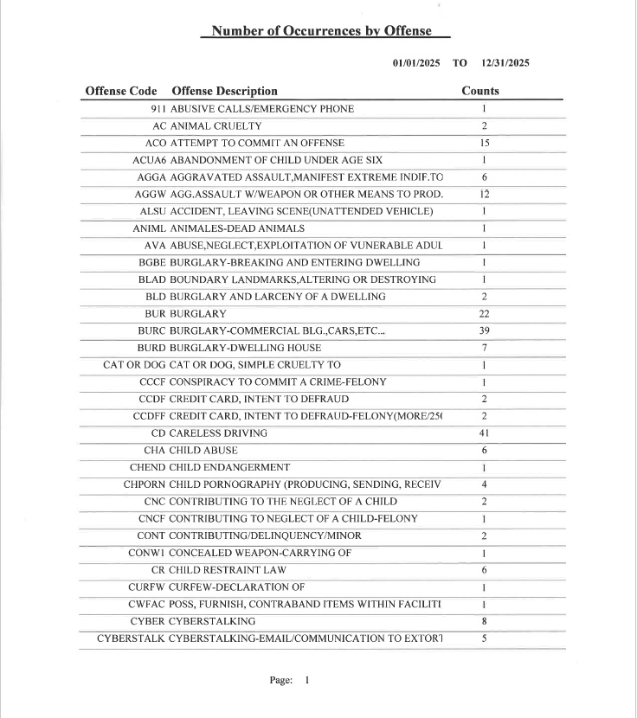

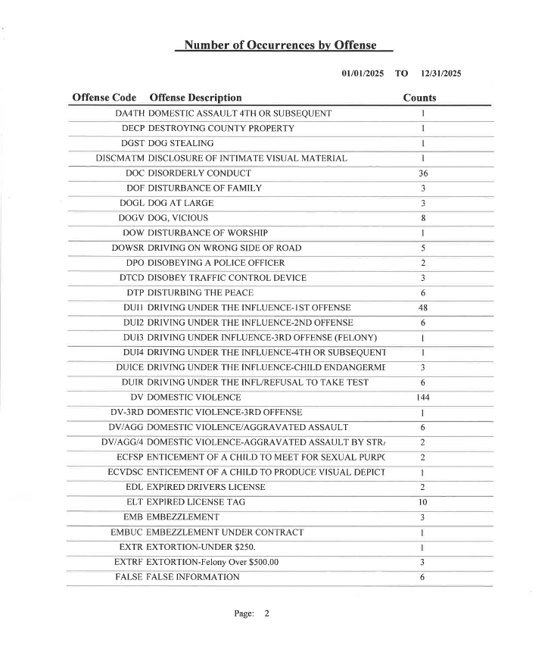
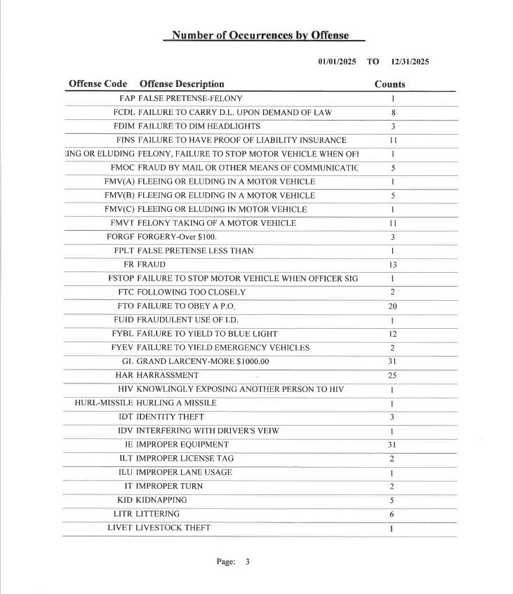

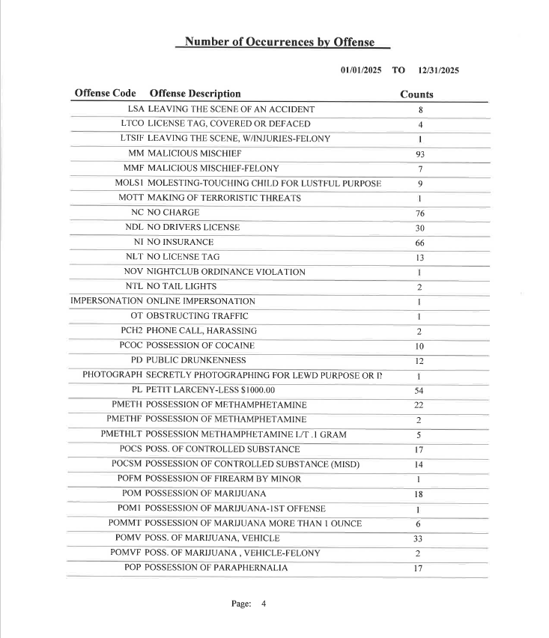

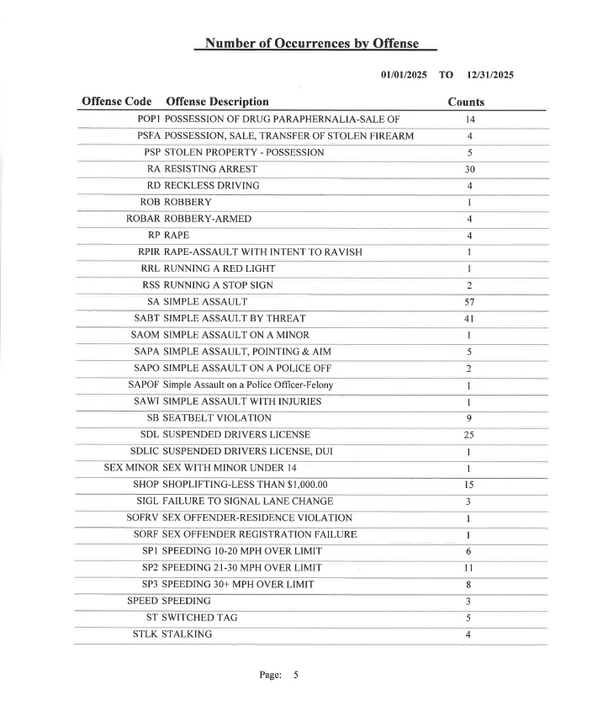
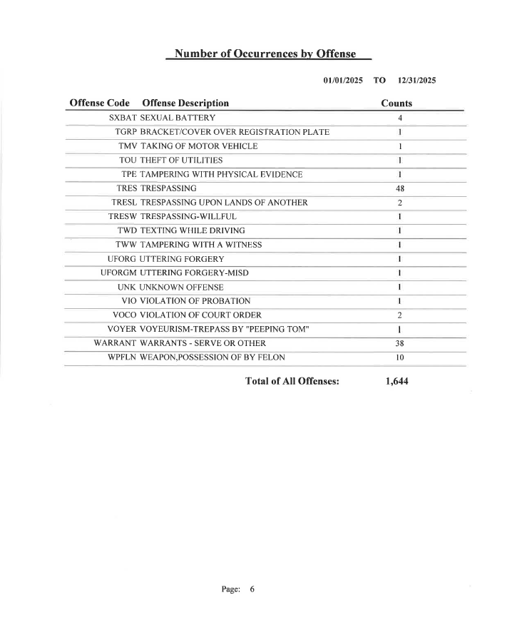Lowndes County Sheriff Department Statistics – 2024

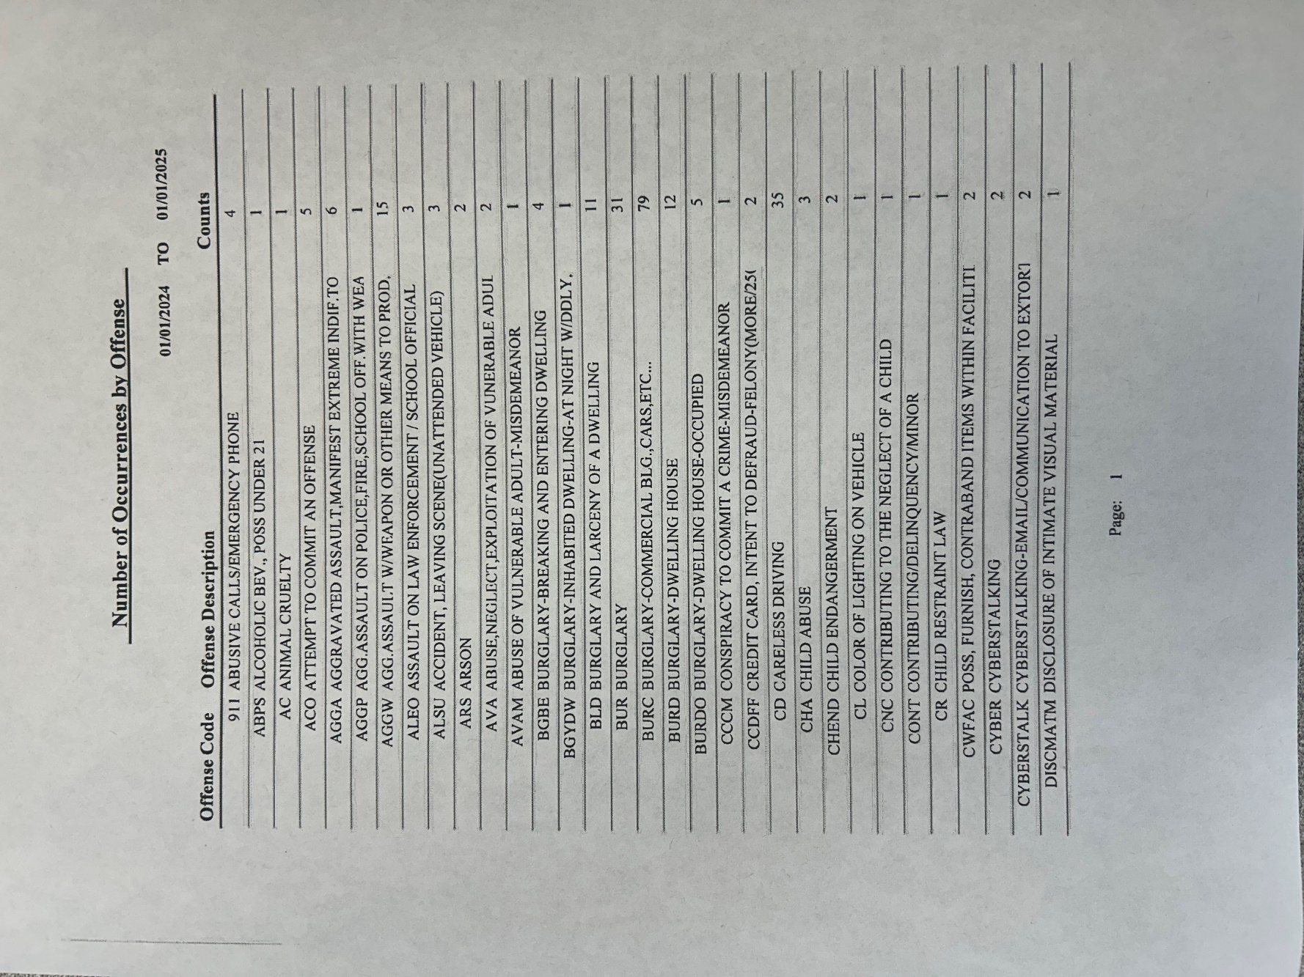

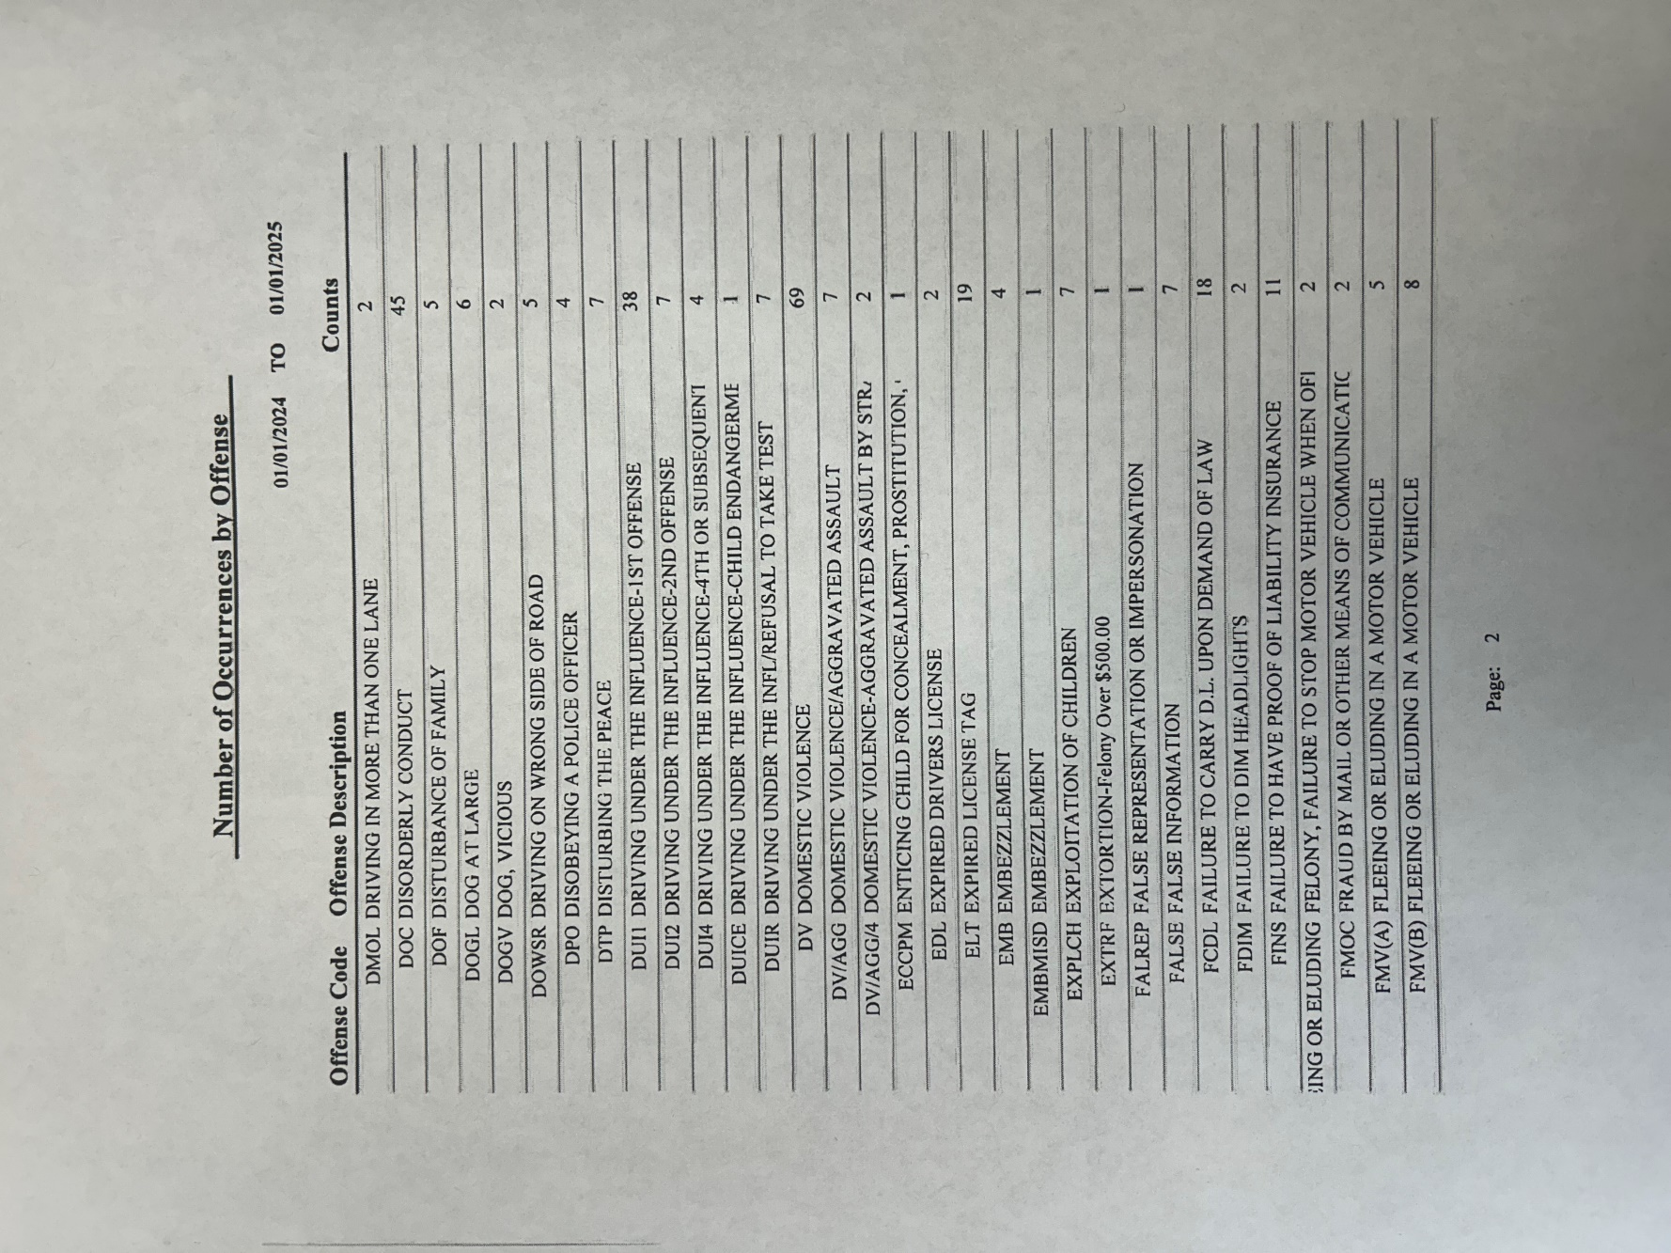

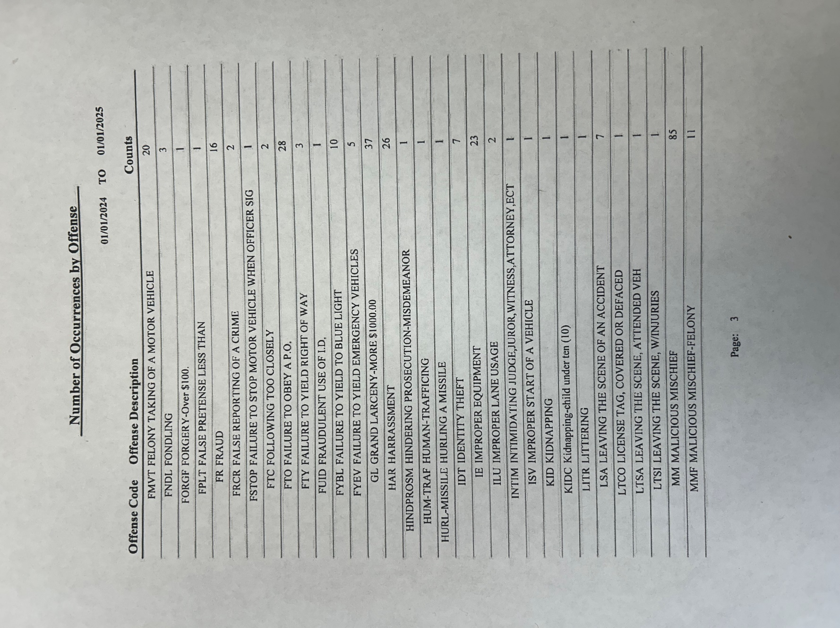

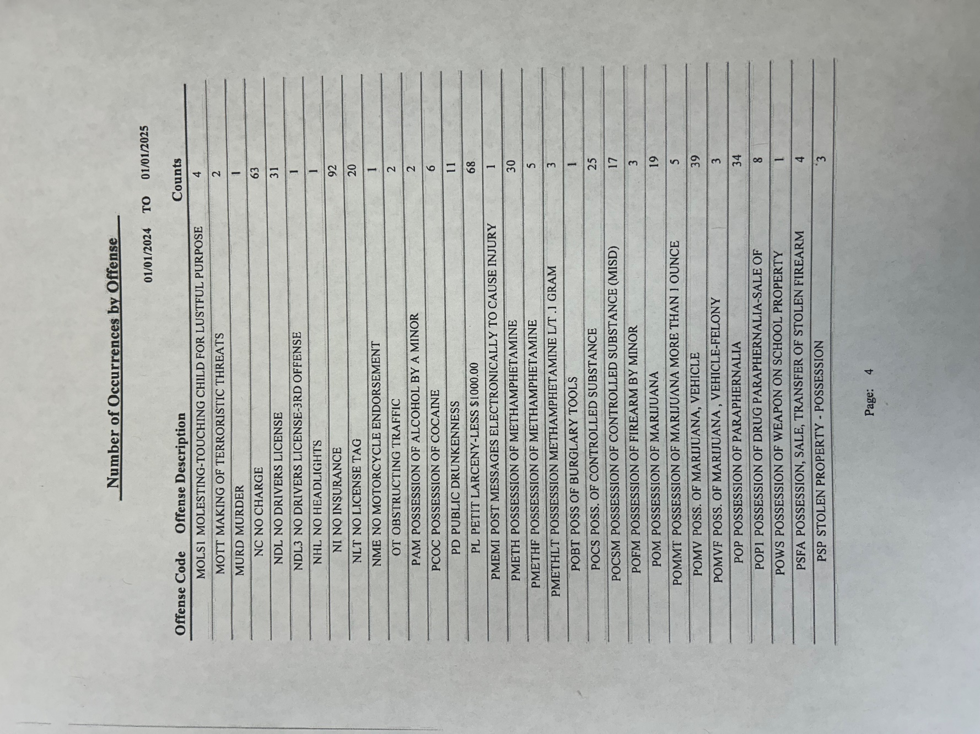

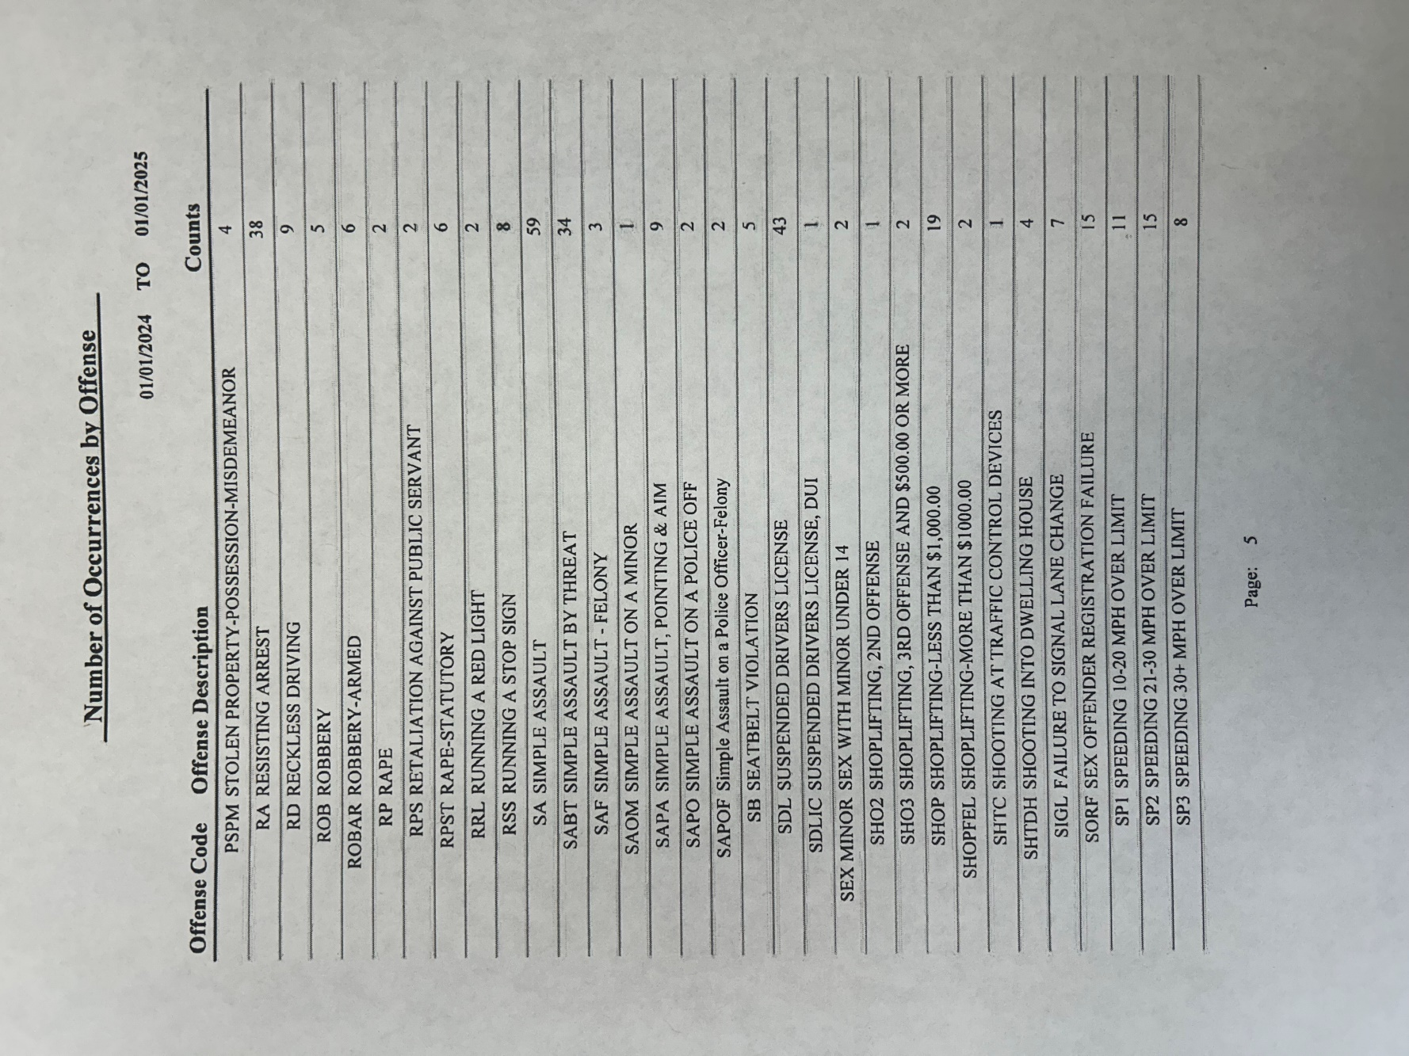

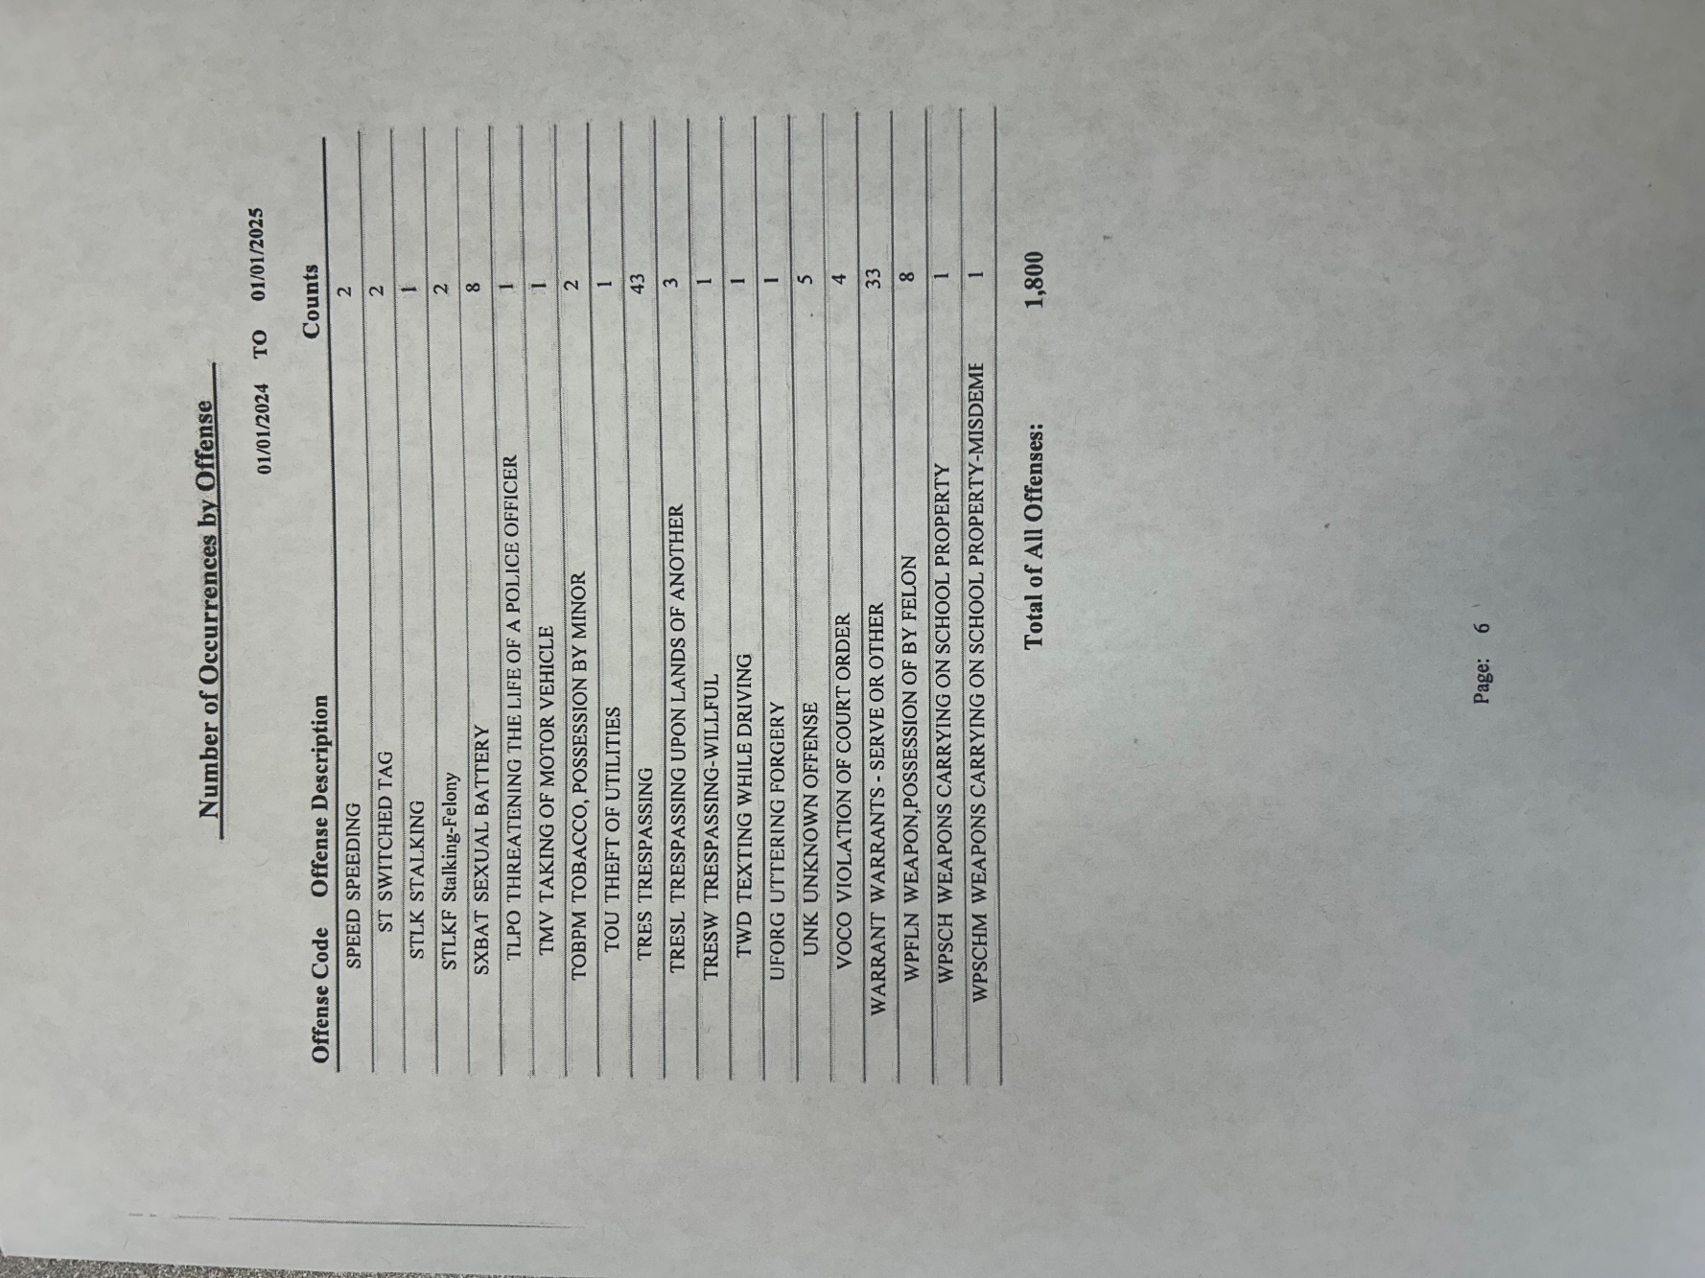

Lowndes County Sheriff Department Statistics – 2023

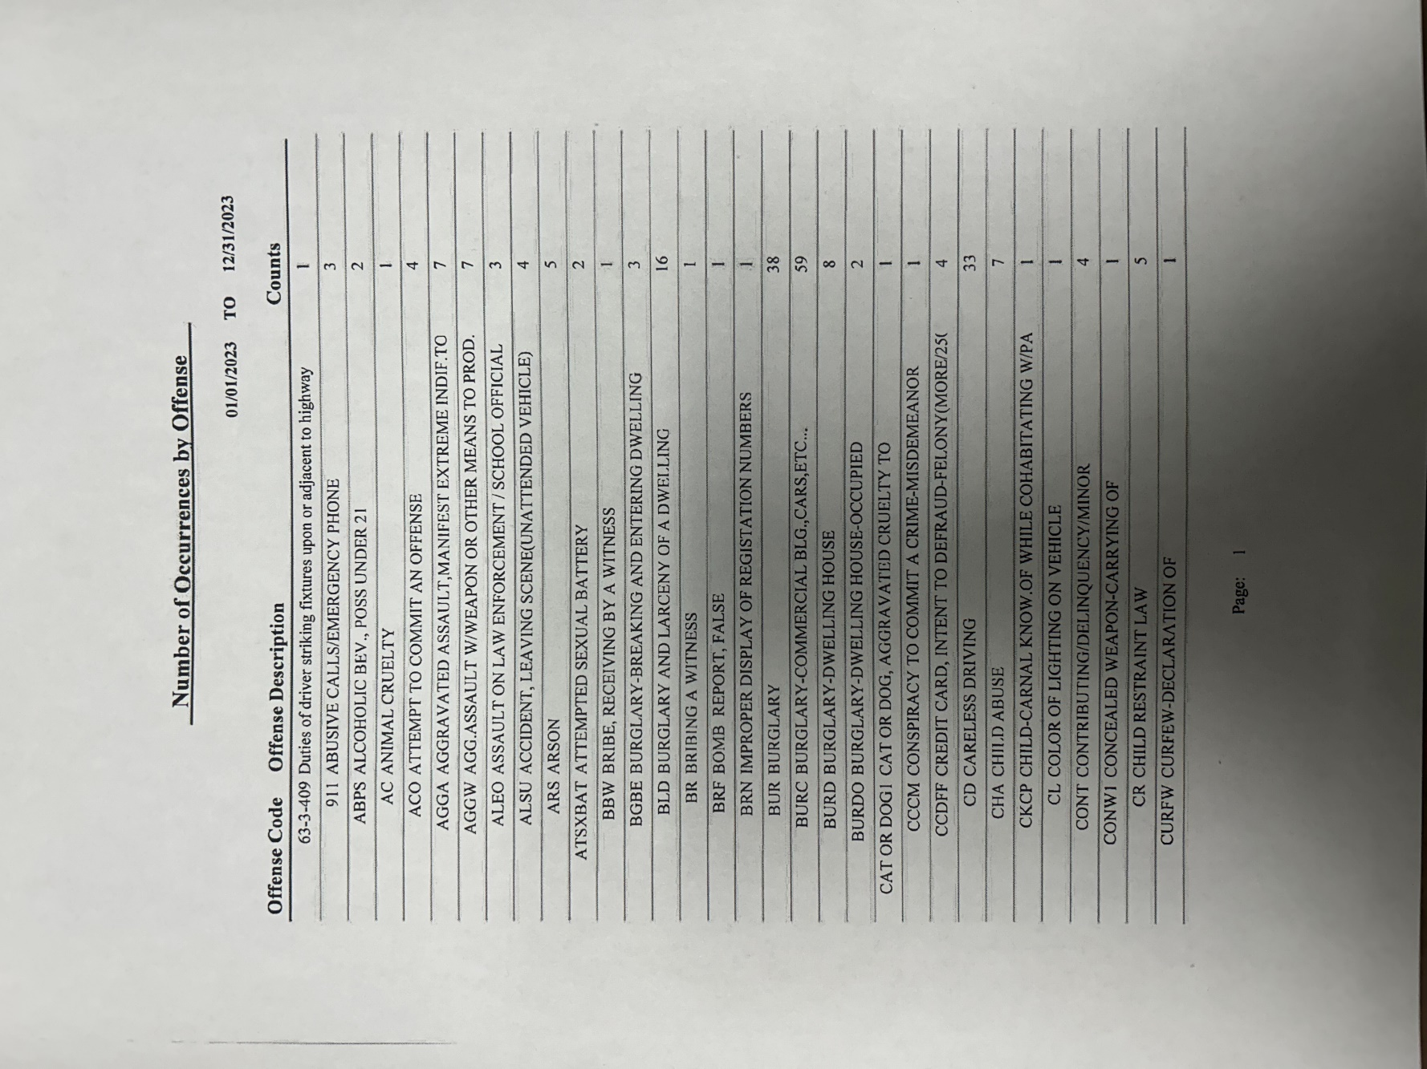

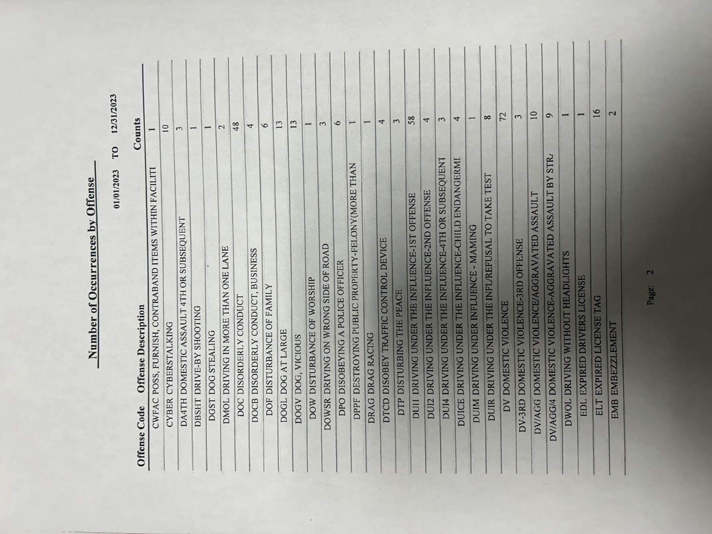

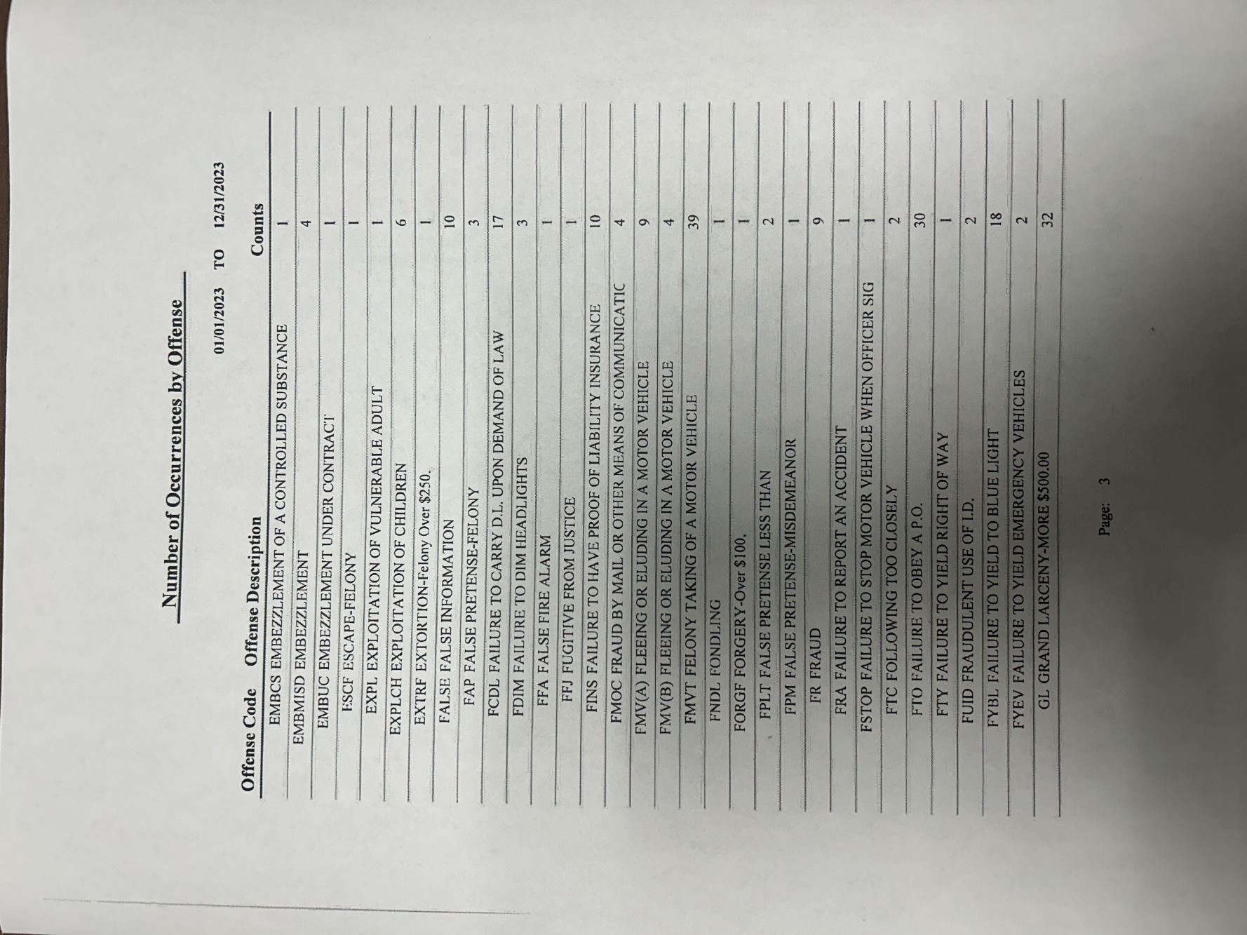

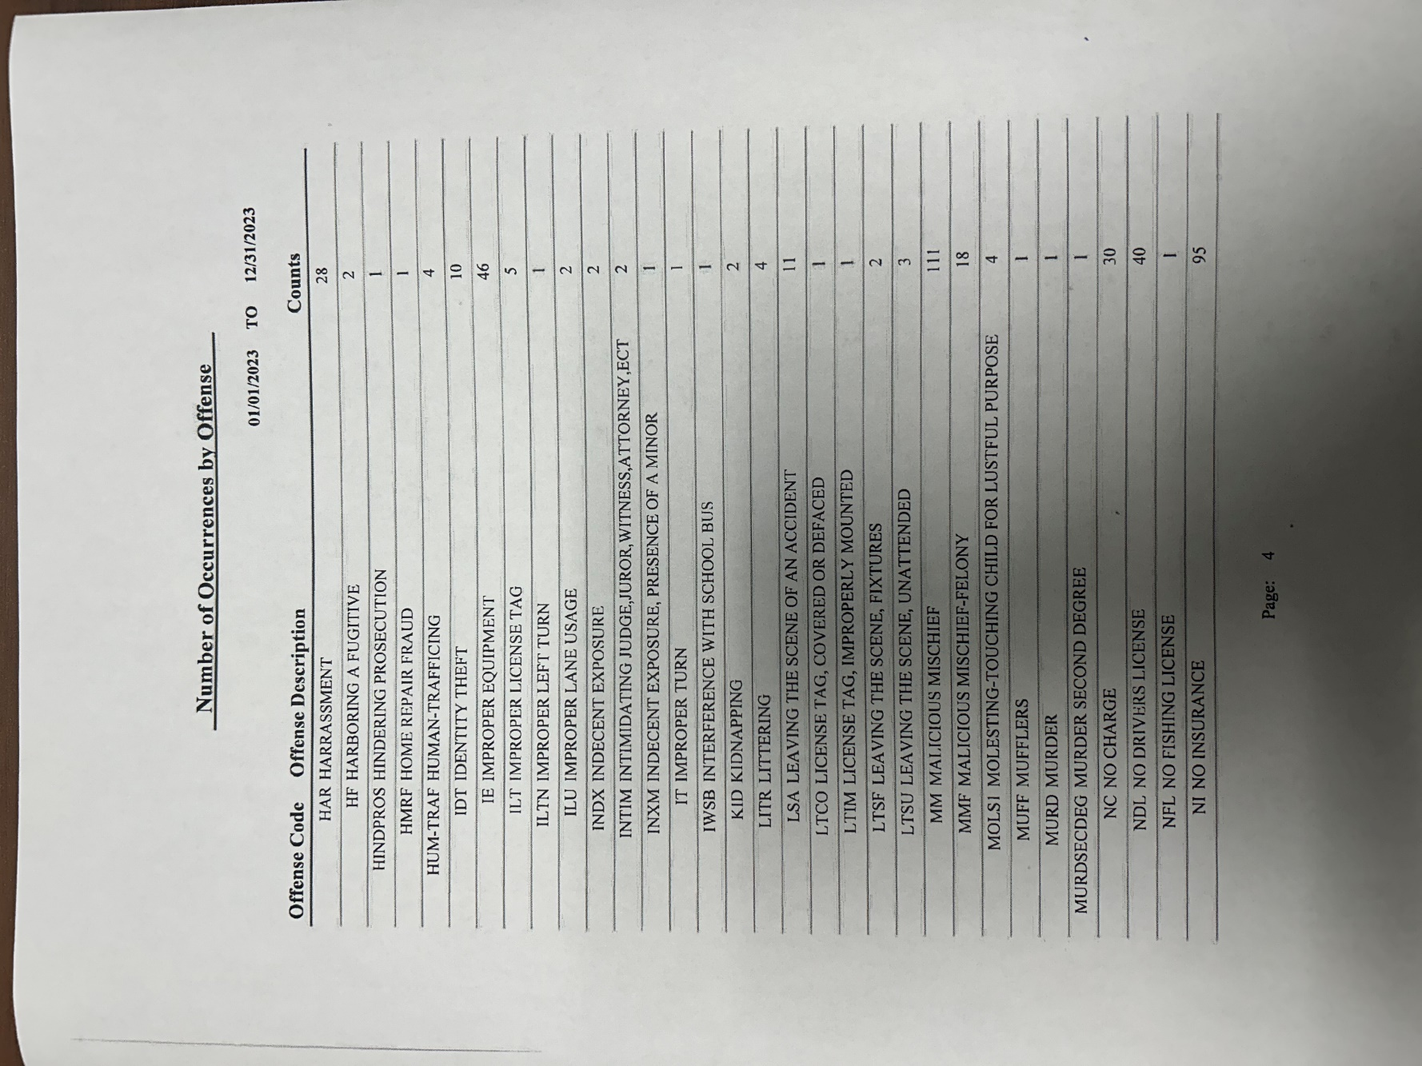

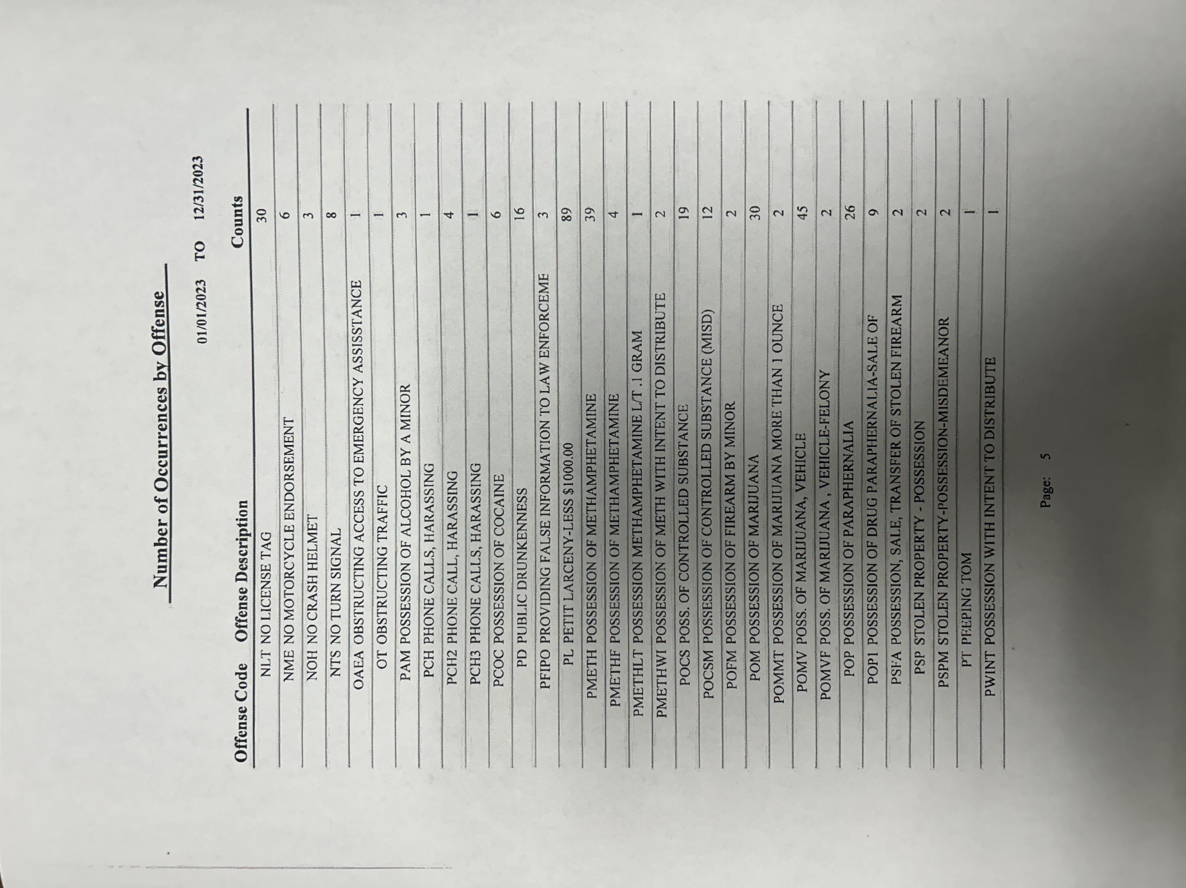

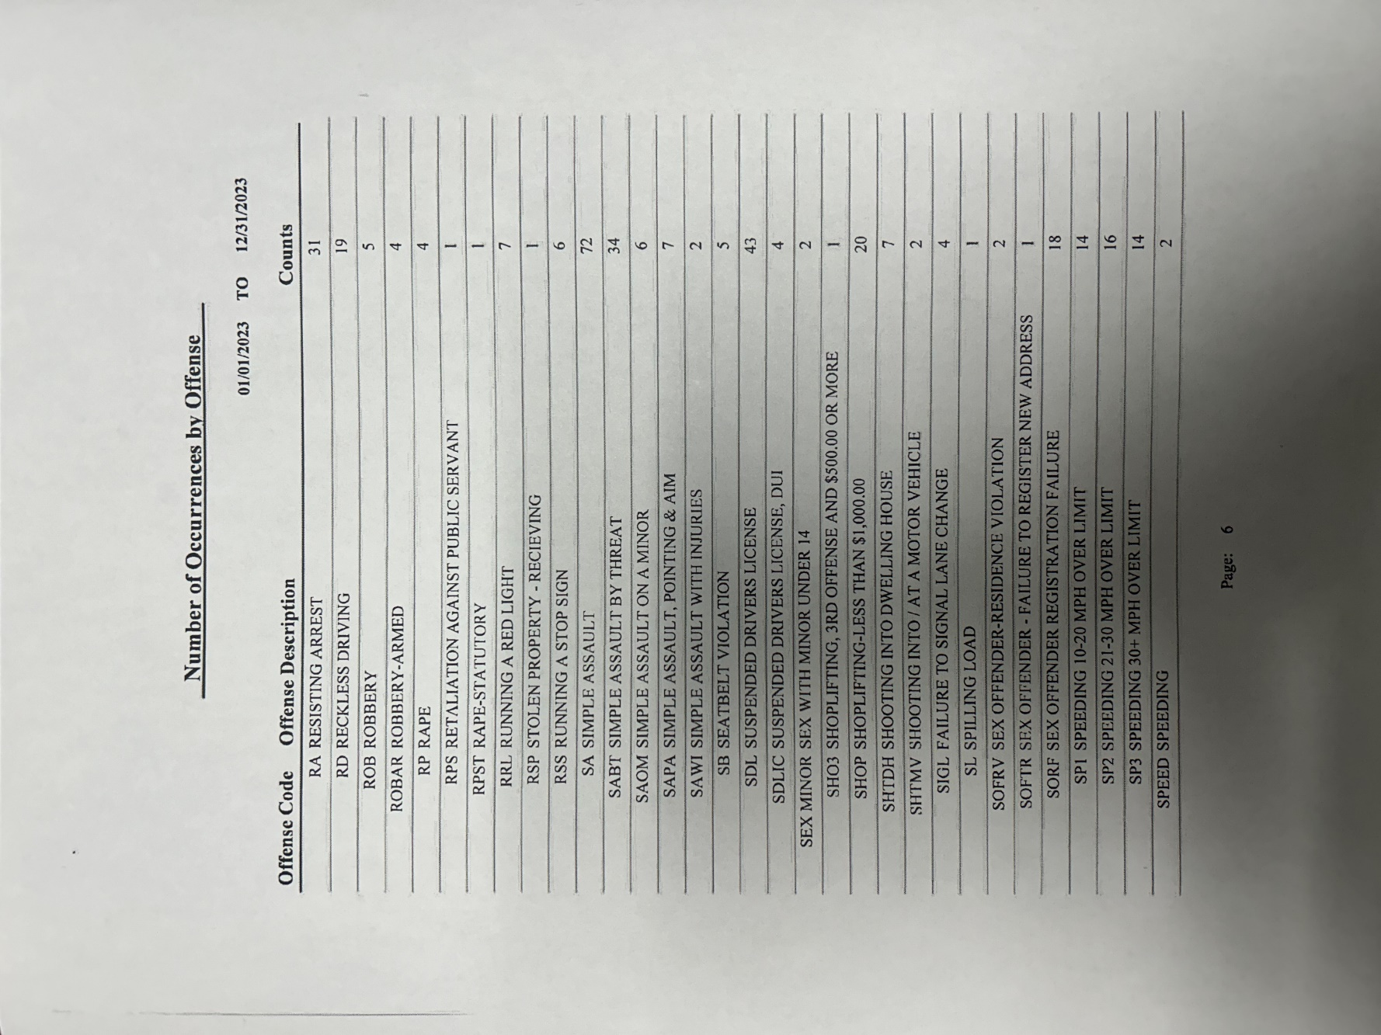

CRIME STATS – CITY OF COLUMBUS POLICE DEPARTMENT

City of Columbus Police Department Statistics – 2025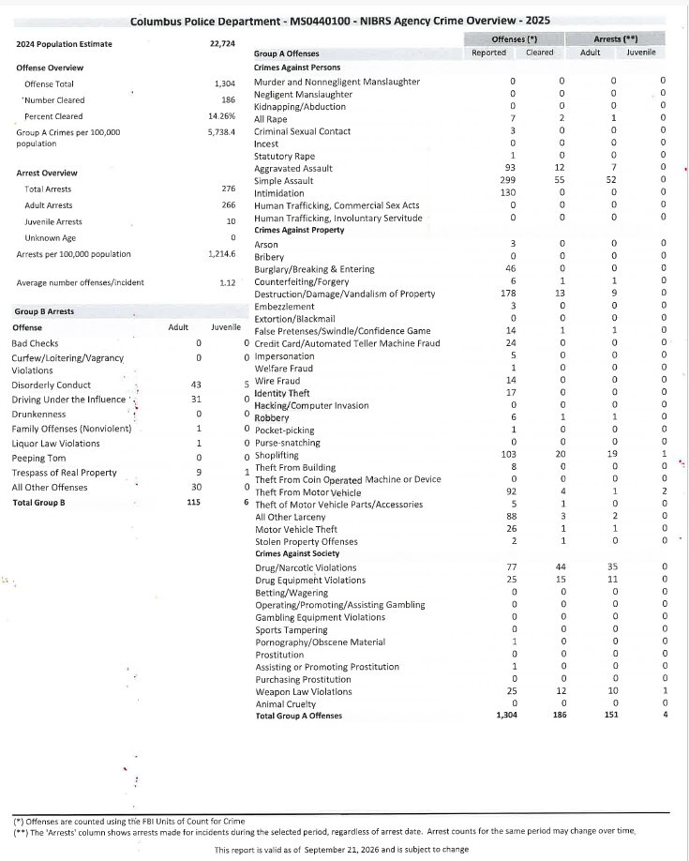

City of Columbus Police Department Statistics – 2024
The City of Columbus Police Department did not provide their 2024 crime stats.

City of Columbus Police Department Statistics – 2023

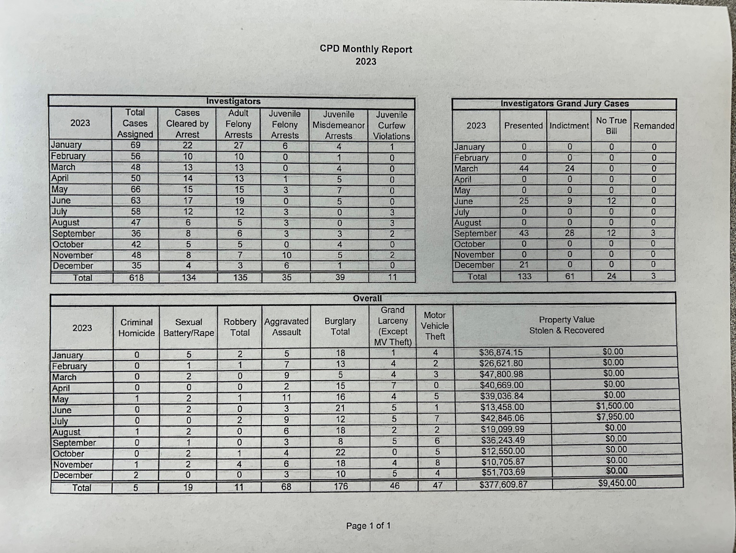

HOUSING REPORT

Types of student housing available

On Campus Housing | Physical Address | Double Rooms | Single Rooms | Suites | Gender
Callaway Hall | 1204 College Street  Columbus, MS 39701 | X | X | X | Female
Columbus Hall | 1206 College Street  Columbus, MS 39701 | X | X | X | Male
Goen Hall* | 1200 6th Avenue South Columbus, MS 39701 | X | X | X | Female
Grossnickle Hall | 100 3rd Avenue South Columbus, MS 39701 | X | X | X | Female Male
Frazer Hall* | 603 Serenade Drive  Columbus, MS 39701 | X | X | X | Male
Hasting/Simmons Hall | 1210 College Street  Columbus, MS 39701 | X | X | X | Female
Jones Hall | 604 Serenade Drive  Columbus, MS 39701 | X | X | X | Female
Kincannon Hall | 1100 6th Avenue South Columbus, MS 39701 | X | X | X | Female Male
University Housing** | 900 5th Avenue South Columbus, MS 39701 | X | X | X | Female Male

*Goen Hall and Frazer Hall are occupied with students who attend Mississippi School for Mathematics and Science which is a junior and senior high school.

**University Housing is an apartment complex owned by the university and managed through the Resource Management office. These apartments are for faculty and staff. However, when availability arises, students can apply for an apartment through this office.

All campus residence halls are single gender within a room or suite. Housing for married students or family housing is not available in the residence halls.

Policies on housing assignments and requested assignment changes

Students are able to request a roommate when they complete the housing contract. Every effort is made to honor mutual roommate requests. Students who do not request a roommate will be matched with a roommate by the use of Simple Campus Housing software that is utilized for all housing contracts.

Students are allowed to change rooms during the school year. The student who is seeking a room change request must meet with the residence hall director within their residence hall. The residence director will work the Director of Housing and Residence Life to accommodate most room change requests as long as space is available and mutual agreement is met among other students that will be affected by the room change.

Policy on admission of visitors in student housing facilities
The residence halls are intended for use by residents of the building and their invited guests. A guest is identified as a person visiting a resident of the residence hall at the resident’s invitation. Housing and Residence Life has outlined the following Visitation Policy:

Visitation Policy
Mississippi University for Women considers the safety and security of students, employees, and guests to be a minimal prerequisite for the establishment of a residential learning environment. It is the intention of the university to allow on-campus residents visitation freedoms and privileges while taking every precaution and effort to ensure a safe and secure residential environment. It is also the intention of the university to
take whatever action may be needed to prevent, correct, and if necessary, discipline behavior that violates this policy.

Host & Guest Expectations
- For the purpose of this policy, a guest is defined as any individual who is not a resident, as assigned by the Office of Housing and Residence Life, of the residence hall being visited. Guest excludes university employees or contractors in the official performance of their duties.
- The host must meet the guest in the main lobby of the residence hall and escort the guest at all times.
- Guests traveling with a resident within the residence hall must properly check in with the front desk. Guest must show a government issued picture ID, such as MUW student ID or driver’s license, at the front desk in order to check in. Desk attendant will collect the name, student ID number or driver’s license #, host name, room number, and contact number(s).
- Residents may register up to 2 guests at a time during visitation hours (1:00pm-1:00am/Sunday through Saturday).
- Prior to the end of visitation hours, hosts must escort guest(s) to the front desk to check out. This must be completed prior to 1:00AM which is the end of visitation.
- In co-residential halls, residents are required to check in with the front desk prior to visiting a resident of the opposite gender. The guest resident must be escorted by the host resident at all times and will be required to check out at the front desk at the conclusion of visitation hours.
- Guests must only enter/exit the residence halls by way of the main lobby door(s). Entry/exit through other doors is strictly prohibited.
- Hosts will be responsible for all actions of the guest. Guests are required to adhere to all policies of the Office of Housing and Residence Life and Mississippi University for Women. Failure to adhere to these policies will result in referral to the Residence Director.
- Visitation log will remain at the front desk in each residence hall. Once guest returns, the date and time of checkout will be recorded.

Approved Lobby Door Locations
A). Grossnickle Hall –First floor front entrance entering to main lobby.
B). Callaway Hall –Front entrance facing College Street and Back Entrance facing Parking Lot. C). Columbus Hall -Front entrance facing College Street and Back Entrance facing Parking Lot. D). Hasting/Simmons Hall –Front entrance by Shattuck Hall & Back Entrance facing Parking Lot. E). Jones Hall –Front Entrance entering main lobby.
F). Kincannon Hall –Front Entrance entering main lobby.

Registering an Overnight Guest of the Same Gender
- Residents wishing to host a guest for an overnight visit must complete an Overnight Guest Registration Form at the front desk by no later than 10:00pm of the night prior to the first night of

the visit. The form will require the name, contact number, and signature of the host resident; the name, contact number, date of visitation, and signature of the guest (upon arrival); signature of roommates/suitemates. Once this is completed the form must be returned to the front desk in order to be signed by the Residence Director.
- Residents are allowed overnight guests of the same gender who have been properly registered for a maximum of 4 nights during a given month.
- The host must meet the guest in the main lobby of the residence hall and escort the guest at all times.
- Hosts shall be responsible for all actions of the guest. Guests are to adhere to all policies of Housing and Residence Life and Mississippi University for Women. Failure to adhere to these policies will result in referral to the Residence Director.
- The Office of Housing and Residence Life reserves the right to remove any guest from the residence halls.
- Remember that as an assigned occupant of the room, you are responsible for the behavior of guests and visitors in your room. You can only occupy and place belongings in your assigned room.
- Residents must allow residence hall staff entrance into their room during a social gathering to ensure adherence to all university policies and procedures. Refusal to allow entry into the room could result in the involvement of Mississippi University for Women Police Department as well as serious disciplinary action.

Measures to secure entrances to student housing facilities

Every residence hall is equipped with an electronic card access system that permits access to the hall by residents of the building only. The system is operational 24 hours a day, seven days a week. Adjustments to access hours may be made during fall move in day and hall closings.

Each residence hall has an operational front desk which is worked by Desk Assistants. Residents must check their guest in and out at the front desk of each building.

Students may only enter their assigned building by swiping their student ID card at the card reader, located at all front doors and some other doors at particular halls. If a student’s ID fails to unlock the door of their assigned residence hall, the student may gain entry with the assistance of a roommate, housing staff member on duty, or by contacting MUW PD.

Students who want to visit a resident of another building or have a visitor to their room, must follow the Housing and Residence Life Visitation Policy.

Type, number, and description of security training provided to student housing employees

The Housing and Residence Life professional staff and student staff receive a variety of security trainings throughout the year which includes:
- On Duty protocol training (annually)
- Risk management training (annually)
- Community Standards/Disciplinary Protocol training (annually)
- Fire Safety Training (annually)
- Safety/Security protocols (annually)
- Crisis Response/Emergency training (annually)

Residence Directors (professional staff) and Resident Advisors (student staff) receive a manual specific to their jobs and participate in on-going trainings during the year.

Type and frequency of programs designed to inform student housing residents about housing security and enforcement procedures

Resident advisors are required to hold floor meetings each semester and additional floor meetings as needed to address safety and security along with all housing policies.

ANNUAL FIRE SAFETY REPORT

Fire Safety

The MUW PD works closely with Facilities Management as well as the Columbus Fire Department. The goal of the MUW PD and Columbus Fire Department is to educate MUW community about fire and life safety, to prevent fire emergencies and to reduce alarms.

The State Fire Code prohibits anyone from tampering with fire and safety equipment in the residence halls or in any campus building. Tampering includes pulling false fire alarms, discharging fire extinguishers, removing exit signs, and interfering with smoke detectors. Interference with smoke detectors mandates immediate attention. Students responsible will be assessed for damages and for the hourly rate of the repair person’s labor. All violators are subject to disciplinary action and possible criminal prosecution.
The maximum civil penalty for malicious use of fire and safety equipment will be enforced.

Fire Statistics for On-Campus Student Housing Facilities

In accordance with the Higher Education Opportunity Act of 2008, Mississippi University for Women is providing mandatory fire safety information as part of this Annual Report. All reports of fires and fire alarms are maintained in a database within the MUW PD. Data collected includes, but is not limited to, the building name, alarm location, time and date, the number and cause of each fire, any and all injuries, any fatalities and dollar values for property damage by the fire.

Description of On-Campus Student Housing Fire Safety Systems

Every University student residence has:
- An interior alarm is located in each room, hallway and lobby area. There are smoke and heat detectors. The detectors are auditory and visual with strobes.
- There is a yearly inspection of all fire alarm systems, sprinkler systems and all fire suppression equipment. All records of the tests are kept at Facilities Management.
- The fire alarm panel triggers an alarm directly to the MUW PD, who in turn, contacts the Columbus Fire Department.
- Sprinkler systems are in every residence hall.
- Columbus Hall and Grossnickle Hall are equipped with fire doors.

Residence Hall Fire Drills

MUW residence halls are required to conduct periodic fire drills each semester. Failure to respond appropriately to fire alarms will necessitate the scheduling of additional drills and disciplinary action against the resident(s) involved. If a resident fails to respond to a fire alarm, he/she may incur a fine as well as be subject to further disciplinary action. Housing and Residence Life Staff and University Police reserve the right to enter student rooms to locate the source of the problem and to ensure that everyone has evacuated the building.

Annual Disclosure of Fire Statistics for Each On-Campus Student Housing Facility Year – 2025
Residence Hall | Date of Fire | Cause of Fire | # of persons w/fire related injuries | # of fire related deaths | Property damage
Callaway Hall | 0 | 0 | 0 | 0 | 0
Columbus Hall | 0 | 0 | 0 | 0 | 0
Frazer Hall* | 0 | 0 | 0 | 0 | 0
Goen Hall* | 0 | 0 | 0 | 0 | 0
Grossnickle Hall | 0 | 0 | 0 | 0 | 0
Hasting/Simmons Hall | 0 | 0 | 0 | 0 | 0
Jones Hall | 0 | 0 | 0 | 0 | 0
Kincannon Hall | 0 | 0 | 0 | 0 | 0
University Housing** | 0 | 0 | 0 | 0 | 0

*Goen Hall and Frazer Hall are occupied with students who attend Mississippi School for Mathematics and Science which is a junior and senior high school.

**University Housing is an apartment complex owned by the university and managed through the Resource Management office. These apartments are for faculty and staff. However, when availability arises, students can apply for an apartment through this office.

Year - 2024
Residence Hall | Date of Fire | Cause of Fire | # of persons w/fire related injuries | # of fire related deaths | Property damage
Callaway Hall | 0 | 0 | 0 | 0 | 0
Columbus Hall | 0 | 0 | 0 | 0 | 0
Frazer Hall* | 0 | 0 | 0 | 0 | 0
Goen Hall* | 0 | 0 | 0 | 0 | 0
Grossnickle Hall | 0 | 0 | 0 | 0 | 0
Hasting/Simmons Hall | 0 | 0 | 0 | 0 | 0
Jones Hall | 0 | 0 | 0 | 0 | 0
Kincannon Hall | 0 | 0 | 0 | 0 | 0
University Housing** | 0 | 0 | 0 | 0 | 0
*Goen Hall and Frazer Hall are occupied with students who attend Mississippi School for Mathematics and Science which is a junior and senior high school.

**University Housing is an apartment complex owned by the university and managed through the Resource Management office. These apartments are for faculty and staff. However, when availability arises, students can apply for an apartment through this office.

Year - 2023
Residence Hall | Date of Fire | Cause of Fire | # of persons w/fire related injuries | # of fire related deaths | Property damage
Callaway Hall | 0 | 0 | 0 | 0 | 0
Columbus Hall | 0 | 0 | 0 | 0 | 0
Frazer Hall* | 0 | 0 | 0 | 0 | 0
Goen Hall* | 0 | 0 | 0 | 0 | 0
Grossnickle Hall | 0 | 0 | 0 | 0 | 0
Hasting/Simmons Hall | 0 | 0 | 0 | 0 | 0
Jones Hall | 0 | 0 | 0 | 0 | 0
Kincannon Hall | 0 | 0 | 0 | 0 | 0
University Housing** | 0 | 0 | 0 | 0 | 0
*Goen Hall and Frazer Hall are occupied with students who attend Mississippi School for Mathematics and Science which is a junior and senior high school.

**University Housing is an apartment complex owned by the university and managed through the Resource Management office. These apartments are for faculty and staff. However, when availability arises, students can apply for an apartment through this office.

Prohibitions on Portable Electrical Appliances, Smoking and Open Flames

Housing and Residence Life have policies that outline cooking appliances and fire prevention within the residence halls.

Cooking and Appliance Policy
Due to the nature of residence hall living, the physical facilities of the halls, and the concerns for fire and safety standards, only microwave cooking is permitted in student rooms (unless the suite is equipped with a kitchenette). MicroFridges (combination microwave, refrigerator, and freezer) are provided and the proper use of the MicroFridge is the responsibility of each student. Students are not allowed to have an additional refrigerator/microwave in his/her room. Cooking appliances (such as percolators, toasters, toaster ovens, electric skillets, crock pots, and hot plates) are not allowed in student rooms. George Foreman grills or similar products are also not permitted.

Fire Prevention
Below are residence hall policies and guidelines:
- Candles, oil lamps, and other open-flame or continuous burning objects are not permitted (even for decoration purposes).
- Students may not place or store furniture, trash or personal belongings in the hallways.
- Keep posters and other combustible decorations to a minimum.
- Incense is not permissible. Air freshener is acceptable as a plugin or spray.
- Check electrical cords and appliances to insure they are in proper working order. Extension Cords are not allowed, only surge protectors can be used. Only one surge protector may be used per outlet (surge protectors may not be plugged into other surge protectors).
- Check electrical outlets and surge protectors to ensure they are not overloaded. Residence hall staff reserves the right to confiscate any electrical outlet or surge protector for health and safety reasons.
- Stairwell, hallway and fire doors should never be propped open.

- Halogen lamps, lava lamps, multi-plug adapters, and bulbs are prohibited in resident rooms.
- To avoid fire hazard, live Christmas trees are not permitted in residence hall rooms or in the residence common areas.
- Low-heat bulbs and flame retardant materials may be used to decorate residence hall rooms. Students violating any of the above guidelines may face disciplinary action.

Student Housing Fire Evacuation Procedures

In case of a fire:
- Sound the fire alarm.
- Evacuate the building.
- Call the MUW PD at extension (662) 241-7777.

When an alarm sounds:
- Feel the door from top to bottom with your hands. If it is hot, do not open it!
- If the door is cool, crouch low and open it slowly. If there is heavy smoke, close the door quickly.
- If the hallway is clear, exit via the nearest stairwell.
- Do not use the elevator.
- If you encounter heavy smoke in the stairwell, do not proceed; but try to go to a different stairwell.

If trapped in a room:
- Stuff towels or clothing under the door.
- Open windows – attract someone’s attention.
- Stay near the window for fresh air.

Campus Building Fire Evacuation Procedures

If you discover a fire in a campus building:
  - Immediately pull the nearest fire alarm as exit the building.
  - When evacuating the building, remember to feel doors before opening them to be sure that there is no fire danger on the other side. If you must enter a smoke-filled room or hallway, stay low, keeping one hand on the wall to avoid disorientation and crawl to the nearest exit, keep head near the floor.
  - Once safely away from danger, call 911 and 662-241-7777 to report the fire.
  - Leave the building at once but stand by to direct emergency teams to the location of the fire.

FIRE SAFETY PRECAUTIONS
- Keep doorways, corridors and stairwells clear and unobstructed. Keep the fire doors closed.
- Make sure that all electrical appliances and cords are in good condition and UL approved.
- Do not overload electrical outlets. Use fuse-protected multi-outlet power strips and extension cords when necessary.
- Extinguish all smoking materials properly and thoroughly.
- Never store flammable substances in your room or apartment. Unauthorized use of candles and live holiday decorations are not permitted in University buildings.
- Be aware that transmitting a false alarm is a criminal offense that endangers the lives of both building occupants and emergency personnel. It is also an offense to prop open fire doors or to tamper in any way with alarm equipment, electromagnetic locks, or other safety devices or to block or obstruct paths of egress.

Note: If a member of the MUW community finds evidence of a fire that has been extinguished and the person is not sure whether MUW PD or the City of Columbus Fire Department has already responded, that person should notify the MUW PD or the City of Columbus Fire Department, who will investigate and document the incident.

FIRE RESPONSE DOS AND DON’TS
  - DO treat every alarm as an emergency. If an alarm sounds, exit the building immediately.
  - DON’T assume that a fire alarm is a drill or test. All building alarm systems are tested as required by law, but these tests are announced in advance.
  - DO remain in your room if you cannot get out of the building because of heat or smoke. Call the POLICE and FIRE DEPARTMENT right away. Keep the door closed and wait for assistance from the Fire Department. If smoke is entering around the door, stuff the crack under the door with sheets, clothes, or blankets. If possible, open the window and wave a brightly colored garment or towel from your window---the Fire Department will be looking for this sign.
  - DO close the door behind you if it is safe to leave your room.
  - DON’T waste time collecting personal valuables. Take your keys so that you can reenter your room if exit from the building is not possible.
  - DON’T use an elevator during a fire emergency: ALWAYS USE THE STAIRS.

Fire Safety Education and Training Programs for Students, Staff, and Faculty

The Housing and Residence Life professional staff and student staff receive a variety of security trainings throughout the year which include fire safety.

Fire Incident Reporting

Students, faculty and staff are instructed to call 911 to report a fire emergency. Immediate notification for a non-emergency incident (example: fire is out, evidence that something burned, etc.) shall be made to: MUW PD: 662-241-7777

Housing and Residence Life: 662-329-7127 Dean of Students: 662-329-7129

Plans for Future Improvements in Fire Safety

All Mississippi University for Women buildings meet or exceed City of Columbus and State of Mississippi fire safety requirements. In addition, as the University renovates buildings, additional fire suppression and detection devices are being added to bring our buildings above, or beyond, current requirements.



IMPORTANT NUMBERS

MUW Police Department
Emergency: 911
662-241-7777
Building: McDevitt Hall

MUW Health Center
662-329-7289
Building: Eckford Hall

MUW Counseling Center
662-329-7748
Building: 11th Street South & 4th Avenue (Blue House)

Dean of Students Office
662-329-7129
Building: Cochran Hall, Room 400

Title IX Coordinator
662-370-1035
Building: Cochran Hall Room 300

Division of Student Affairs
662-329-7129
Building: Cochran Hall, Room 400

Housing and Residence Life
662-329-7127
Building: Cochran Hall, 2nd Floor

MUW Facilities Management
662-329-7396
Building: Physical Plant Warehouse

