




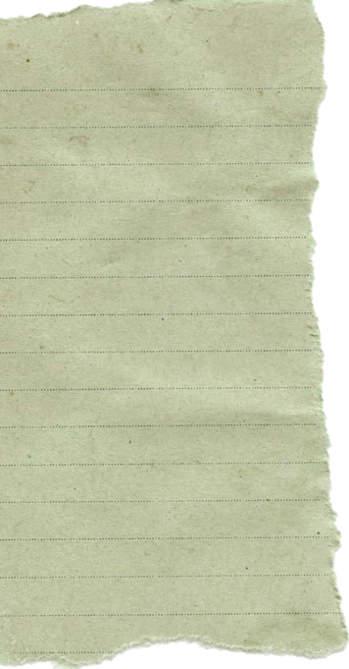
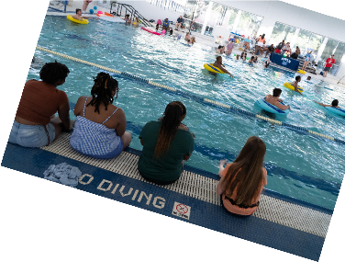



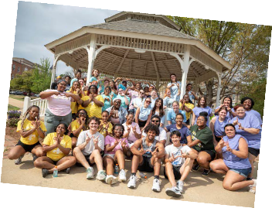

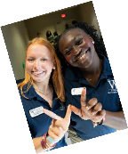

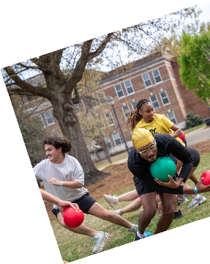













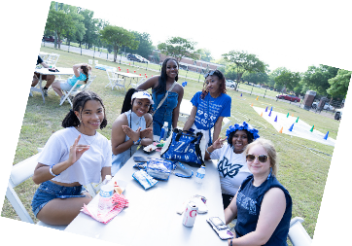

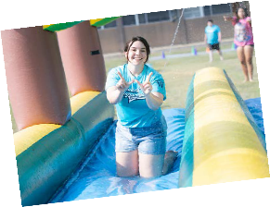

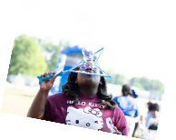

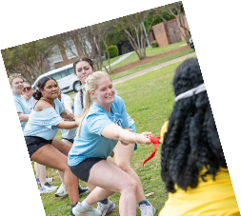

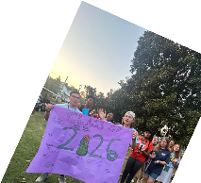






Saturday 8/15
8am Move In Day!
Across campus!
5pm Pizza Pies & Goodbyes
The W Room
7pm Floor Meetings (Residents only) Residence Halls
8pm W Family Feud
Nissan Auditorium

Sunday 8/16
9am Rise & Grind
Cereal, coffee, and cartoons
The Nest
3pm Playfair
(Required for new students)
Pohl Gymnasium
4:30pm Sunday Sundaes Pohl Gym Lobby
7pm Owl-Palooza
Concert
Pohl Greenspace

Monday 8/17
10am-12pm Schedule Stroll Library, Common Grounds
2pm Serenade Rehearsal Carrier Chapel
6pm New Student Serenade
Nissan Auditorium 8:30pm Ghost Tours The W Room

Tuesday 8/18
8am-4pm First Day Photos
Turner Lawn
2pm Rootbeers & Readiness
Turner Lawn
6pm BSU Back to School Bash
Baptist Student Union
9pm Late Night Breakfast Hogarth Cafeteria

Wednesday 8/19
11am-2pm Crafternoon Crafts & Snacks
The Nest
3-4:30pm Syllabus Savvy
Library, Gail P. Gunter Room
7pm Nest Night
Campus Scavenger Hunt
The Nest

Thursday 8/20
10am-2pm Blood Drive Stark Recreation Center 12pm BSU Noonday
Baptist Student Union
1pm-2pm Meet Your Mentors: Real Talk for a Great Semester Library, Gail P. Gunter Room
5-7pm Library Open House Fant Memorial Library
8pm Social & Greek Game Night & Taco Bar
Limbert Assembly Room

Friday 8/21
8am-10am Donut fret, it’s Friday!
Donuts, juice, & iced coffee
Turner Lawn
1-3pm Hats off to a great first week!
DIY trucker hats
The Nest
6pm Owlfest
Petting zoo, horse rides, dunking booth, bungee trampoline, & more!
Bryan Green Gazebo

Saturday 8/22
8:30am-1pm RSO Training Day!
Cochran Hall
3-5pm Mud Volleyball Tournament
Mud Volleyball Court
8pm Glow Party
The W Room

Sunday 8/23
6pm Luau & Dive In Movie
Stark Recreation

Monday 8/24
2-4pm Welcome to Whitfield Whitfield Hall, Career Center 5:30pm Mamba Day Basketball Tournament
Stark Recreation

Tuesday 8/25
6-8pm Involvement Fair
Pohl Gymnasium

