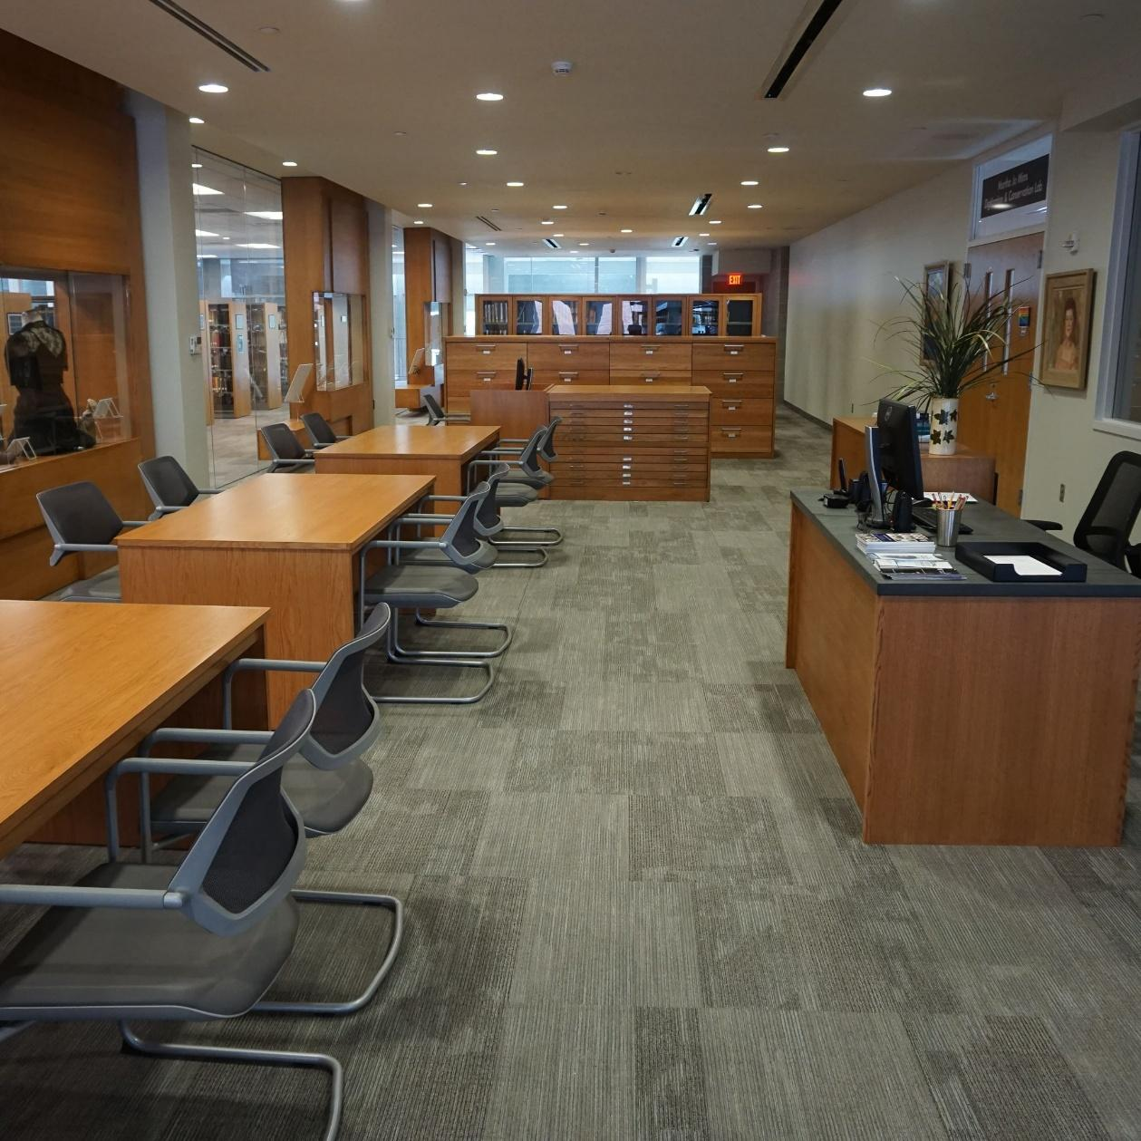
Beulah Culbertson Archives and Special Collections FY25 Annual Report

STEPHANIE R SALVATERRA

I: Unit Overview

FY25 Staffing
1 FTE Faculty- Archivist and Special Collections Librarian, Stephanie Salvaterra
1 FTE Staff- Archives Specialist, Sarah Parrish
3-4 student workers
1 volunteer

Clientele
Mississippi University for Women students, faculty, staff and alumni. Mississippi School for Mathematics and Science students, faculty, staff, and alumni. Campus community members. Scholars and people working in higher education.

Mission
The primary purpose of the Beulah Culbertson Archives and Special Collections is to support the university’s mission and commitment to excellence, leadership, and personalized learning via the following core functions:
- Collecting, preserving, and making available written records, manuscripts, artifacts, memorabilia, and other items of historical significance that document the history and legacy of Mississippi University for Women as well as the history of Mississippi women and Mississippi women’s leadership.
- Documenting in the same manner the lives of those who have touched and changed the institution, including but not limited to those who fought for the establishment of the Columbus Female Institute/Industrial Institute and College, our past presidents, and our famous faculty and alumni.
- Making available the rare and unique resources within our holdings to faculty, staff, students, alumni, visiting scholars, and the wider public.
- Becoming a destination for the study of Mississippi women’s history and leadership.

Narrative
During FY25, Beulah Culbertson Archives and Special Collections continued to engage in a wide variety of projects intended to support and fulfill the mission of collecting, preserving, and providing access to original materials documenting the university’s history and that of Mississippi women. Work was also guided by the Archives’ 2023-2026 Strategic Plan, with a specific focus on improving intellectual and physical control over the collection. We have undertaken this work with the goal of making the collection more accessible and understandable, and have endeavored to achieve a balance between access to materials and adequate description of them. This balance is necessary in the interest of serving the Archives’ constituents and ensuring that the collection is findable, usable, and that the organization of it is understandable to the next people working in the archives.
This document will serve as a record of the activities and accomplishments of the Archives during FY25, a reminder of the goals and direction of our work, and a source of statistics.

Major activities and accomplishments during FY25
- The audit of all Archives and Special Collections bins was completed. Approx. 119 bins were audited from January-August of 2024. Completing this audit significantly improved our knowledge of the content and location of archives materials stored in the ASRS.
- Student workers and staff completed an inventory of bins containing Special Collections and unprocessed materials. A total of 44 bins containing 43 accessions and over 2800 items were inventoried. These inventories allowed us to create new and improve old descriptions, affording more contextual information about the archives’ holdings as well as a more complete picture of the contents of Athena.
- The Archives provided names and source material for 9 students from MSMS’ Tales from the Crypt class. Four of these were selected to perform at Homecoming as well as the official Tales from the Crypt performances. The collaboration resulted in a donation of $500 from the students and a press release and articles in local newspapers. https://www.muw.edu/news/msms-students-strengthen-historical-ties-with-500-gift-to-w-archives/
- Archives staff supported The Society of Mississippi Archivists in hosting their Annual Meeting at the library in March 2025. In addition to serving as liaisons for the SMA board, Archives staff presented at the meeting. https://mississippiarchivists.org/2025/02/19/2025-annual-meeting/
- The Library Associate Archives and Special Collections position was successfully modified into an Archives Specialist position. Along with the change in title, University Administration approved a re-classification of the position and a raise accompanied by a move to a higher salary band.
- In collaboration with Technical Services and Public Services staff, 694 books in the Welty-Faulkner collection have been cataloged as Special Collections and shelved according to Library of Congress classification in the reading room.
- All Nursing theses ETDs re-sent by ProQuest to replace those lost in malware attack in 2020 at no cost to the library

II: Collections

Newly Accessible Materials
The Archives continued our work to update and maintain searchable online descriptions of the collection’s contents on ArchivesSpace. This description helps researchers discover the archives and The W in many ways. For scholars who know that they are interested in The W, searchable online description is an essential tool for learning about the kind of information they can access if they research at the archives. For those who don’t know they are specifically looking for information at The W, search engine optimization allows description on ArchivesSpace to appear as search results on sites like Google, broadening the reach of the archives.
Folder-level description of approximately 49 cubic feet worth of materials were uploaded to ArchivesSpace over the course of FY25. Investment of time in creating online description allows staff to point researchers in the direction of existing resources, which helps researchers work more independently and use their time in the archives more efficiently. Identifying resources earlier in the research process also allows scholars time to pivot if they need to change their topic, and makes the reference process less time- and labor-intensive for staff.
FY25 also saw great improvement in accessibility for Special Collections materials. 694 books authored by William Faulkner and Eudora Welty, many of which are limited and first editions, were added to the library catalog this year and enhanced their discoverability. Eight books previously cataloged as part of the Juvenile Collection were also transferred to Special Collections, which will help ensure their preservation.

Collecting
FY25 saw an increase in transfers of records from units on campus. Approximately 74 cubic feet of records were transferred from the Office of Academic Affairs, including materials with information on accreditation and the work of the Faculty Research Committee and other university-wide committees. The Kossen Center for Teaching and Learning also transferred approximately 35 cubic feet of records from the Office of Special Projects dating from c. 1996-2018. Archives staff worked to appraise the grant records in accordance with State records retention schedules, retaining approximately 15 cubic feet of records. Work will continue on these records to appraise, process, arrange, and describe them and make them available to researchers. Oral History Interviews with the 2024 class of Golden Girls were also transferred from the Center for Women’s Research and Public Policy.
Outside of transfers from departments in the university, the archives had 15 donation inquiries during FY25, about 7of which were accepted. Accepted donations include records from the Rogue and Highlander Social Clubs, issues of the Dilettanti from the 1960s donated by the editor of the publication, and pages from the scrapbook of a student who attended The W in the 1920s.
This year, archives staff discovered an almost complete collection of first editions of works by George Eliot, a favorite of early students including Blanche Colton Williams of the class of 1898, who went on to publish a biography of Eliot in the 1930s. Williams donated over 1000 volumes from her personal collection to the library in 1941, including first editions of all of Eliot’s works except Scenes of a Clerical Life and Romola. Considering George Eliot’s standing as a woman writer, her relationship to Dr. Williams, and the role Eliot’s writing has played in educating generations of W students, we purchased first editions of those 2 works and have completed the collection.

III: Usage of and Interaction with Materials

Outreach
- 5 instruction sessions, 3 University History presentations
  - History Capstone, Museum Studies and Intro to Historical Thinking and Research visited the archives to learn about archival research
  - Museum Studies came twice to research and select materials for Trailblazing Women: Our Legacy II exhibit
  - University History presentation done for New Faculty Orientation, Orientation Leaders, and Daughters of the American Revolution meeting
- Exhibits on Blanche Colton Williams and George Eliot, longtime employees and Juneteenth celebrations researched, mounted, and displayed
- Stephanie attended/spoke at Homecoming Tales from the Crypt performance
- Archives brochures, copies of In Their Footsteps, Stephanie’s business cards set up around library
- Archives brochure updated and reprinted, distributed at New Student Orientations and New Faculty Orientation
- Coordinated with Mona Vance-Ali at the Columbus Lowndes Public Library to put together a list of the dates covered by our respective collections of Dispatch microfilm
- Visited Department of Science and Mathematics offices to give advice on records to keep and throw away, arranged for gradual transfer as Chair Bonnie Oppenheimer winds down before retirement

Appointments
MUW and MSMS students, faculty and staff, and MUW community members utilized the archives in a number of ways during FY25. Over the course of the year, researchers came to the archives to use materials from the collection 66 times. September and October of 2024 were the busiest months with 20 and 17 appointments respectively.

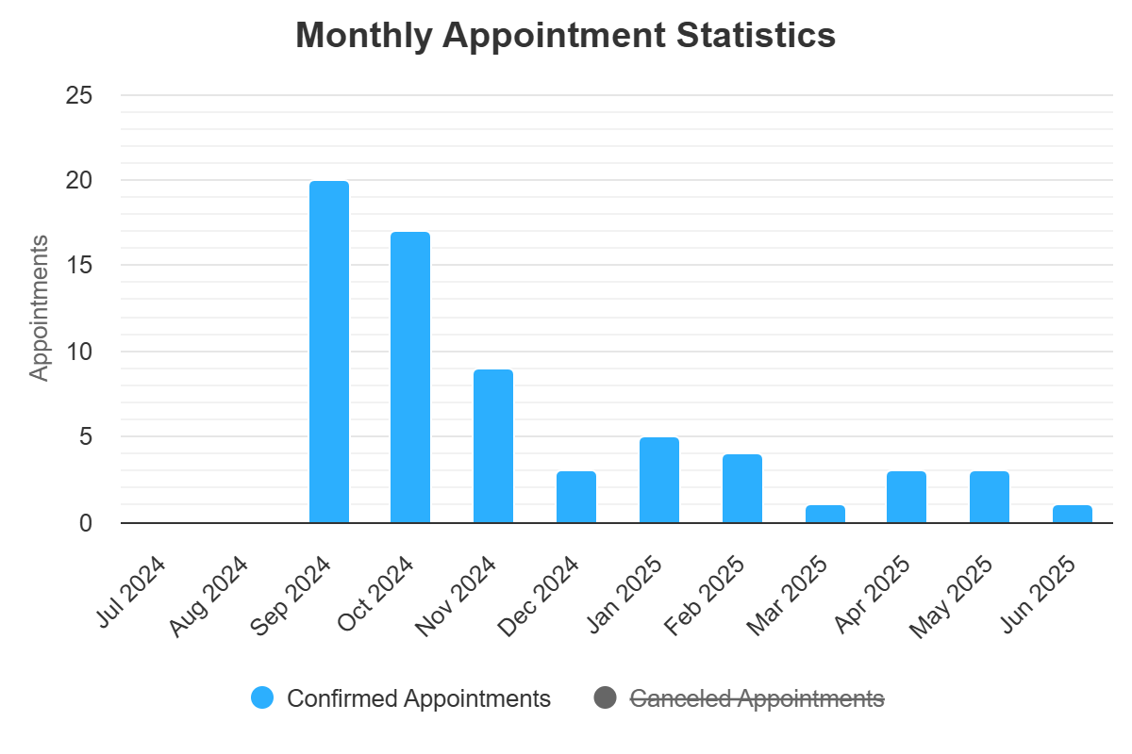

User Groups
- MSMS students scheduled 58 appointments
- MUW students scheduled 11 appointments
- MUW faculty/staff scheduled 5 appointments
- Community members scheduled 5 appointments
5 Most Frequently Used Collections
Emma Ody Pohl Papers- 11 appointments
Eichelberger-Cannon Family Papers- 10 appointments
Peyton Family Papers- 7 appointments
Demonstration School Records- 7 appointments
Mississippi School for Mathematics and Science Records

Reference
Questions asked by patrons who do not conduct their own research, donation inquiries, requests for materials to be scanned are categorized as reference transactions. In FY25, the archives had 91 reference transactions. April of 2025 was the busiest month with 12 transactions.

Monthly Reference Transactions
This chart shows the number of reference transactions the archives handled during FY25 broken down by month.

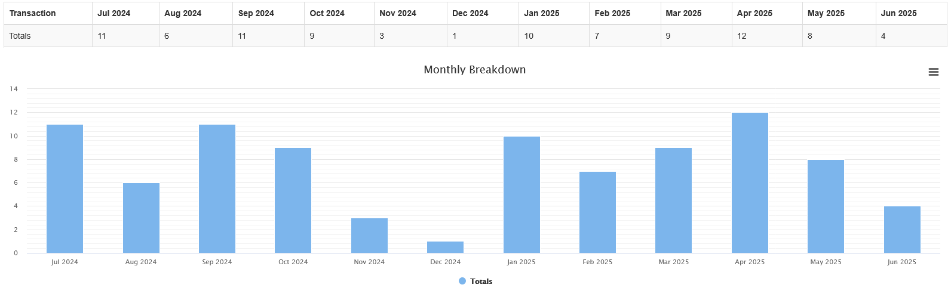
User Groups
This chart shows what kind of people were requesting reference from the archives. The Student and Faculty/Staff categories refer to both MUW and MSMS students and employees, while Alumni refers to MUW alums and Other refers to community patrons.
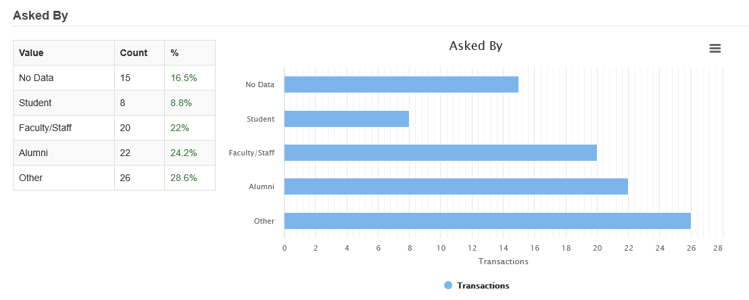
Publications and Presentations Using Archives Materials
- Student Capstone on Emma Ody Pohl presented at Undergraduate Research Conference
- Article, Mississippi Encyclopedia entry on Neill James published by University of Mississippi Institute of Southern Studies
- Trailblazing Women: Our Legacy II exhibit up March 6-May 2 2025 in Summer Hall
- Tales from the Crypt performance at Homecoming
- Tales from the Crypt performances at Friendship Cemetery
Online Archives Resources
Digital Records
Athena Commons
- 136 works posted
- 12,704 downloads
  - 121 countries
- Top 5 most downloaded works
  - Meh Lady, 1975- 67 downloads
  - Meh Lady, 1974- 59 downloads
  - Meh Lady, 1972- 52 downloads
  - Meh Lady, 1979- 49 downloads
  - Meh Lady, 1976- 45 downloads
Mississippi Digital Library
- 626 views
- 111 users
Information about Using the Archives

FAQs
- 15 FAQs with “Archives” and “Special Collections” tagged as topics
  - 307 views in total
    - January 2025 busiest month with 48 views overall
  - Top 5 most popular FAQs
    - Where can I find Meh Lady yearbooks? (106 views)
    - How do I find a Master’s thesis or a dissertation? (36 views)
    - What is Athena Commons? (32 views)
    - How can I research information about the founding and history of the W? (26 views)
    - How do I cite materials from MUW’s archives? (26 views)
Social Media
The archives uses social media to communicate and share resources and information with the MUW campus community. It is a way for people to connect with the work we do and the history they share through MUW. In general, Facebook is an effective way to communicate with alumni, and Instagram is an effective way to communicate with students and other people currently on campus. The linktree allows us to share links on Instagram, which does not allow links in captions of posts.
- 7 posts shared to Instagram and Facebook accounts
Instagram
- 544 followers
- 580 reach
- 110 content interactions
- 184 profile visits
- 38 new follows
Facebook
- 880 followers
- 6543 reach
- 148 content interactions
- 296 page visits
- 14 new follows
Linktree
- 149 views
- 57 clicks
- 38% click rate

Appendix A: Archives Strategic Plan 2023-2026 Goals and Objectives
Goals (Adapted from Dickinson College Archives and Special Collections Strategic Plan 2020-2025 https://archives.dickinson.edu/sites/all/files/Archives_Strategic_Plan_2020.pdf )
Goal 1- Increase physical and intellectual control over the collection
The collection is inventoried in a variety of ways. Legacy inventories help to contextualize how the collection has been shaped, how previous archives staff have understood the collection, and what decisions have been made regarding arrangement and description. The lack of translation between systems of arrangement, lack of documentation of decision making, and lack of information about the contents of the ASRS impact our ability to provide access to the collection.

Our ability to quickly and accurately locate sources that are needed to answer reference questions or provide materials for researchers is directly impacted by the degree to which we have descriptive information about our holdings readily accessible. Additionally, a lack of clear, accurate information about the collection in our finding aids limits the access of potential researchers looking for materials.

By creating and improving descriptive tools, compiling information about past systems, and updating existing tools to ensure accuracy, we seek to improve our knowledge of our holdings so that content is more easily discoverable and retrievable- by staff and by patrons.

- Objective 1- Ensure that we have accurate inventories of all collections
  - Achieved by: Athena audit, Updating and maintaining ArchivesSpace, Compiling, scanning and comparing legacy inventories
- Objective 2- Ensure that we have accurate inventories of all storage locations
  - Achieved by: Creating and maintaining inventories of- subject files, photograph collection, Mississippi collection, classroom storage and classroom, flat file drawers in reading room and closed stacks, closed stack shelves, special collections stacks, backlog closet, storage closet, Cromwell, Orr, storage units, external storage in circulation stacks; Athena audit
- Objective 3- House and label all materials consistently and record their locations
  - Achieved by: Refoldering, Standardizing information recorded in Athena, Updating and maintaining ArchivesSpace, Creating new collections inventory and accession register
- Objective 4- Create consistent metadata for digital materials
  - Achieved by: Assessing current metadata for materials on Athena Commons, Creating standard for Preservica, Adhering to existing photo naming and metadata policy, Exploring adding metadata at time of scanning
- Objective 5- Standardize and apply naming conventions for digital resources
  - Achieved by: Adhering to existing photo naming and metadata policy

Goal 2- Improve accessibility of materials
BCASC must continue to balance materials that have already been described and new accessions and accruals. A small percentage of the Approx. 700 linear feet of materials in the collection have box- or folder-level description on ArchivesSpace, and an even smaller percentage has trustworthy description. Additionally, BCASC has an extensive accession and processing backlog. Accessioning and processing are time consuming, and necessarily limited to being performed by people with archival education/training, and so can only be completed by the Archivist and/or Archives Associate.
ArchivesSpace and Athena Commons serve as the means through which most people conducting research on the internet access and interact with the collection. By improving the information available through these platforms and making them accessible, we seek to improve the experience of researchers in accessing information about the collection, streamline the process of requesting materials and conducting in-person research, and provide more and better description to researchers for citation purposes.
- Objective 1- Build on number of boxes described on ArchivesSpace
  - Achieved by: Refoldering, Processing
- Objective 2- Improve accuracy of information, searchability on ArchivesSpace
  - Achieved by: Taking information from Athena audit and applying it to existing ASpace records, Proofreading ASpace, Nesting all folder-level description under box-level description, Updating bio/historical notes, Updating scope and content, Making decisions about separated collections like Clubs and Campus Pubs
- Objective 3- Ensure that access can be provided to materials listed on ArchivesSpace
  - Achieved by: Taking information from Athena audit and applying it to existing ASpace records, Completing inventories and putting location information on ASpace
- Objective 4- Updating oral history collections on Athena Commons
  - Achieved by: Pulling together Derek’s records and figuring out which recordings already have transcripts, Transcribing those that don’t have transcripts, Figuring out existing paperwork re: permissions, identification etc. for LGBT, Uploading new Golden Girls recordings, Ensuring that pages for each recording have same buttons and access to recordings, Figuring out which recordings came from CLPL
- Objective 5- Re-organize Athena Commons and delete unused communities
  - Achieved by: Re-establishing Athena Commons committee, Reviewing conversations from last summer about restructure, Identifying empty communities and determining whether they need to be populated or deleted, Contacting Colleen (if still Colleen) and working with her to make changes
- Objective 6- Create workflow for new accessions and donations
  - Achieved by: Following up if contacted about but did not receive donation, Creating or adapting forms, Deciding where unprocessed materials should be stored, Creating new accession register outside of ASpace, Adding existing steps of scanning and storing donation forms
- Objective 7- Label everything in backlog closet and check items against legacy inventories
  - Achieved by: Having Martha Jo go in with a student and identify everything she recognizes, Looking for what we know is in there on legacy inventories, Labeling shelves with new magnetic labels
- Objective 8- Translate Martha Jo box inventories to spreadsheets and upload to ArchivesSpace
- Objective 9- Finish processing NMWA, Governor’s School collections
  - Achieved by: Opening up internship, Choosing whether to keep NMWA magazines

Goal 3- Document decision making and codify procedures
Patrons’ needs are constantly changing and many processes have changed since previous policies were put in place. BCASC staff spend a lot of time doing detective work to figure out how previous staff handled processes and made decisions, and we want to put the work in to document our processes and decisions so future archives staff will be able to spend their time on other work. Re-creating processes every time a request is made is inefficient and time consuming, and often delivers inconsistent results. To ensure that patron and university needs are handled efficiently and consistently, we plan to review and revise existing policies and procedures and document new ones.
- Objective 1- Review deed of gift form and donation policy and procedure
- Objective 2- Codify intra-university records transfer documentation and procedures
- Objective 3- Codify Athena Commons materials selection procedure
- Objective 4- Review and revise Rare Books collection policy
- Objective 5- Review and revise weeding/deaccessioning policy and procedures
- Objective 6- Review and revise appointment scheduling requirements
- Objective 7- Codify procedures for providing reference to off-site researchers
- Objective 8- Codify internal records management
- Objective 9- Maintain desk manuals
- Objective 10- Start new archivist external hard drive

2026 and Beyond

Short-Term
- Complete Cromwell move
  - Should be done in next year
- Complete Grants processing
- Rehouse unprocessed materials in Athena and create folder listings
  - Need to decide whether to give barcodes
- Community on Athena Commons for Annual Reports
- Projects to connect historical info on front pages of university website to archives
- Using Archives libguide/Archives educational resources through libwizard
- Update archives-related libguides, FAQs
- Improved project management/documentation
- Develop workflow for circulation tracking, statistic keeping
- Archives fellowship
- Switch appointments to Spaces in LibCal and update buttons
- Review and update website
Long-Term
- Explore options/workflows for metadata creation and storage
- Collaboration on social media/consistent posting
- ArchivesSpace population/improvement
- Increased classroom integration of archives materials
- Lesson plans built around special collections items (eg George Eliot, women writers, authors from BCW collection etc.)
- Outreach to professors to share what they need to know to have student research
- Hiring more staff
- Web archiving
- Clear out OneDrive
- Fix nursing theses metadata on Athena Commons
- Regular updates to MDL collection on Athena Commons

