Mississippi University for Women

Department of Music

# Student

## Handbook

**2021 - 2022**

### Music Faculty

Dr. Julia Mortyakova

Chair, Department of Music and Professor of Music

[jvmortyakova@muw.edu](mailto:jvmortyakova@muw.edu)

Office: 101 Poindexter 329-7382

Dr. Joe L. Alexander Dr. Susan Hurley Dr. William Reber

Professor of Music Assistant Professor of Voice Adjunct Instructor & Director of Choirs

[jlalexander3@muw.edu](mailto:rmmontalto@muw.edu) slhurley@muw.edu [wfreber@muw.edu](mailto:wfreber@muw.edu)

Office: 212 Poindexter 329-7203 Office: 108 Poindexter 329-7199 Office: 302 Poindexter 241-6399

Dr. Valentin Bogdan Ms. Elizabeth Jones Ginger Zingara

Professor of Music Visiting Instructor of Voice V. Instructor of Music Education/Director of Bands

[vmbogdan@muw.edu](mailto:vmbogdan@muw.edu) eajones@muw.edu vmzingara@muw.edu

Office: 114 Poindexter 241-7764 Office: 312 Poindexter 329-7207 Office: 301 Poindexter 329-7430

Ms. Carmen Osburn Dr. Jon Fessenden Dr. Larry Bradford

Professor of Music, Director of Music Therapy Assistant Professor of Music Therapy Adjunct Instructor of Percussion

[ceosburn@muw.edu](mailto:ceosburn@muw.edu) jwfessenden@muw.edu [jlbradford@muw.edu](mailto:jlbradford@muw.edu)

Office: 201 Poindexter 241-7897 Office: 202 Poindexter 241-6146 Office: 241-6399

Dr. Joe Ortiguera

Adjunct Instructor of Music

[jbortiguera@muw.edu](mailto:jbortiguera@muw.edu)

Telephone: 241-6399

**Music Office**

Jennifer Dowdy

Administrative Assistant

[jtdowdy@muw.edu](mailto:jtdowdy@muw.edu)

Office: 102 Poindexter 241-6399

#### DEGREE INFORMATION

Mississippi University for Women offers the following degrees for a major in music:

Bachelor of Arts in Music (BA)

Bachelor of Arts in Music (BA) Performance Emphasis

Bachelor of Arts in Music (BA) Composition Emphasis

Bachelor of Music in Music Education (BM)

Bachelor of Music in Music Therapy (BM)

#### ACCREDITATION

The Mississippi University for Women Department of Music is accredited by the Commission on Colleges of the Southern Association of Colleges and Schools.

The Mississippi University for Women Department of Music is accredited by:

The National Council for Accreditation of Teacher Education

Council for the Accreditation of Educator Preparation

The National Association of Schools of Music

The Music Therapy program is approved by the American Music Therapy Association.

**INTRODUCTION**

The following Mission Statement and Educational Goals have been designed by music faculty to serve as guides for the activities of the department. It is our hope that work in the classroom and on the stage is reflective of these principles, which strive to view music not only as an entertainment, but also as a means to transform the lives of those affected by it.

**MISSION STATEMENT**

The music department aims to empower students through study of theory, history, and aesthetics of performance; strives to develop an appreciation of music as a complex means of artistic expression of humanity’s struggle to understand itself; and is committed to the development of dynamic personal experiences with those essential skills necessary to create, teach, perform, and work in their chosen field.

The program encourages each student to exercise aesthetic judgment; think critically; work collaboratively; synthesize and apply principles in the process of performance; engage in creative expression; develop personal discipline and constructive work habits; and foster respect for one’s self, colleagues, audience, and community.

The music program makes available to all students at Mississippi University for Women opportunities to participate in an environment which attempts to propagate, disseminate, and nurture an understanding of the truths which music has to offer, through experiences which are joyful, beautiful, and passionate.

**EDUCATIONAL GOALS**

* To serve as an educational /artistic or a vocational resource for our campus and community.
* To provide each student with opportunities to strengthen basic organizational, communication, and analytical skills, enhance leadership potential, and an understanding of the human condition.
* To enhance student appreciation of our cultural diversity within the arts.
* To encourage students’ potential to make cognitive connections with work of his/her academic studies and the social, historical, philosophical and humanistic issues they illuminate.
* To introduce people of all ages to the joys and beauty of live performance and the potential as a learning tool with which to better understand and participate in contemporary life.

#### REQUIREMENTS POLICIES GUIDELINES

**Attendance:**

Students are advised to consult individual course syllabi for attendance policies.

Students shall be permitted to make up work for the following excused absences (with a few exceptions)

* Authorized university activities
* Injury or illness, physical or mental, of the student or dependent
* Medical conditions related to pregnancy
* Death of a member of the student’s immediate family
* Legal responsibilities including jury duty or court appearance
* Military service
* Religious observances
* Mandatory scheduled interview for employment, graduate school, or postgraduate program, etc.

Students are expected to come to lessons and classes practiced and prepared to sing/play/discuss. A teacher must be informed of a student’s illness in advance to facilitate the cancellation of lessons when a student is sick. Consult your applied teacher regarding policies of absence notification.

It is the responsibility of the student to schedule a time for applied lessons. Scheduling must be accomplished during the first week of classes each semester.

**Music majors are required to attend all publicized departmental events, in person or virtually.** Attendance at these events will be reflected in the applied music grade. Failure to attend departmental events will result in a loss of 10% of a student’s applied major lesson grade Attendance sign-in sheets will be available outside the auditorium prior to and following the event.

***Addendum Fall/Spring 21-22’ – Please refer to your applied faculty’s suggestions on virtual event attendance.***

##### **UTILIZATION OF POINDEXTER HALL**

Poindexter Hall is open from 8 a.m. until 5 p.m. Monday through Friday.

Music students will also have after hour and weekend access with their student ID.

Any student using Poindexter Hall after hours must have his/her ID and may be requested to show it to Campus Security personnel. Unauthorized individuals may be removed from the building.

Practice rooms are located on the second, third, and fourth floor on the south side of Poindexter. Practice rooms with grand pianos are reserved for piano majors. Non-piano majors can use these practice rooms; however, piano majors have priority and may ask others to vacate the practice room.

Music majors have priority for use of practice rooms, followed by secondary students and then elective students.

Students are not allowed to teach private lessons in Poindexter Hall to anyone under the age of 18.

***Addendum Fall/Spring 21-22’ – students will only be allowed to use the practice rooms for which they have been assigned. Only one person is allowed per practice room at a time. Students cannot bring anyone to Poindexter.***

**Music Departmental Practice Policies**

Please consult individual faculty syllabi regarding specific studio practice requirements.

**Smoking, Food, Drink:**

By state law, there can be no smoking in a public school in the state of Mississippi. MUW Campus is a smoke free and vaping free campus.

Food and drinks are prohibited in classrooms, practice rooms, and the auditorium. Students are allowed to have water in a closed container.

**INJURY PREVENTION**

While practicing, it is important to be aware of one’s body. Correct posture, practice breaks and stretching are key to a musician’s health. Practicing away from your instrument (listening to your music, studying the score, recording and critiquing yourself) is very important. It builds mental confidence and lets your muscles have a break. Situations of trying to learn vast amounts of material fast, in other words, “cramming” should be avoided at all cost. They lead to poor results and create stress, which in turn can cause your muscles to be more tense and can lead to pain or/and an injury. Time management is an essential part of every musician’s life and with careful planning there should be no reason for last minute preparations.

If you sense any kind of pain while practicing you should stop immediately because it will only become worse. Letting muscles rest should heal the problem and let you get back to your practice routine. You should discuss your situation with your applied teacher and when necessary seek medical attention for a problem which persists.

Please check out the Music Health and Safety Information listed at <http://www.muw.edu/as/music/current>

##### **MUSIC SCHOLARSHIPS**

Scholarships are available for music majors by audition. Auditions must be scheduled in advance. Auditions must take place in the semester prior to award.

Students receiving scholarships must enroll as full-time students (twelve (12) hours minimum).

Current student scholarships are awarded on the basis of a combination of grade point average and audition. The university required GPA for a scholarship is a 2.5. In addition to audition, entering student scholarship recipients must show evidence of satisfactory

high school or college work.

All music scholarships are awarded on a year-to-year basis.

Students receiving music scholarships must maintain a minimum of a “B” grade in each music course and an overall university GPA average of a 2.5. Students who do not maintain a “B” in all music classes and/or the required university GPA will meet with their advisor, be placed on probation, and their academic performance will be evaluated at the conclusion of the following semester. Failure to improve the grade will result in the loss of the music scholarship for the next academic year.

Students receiving music scholarships will enroll in all major courses as specified under the appropriate course of study. Failure to do so will result in loss of a scholarship.

Music Ensemble Scholarships are awarded to students who actively participate in music ensembles. Awards are directly related to attendance at all rehearsals and performances. The awards may be given at various times in the school year and may not be awarded if the student does not fulfill the agreed upon obligations. Ensemble awards will be credited to accounts by the end of the semester. Depending on availability, ensemble awards may also be awarded to students for conference attendance and participation in competitions and other professional events. Please see the Music Office for more information.

A student who has lost a scholarship must wait one semester before reapplying.

**REHEARSAL DEMEANOR**

* Arrive at rehearsal 10 minutes early so you are ready to begin at the designated time. Any tardiness or absence from rehearsal or call time may result in lowering of grade and/or decrease in the Music Service Scholarship, or replacement.
* Wear shoes, clothing, and hair style appropriate to the individual rehearsal.
* Bring a pencil (not a pen) and paper to every rehearsal to take notes during and after rehearsal.
* The only person qualified and in authority to fix even the smallest of problems is the conductor.
* Please leave your personal problems and grievances at the door when you come to a rehearsal or performance. They can be detrimental to your work and others’.
* No food or drinks (other than water) are allowed in the rehearsal area. Throw away your trash, even water bottles.
* Cell phones and other electronic devices should be turned off during rehearsals.

**POLICIES FOR PERFORMANCE (INCLUDING RECITAL CLASS):**

All students performing on a concert **MUST** fill out the “Recital/Accompanist Information” form (found on the Music website under the ‘Current Students’ tab) and submit it via email to the Administrative Assistant, their applied instructor and accompanist at least 2 weeks prior to the performance. **Failure to do this may prevent the student from being included in the program.**

Students enrolled in major applied courses must perform in at least one Recital Class each semester, beginning in the second semester of the freshman year. Students enrolled in applied lessons at Mississippi State must perform on the MUW Student Recital once per semester as well. Attendance in student Recital Class is mandatory. Participation in and attendance at Recital Class is reflected in the student’s applied music grade.

Appropriate Performance Attire will be discussed with your applied studio instructor and ensemble director.

* No flash photography is permitted during performances.
* Cellular telephones must be turned off during performances.
* Children under the age of 4 may not attend a Department of Music public performance.

Department events strive to start **on-time.** Please ask your family and friends to arrive before the event begins, as there are times when latecomers may not be seated, and “knowing someone in the performance” is not insurance of special treatment. Because most of our department’s performances are seated on a first-come, first-served basis, please do not save seats for someone simply because they cannot arrive on-time.

**CHORAL ENSEMBLE AUDITION POLICY**

MUW choirs are open to all MUW students. Students will be auditioned and placed in the appropriate ensembles. Anyone interested in singing in choir should contact Dr. Reber (wfreber[@muw.edu](mailto:phstockton@muw.edu)) for more details.

**JAZZ ENSEMBLE & WIND ENSEMBLE AUDITION POLICY**

MUW Jazz Ensemble & Wind Ensemble are open to all MUW students. Audition is a requirement. All students must be proficient on their instrument. Please contact Professor Zingara, call 662-329-7430.

**ENSEMBLE ENROLLMENT POLICIES**

Music Therapy majors must have a minimum of four (4) hours of ensemble credit prior to enrolling in a Music Therapy internship.

Piano majors should not enroll in more than one ensemble per semester; exceptions will be granted by special permission from the student’s advisor and applied professor.

All music majors are required to enroll and participate in an MUW ensemble during each semester enrolled as a full-time student.

**USE OF KOSSEN AUDITORIUM**

Kossen Auditorium may only be used by students with the supervision of a faculty member.

1. Kossen Auditorium needs to be reserved in the Music Office at least 24 hours in advance. All official university groups and off campus groups must reserve Poindexter Hall the Resources Management.
2. The stage must be left in the same condition as it was found.
3. Stage pianos can only be used by faculty, accompanist, or students under supervision under faculty.
4. When not being used, pianos must remain locked and covered at all times.
5. All trash must be disposed of appropriately before leaving the auditorium.
6. The florescent lights on the stage should always be used for rehearsals. There is no need to use full stage/house lighting for rehearsal purposes. All lights must be turned off before leaving.
7. NO FOOD and NO DRINK other than water are allowed in Kossen Auditorium at any time.

***Addendum Fall/Spring 21-22’ – Kossen Auditorium will not be used by students with the only exception being by special permission by the Department Chair.***

**JURIES**

Juries are required of all students enrolled in a Major Applied Music course.

**SOPHOMORE REVIEWS (AND TRANSFER BARRIER JURY)**

Each student interested in continuing as music major must complete an interview with the faculty prior to the end of the sophomore year. The sophomore jury is designed to assess the student’s performance skills before entering junior level work. The faculty will make recommendations to the student concerning completion of the program and goal setting. Any student taking instrumental lessons at Mississippi State University will also perform a sophomore jury for the MUW Music faculty. In the event that they do not have access to a proper instrument, they may video record their MS State jury and present the video recording in lieu of the live one.

All transfer music majors will be required to perform a barrier jury at the completion of their first semester at MUW in front of the Music faculty. This jury will serve in place of the sophomore review and will be adjudicated in the same manner.

Sophomore barrier will be graded on a PASS/FAIL basis. Students who pass the examination are allowed to register for the next applied lessons course number.  Students who fail the examination will receive a grade of F in the applied lesson course there are registered for at the time of the examination.  They will be required to repeat the same course the following semester, and to retake the sophomore barrier exam.  Failing it the second time will the result in the student being dismissed from the music department.

**MUSIC THERAPY PROFICIENCY**

Music Therapy proficiency exam must be passed before students are allowed to register for the 400-level Music Therapy courses.

**MUSIC EDUCATION PROFICIENCY**

The Music Education piano proficiency must be attempted by the junior year and passed before graduation.

**STUDENT’S MAJOR INSTRUMENT EMPHASIS WITHIN A DEGREE:**

Students will not be allowed to switch their major instrument after the first semester of their sophomore year of applied lessons. Exceptions will be evaluated on a case by case basis following a consultation with the department chair.

**SENIOR RECITALS (OR THE FINAL SEMESTER OF APPLIED LESSONS)**

Senior recitals (or recitals given in the final semester of applied lessons) for music majors are designed by the college to be a capstone experience for the students. The faculty is committed to making sure that recitals will allow the student to demonstrate abilities in a significant way. Senior recitals require a hearing in front of the faculty two weeks prior to the recital to determine if the student is ready. You must have your complete recital program, in the correct format (works, program notes, etc.), emailed to the Administrative Assistant, your applied instructor and accompanist (if applicable) at least two weeks before your recital date. A sample recital program may be obtained by contacting the Administrative Assistant in the Music Office. Students are not required to perform a jury the semester of their senior recital.

**ACCOMPANISTS**

Voice majors are required to have an accompanist for all performances. The Department of Music does not provide free accompanists for students and students are responsible for finding them. They can contact a number of local collaborative pianists and make arrangements with them; a list is available in the Music Office. Rates should be negotiated directly with the accompanist. In certain cases it may be possible for students to accompany other students.

**Professional accompanists will need to be paid in full by midterm. Failure to do so will lead to academic consequences.**

***Addendum Fall/Spring 21-22’ – due to the present unusual circumstances, the Department will be providing a professional collaborative pianist, free of charge to students needing an accompanist (for this semester only).* Three weeks prior to needing the accompanist’s services**, please send following to your accompanist AND applied professor:

**1. Title and Composer of work**

**2. PDF of your music (NO PHOTOS & Check for complete score and that it is legible)**

**3. Date the accompaniment is needed**

Students must correspond with their accompanist, provide him or her the music, and have a rehearsal at least one week prior to any scheduled performance (including studio class). Students are required to email their accompanist their music three weeks prior to a rehearsal, recording, lesson, etc, and fill out a “Recital/Accompanist Information” form whenever they want to perform for a recital. Please see the section below for more information about deadlines.

**DEPARTMENTAL FORMS**

If an accompanist is used during the semester, the following procedure must be followed:

**Three weeks prior to needing the accompanist’s services** please send an email to the accompanist, **containing** **the title and composer of the work; the date the accompaniment is needed; and the PDF of your music**. **Be sure to copy your applied professor on this email.** The applied instructor and collaborative pianist will reply that they have received and approve/disapprove the repertoire and agree/do not agree to accompany the selected work. Please make sure the PDF contains the complete score and is legible. **DO NOT** upload picture files.

Fall/Spring 21-22’ Collaborative Pianist: Dr. William Reber, [wfreber@muw.edu](mailto:wfreber@muw.edu).

If you have an upcoming recital you **MUST** have your Recital/Accompanist Information Form completed and emailed to your applied professor, accompanist and the Administrative Assistant by 5 p.m. two weeks prior to the date of the recital. **Failure to submit a digital copy will result in you not being able to perform on the recital date.** The applied professor and collaborative pianist will reply that they have received and approve/disapprove the repertoire and agree/do not agree to accompany the performance.

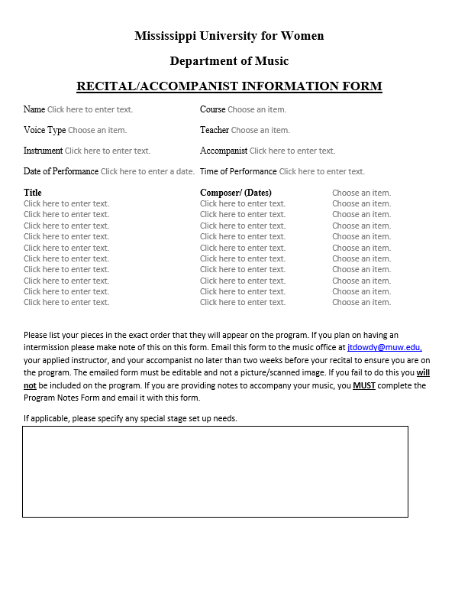

If you are including program notes as part of your recital, you must complete the Program Notes Form. Email this typed and completed form to the Music Office by 5 p.m. at least two weeks prior to your recital in order to have your notes listed on the program.

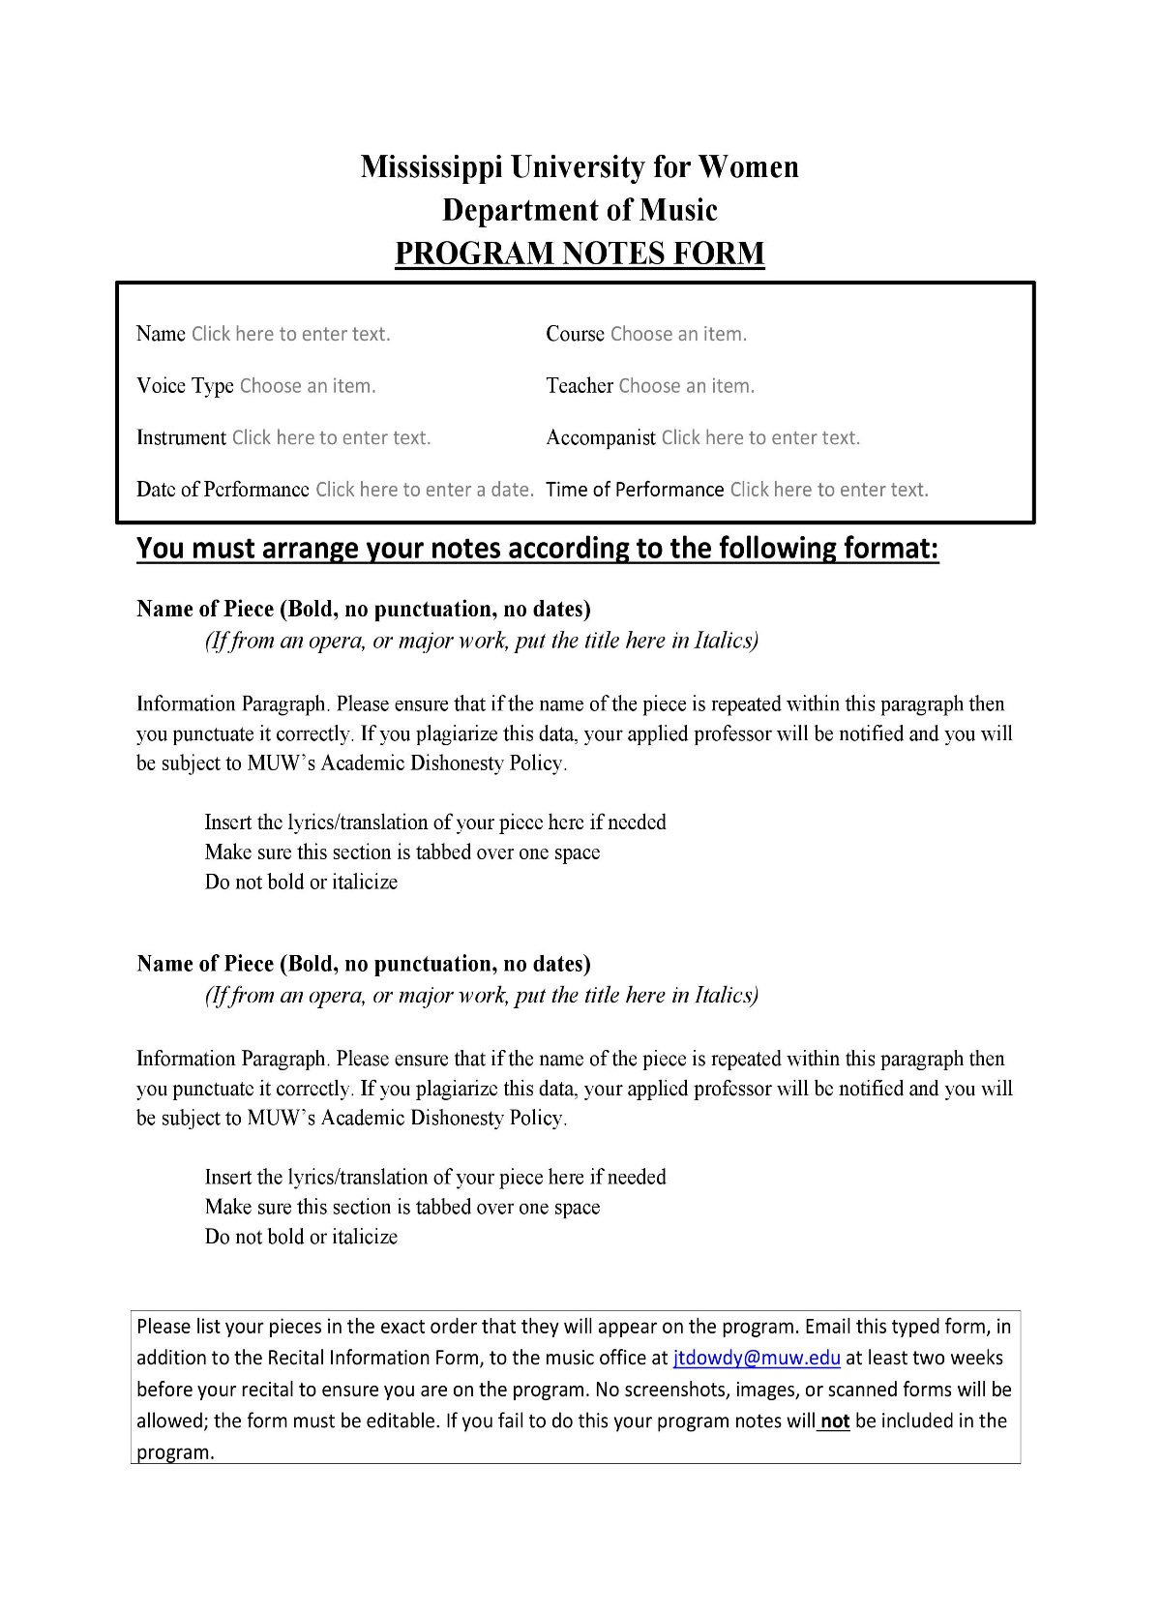

**OFFICIAL MEANS OF COMMUNICATION**

All students in the Department **MUST**have a MUW e-mail address and are obligated to check it every day for Departmental announcements, and/or important communication from your instructors.

**PROFESSIONAL INTERACTION BETWEEN STUDENTS & FACULTY**

Students should address their faculty properly, using title (Dr., Professor) and last name. Students should not text or call faculty cell phones except in emergency situations or by permission of instructor.

**CELLPHONE USE**

Cellphones and other electronic devices must be placed in silent mode during class and must be stored out of sight. Students may not place or answer calls during class. All texting is prohibited. Cellphone cameras may be used to document whiteboard information only with permission of the instructor.

**WORK STUDY**

There are a limited number of Federal Work-Study hours available in the Department of Music. The jobs range from clerical work, organizing choral library, concert staff, to other tasks needed by the department. Work study is paid through MUW at minimum wage. Positions are based on skill and seniority. Any work-study student who does not report for duty may be replaced.

Students working concerts should wear appropriate, professional clothing including comfortable shoes. **NO** flip flops, excessively high heels, or revealing/casual clothes. Please consult the faculty event organizer for other specific instructions.

**SERVICE HOURS**

Students needing service hours are invited to fulfill them by working concerts and events in the Department of Music including the Music by Women Festival.

**MUSIC ORGANIZATIONS**

Current Music Organizations: Mu Theta Chi, the Music Therapy club

**MUSIC WEBSITE AND ONLINE SOURCES**

Website: [www.muw.edu/music](http://www.muw.edu/music)

Facebook Page: MUW Music

**MUSIC BY WOMEN FESTIVAL**

The Fifth Annual International Music by Women Festival will be held March 2021. Further details will follow throughout the school year.

Website: [www.muw.edu/musicbywomen](http://www.muw.edu/musicbywomen)

Facebook: Music by Women Festival

**LIBRARY RESOURCES**

MUW Library Music Database Page: <https://www.muw.edu/library>

Access to Grove Music Online (musical scholarship) and NAXOS Music Library (music recordings)

MUW offers a service to enrolled music students through NAXOS, which allows you to listen to recordings of music for free.

Your Login Information is:

Username: MUWps  
Password: MUWps

Go to: [www.naxosmusiclibrary.com](http://www.naxosmusiclibrary.com/) to login.

**STUDENT COMPUTER LAB**

1. The student computer lab is open 24 hours a day. (Fall 2021- social distancing guidelines - limit one student in the lab at a time)

2. No food or drink of any kind is allowed in the computer lab.

3. You **MUST** save your work on a flash drive or by emailing it to yourself. Do not save it on the computer lab computers.

4. Sibelius and Finale music notation software is installed on two of the computers. Students may print Sibelius scores only and pick them up in the Music Office Monday-Friday from 8-5 pm.

5. Keyboards for use with Sibelius are available in the Music Office and can be checked out Monday-Friday from 8-5 pm.

6. Praxis study materials are installed on two computers.

**In case of an emergency, Campus Security may be reached at 662-241-7777.**

**IN THE EVENT OF BUILDING LOCKDOWN**

1st Floor

Please seek shelter in a Faculty member’s office, or Rooms 133 Student Lounge or 134 Dressing Room

2nd Floor (Front of the building)

Please seek shelter in a Faculty member’s office, the unisex bathroom, or a classroom

2nd Floor (Back)

Please seek shelter in 224 Computer Lab, or Room 231 Electrical

3rd Floor (Front of the building)

Please seek shelter in a Faculty member’s office or Room 305 Sheet Music (located in the Choir Room) or the unisex bathroom

3rd Floor (Back)

Please seek shelter in the unisex bathroom, or classroom 322 Group Piano Lab

4th Floor (Back)

Please seek shelter in the unisex bathroom

**CREDIT-HOUR ALLOCATION**

The calculation of credit-hour allocation for music courses is as follows:

1. Lecture courses: 1 credit hour per 50 minutes of instruction/week

2. Individual applied instruction: 2 credit hours per 50 minutes of instruction/week

3. Ensembles: 1 credit hour; a minimum of 150 minutes per week of rehearsal

4. Music Theory Lab I-IV: 1 credit hour per 100 minutes of instruction/week

5. Class applied instruction: 1 credit hour per 50 minutes of instruction/week

6. Individual Elective instruction: 1 credit per 30 minutes of instruction/week