_______________________________________________________________________________________________
Banner Finance
Purchasing and Procurement
Training Workbook
Release 8.4 – December 2009
Updated 12/14/2012

Ellucian
4 Country View Road
Malvern, Pennsylvania 19355
United States of America
(800) 522 - 4827

Customer Support Center website
http://connect.ellucian.com

Distribution Services e-mail address
distserv@ ellucian.com

Other services
In preparing and providing this publication, Ellucian is not rendering legal, accounting, or other similar professional services. Ellucian makes no claims that an institution's use of this publication or the software for which it is provided will insure compliance with applicable federal or state laws, rules, or regulations. Each organization should seek legal, accounting and other similar professional services from competent providers of the organization's own choosing.

Trademark
Banner®, Colleague®, PowerCAMPUS®, Luminis® and Datatel® are trademarks of Ellucian or its affiliates and are registered in the U.S. and other countries. Ellucian, Advance, Recruiter, and Open Digital Campus are trademarks of Ellucian or its affiliates. Other names may be trademarks of their respective owners.

Revision History Log
Publication Date | Summary
4/30/2008 | New version that supports 8.0 software.
5/30/2008 | Minor formatting changes.
1/05/2009 | Minor clarifications about 1099 vendors, bid processing, and other misc. changes.
3/16/2009 | Modifications for additional requisition queries, clause entry form, and closing purchase orders in Batch.
6/30/2009  08/10/2009 | Added a lesson on displaying new person fields for internationalization.  Minor clarification on the default organization used on requisitions and purchase orders.
02/01/2010 | Updated for Banner 8.4
2/21/2012 | Updated to clarify page 57-59.
4/30/2012 | Updated with Ellucian template.
12/14/2012 Made minor unpdate of language regarding change orders and blanket orders

Notice of rights
© 2012 Ellucian. All rights reserved.
Contains confidential and proprietary information of Ellucian and its subsidiaries. Use of these materials is limited to Ellucian licensees, and is subject to the terms and conditions of one or more written license agreements between Ellucian and the licensee in question.

Table of Contents
Introduction 5
Process Introduction 7
Set Up 8
Set-up Forms Used in Purchasing and Procurement 9
Displaying New Person Fields for Internationalization 10
Creating a Vendor 13
Creating a Commodity 20
Linking Vendor Codes to Commodity Codes 23
Creating or Modifying Standard Purchasing Clauses 26
Creating or Modifying Buyer Codes 28
Creating Vendor Agreements 32
Self Check 35
Answer Key for Self Check 37
Day-to-Day Operations 39
Process Introduction 40
Creating a Requisition 41
Adding Text to Any Purchasing Document 57
Querying Uncompleted, Completed, and Approved 60
Additional Requisition Queries 62
Canceling a Requisition 63
Printing a Requisition 65
Assigning a Buyer to an Approved Requisition 67
Using the Bid Process 73
Starting the Bid Process 74
Identifying Prospective Vendors 80
Identifying Commodities 83
Generating Bid Request Forms 85
Entering Vendor Pricing Data 87
Comparing Vendor Data Online 89
Generating a Printed Report to Compare Vendor Data 91
Assigning a Chosen Vendor 93
Assigning a Requisition to a Purchase Order 95
Creating a Purchase Order from a Requisition 98
Creating a Purchase, Using Document Level 103
Creating a Purchase, Using Commodity Level 109
Creating a Standing Order Using Document Level 113
Copying Information to a New Purchase Order 118
Creating a Blanket Order 122
Creating a Regular Order from a Blanket Purchase 127
Monitoring Blanket Order Activity 132
Canceling a Purchase/Blanket Order 134
Printing a Purchase Order 136
Creating a Change Order 138
Canceling a Change Order 142
Printing a Change Order 144
Creating a Purchase Order Quickly 146
Querying Completed and Approved Purchase/Blanket/ Change Orders 149
Additional Purchase Order Queries 151
Querying Document History 152
Opening/Closing Encumbrances 154
Closing Purchase Orders in Batch 159
Receiving Purchased Goods 161
Receiving Goods Query 170
Returning Purchased Goods 172
Summary 174
Self Check 175
Answer Key for Self Check 180
Appendix 185
Forms Job Aid 186
Terminology 190

Introduction
Course goal
The goal of this workbook is to provide you with the knowledge and practice to perform and track the requisition, bid, and purchasing process at your institution. The workbook is divided into these sections:
- Introduction
- Set-up
- Day-to-day operations
Course objectives
In this course you will learn how to
- identify and describe the setup forms that will be needed in the purchasing and procurement process
- create and maintain vendor, commodity, and buyer records
- link vendor codes to commodity codes
- create, cancel, and query requisitions
- assign a buyer to a requisition
- use the bid process from the request through award stages
- create, cancel, and query purchase orders
- receive and return purchase goods.
Intended audience
The staff who perform and track the requisition, bid, and purchasing process.
Prerequisites
To complete this course, you should have
- completed the Education Practices computer-based training (CBT) tutorial Banner 8 Fundamentals, or have equivalent experience navigating in the Banner system
- completed the Chart of Accounts training workbook
- administrative rights to create the setup forms needed in Purchasing and Procurement.

Process Introduction
Introduction
The Finance process includes several processes that occur simultaneously on a daily basis. The exception is the budget process, which occurs once a year.
Flow diagram
This diagram highlights the Requisition to Check process. The purchasing process is part of the Requisition to Check process.

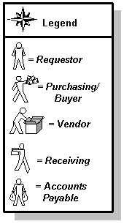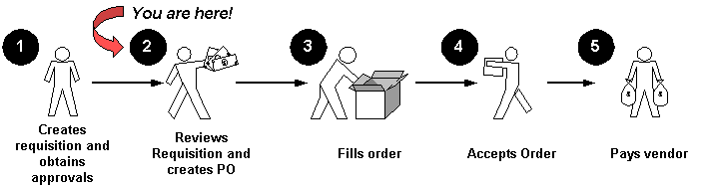
About the process
The purchasing process can occur in one of two ways
- In decentralized purchasing, the requestor can create the online requisition through Banner, Self Service, or E-Procurement.
- In centralized purchasing, the requestor sends the paper requisition to the Purchasing department, who would then create the online purchase order in Banner.

Set Up
Section goal
The purpose of this section is to outline the set-up process and detail the procedures to set-up your Banner system for purchasing and procurement.
Objectives
In this section you will learn how to
- identify and describe the setup forms that will be needed in the purchasing and procurement process
- create and maintain vendor, commodity, and buyer records
- link vendor codes to commodity codes.

Set-up Forms Used in Purchasing and Procurement
Introduction
Before Banner can process purchasing data, there are several forms that need to be completed. You will also need to decide if you want to display the new person fields for internationalization.
Set-up forms
The following set-up forms play important roles in the Purchasing and Procurement module. This list includes forms that are covered in the exercises that follow, as well as additional forms. Review and add values to these forms as necessary.

Form Description | Banner Name
Vendor Maintenance | FTMVEND
Commodity Maintenance | FTMCOMM
Vendor Products Maintenance | FTMVPRD
Clause Entry Maintenance | FOACLAU
Buyer Code Maintenance | FTMBUYR
Vendor Type Code Maintenance | FTMVTYP
Unit of Measure Maintenance | FTMUOMS
FOB Code Maintenance | FTMFOBS
Ship to Address Maintenance | FTMSHIP
Equivalency Maintenance | FTMEQUL
Purchase Order Classification Maintenance | FTMPCLS
Cancellation Reason Code Maintenance | FTMCRSN
Receiving Method Maintenance | FTMRCMT
Return Reason Maintenance | FTMRRSN
Bid Classification | FTMBCLS
Discount Code Maintenance | FTMDISC
User Profile Maintenance | FOMPROF

Displaying New Person Fields for Internationalization
Introduction
A major initiative of SunGard Higher Education is to make Banner more adaptable for use in different countries and with different languages. This ongoing effort is called internationalization (often abbreviated I18N).
As part of this initiative, Banner Finance 8.0 delivered several new fields in the database. These fields, however, were not visible on the user interface. With Banner Finance 8.3, these new fields can be displayed on forms and reports. This enhancement provides worldwide clients with a more robust, accurate, and efficient method of storing personal data.
New person fields
The following person fields are now available on several Banner Finance Forms and reports:

Field | Length | Description
Last Name Prefix | 60 characters | Prefix that precedes a last name (for example, “Von” in the last name “Von Hintz”)
House Number | 10 characters | Unique number assigned to each building on a street or in an area and used as part of the postal address in some countries (no validation)
Street Line 4 | 75 characters | Additional street address (no validation)
Telephone Country Code | 4 characters | Code that designates the region and country of the telephone number (no validation)
Masked fields
Some users do not need these new fields on Banner forms. For this reason, Banner Finance 8.3 is being delivered with masking rules turned on for these new fields. This means the fields are not displayed on forms when you first upgrade to Banner Finance 8.3. If you want to display the new fields, you can do one of the following:
- Run the gssmask.sql script, delivered with Banner General 8.2, to unmask the new fields. Refer to the Banner General 8.2 Release Guide for more details.
- Use the Data Display Mask Rules Form (GORDMSK) to unmask the fields. You can unmask specific fields on specific forms. Refer to the Banner General Data Security Handbook for more details.
Masking rules apply only to name fields when they are displayed independently (that is, not concatenated). If fields are concatenated, the masking rules do not apply. It is assumed that the fields where data would normally be entered would be masked, preventing data entry. As a result, no values would be available for display on forms when the fields are concatenated.
Changed forms
Several forms can display the new person fields. Some forms display all new person fields; other forms display some of the new person fields. In general, the new person fields are displayed on forms as follows:
- Last Name Prefix is displayed before the Last Name field.
- House Number is displayed before the Street Line 1 field.
- Street Line 4 is displayed after the Street Line 3 field. (If a form does not include Street Line 3, then Street Line 4 is not included on the form.)
- Telephone Country Code is displayed before the Telephone Area Code field.
The following forms support the new person fields:
- Agreement Processing (FPAAGRD)
- Blanket Order Form (FPABLAR)
- Buyer Code Maintenance Form (FTMBUYR)
- Change Order Form (FPACHAR)
- Entity Name/ID Search (FTIIDEN)
- Finance Person Search (FOIIDEN)
- Location Code Maintenance (FTMLOCN)
- Prospective Bidders Form (FPAPRBD)
- Purchase Order Entry Form (FPAPURR)
- Purchase/Blanket Order Inquiry Form (FPIPURR)
- Requisition Entry Form (FPAREQN)
- Returned Goods Form (FPARTRN)
- Requisition Commodity Summary (FPICOMS)
- Requisition Inquiry Form (FPIREQN)
- Ship To Address Maintenance (FTMSHIP)
- Ship To Validation Form (FTVSHIP)
- User Profile Maintenance (FOMPROF)

Creating a Vendor
Purpose
The Vendor Maintenance Form (FTMVEND) is used to add, change, or delete vendor information. The following exercise will demonstrate how to create a new vendor. Vendor name changes are processed on the Personal Identification Form (FOAIDEN) if the tax ID number is not changing.
Note: If Common Matching is turned on, entering a new Vendor code or clicking on Generate ID will send you to the common matching form GOAMTCH. Unless training on Common Matching is intended, this feature can be turned off on GUAINST. Uncheck the Online Matching Process Enabled checkbox to turn off Common Matching.
Banner form
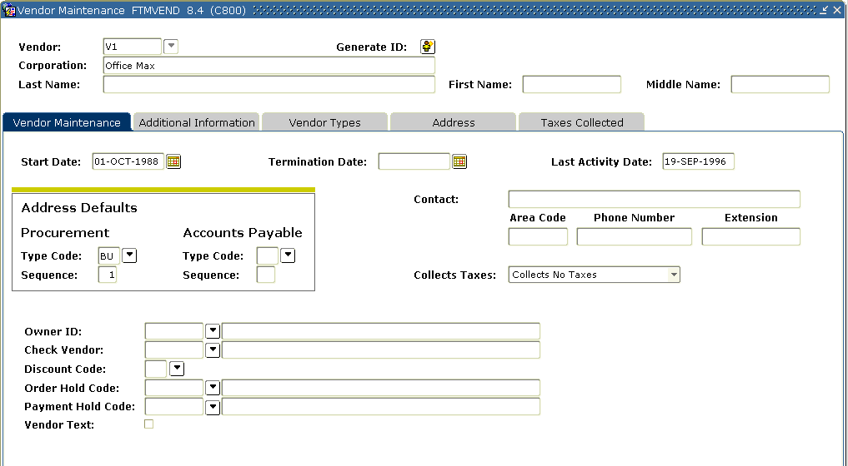

Steps
Follow these steps to complete the process.

- Access the Vendor Maintenance Form (FTMVEND).
- Enter the vendor number in the Vendor field or if common matching is turned off click the Generate ID icon.
- Is the vendor a person or a corporation?
IF | THEN
Person | Last name, first name, middle name fields
corporation | Corporation field
- Click the Next Block icon.
- Enter the date the vendor information is active in the Start Date field.
- Enter a date in the Termination Date field, if appropriate.
- Select BU in the Address Type Code field and 1 (one) in the Sequence Number field in the two PO Default fields in the Address Defaults block.
- If the billing address is different from the business address, select BI in the Address Type Code field and 1 (one) in the Sequence Number field in the two A/P Defaults
Note: If you do not assign a Type Code to the A/P Default address, Banner will assume the address is the same as the PO Default address.
Actual addresses will be entered later.
- Enter a primary contact name in the Contact field.
- Enter the telephone number in the Phone field.
- Select Collects No Tax, in the Collects Taxes field.
Note: The field allows for the calculation and appropriate remittance of tax on purchases to the taxing authority if tax processing is turned on. Because of various tax jurisdictions, Banner allows the user to specify Collects All Taxes for the vendors who collect taxes for which your institution is subject, Collects No Taxes for the vendors who do not collect any taxes, and Collects Selected Taxes for the vendors who collect selected taxes. Collects Selected Taxes allows the user to list the taxes collected in the Taxes Collected window.

- Click the Search icon in the Owner ID field to enter a parent corporation.
Note: This field is used when the vendor you are creating is a D/B/A (doing business as), or when the vendor shares a 1099 Tax ID with the parent company.
The owner ID must have been created previously on the vendor table. If you enter an Owner ID, the Tax ID for the parent vendor will default in the Tax ID field on the Vendor Header Additional Information window.
- Select a discount code in the Discount Code field.
- Select Text from the Options menu.
- Click the Save icon.
- Enter “This vendor requires a three-week delivery lead time.” in the Text field.
- Click the Save icon.
- Click the Exit icon.
Note: Notice that the Text Exists field is now populated with a Y (Yes).
- Select the Additional Information tab.
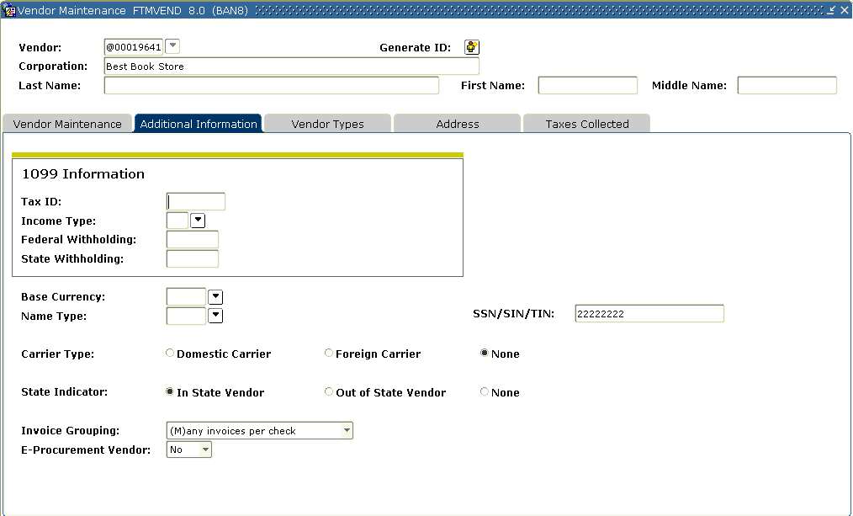

- For a 1099 vendor, enter the tax id number in the Tax ID field.
Note: If a value is entered here, Banner displays the Tax ID on the Invoice/Credit Memo Form (FAAINVE), which you can override. If you do not enter a Tax ID here, you can enter the ID on an individual invoice.
- For a 1099 Vendor, double-click on the Income Type field, and select an income type.
Note: Banner requires you to enter an Income Type when a Tax ID is entered. This identifies the income classification for 1099 reporting.
- Enter the withholding percentage for federal in the Federal Withholding field, if appropriate.
- Enter the withholding percentage for the state in the State Withholding field, if appropriate.
Note: Withholdings deduct the appropriate amount from the vendor’s check and create a liability for the remittance to the taxing authority. (Tax processing does not need to be turned on.)
Before using the withholding fields, be sure to specify the liability account as a Posting Modifier for the G010 process code in Rule Classes “DDWI – Federal Withholding,” “DTWI - State Withholding,” “CDWI – Federal Withholding on Cancel Check” and “CTWI – State Withholding on Cancel Check.”
- Enter the proper Currency code if this is a foreign vendor or disbursing agent in the Base Currency field.
- Select the Domestic, Foreign, or None radio buttons that describes the Carrier.
- Select the In State, Out of State, or None radio button as the State Indicator that describes the vendor.
- Select a payment option in the Invoice Grouping field.
Note: The valid choices are One invoice per check or Many invoices per check.
- For non 1099 Vendors, enter the tax id number in the SSN/SIN/TIN field
- Click the Save icon.
- Click the Exit icon.
- Select the Vendor Types tab.
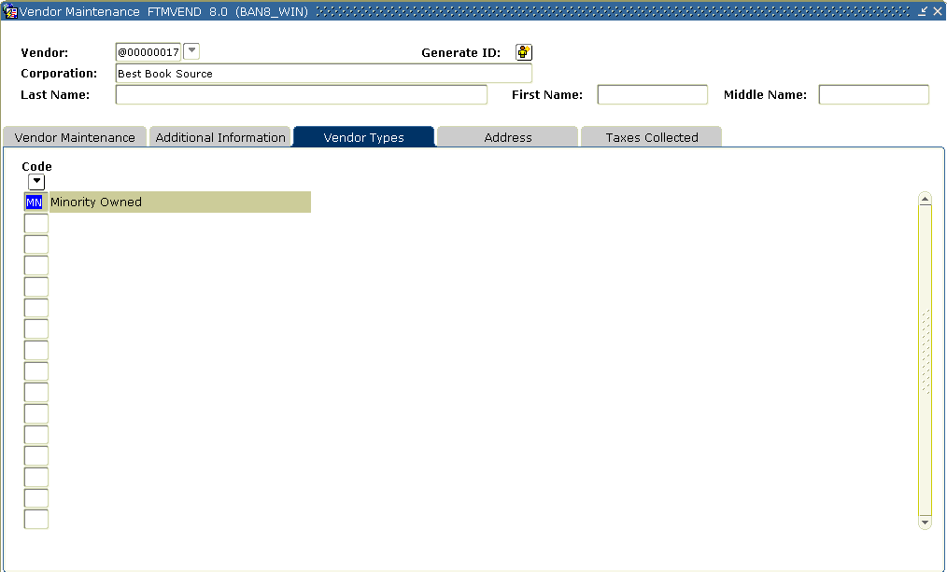
- Double-click in the Code field, and select all vendor types that apply.
Note: The Vendor Type List (FTVVTYP) gives a view of the available user-defined types.
- Click the Save icon.
- Select the Address tab.
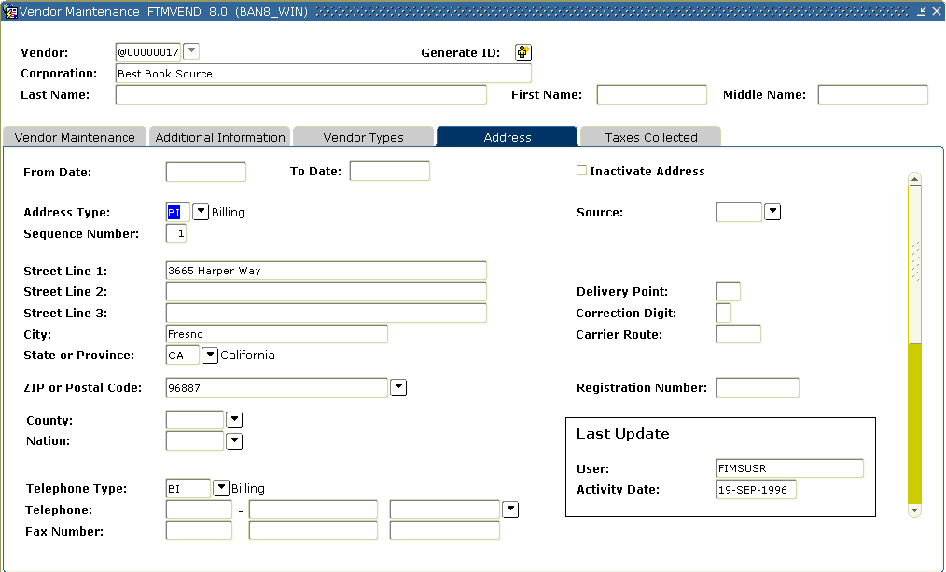

- Enter or edit the address in the Address field.
Tip: Clicking the Search icon in the Zip or Postal Code field, and selecting a zip or postal code from GTVZIPC will automatically populate the City, State, and Zip or Postal Code fields.
- Enter or edit the city in the City field.
- Double-click in the State or Province field, and select a state.
- Click the Search icon in the Zip or Postal Code field, and select a zip or postal code.
- Double-click in the Phone Type field, and select BU from the list.
- Enter or edit a phone number.
Note: Do not enter dashes in the phone number.
- Perform an Insert Record function to enter a second address.
Warning: If using the same type code, enter 2 in the Sequence Number field.
- Click the Save icon.
- Click the Exit icon.
- Select the Taxes Collected tab.
Note: Use the Taxes Collected tab of the Vendor Maintenance Form to establish tax collection data for a vendor. You can only access this window when you define a vendor that Collects Selected Taxes in the main window. When you collect taxes, the system uses the set of records that you enter to calculate the total tax due on transactions that involve this vendor.
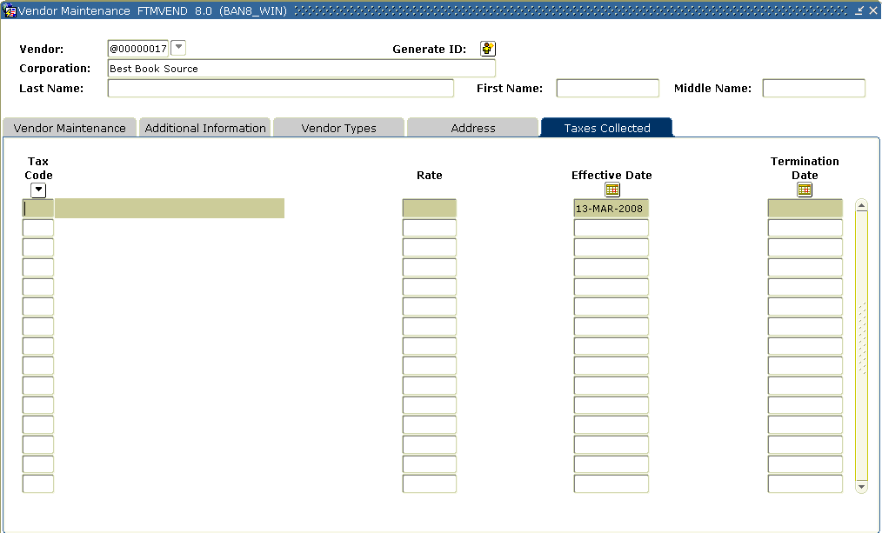
- Select a tax in the Tax Code field.
- Enter a date in the Effective Date field.
- Click the Save icon.

Creating a Commodity
Purpose
The Commodity Maintenance Form (FTMCOMM) is used to add, change, or delete Commodity codes and default account relationships.
Banner form
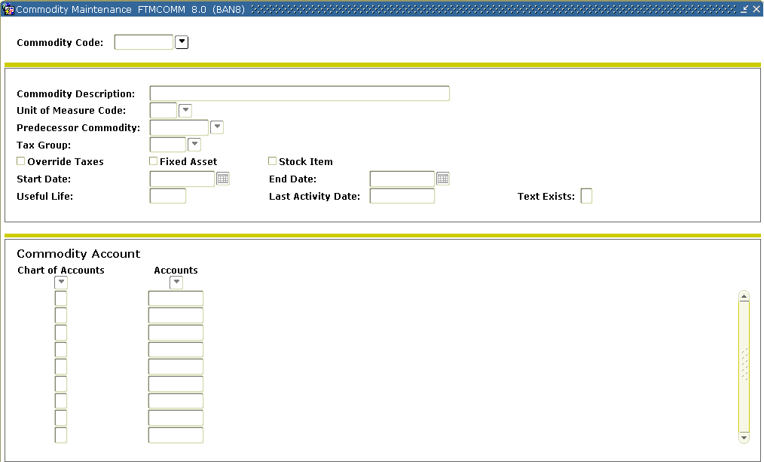
Steps
Follow these steps to complete the process. Review the tables on the previous pages as necessary.

- Access the Commodity Maintenance Form (FTMCOMM).
- Enter Next in the Commodity Code field. The system will assign a new commodity number after the new code has been added.
- Perform a Next Block function.
- Enter a description of the commodity in the Commodity Description field.
- Double-click in the Unit of Measure Code field, and select the commodity’s unitized values (Each, Box, Gallon, etc.).
- Double-click in the Predecessor Commodity field, and select a value from the existing commodity records.
- Double-click in the Tax Group field, and select a value from the available user-defined commodity records, if tax processing is on.
- Check the Stock Item to identify the commodity as a stock item for processing in the Stores Inventory module.
- Enter the date the commodity is active in the Start Date field.
Note: The date defaults to the current date.
- Enter a date in the End Date field, if appropriate.
- Select Commodity Text from the Options menu.
- Enter This is a new commodity in the Text field for this commodity.
Note: The print box is not enabled here even if checked.
- Click the Save icon.
- Click the Exit icon.
Note: Notice that the Text Exists field is now populated with a Y (Yes).
- Select Hierarchy Information from the Options menu to show the relationship between the commodity being entered and all preceding commodities in its hierarchy.
- Perform a Next Block function.
- Double-click in the Chart of Accounts field, and select a chart of account.
- Double-click on the Accounts field, and select an account number.
Note: This must be an expenditure account. The Chart of Accounts and the Accounts fields allow you to establish chart-specific account relationships for this commodity.
This allows defaults for the Account code for your chart of accounts on procurement and accounts payable documents when you use this commodity.
- Click the Save icon.
- Click the Exit icon.

Linking Vendor Codes to Commodity Codes
Purpose
The Vendor Products Maintenance Form (FTMVPRD) is used to create an electronic catalog of a vendor's products.
Banner form
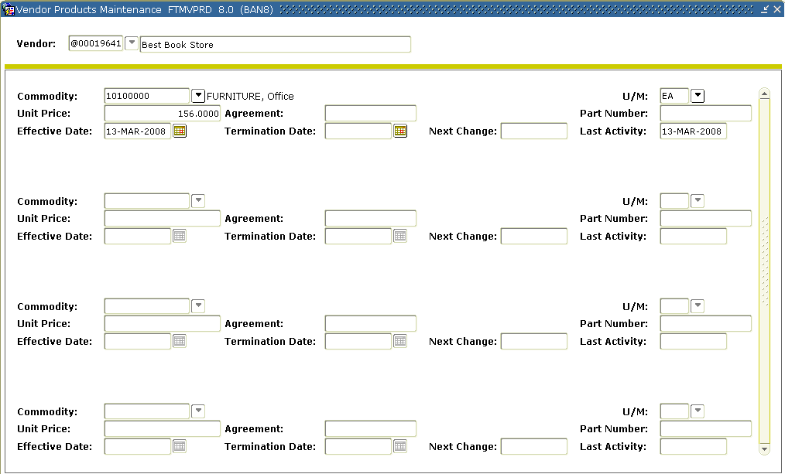
Steps
Follow these steps to complete the process.

- Access the Vendor Products Maintenance Form (FTMVPRD).
- Click the Search icon in the Vendor field, and select a vendor.
- Perform a Next Block function and navigate to a blank record.
Note: Banner displays all commodities already linked to the selected vendor. The Agreement field indicates a catalog record that may have been created from entries on the Agreement Processing Form (FPAAGRD). The FPAAGRD form will update the FTMVPRD form automatically.
- Double-click in the Commodity field, and enter an existing commodity code (your instructor will provide a code).
- Double-click in the U/M field, and select the vendor’s unit of measure.
Note: The U/M field will default from the commodity record, but any number of entries with different units of measure for the same commodity can exist in the vendor products catalog.
- Enter the vendor’s unit price in the Unit Price field, if appropriate.
- Enter the part number in the Part Number (reference number) field, if appropriate.

- Enter the effective date in the Effective field.
- Enter the termination date Termination field, if appropriate.
- Click the Save icon.
Note: If you want to link other vendors to commodities, click Rollback and repeat steps 2 - 9.
- Click the Exit icon.

Purpose
The Vendor Products Query Form (FPIVPRD) is used to look up a commodity available from different vendors. This form is an option available to users entering a commodity code on a requisition or a purchase order. This query only works if the Vendor Products Maintenance Form (FTMVPRD) has vendors linked to commodities.
Banner form
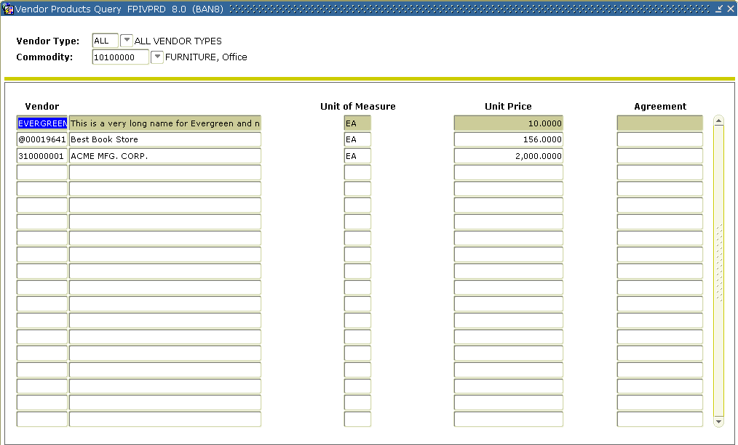
Steps
Follow these steps to query the products.

- Access the Vendor Products Query Form (FPIVPRD).
- Double-click in the Vendor Type field, and enter ALL in the field. This will allow you to retrieve all vendor records with a specific commodity.
Note: You can also enter a specific vendor type to query a user-defined group of vendors. You can view records on the Vendor Type List (FTVVTYP).
- Double-click in the Commodity field, and enter an existing commodity code.
- Perform a Next Block function.
Note: Banner displays the matching records in the Query Results block. If you want to view other vendor and commodity links, click Rollback and, repeat steps 2 - 4.
- Click the Exit icon.
Creating or Modifying Standard Purchasing Clauses
Purpose
The Clause Entry Form (FOACLAU) is used to create or maintain standard clauses to be used on requisitions, bids, purchase orders, blanket orders, change orders, and vendor agreements. Creating clauses here allows you to choose and modify standard texts without having to type them out every time.
Banner form
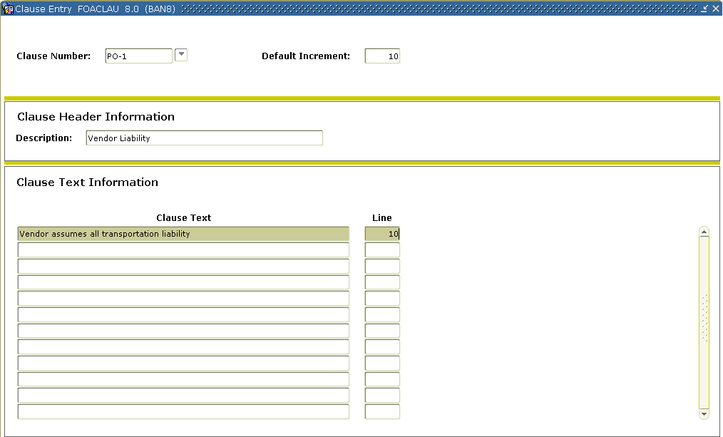
Steps
Follow these steps to create a new clause.

- Access the Clause Entry Form (FOACLAU).
- Enter an alphanumeric code in the Clause Number field.
- Perform a Next Block function to go to Clause Header Information block.
- Enter the name of the clause in the Description field.
- Perform a Next Block function to go to Clause Text Information block.
- Enter the text to be associated with this clause number.
Note: Use Next Record and Previous Record to move between lines of text.
- Press the Save icon.
- Rollback to enter a new clause or Exit this form.
Creating or Modifying Buyer Codes
Purpose
The Buyer Code Maintenance Form (FTMBUYR) is used to create buyers within Banner. By establishing multiple buyers, you can route requisitions to the appropriate buyers electronically for their action.
Banner form
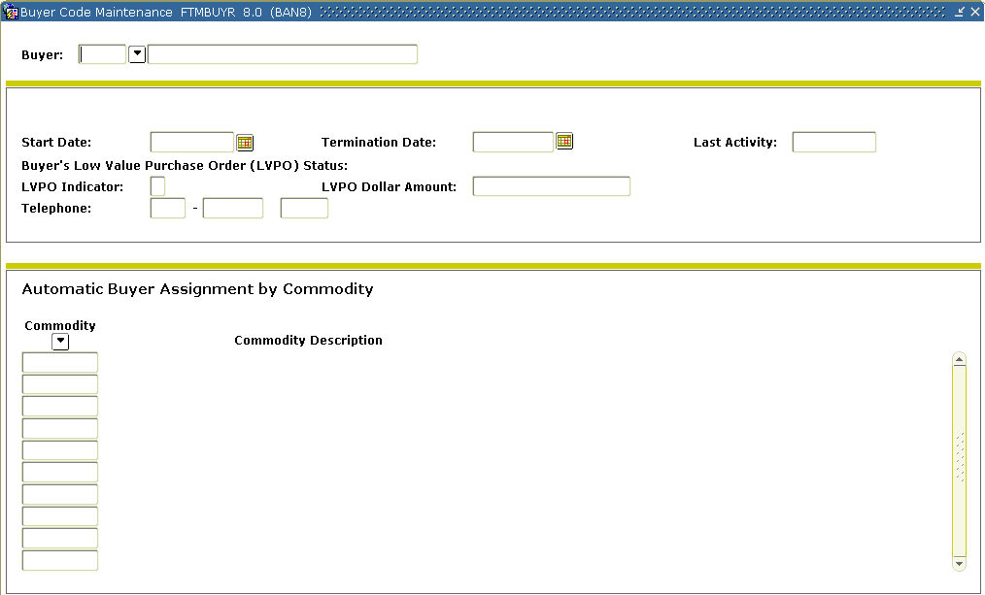
Fields – Buyer header block
This table shows fields you should know when completing the procedures that follow.

Field | Description
Start | Displays the current system date; however, you can override it.
Last Activity | Indicates when someone last updated the Buyer code.
LVPO (Low Value Purchase Order Limit) | Enables you to specify an upper limit on a purchase order completed by a buyer – put in field info.
Steps – Procedure 1
Follow these steps to create a new buyer.

- Access the Buyer Code Maintenance Form (FTMBUYR).
- Enter the new buyer code and the buyer's description in the Buyer field.
Note: In this exercise you can use your initials as the buyer code.
- Perform a Next Block function to go to the Buyer Header block.
- Enter the date the buyer code will be active in the Start field.
- Enter the date in the Termination field when the buyer code will no longer be available for use, if appropriate.
- Go to the LVPO Indicator field and enter Y (Yes), if appropriate.
- In the LVPO Dollar Amount field, enter the dollar limit, if appropriate.
Note: The purchase order will be stopped at the balancing/completion stage when the net PO amount is greater than the LVPO limit. This provides limited security since a user can enter in a different buyer code.
- Go to the Phone Number and Extension fields and enter the buyer's phone number and extension.
- Click the Save icon.
- Select Assign Commodities on the Options menu to go to the Automatic Buyer Assignment By Commodity window.
Note: In this window, associate specific commodities with the buyer.
- Double-click in the Commodity field, and enter a Commodity code.
Note: If you want to add more commodities/organizations, perform a Next Record function and repeat the data entry.
Note: Every time a completed requisition contains the commodities listed in this window, Banner assigns them to this buyer. In addition, if a requisition contains commodities assigned to different buyers, then the requisition will be spilt among the buyers.
- Perform a Next Block function.
Result: This will take you to the Automatic Buyer Assignment By Organization window.
Note: In this window, assign specific organization codes to the buyer. The automatic buyer assignment function is enabled in the form FOASYSC.
- Double-click in the COA field, and enter the Chart of Accounts code.
Note: This identifies the correct set of organization codes.
- Double-click in the Organization field, and enter a data-enterable Organization code assigned to the buyer.
Note: If you want to add more commodities/organizations, perform a Next Record function and repeat the data entry.
Note: If a requisition contains a commodity assigned to one buyer and an organization code assigned to another, Banner will use the organization to determine the buyer.
Note: The automatic buyer assignment process does not correctly when non data-enterable organizations are used.
- Click the Save icon.
- Click Rollback.

Steps – Procedure 2
Follow these steps to modify buyer’s codes.

- Access the Buyer Maintenance Form (FTMBUYR).
- Click the Search icon on the Buyer field, and select the buyer you want to modify.
- Perform a Next Block function.
- Enter or change information for the buyer in the main record, or use the Options menu to enter or change commodity and organization information.
Example: Change the start date to be two days prior to the date it currently shows.
Note: Any information on this record could be changed.
- Click the Save icon when finished.
- Click the Exit icon.

Creating Vendor Agreements
Purpose
The Agreement Processing Form (FPAAGRD) is used to maintain purchase agreements with vendors.
Note: The Termination Date field specifies the date when the vendor’s agreement terminates and the record is no longer available for transactions after that date.
Banner form
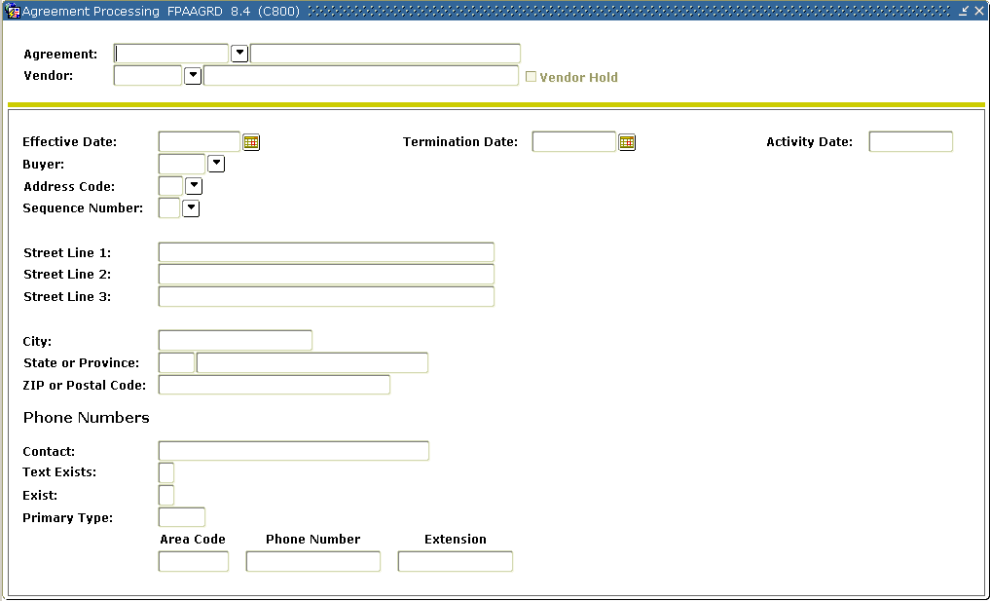
Fields – Commodity Items window
This table shows fields and checkboxes you should know when completing the procedures that follow.

Field | Description
Max Dollars | This is an information-only field.
Min Quantity | This value is the minimum amount that must be purchased at one time for this agreement to apply.
Steps
Follow these steps to complete the process.

- Access the Agreement Processing Form (FPAAGRD).
- Enter Next in the Agreement field.
Result: Banner will generate an agreement code.
- Enter the agreement description in the next field.
- Click the Search icon in the Vendor field, and enter a vendor code.
Note: This is a required field.
- Perform a Next Block function.
- Enter the date the agreement will be active in the Effective field.
- Go to the Termination field. Add two years to the current date and enter it in the field.
- Double-click in the Buyer field, and select a buyer code to be identified with this agreement.
Note: The Address fields will default from selected vendor’s PO Default value.
- Click the Save icon.
- Select Commodity Information from the Options menu to go to the Commodity Items window.
- Double-click on the Commodity field and enter a commodity code.
- Enter the maximum total expenses in the Max Dollars field for the commodity over the life of the agreement.
Note: Banner does not automatically update the Amount to Date field with the summary of purchases from the vendor.
- Enter the minimum quantity value in the Min Quantity field.
- Note: The Unit of Measure defaults from the Commodity Maintenance Form (FTMCOMM). You may change this, if appropriate.
- Enter the unit price as supplied by the vendor.
- Enter the part (item) number as supplied by the vendor, if appropriate.
- Click the Save icon.
- Select Agreement Information from the Options menu.
Result: This will return you to the header vendor information.
- Select Agreement Text from the Options menu.
Result: This will access the Procurement Text Entry Form (FOAPOXT) that will enable you to enter detailed information about the agreement.
- Perform a Next Block function.
- Go to the Text field, and enter This is a new agreement in the field.
- Click the Save icon.
- Click the Exit icon.
- Click the Exit icon once more to exit the Agreement Processing Form (FPAAGRD).

Self Check
Directions
Use the information you have learned in this workbook to complete this self check activity.
Question 1
What is the purpose of the Vendor Maintenance Form (FTMVEND)?
Question 2
On the Vendor Maintenance Form (FTMVEND), a vendor can be identified as either a person or a corporation, but not both.
True or False
Question 3
On FTMVEND, the address codes entered in the Procurement and Accounts Payable fields in the Vendor Addresses window will always be the default addresses for purchase orders and accounts payable documents.
True or False
Question 4
Which form is used to add, change, or delete Commodity codes?
Question 5
Purchase agreements with vendors are maintained on what form?
Question 6
Which form is used to create a buyer within Banner?
Question 7
Once a Buyer’s code is established, it cannot be modified.
True or False
Question 8
Which form is used to view vendor choices for a commodity?

Answer Key for Self Check
Question 1
What is the purpose of the Vendor Maintenance Form (FTMVEND)?
The Vendor Maintenance Form (FTMVEND) is used to add, change, or delete vendor information.
Question 2
On the Vendor Maintenance Form (FTMVEND), a vendor can be identified as either a person or a corporation, but not both.
True
Question 3
On FTMVEND, the address codes entered in the Procurement and Accounts Payable fields in the Vendor Addresses window will always be the default addresses for purchase orders and accounts payable documents.
False. A default address can be overridden at transaction time.
Question 4
Which form is used to add, change, or delete Commodity codes?
The Commodity Maintenance Form (FTMCOMM)
Question 5
Purchase agreements with vendors are maintained on what form?
The Agreement Processing Form (FPAAGRD)
Question 6
Which form is used to create a buyer within Banner?
The Buyer Code Maintenance Form (FTMBUYR)
Question 7
Once a Buyer’s code is established, it cannot be modified.
False. You can enter or change information for an established buyer in the main record, or use the Navigation Frame to enter or change commodity and/or organization information.
Question 8
Which form is used to view vendor choices for a commodity?
The Vendor Products Query Form (FPIVPRD)

Day-to-Day Operations
Section goal
The purpose of this section is to explain the day-to-day or operational procedures to handle purchasing and procurement procedures at your institution.
Objectives
In this section you will learn how to
- create, cancel, and query requisitions
- assign a buyer to a requisition
- use the bid process from the request through award stages
- create, cancel, and query purchase orders
- receive and return purchase goods.

Process Introduction
About the process
- Requisitions, the bid process, and receiving are all optional steps in Banner.
- Not every requisition will have a bid.
- Receiving may or may not be online.
- The only thing that is required in Banner is completing the PO (FPAPURR).
Flow diagram
This diagram highlights the processes used in the purchasing and procurement process.

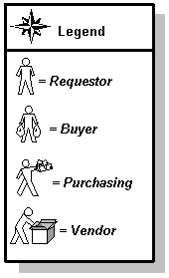
What happens
The stages of the process are described in this table.

Stage | Who does it | Description
1 | Requestor | Creates a requisition for goods and services and obtains approval.
 |  | Forwards requisition to Purchasing.
2 | Purchasing | Reviews the requisition and assigns it to a buyer.
3 | Buyer | Conducts a bid process if desired.
 |  | Selects vendor and creates purchase order.
4 | Vendor | Fills order.

Creating a Requisition
Introduction
The Requisition Form (FPAREQN) initiates the procurement process by defining an internal request to acquire goods or services. It enables you to define departmental needs by identifying the requestor, vendor, commodity, and accounting information. Entering a vendor is optional.
Banner form

Access the Requisition Form (FPAREQN) and perform a Next Block function or enter an existing requisition number to open the form.

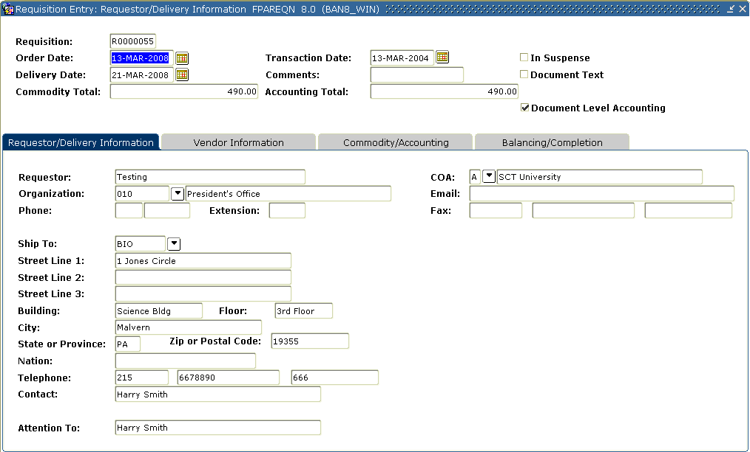

Steps – Procedure 1
The following exercise will demonstrate how to create a requisition using document level accounting with a system generated requisition number. Follow these steps to complete the process.
Note: If set up appropriately, the User Profile Maintenance Form (FOMPROF) will default in the values for requestor, organization, chart of account, and shipping address information.

- Access the Requisition Form (FPAREQN).
- Perform a Next Block function.
- Change the order date in the Order Date field, if appropriate.
- Change the transaction date in the Transaction Date field, if appropriate.
- Enter a delivery date in the Delivery Date field.
Note: The delivery date must be the same as or later than the order date.
- Enter the requestor in the Requestor field.
- Enter a comment in the Comment field, such as Rush.
- Select a chart of accounts in the COA field.
- Select an organization in the Organization field.
Note: The user must have posting capabilities to the organization selected.
- Click the Search icon, and enter a shipping address in the Ship To field.
Note: When you select a shipping address the Address, Phone, Contact, and Attention fields will be filled in if the information was built on the Ship to Address Maintenance Form (FTMSHIP).

- Select the Vendor Information tab.
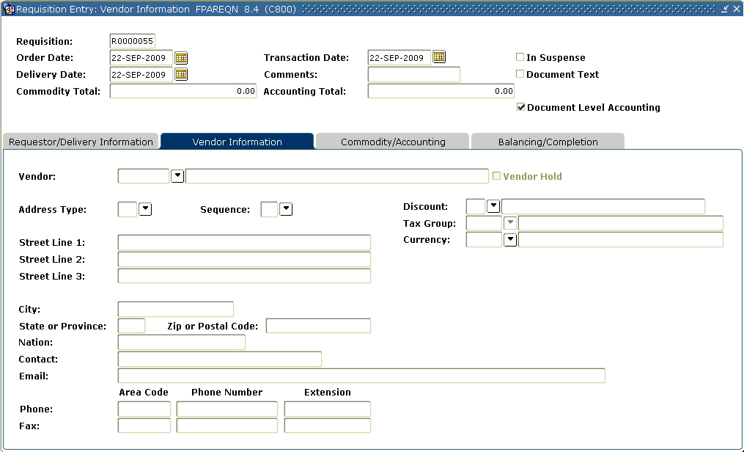
- Click the Search icon in the Vendor field, and enter a vendor.
Note: Once a vendor is selected, the remaining fields will be filled in for you, if the Procurement address exists for the vendor. If you need to create a vendor or add address information for the vendor, use the Vendor Maintenance Form (FTMVEND).
- Do you want to enter a commodity using a commodity code?
- If yes, go to Procedure 2.
- If no, go to Procedure 3.

Steps – Procedure 2
Follow these steps to enter a commodity using a commodity code.
The Commodity Maintenance Form (FTMCOMM) will default in values for unit of measure and unit price if defined for that commodity.

- Select the Commodity/Accounting tab.
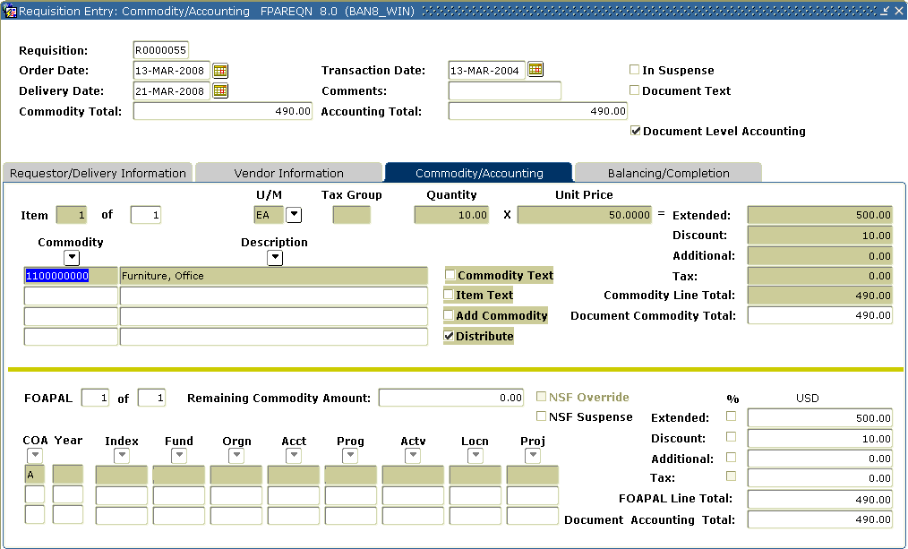
- Select a commodity in the Commodity field.
Note: The commodity information will be defaulted once selected. The requestor can change the values displayed.
- Select EA in a unit of measure in the U/M field.
- Enter 10 for the quantity to be requested Quantity field.
- Enter $50 for the unit price of this commodity in the Unit Price field.
- Tab to the Discount field. Enter a discount of $10
Result: The extended price has been filled in by Banner.
- Tab to the Additional field. Enter $15 for the freight charges of this item.
- Perform a Next Record function.
- Repeat steps 1 - 7 if additional commodities are to be added to this requisition.
- Perform a Next Block function.

- Click the Search icon for COA and select your chart.
Note: Fiscal year will default in based on the transaction date
- Click the Search icon for Fund and select fund 1110.
- Click the Search icon for Orgn and select 11102
- Click the Search icon for Acct and then select 7210
- Click the Search Icon for Prog and then select 10
- Enter the amount to be charged to this account in the USD extended field.
Note the discount and additional amounts are populated automatically.
- If additional accounts were to be charged after entering the amount charged,
- tab to the Chart field
- perform a Next Record function
- and repeat steps 11 -16.
- When finished, select the Balancing/Completion tab. 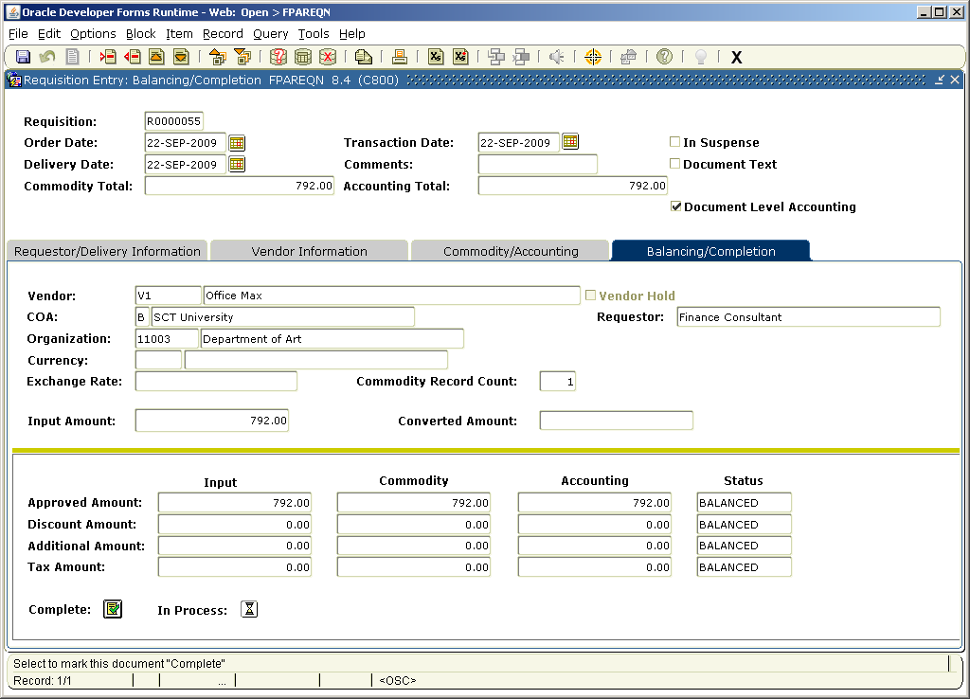
- Review the Header, Commodity, and Accounting amounts.
- Are these amounts in balance?
If yes, click the Complete button.
- Write down the requisition number list on the help bar (bottom left).

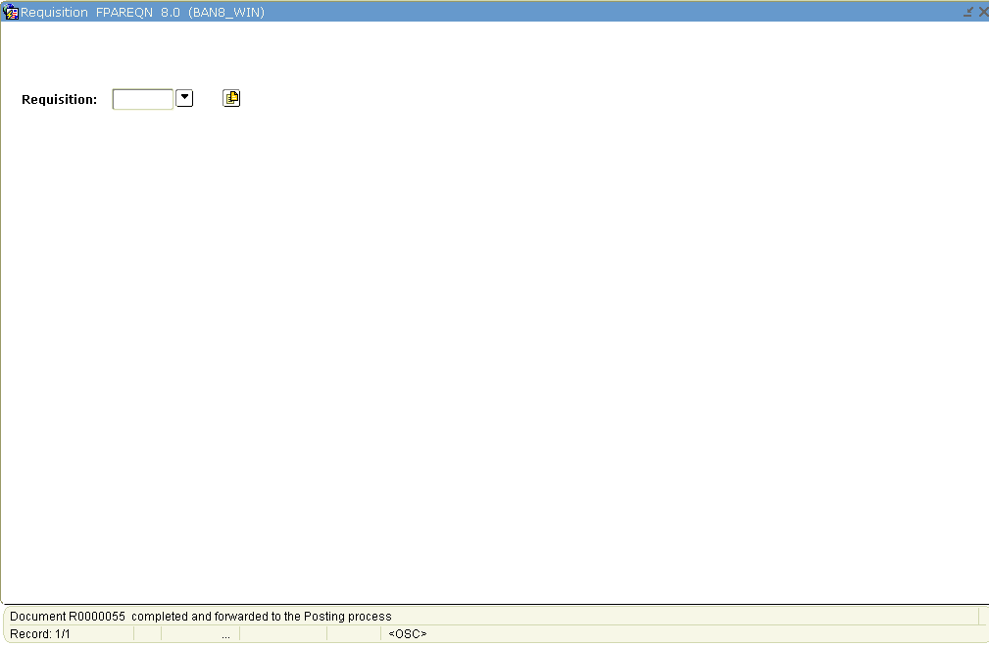
Steps – Procedure 3
Follow these steps to enter a commodity not using commodity codes.

- Select the Commodity/Accounting tab.
- Tab to the Description field and type a user-defined item.
For this exercise, enter three-foot high bookcase with glass doors.
- Select EA in a unit of measure in the U/M field.
- Enter 10 for the quantity to be requested Quantity field.
- Enter $50 for the unit price of this commodity in the Unit Price field.
- Tab to the Discount field. Enter a discount of $10
Result: Notice the extended price has been filled in by Banner.
- Tab to the Additional field. Enter $15 for the freight charges of this item.
- Perform a Next Record function and repeat steps 1 - 7 if additional commodities are to be added to this requisition.
- When finished, perform a Next Block function.
- Click the Search icon for COA and select your chart.
Note: Fiscal year will default in based on the transaction date
- Click the Search icon for Fund and select fund 1110.
- Click the Search icon for Orgn and select 11102
- Click the Search icon for Acct and then select 7210
- Click the Search Icon for Prog and then select 10
- Enter the amount to be charged to this account in the USD extended field.

Note the discount and additional amounts are populated automatically.
- If additional accounts were to be charged after entering the amount charged
- tab to the Chart field
- perform a Next Record function
- repeat steps 10 -15.
- Select the Balancing/Completion tab.
- Review the Header, Commodity, and Accounting amounts.

- Are these amounts in balance?
If yes, click the Complete button.
- Write down the requisition number list on the help bar (bottom left).

Steps – Procedure 4
Follow these steps to create a requisition using commodity level accounting with a system generated requisition number. Notes: If set up appropriately, the User Profile Maintenance Form (FOMPROF) will default in the values for requestor, organization, chart of account, and shipping address information.
The Commodity Maintenance Form (FTMCOMM) will default in values for unit of measure and unit price if defined for that commodity.
- Access the Requisition Form (FPAREQN).
- Perform a Next Block function.
- Change the order date in the Order Date field, if appropriate.
- Change the transaction date in the Transaction Date field, if appropriate.
- Enter a delivery date in the Delivery Date field.
Note: The delivery date must be the same as or later than the order date.
- Enter the requestor in the Requestor field.
- Enter a chart of account in the COA field.
- Select an organization in the Organization field.
Note: The user must have posting capabilities to the organization selected.
- Select a shipping address in the Ship To field.
Note: When you select a shipping address the Address, Phone, Contact, and Attention fields will be filled in if the information was built on the Ship to Address Maintenance Form (FTMSHIP).
- Select the Vendor Information tab.
- Select a vendor in the Vendor field.
Note: Once a vendor is selected, the remaining fields will be filled in for you, if the Procurement address exists for the vendor. If you need to create a vendor or add address information for the vendor, use the Vendor Maintenance Form (FTMVEND).
- Perform a Next Block function.

- Uncheck the Document Level Accounting field to turn on Commodity Level Accounting.
- Select a commodity in the Commodity field.
Note: The commodity information will be defaulted once selected. The requestor can change the values displayed.
- Select EA in the U/M field..
- Tab to the Quantity field and enter in 10 for the quantity of items to be requested.
- Tab to the Unit Price field and enter in $50 for the unit price of this commodity
- Tab to the Discount field. Enter a discount of $10
Result: The extended price has been filled in by Banner.
- Tab to the Additional field. Enter $15 for the freight charges of this item.
- Tab to the Commodity field.
- Perform a Next Block function.
- Enter your chart of accounts code in the COA field.
Note: Fiscal year will default in based on the transaction date.
- Click the Search icon for Fund and select fund 1110.
- Click the Search icon for Orgn and select 11102.
- Click the Search icon for Acct and then select 7210
- Click the Search icon for Prog and then select 10
- Enter the amount to be charged to this account in the USD extended field.

Note the discount and additional amounts are populated automatically.
- Perform a Previous Block function.
- Perform a Next Record function.
- Repeat steps 14 - 29 to enter additional commodities.
- When finished, select the Balancing/Completion tab.
- Review the Header, Commodity, and Accounting amounts to make sure they are in balance.
- Are these amounts are in balance?
If yes, click the Complete button.
- Write down the requisition number list on the help bar (bottom left).
Steps - Procedure 5
The Copy Requisition window enables you to copy data from a completed and posted requisition to a new requisition document.
Follow these steps to create a requisition using the copy function.

- Create your own requisition code in the Requisition field, or allow the system to generate one by entering Next in the field.
- Click the Copy icon or select Copy Requisition from the Options menu.
Result: The Copy window opens.
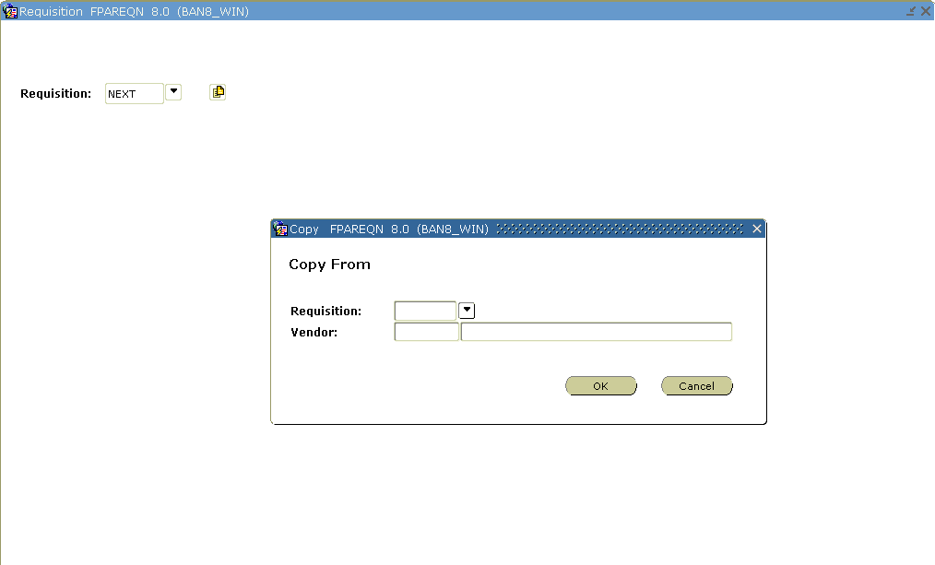
- Enter or select a value in the Copy From Requisition field.
Note: The Vendor field can help verify that you have selected the correct requisition to be copied. If the requisition you are coping did not contain a vendor, then it will not appear in the Vendor field
- Click OK. This will copy the information from the old document to the new document, and you will be taken to the Requestor/Delivery Information window.
Result: The requestor, vendor, commodity, and accounting information are carried forward to the new document. All suspense flags are set to Y. You must navigate through the new requisition to remove the document from suspense and complete it.
Warning: The copy functionality will not check or update available balance until you navigate through the form.
- Change the order date in the Order Date field, if appropriate.

- Change the transaction date in the Transaction Date field, if appropriate
- Enter a delivery date in the Delivery Date field.
Note: The delivery date must be the same as or later than the order date.
- Change the requestor in the Requestor field, if applicable.
- Change the organization, if applicable, by clicking the Search icon, and enter an organization in the Organization field.
Note: The user must have posting capabilities to the organization selected.
- Change the chart of accounts, if applicable, by clicking the Search icon, and enter a chart of account in the COA field.
- Change the ship to, if applicable, by clicking the Search icon, and enter a shipping address in the Ship To field.
Note: When you select a shipping address the Address, Phone, Contact, and Attention fields will be filled in if the information was built on the Ship to Address Maintenance Form (FTMSHIP).
- Perform a Next Block function.
- Confirm this is the correct vendor and vendor address to be used.
- If the information is not correct, to update the vendor, click the Search icon in the Vendor field, and enter a vendor.
Note: Once a vendor is selected, the remaining fields will be filled in for you, if the PO Default address exists for the vendor.
Note: If you need to create a vendor or add address information for the vendor, use the Vendor Maintenance Form (FTMVEND).
- Perform a Next Block function.
- Review and update all the information in the Commodity/Accounting window and the Commodity Supplemental Information window. Refer to procedures 2, 3, and 4 to do this.
Note: To remove the In Suspense flag, navigate through each commodity record and FOAPAL record to review the data.
- When you are ready to proceed to the Balancing/Completion window, perform a Next Block function.
- Review the Header, Commodity, and Accounting amounts to make sure they are in balance.
- Click Complete.
- Write down the requisition number list on the help bar (bottom left).
- Click the Exit icon.

Adding Text to Any Purchasing Document
Introduction
Once all required fields have been entered on a purchasing document (bid, requisition, purchase order, blanket order, change order, or vendor agreement), Document Text can be entered that applies to the entire document. Also, when on the commodity line of any document, Item Text can be added for that commodity.
Banner form
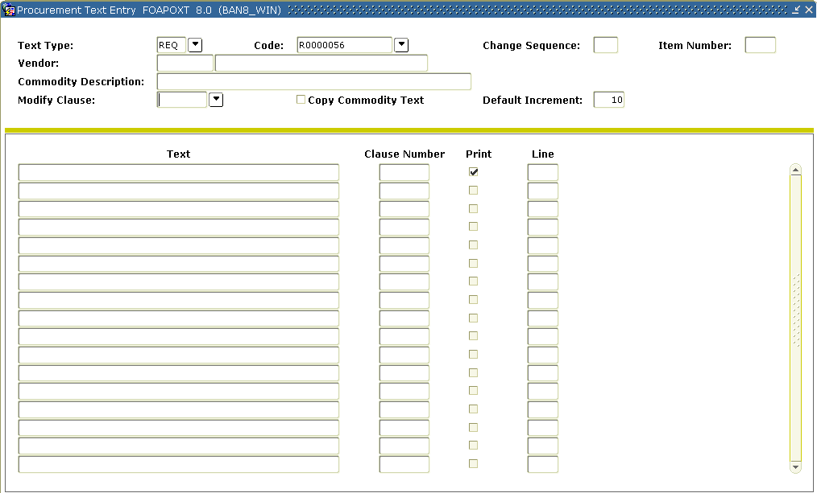

Steps
Follow these steps to complete the process.

- Create a new requisition or other purchasing document – refer to previous lessons (or select an incomplete purchasing document)
- Once all required fields have been entered, select Document Text (FOAPOXT) from the Options menu.
Note: The Text Type, Code, and Vendor information will default into the header block from the calling document.
- Perform a Next Block function to view current text information.
Note: If no text exists, then the Text block will not have any data displayed
- Enter “Test” in the TEXT field and leave the Clause Number field blank next to it.
- Click SAVE
- Perform a Rollback function
- Your cursor will be in the Modify Clause field
- Select a Clause Number from the drop down list.
- Perform an Insert Record function to bring the Clause Text to the block below.
Note: The Clause Text was added after the first text line, “Test”. You can repeat steps 6 and 9 to insert additional Clause Text.
- Modify the text inserted from the clause and/or add additional text.
Note: Use Next Record and Previous Record to move between lines of text.
Warning: Never have text in the Text field and have also keyed in a clause number in the Clause Number field on the same line or the Clause Text will override the text.
- To return to the calling document, Save and Exit.
- Click on the Commodity/Accounting tab or select this link from the Options menu.
- Make sure your cursor is on completed commodity line.
- Select this Item Text (FOAPOXT) from the Options menu.
Note: The Text Type, Code, Item Number, Vendor, and Commodity Description will default from the calling document
- You can follow steps 3 -7 to add text Item Text here just as you did for Document Text above.
Note: If the calling commodity has Commodity Text previously defined on FTMCOMM, you can modify this text with this form. In the header block check the Copy Commodity Text checkbox and Insert Record. This will put the commodity text on a line below where you can modify it.
Querying Uncompleted, Completed, and Approved
Introduction
Use the Requisition Inquiry Form (FPIREQN) to query and review the requisition information. You cannot change any information on FPIREQN.
Note: The Requisition Form (FPAREQN) initiated the Procurement process. You defined the requestor, vendor, commodity, and accounting information. Once you complete a requisition, you cannot query the information from the Requisition Form (FPAREQN).
Banner form
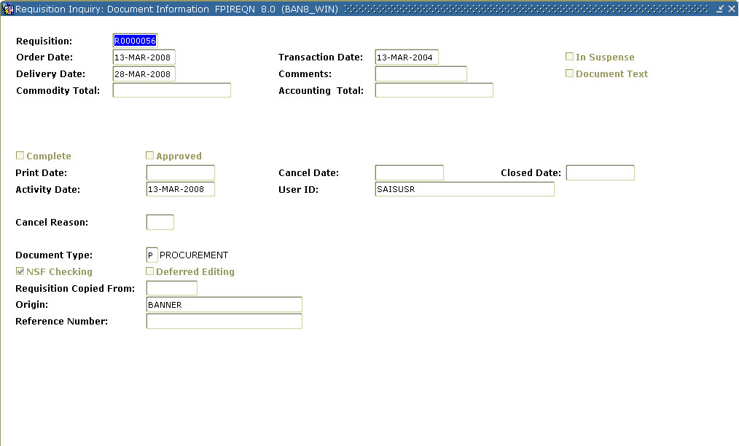

Steps
Follow these steps to complete the process.

- Access the Requisition Inquiry Form (FPIREQN).
- Enter an existing requisition number in the Requisition field. If you do not remember the number, click the Search icon to display all the requisitions, and select one from the list.
- Perform a Next Block function.
Note: This takes you to the Document Information window. Information can be viewed about whether the document was completed and approved; if it was printed, cancelled, or closed, and the date those activities happened.
- Perform a Next Block function to go to the Requestor/Delivery Information window. View all desired information in this window.
- Perform a Next Block function to go to the Vendor Information window. View all desired information in this window.
- Perform a Next Block function to go to the Commodity/Accounting window.
Note: This window also includes the Original Commodity Description pop-up window, allowing you to see the Commodity description as defined for the code if the description was overwritten on FPAREQN.
- From the Options menu, select Commodity Supplemental Information.
Note: It displays additional information regarding this commodity. The Delivery Date and Ship To fields entered on the requisition, as well as the Assigned Buyer, Bid Assigned (if applicable), Assigned to PO, and PO Item Number fields.
- Click the Close icon to close this window.
- Click the Exit icon.

Additional Requisition Queries
Introduction
Besides FPIREQN, there two other helpful inquiry forms related to requisitions. Users can quickly see requisitions in suspense by using the Requisition Suspense List (FPIREQS). Users can see all requisitions open by FOAPAL by using Open Requisition by FOAPAL Query (FPIORQF). On FPIORQF, fund/org security can be invoked so users can only see the requisitions related to their fund and organizations.

Form Description | Banner Name
Requisition Suspense List | FPIREQS
Open Requisition by FOAPAL Query | FPIORQF
Canceling a Requisition
Introduction
The Requisition Cancel Form (FPARDEL) is used to reverse postings of the original requisition and cancel its availability for any further action in Banner. Before you can delete a requisition, you must complete, approve, and post it. Also, if the request has subsequent activity (e.g., Bid, PO, Delivery Receipt, etc.), you cannot cancel it.
Note: Use the Record remove key twice to delete a requisition that is incomplete. Canceling or removing the requisition liquidates the reservation.
Banner form
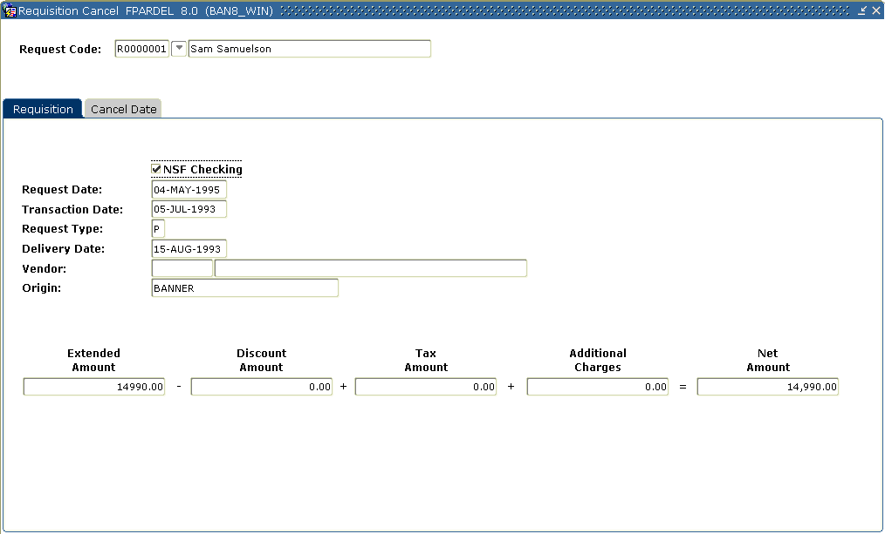

Steps
Follow these steps to complete the process.

- Access the Requisition Cancel Form (FPARDEL).
- Enter the Requisition code you want to cancel in the Request Code field. (Click on the search icon if you need to look up and select a Requisition code.)
- Perform a Next Block function to go to the Cancel Header block.
Note: Banner displays the requisition detail in this block to help confirm correct selection of the requisition to be cancelled.
- Click the Cancel Date tab.
Note: The cursor is in the Cancel Date field, which displays the current date. You can enter another date, but it must be after the original Transaction date and in an open fiscal year period.
- Double-click in the Reason Code field, and select a reason.
Note: The Reason Code field is defined by users to explain why the item is to be cancelled.
- Select Process Cancellation from the Options menu to cancel the requisition.
- Click the Exit icon.

Printing a Requisition
Banner form
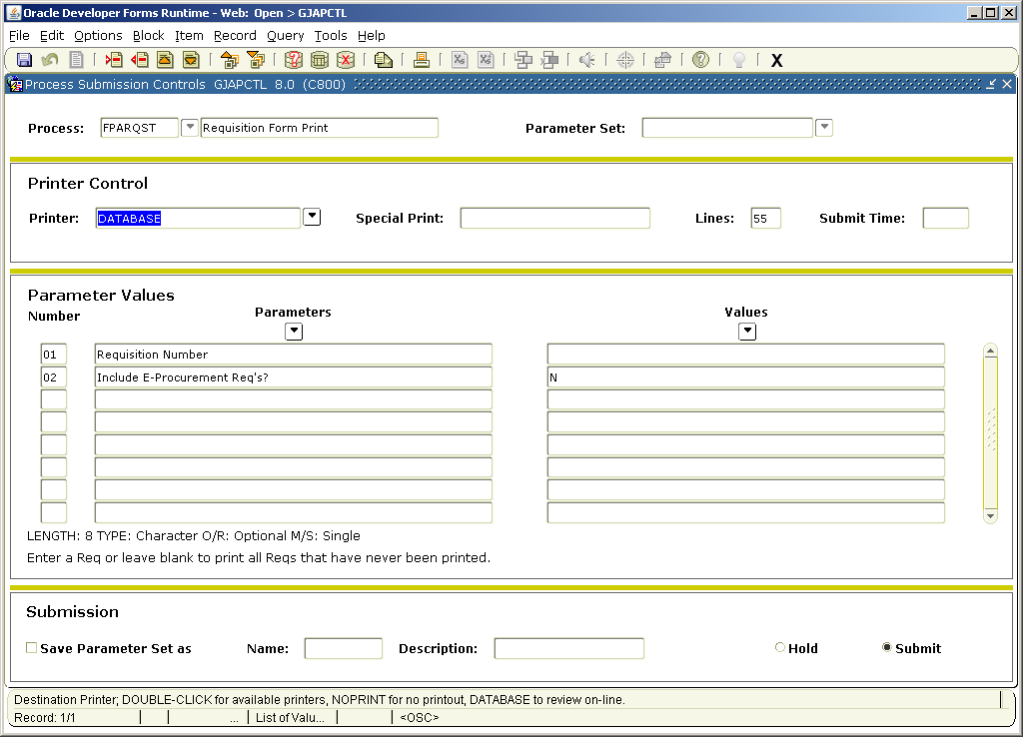
Steps
Follow these steps to print a requisition.

- Access the GJAPCTL form simply by entering FPARQST in the Go To field.
- Perform a Next Block Function.
- Enter DATABASE in the Printer Field.
- Perform a Next Block Function.
- Enter into parameter 01 the number of a requisition you created. If left blank, all previously unprinted requisitions will print.
Note the help information below the parameters for each parameter in this process.
- Parameter 02 can be used to print e-Procurement requisitions.
- Perform a Next Block Function.
- Click the Save icon.
- Review the output.
- Click the Exit icon.
Assigning a Buyer to an Approved Requisition
Introduction
The Buyer Assignment Form (FPAABUY) is used to assign completed, approved, and posted requests to buyers on the basis of internal policies and procedures.
Banner form
Methods of assigning a buyer
There are two methods to assign a buyer to a requisition.
- Manual
- Automatic
This lesson describes both methods.
Warning: The instructor should be the only person entering data on the two forms in this exercise, FPAABUY and FOASYSC. The participants should watch the demonstration of the process unless instructed otherwise.
Assigning a buyer by document or item
The Assign by: Document and Item radio buttons determine how the records will be displayed and allow for easier assignment of buyers according to policy.
Selecting Assign by: Document will list all requests based on document in document number order.
When using this functionality, assigning a buyer to a requisition document will assign that buyer for all items not previously assigned by item.
If you prefer to do the assignment by item, then select the Assign by: Item radio button. The display will automatically reconfigure to show information by item.

Manual method
In a manual buyer assignment, there are four ways to manipulate the data. Each of these four ways will be shown in the four exercises that follow.
Steps – Procedure 1 - manual buyer assignment
Follow these steps to complete the process for a manual buyer assignment.

- Access the Buyer Assignment Form (FPAABUY).
Result: The cursor is in the Buyer field.
- Double-click in the Buyer Code field and select a buyer.
- Double-click in the Chart of Accounts field and select a chart.
Note: If set up, this will default in from your FOMPROF settings.
- Perform a Next Block function.
- Select the appropriate radio button: Assign by: Document or Assign by: Item.
Note: The display will automatically sort the requisitions first by requisition number, then by item. You can query existing records by clicking View Document from the Options menu.
- The Buyer code will be defaulted in.
Note: Double-clicking in the Buyer field and selecting a different buyer can change the buyer code.
- Click the Save icon to confirm the assignments defaulted or entered.
- Click the Exit icon.

Steps – Procedure 2 - manual buyer assignment
Follow these steps to complete the process.

- Access the Buyer Assignment Form (FPAABUY).
Result: The cursor is in the Buyer field.
- Do not enter a buyer code.
- Do not select a chart of accounts
- Perform a Next Block function.
Note: Banner displays all the unassigned requisitions for manual assignment by the user.
- Select the appropriate radio button: Assign by: Document or Assign by: Item.
Note: The display will automatically sort the requisitions first by requisition number, then by item. You can query existing records by clicking View Document from the Options menu.
- Double-click in the Buyer Code field to select buyer for the document or item.
- Click the Save icon to confirm the assignments defaulted or entered.
- Click the Exit icon.

Steps – Procedure 3 - manual buyer assignment
Follow these steps to complete the process.

- Access the Buyer Assignment Form (FPAABUY).
Result: The cursor is in the Buyer field.
- Double-click in the Buyer Code field and select a buyer.
- Double click in the Chart of Accounts field and select a chart
- Double click in the Organization field and select an organization
- Use the Search icon in the Commodity field and select a commodity, if appropriate.
- Perform a Next Block function.
Note: Banner defaults all of the requisitions matching the selection to that buyer.
- Select either Assign by: Document or Assign by: Item radio buttons.
Note: The display will automatically sort the requisitions first by requisition number, then by item. You can query existing records by clicking View Document from the Options menu.
- The buyer code will be defaulted in.
Note: Double clicking in the Buyer field and selecting a different buyer can change the buyer code.
- Click the Save icon to confirm the assignments defaulted or entered.
- Click the Exit icon.

Steps – Procedure 4 – manual buyer assignment
Follow these steps to complete the process.

- Access the Buyer Assignment Form (FPAABUY).
Result: The cursor is in the Buyer field.
- Do not enter a buyer code.
- Double-click in the Chart of Accounts field and select a chart
- Double click in the Organization field and select an organization
- Use the Search icon in the Commodity field and select a commodity, if appropriate.
- Perform a Next Block function.
Note: Banner defaults all of the requisitions matching the selection.
- Select either Assign by: Document or Assign by: Item radio buttons.
Note: The display will automatically sort the requisitions first by requisition number, then by item. You can query existing records by clicking View Document from the Options menu.
- Double-click in the Buyer Code field to select the buyer for the document or item.
- Click the Save icon to confirm the assignments defaulted or entered.
- Click the Exit icon.

Steps – Procedure 5 – automatic buyer assignment
Follow these steps to complete the process for automatic buyer assignment. The Buyer Code Maintenance Form (FTMBUYR) needs to have organizations or commodities assigned to buyers before the automatic buyer assignment process is turned on.

- Access the System Control Maintenance Form (FOASYSC).
Note: On this form, you will activate the Automatic Buyer Assignment.
- Perform an Insert Record function.
- Perform a Duplicate Record function.
- Enter today’s date in the Effective Date field.
- Select Procurement Processing Info from the Options menu.
- Check the Automatic Buyer Assignment checkbox.
- Click the Save icon.
- Click the Exit icon to exit the form.
- Logoff the Banner system and then logon again.
Note: You must logoff Banner in order for any changes made to FOASYSC to become effective. Only the person updating the form needs to logoff and logon.
Next steps
Now that you have seen the Automatic Buyer Assignment process, create three or four new requisitions with commodities and organizations that have been assigned to a specific buyer on the Buyer Maintenance Form (FTMBUYR).
Use the Requisition Inquiry Form (FPIREQN) to query the completed, approved, and posted requisitions. Note the Buyer codes that Banner assigned.

Using the Bid Process
Starting the bid process
The Bid Process supports the development and maintenance of bid documents from the request through award stages.
There are two ways to start the Bid Process.
Method 1: Create bids from open requisitions assigned to a buyer using the Bid Creation Form (FPACTBD).
Method 2: Create bids using the Bid Header Form (FPABIDH).
Bid process steps
There are eight steps to the bid process. Depending on which method you choose, the forms used may vary.

Step | Form(s) Used
Starting the Bid Process | FPACTBD (method 1 only)  FPABIDH (methods 1 and 2)
Identifying Prospective Vendors | FPAPRBD
Identifying Commodities | FPABIDH
Generating Bid Request Forms | FPABIDD
Entering Vendor Pricing Data | FPABIDE
Comparing Vendor Data Online | FPABIDC
Generating a Printed Report to Compare Vendor Data | FPRBEVL
Assigning a Chosen Vendor | FPABAWD
Searching for bid information
There are two query forms to help you search for bid information entered in the Banner system.
The Bid Alpha Search Form (FTIABID) provides an alphanumeric bid search capability based on the spelling of the bid description.
The Bid List Validation Form (FTIBIDS) provides an online listing of all un-awarded bids entered into the Purchasing System.

Starting the Bid Process
Introduction
The Bid Creation Form (FPACTBD) enables you to consolidate existing requisitions into a single bid and provides a mechanism for tracking a bid request.
Note: This form is similar to the Purchase Order Assignment Form (FPAPOAS). The Buyer Assignment Form (FPAABUY) updates both forms. The buyer, or other designated employee, assigns a bid number to an open requisition after which the bid appears on the subsequent Bid Processing forms.
Note: Using this form is only necessary when you are creating a bid from an existing requisition (method 1).
Banner form
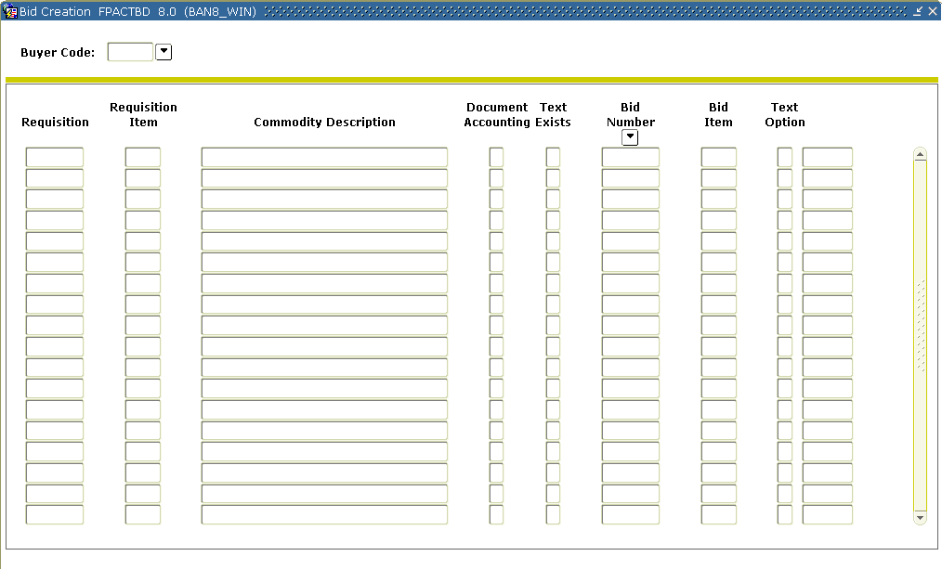
Steps 1 – method 1
Follow these steps to create a bid number from an existing requisition.
Note: In this exercise, you will create a bid using method 1. The Bid Creation Form (FPACTBD) is used only in this method.

- Access the Bid Creation Form (FPACTBD).
- Enter the Buyer code in the key block.
- Perform a Next Block function.
Note: The system displays open requisitions for that Buyer code.
- Assign new or existing bid numbers to requests, or enter Next in a Bid Number field for Banner to assign a bid number to a request.

Note: The Text Option field allows you to copy the requisition commodity text into the bid and purchase order by entering a C for copy (default). You can also choose I to ignore the text or V to view it.
- Click the Save icon.

Steps – Procedure 2– method 1
Follow these steps to continue creating a bid from an existing requisition.
Note: The Bid Class field in the header block refers to the Bid Classification Maintenance Form (FTMBCLS), which permits users to track the status of a bid through user-defined categories.
Banner form

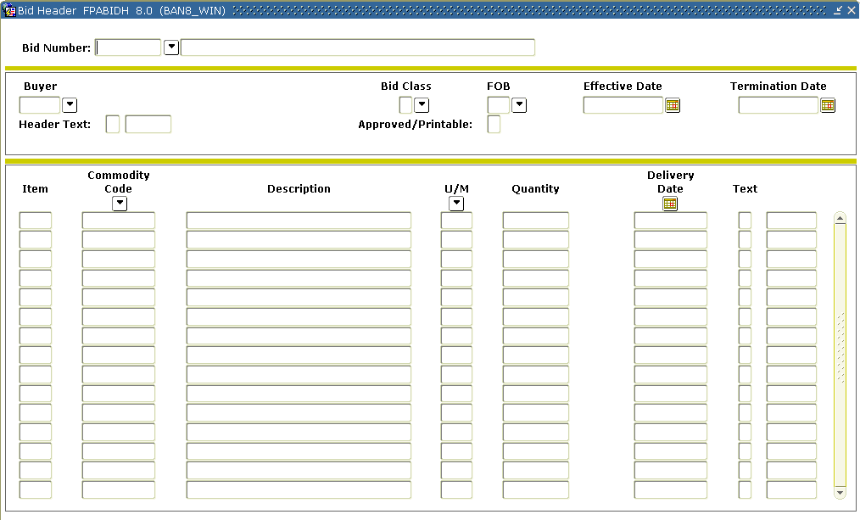
- Access the Bid Header Form (FPABIDH).
- Use the Search icon in the Bid field to select one of the Bids you just created in FPACTBD.
- Enter a name for the new bid.
- Perform a Next Block function.
- Use the Search icon in the Bid Class field to enter a value in the Bid Class field, if appropriate.
- Use the Search icon in the FOB field to enter a value in the FOB field, if appropriate.
- Enter a bid termination date in the Termination Date field, if appropriate.
Note: Bids should have a set time to end.
- Perform a Next Block function.
Note: Banner displays the requisition buyer and commodity data for the bid.
- Modify this information, if appropriate, or add more commodity data for the bid as necessary.
Note: after the bid has been awarded, the buyer may still add commodities to the purchase order, like transportation cost.
- Click the Save icon.
- Click the Exit icon.

Steps – method 2
In method 2 of bid creation, the bid process is started using the Bid Header Form (FPABIDH).
Follow these steps to start the Bid Process by identifying buyer and commodity data.
Note: The Bid Class field in the header block refers to the Bid Classification Maintenance Form (FTMBCLS), which permits users to track the status of a bid through user-defined categories.

- Access the Bid Header Form (FPABIDH).
- Enter Next in the Bid Number field to have Banner assign a bid number.
- Enter a name for the new bid.
- Perform a Next block function.
- Double-click in the Buyer Code field and select a buyer.
- Change the effective date if the bid did not start today.
- Enter a bid termination date in the Termination Date field, if appropriate.
Note: Bids should have a set time to end.
- Perform a Next block function.
- Perform either of the following:
- Double-click the Search icon in the Commodity Code field and select a commodity, or
- Enter a user-defined description in the Commodity Description field.
- Double-click in the U/M field and select a unit of measure.
- Enter in a quantity in the Quantity field.
- Enter the delivery date in the Delivery Date field.
- Click the Save icon.
- Click the Exit icon.
Identifying Prospective Vendors
Introduction
The Prospective Bidders Form (FPAPRBD) identifies prospective vendors who might participate in the bid process.
Banner form
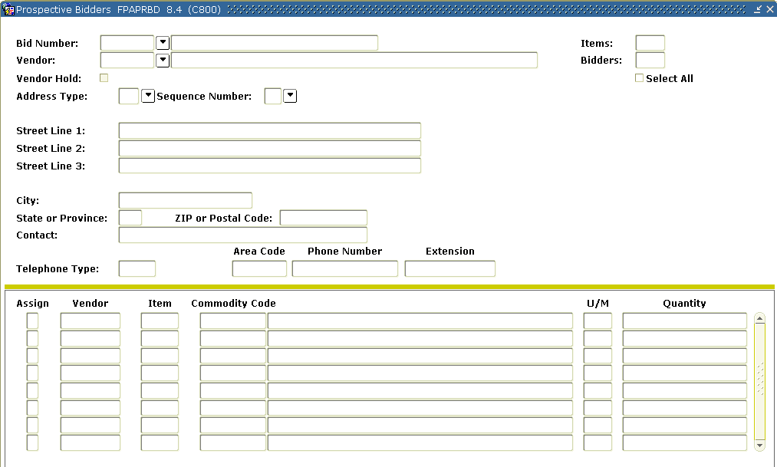

Steps – method 1
Using method 1, follow these steps to identify prospective vendors who might participate in the bid process.

- Access the Prospective Bidders Form (FPAPRBD).
- Enter the bid number in the Bid Number field or click the Search icon to find it.
Note: If clicking the Search icon, choose List of Bids (FTIBIDS) from the options to select the bid.
- Tab to the Vendor field.
- Click the Search icon
- Select the List of Assigned Vendors.
- Select one of the assigned vendors from the list.
- Tab to the Address Code field.
- Verify the vendor address information, which is automatically displayed on the form.
- Perform a Next Block function.
Note: The Bid items automatically defaults for the selected vendor.
- Verify the all commodities have defaulted with Y (Yes) in the Assign column.
- If appropriate, un-assign any commodities by removing the Y in the Assign column.
- Click the Save icon.
- Select Rollback and repeat steps 3 - 11 to enter or update another vendor.

Steps – method 2
Using method 2, follow these steps to identify prospective vendors who might participate in the bid process.

- Access the Prospective Bidders Form (FPAPRBD).
- Enter the bid number in the Bid Number field or click the Search icon to find it.
Note: If clicking the Search icon, choose List of Bids (FTIBIDS) from the options to select the bid.
- Tab to the Vendor field.
- Click the Search icon and select Entity Name ID Search (FTIIDEN).
- Execute a query.
- Select one of the vendors from the list.
- Tab to the Address Code field.
- Verify the vendor address information, which is automatically displayed on the form.
- Perform a Next Block function.
Note: The commodity information automatically defaults for the selected vendor.
- Enter a Y (Yes) in the Assign column for each commodity that you wish to assign to the indicated vendor.
- Click the Save icon.
- Select Rollback and repeat steps 3 - 11 to enter or update another vendor.

Identifying Commodities
Introduction
You can use the Bid Header Form (FPABIDH) to identify commodities.
Banner form

Steps
Follow these steps to complete the process.
Note: The remaining steps in the bid creation process are the same, regardless of whether you are using method 1 or 2.

- Return to the Bid Header Form (FPABIDH).
- Enter the bid number in the Bid Number field.
Note: Use the Search icon to find the bid number if necessary.
- Perform a Next Block function.
- Enter Y (Yes) in the Approved/Printable field.
Note: Y (Yes) indicates you are ready to print this bid. Even if you do not actually print the bid forms, this field must be set to Y (Yes) before bids can be awarded.
- Click the Save icon.
Warning: Once this step has been completed, you cannot update commodity information or modify vendor information.

Generating Bid Request Forms
Introduction
You can run the Print Bid Forms process (FPABIDD) to generate the Bid Request forms, which you send to the vendors entered as Prospective Bidders. This process runs for each bid not previously printed or by specific bid number, and prints a Request For Bid form for each vendor.
Once the prospective vendors return their bids, go to the Bid Entry Form (FPABIDE).
Banner form
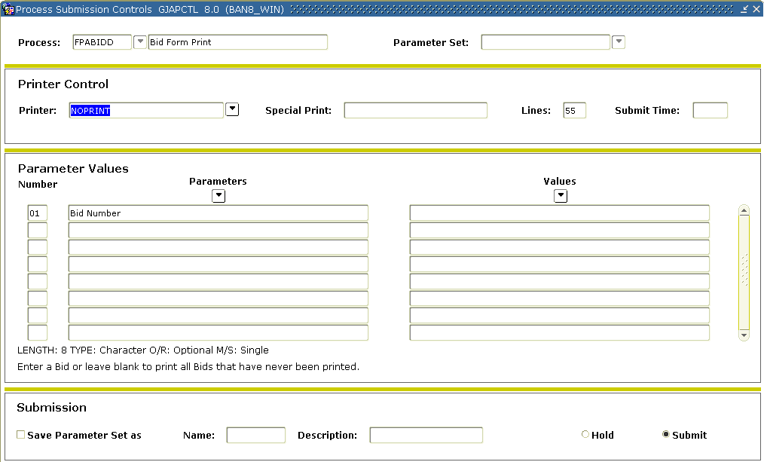

Steps
Follow these steps to complete the process. Run the Print Bid Forms Process (FPABIDD) to generate the Bid Request forms.

- Access the Print Bid Forms Process (FPABIDD).
- Select the printer you want to submit this to in the Printer field.
- Enter the bid you want to print, or leave it blank to print all bids that you haven’t printed before.
- Perform a Next Block function.
- Click the Save icon.
- Click the Exit icon.
- Send the Bid Request forms to the vendors entered as Prospective Bidders.
Note: Once the prospective vendors return their bids, go to the Bid Entry Form (FPABIDE).

Entering Vendor Pricing Data
Introduction
The Bid Entry Form (FPABIDE) enables you to enter vendor pricing data to facilitate vendor bid comparisons.
Banner form
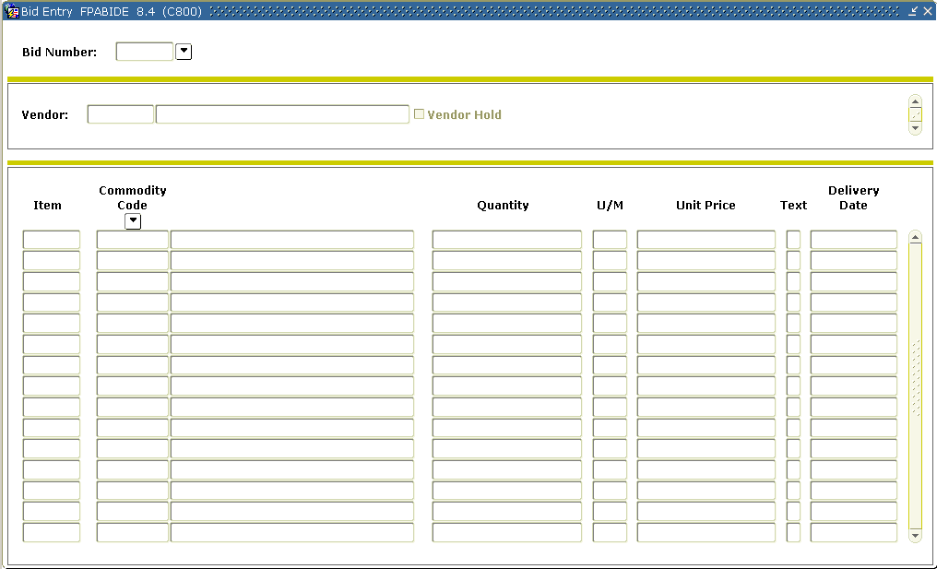

Steps
Follow these steps to complete the process.

- Access the Bid Entry Form (FPABIDE).
- Enter the bid number or use the Search icon to find the bid.
- Perform a Next Block function.
Note: The first vendor assigned to this bid will default in.
- Perform a Next Block function.
- Enter the unit price for each commodity associated with this vendor.
- Perform a Previous Block function.
- Perform a Next Record function.
Result: This brings up the next vendor associated with this bid.
- Repeat steps 4 - 7 until completed for each vendor.
- Click the Save icon.
- Click the Exit icon.

Comparing Vendor Data Online
Introduction
The Bid Comparison Form (FPIBIDC) provides an online display of comparative vendor data.
Banner form
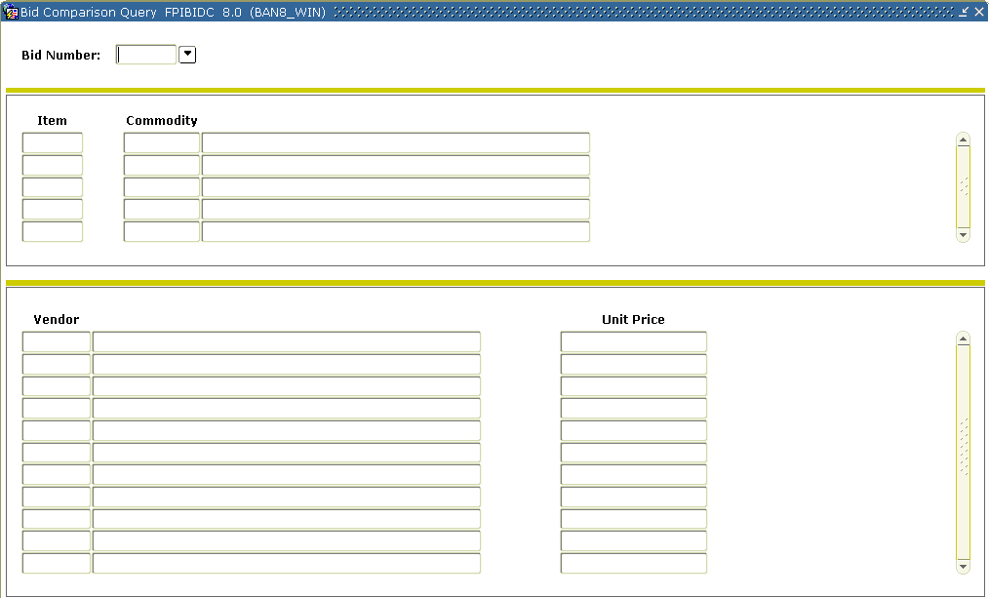
Steps
Follow these steps to complete the process.

- Access the Bid Comparison Form (FPIBIDC).
- Enter the bid number or double-click in the Bid Number field to find the bid.
- Perform a Next Block function.
Note: The first commodity will default in. All the vendor information for that commodity will be shown.
- Perform a Next Record function to select the next commodity.
Note: All the vendor information for that commodity will be shown.
- Repeat step 4 until you have reviewed the information for all commodities.
- Click the Exit icon.

Generating a Printed Report to Compare Vendor Data
Introduction
The Bid Evaluation Report (FPRBEVL) is a hard copy report that provides bid comparisons by vendor. Run this report to complete step 8 in the bid process.
Banner form
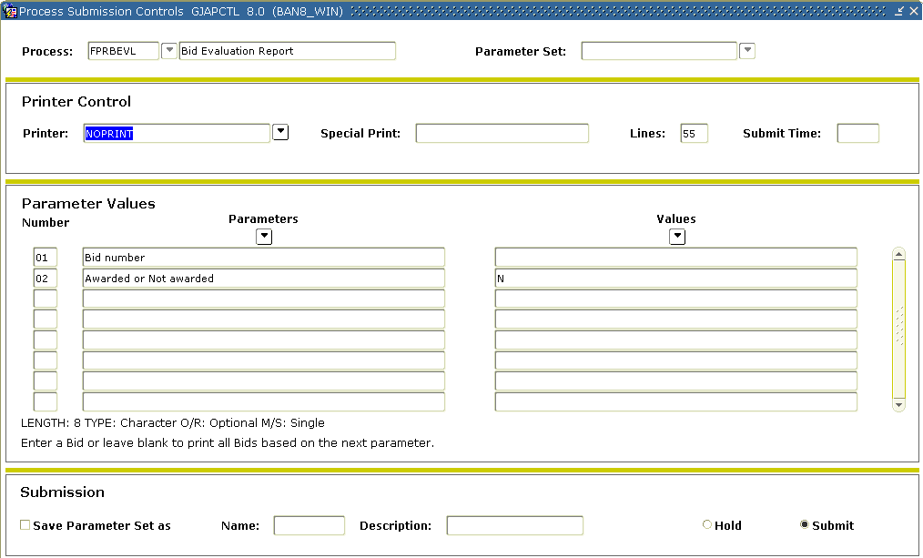

Steps
Follow these steps to complete the process.

- Access the Bid Evaluation Report (FPRBEVL).
- Enter the printer you want to submit this to in the Printer field.
- Enter these parameter values.
Parameter | Value
01: Bid Number | Enter the bid you want to print, or leave it blank to print all bids based on the next parameter.
02: Awarded or Not Awarded | Has the bid been awarded?  If awarded, enter Y.  If not awarded, enter N.
- Click the Save Parameter Set as checkbox.
- Enter a name and description in the Name and Description fields.
- Click the Submit radio button.
- Click the Save icon to execute the report.
- Select Review Output on the Options menu to review the report.
- Click the Exit icon.

Assigning a Chosen Vendor
Introduction
The Bid Award Form (FPABAWD) enables you to assign a chosen vendor to each commodity and to create a purchase order number.
Banner form
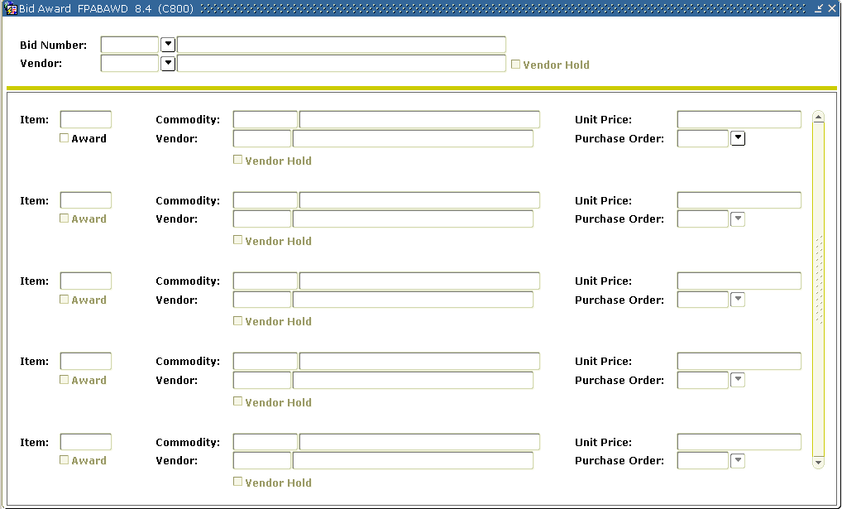
Steps
Follow these steps to complete the process.

- Access the Bid Award Form (FPABAWD).
- Enter in the approved bid in the Bid Number field or click the Search icon to select it.
- Leave the Vendor field blank if you are splitting the requisition/bid award between multiple vendors or enter the vendor number in this field and it will default as the awarded vendor on all the bid items once you block next.
- Perform a Next Block function.
- Click the Award checkbox under the item you want to award to the appropriate vendor..
- Tab to the Purchase Order field.
- Assign a purchase order number or enter Next in the Purchase Order field for each Commodity item.
- Click the Save icon.
- Repeat steps 7 and 8 to assign more commodities to the same PO.
- Click the Exit icon.
Assigning a Requisition to a Purchase Order
Introduction
The Purchase Order Assignment Form (FPAPOAS) is used to assign purchase order numbers to items from a buyer’s request list.
Banner form
Assigning by document or by item
The Assign by: Document and Item radio buttons determine how the records will be displayed, and allow for easier assignment of requisitions to purchase order numbers as required.
Selecting Assign by: Document will list all requests by requisition number order for the selected document.
Selecting the Assign by: Item radio button will assign purchase order numbers by item. The display will automatically reconfigure to show information by item, sorting first by requisition number and then by commodity item. You can then enter Next or assign a purchase order number for each item in the Purchase Order Number field. You can also use the double quote (") feature to combine request items into a purchase order number.
Steps - Procedure 1
Follow these steps to assign a purchase order by document.

- Access the Purchase Order Assignment Form (FPAPOAS).
- Enter a buyer code in the Buyers field or double-click in the field to access the Buyer Code list to select the buyer.
- Perform a Next Block function.
- Verify that the Assign by: Document radio button is selected.
Note: A line item in this view may represent just part of a requisition. Other items in the requisition may already have an assigned purchase order number or may have been assigned to another buyer (or no buyer).
- Tab to the Purchase Order Number field.
- Enter Next in the Purchase Order Number field or enter a number of your choice.
- Is there more than one Request Code that you want to assign to the same purchase order number?
If yes, enter a double quote (") in the Purchase Order Number field of the subsequent Request Code lines that you want assigned to the same purchase order number.
- Click the Save icon.
Result: The request code(s) has been assigned.
- Click the Exit icon.

Steps – Procedure 2
Follow these steps to assign a purchase order by item.

- Access the Purchase Order Assignment Form (FPAPOAS).
- Enter a buyer code in the Buyers field or double-click in the field to access the Buyer Code list to select the buyer.
- Perform a Next Block function.
- Select the Assign by: Item radio button.
Note: Banner will combine multiple requisitions into any incomplete purchase order number if all documents are either Document Level or Commodity Level Accounting. The purchase order will use the vendor choice.
- Tab to the Purchase Order Number field.
- Enter Next in the Purchase Order Number field or enter a number of your choice.
- Is there more than one item that you want to assign to the same purchase order number?
If yes, enter a double quote (") in the Purchase Order Number field of the subsequent Request Code lines that you want assigned to the same purchase order number.
- Click the Save icon.
Result: All commodity items will have the same purchase order number displayed.
- Click the Exit icon.

Creating a Purchase Order from a Requisition
Introduction
The Purchase Order Form (FPAPURR) is used to produce an external request for the purchase of goods or services from a vendor.
Banner form

When you access the Purchase Order Form (FPAPURR), you are prompted to enter a Purchase Order number. You can enter a purchase order or you can perform a Next Block function to access the rest of the form. Similar to the Requisition Form (FPAREQN), the Purchase Order Form (FPAPURR) contains the some of the same tabs.
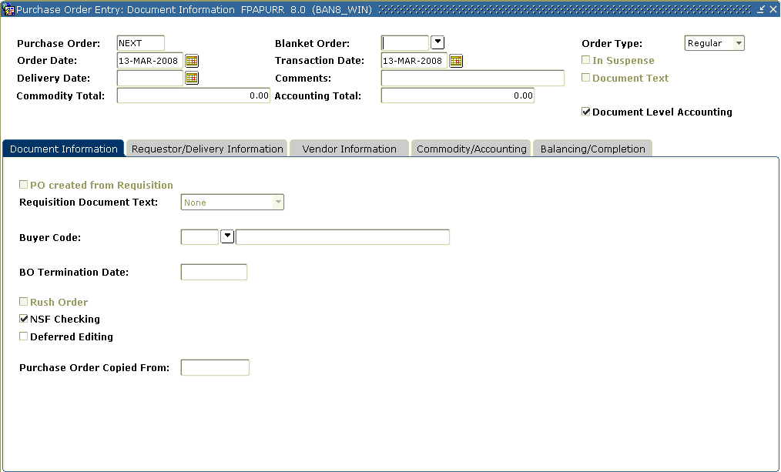

Steps
Follow these steps to create a purchase order from one of the requisitions created in the beginning of this section.

- Access the Purchase Order Form (FPAPURR).
- Enter one of the purchase order numbers you created when you assigned a requisition to a PO in the FPAABUY form in the Purchase Order field. If it is not known, click on the search icon to find the purchase order.
- Perform a Next Block function.
Note: All of the header information is automatically populated if you created the purchase order from a requisition, however it can be overridden
- Confirm that the Order Date, Transaction Date, Delivery Date, and Buyer Code are correct; change if necessary.
Note: the PO Created from Requisition field will be checked.
- Verify the Requisition Document Text pull-down list has the appropriate option selected.
- Check the Deferred Editing and NSF Checking fields if appropriate.
- Select the Requestor/Delivery Information tab.
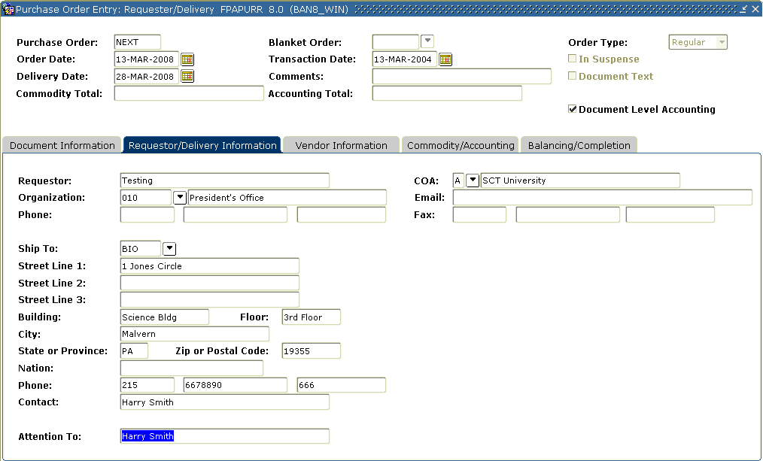
- Confirm the Requestor and Ship to information are correct; change if necessary.

- Select the Vendor Information tab.
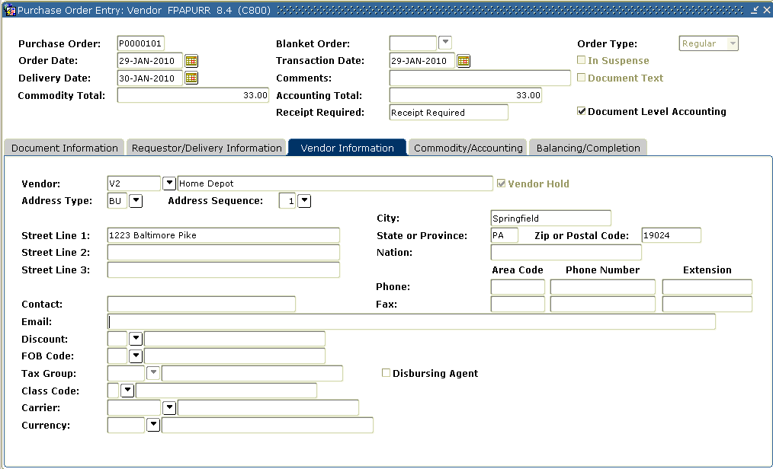
- Confirm that the vendor information is correct, or assign the vendor if the requisition did not.
- Select Document Text from the Options menu.
- Enter in a Modify Clause or click the Search icon to select one.
Note: The modify clause is only entered when you want to temporarily add text to the clause. You still must enter the clause number on its own line. Clauses can be created in FOACLAU.
- Perform a Next Block function.
- Click the Save icon.
- Click the Exit icon.

- Select the Commodity/Accounting tab.
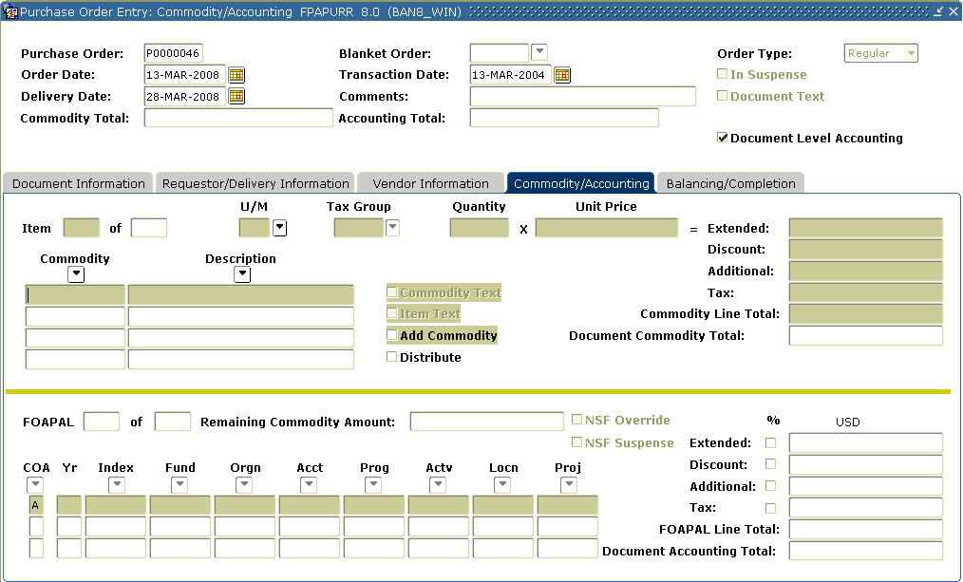
- Confirm that the commodities requested are correct; change if necessary.
- Perform a Next Block function.
- Confirm that the accounting distributions assigned are correct; change if necessary.
- Select the Balancing/Completion tab.
- Verify that the Heading, Commodity, and Accounting approved amounts match.
- Click the Complete button.

Creating a Purchase, Using Document Level
Introduction
You can use the Purchase Order Form (FPAPURR) to create a purchase.
Important fields
Information entered in the Comments field will be passed from the purchase order through the change order, and can be used for internal notes without having to access document text.
You can defer editing from the completion of the document to an independent running of the Interface Process (FGRTRNI) by checking the Deferred Editing field. If the enterprise did not indicate NSF Checking on the System Control Maintenance Form (FOASYSC), you can activate NSF Checking for the document by checking the NSF Checking field.
Banner form
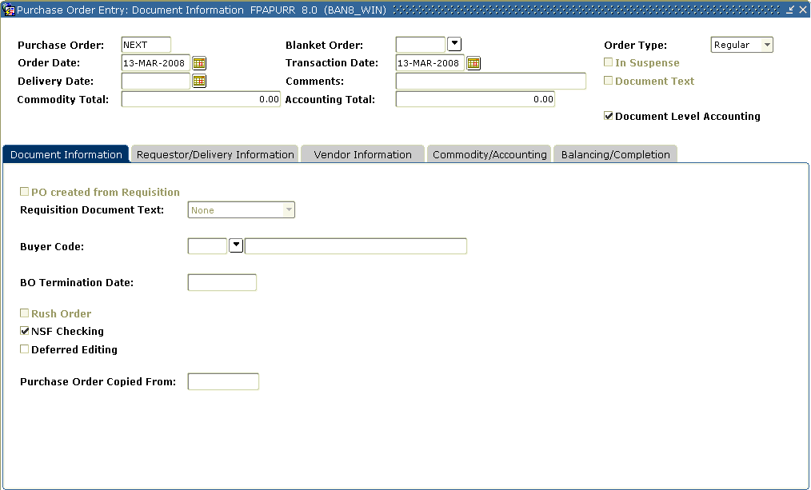

Steps – Procedure 1
Follow these steps to create a regular purchase order with a system generated number that uses document level accounting.

- Access the Purchase Order Form (FPAPURR).
- Enter NEXT in the Purchase Order field to create a system generated number. Leave the blanket order field blank and the type field will default to Regular. This will create a regular purchase order.
- Perform a Next Block function.
- Change the Order Date if today’s date is not appropriate.
- Change the Transaction Date if today’s date is not appropriate
- Enter a delivery date in the Delivery Date field.
Note: The delivery date must be the same as or later than the order date.
- Tab to the Buyers Code field
- Enter in a Buyer Code or click on the search icon to find one.
- Check the Deferred Editing and NSF Checking fields if appropriate.
- Select the Requestor/Delivery Information tab.
Note: If set up, FOMPROF will default the Requestor and Ship to information.
- Enter the requestor in the Requestor field; if appropriate.
- Select a chart of account in the COA field, if appropriate
- Select an organization in the Organization field, if appropriate.
Note: The user must have posting capabilities to the organization selected.
- Select a shipping address in the Ship To field.
Note: When you select a shipping address the Address, Phone, Contact, and Attention fields will be filled in if the information was built on the Ship to Address Maintenance Form (FTMSHIP).
- Select the Vendor Information tab.
- Select a vendor in the Vendor field.
Note: Once a vendor is selected, the remaining fields will be filled in for you, if the Procurement address exists for the vendor. If you need to create a vendor or add address information for the vendor, use the Vendor Maintenance Form (FTMVEND).
- Enter a discount code in the Discount field. View and select from the available records in the Discount Terms List (FTVDISC).
- Enter an FOB code in the FOB Code field. View and select from the available records in the FOB Code List (FTVFOBS).
- Enter a tax group if tax processing is on in the Tax Group field. View and choose from the available records on the Tax Group Table (FTVTGRP).
Note: Tax groups entered in the purchase order override the settings on the System Control Form (FOASYSC) and the Vendor Maintenance Form (FTMVEND).
- Enter a Purchase Order Classification code in the Class Code field. View and choose from the available records on the Purchase Order Classification List (FTVPCLS).
- Enter a Purchase Order Shipping Carrier code in the Carrier field. View and choose from the available records in the Carrier List (FTVCARR).
- Tab to the Currency field. Select a currency code if the order is in a foreign currency.
Note: If your institution does not maintain accounts in foreign currency, and has specified on the Currency Maintenance Form (GUACURR) that a disbursing agent exchanges the funds and makes the actual foreign currency payment, Banner checks the Disbursing Agent box.
- Select Document Text from the Options menu.
- Enter in a Modify Clause or click the Search icon to select one.
- Perform a Next Block function.
- Enter This is a training purchase order.
- Click the Save icon.
- Click the Exit icon.
- Select the Commodity/Accounting tab.
- Do you want to enter a commodity using a commodity code?
- If yes, go to Procedure 2.
- If no, go to Procedure 3.
Steps – Procedure 2
Follow these steps to enter a commodity using a commodity code.
Note: The Commodity Maintenance Form (FTMCOMM) will default in values for unit of measure and unit price if defined for that commodity.

- Select a commodity in the Commodity field.
- Click the Search icon in the U/M field and enter in a unit of measure. Select EA.
- Tab to the Quantity field and enter 10 for the quantity to be requested.
- Tab to the Unit Price field and enter $50 for the unit price of this commodity.
- Tab to the Discount field.
Result: Notice the extended price has been filled in by Banner.
Note: The Discount field is automatically calculated based on the Discount code previously entered. If you have not specified a Discount code, you may enter a discount amount into this field.
- Tab to the Additional field. Enter $15 for the freight charges.
Note: The Tax field is automatically populated based on the tax group you’ve identified on this commodity record.
- Tab to the Commodity field.
- Perform a Next Record function and repeat steps 1 - 7 if additional commodities are to be added to this requisition.
- When finished, perform a Next Block function.
- Enter your chart of accounts code in the COA field.
Note: Fiscal year will default in based on the transaction date.
- Click the Search icon for Fund and select 1110.
- Click the Search icon for Orgn and select 11102.
- Click the Search icon for Acct and select 7210.
- Click the Search icon for Prog and select 10.
- Enter the amount to be charged to this accounting distribution in the USD extended field.
Note: the discount and additional amounts are populated automatically
- If additional accounts were to be charged after entering the amount charged, tab to the COA field, perform a Next Record function, and repeat steps 10 -15.
- Select the Balancing/Completion tab.
- Review the Header, Commodity, and Accounting amounts.
- If these amounts are in balance, click the Complete button.
Steps – Procedure 3
Follow these steps to enter a commodity not using a commodity code.
- Tab to the Description field and enter the user-defined item.
For this exercise, enter three-foot high bookcase with glass doors.
- Tab to the U/M field, click the Search icon, and enter in a unit of measure. Select EA.
- Tab to the Quantity field and enter 10 for the quantity to be requested.
- Tab to the Unit Price field and enter $50 for the unit price of this commodity.
- Tab to the Discount field.
Result: Notice the extended price has been filled in by Banner.
Note: The Discount field is automatically calculated based on the Discount code previously entered. If you have not specified a Discount code, you may enter a discount amount into this field.
- Tab to the Additional field. Enter $15 for the freight charges of this item.
- The Tax field is automatically populated based on the tax group you’ve identified on this commodity record.
- Tab to the Commodity field.
- Perform a Next Record function and repeat steps 1 - 8 if additional commodities are to be added to this requisition.
- When finished, perform a Next Block function.
- Click the Search icon for Chart of Accounts and select your chart.
Note: Fiscal year will default in based on the transaction date.
- Click the Search icon for Fund and select 1110.
- Click the Search icon for Orgn and select 11102.
- Click the Search icon for Acct and select 7210.
- Click the Search icon for Prog and select 10.
- Enter the amount to be charged to this account in the USD extended field.

Note: the discount and additional amounts are populated automatically.
- If additional accounts were to be charged after entering the amount charged, tab to the COA field, perform a Next Record function, and repeat steps 11 - 16.
- When finished, select the Balancing/Completion tab.
- Review the Header, Commodity, and Accounting amounts.
- If these amounts are in balance, click the Complete button.

Creating a Purchase, Using Commodity Level
Introduction
You can also use the Purchase Order Form (FPAPURR) to create a regular purchase order with a system generated number that uses commodity level accounting.
Banner form
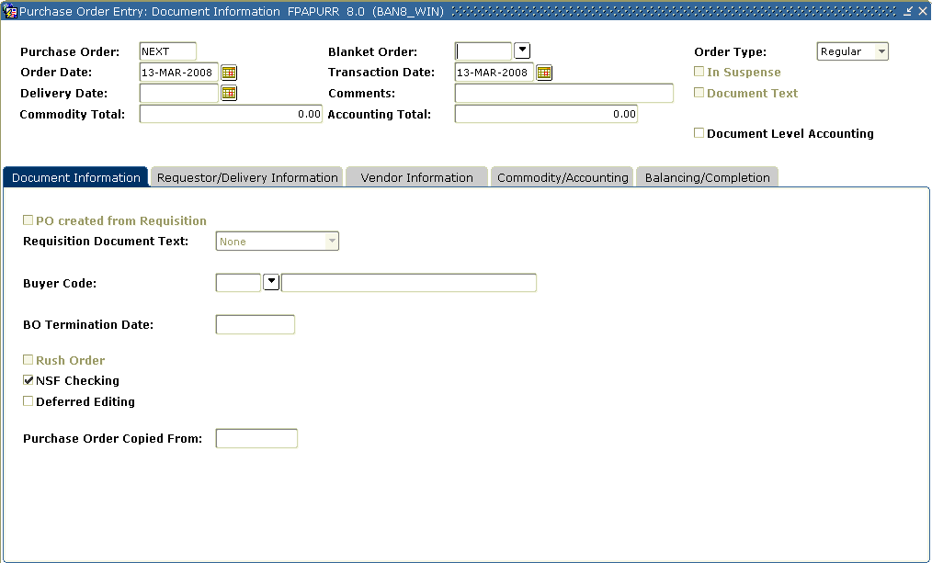
Steps
Follow these steps to create a regular purchase order with a system generated number that uses commodity level accounting.

- Access the Purchase Order Form (FPAPURR).
- Enter NEXT in the Purchase Order field to create a system generated number.
- Perform a Next Block function.
- Change the order date if today’s date is not appropriate.
- Change the transaction date if today’s date is not appropriate
- Enter a delivery date in the Delivery Date field.
Note: Delivery date must be the same as or later than the order date.
- Tab to the Buyers Code field.
- Enter in a buyer code or click on the Search icon to find one.
- Check the Deferred Editing and NSF Checking fields if appropriate.
- Select the Requestor/Delivery Information tab.
Note: If set up, FOMPROF will default in the values for the Requestor and Ship to information.
- Enter the requestor in the Requestor field; if appropriate.
- Select a chart of account in the COA field, if appropriate.
- Select an organization in the Organization field, if appropriate.
Note: The user must have posting capabilities to the organization selected.
- Select a shipping address in the Ship To field, if appropriate.
Note: When you select a shipping address the Address, Phone, Contact, and Attention fields will be filled in if the information was built on the Ship to Address Maintenance Form (FTMSHIP).
- Select the Vendor Information tab.
- Select a vendor in the Vendor field.
Note: Once a vendor is selected, the remaining fields will be filled in for you, if the Procurement address exists for the vendor. If you need to create a vendor or add address information, use FTMVEND.
- Enter a discount code in the Discount field or click the Search icon to select one.
- Select an FOB code in the FOB Code field.
- Enter a tax group in the Tax Group field if tax processing is on.
Note: Tax groups entered in the purchase order override the settings on the System Control Form (FOASYSC) and the Vendor Maintenance Form (FTMVEND).
- Select a Purchase Order classification code in the Class Code field.
- Enter a Purchase Order shipping carrier code in the Carrier field.
- If the order is in a foreign currency, enter the currency code in the Currency field or click the Search icon to select one.
Note: If your institution does not maintain accounts in foreign currency, and has specified on the Currency Maintenance Form (GUACURR) that a disbursing agent exchanges the funds and makes the actual foreign currency payment, Banner checks the Disbursing Agent box.
- Select Document Text from the Options menu.
- Enter in a Modify Clause or click the Search icon to select one.
- Perform a Next Block function.
- Enter This is a training purchase order.
- Click the Save icon.
- Click the Exit icon.
- Select the Commodity/Accounting tab.
- Uncheck the checkmark in the Document Level Accounting checkbox to make this purchase order commodity level accounting.
- Select a commodity in the Commodity field.
Note: In this exercise, the commodity codes will be used, however user defined commodities can be used with commodity level accounting.
- Select EA in the U/M field to enter a unit of measure.
Note: The unit of measure will default in for this commodity if it was set up on FTMCOMM.
- Tab to the Quantity field and enter in 10 for the quantity of items to be requested.
- Tab to the Unit Price field and enter in $50 for the unit price of this commodity
- Tab to the Discount field.
Result: Notice the extended price has been filled in by Banner.
Note: The Discount field is automatically calculated based on the discount code previously entered. If you have not specified a discount code, you may enter a discount amount into this field.
- Tab to the Additional field. Enter $15 for the freight charges of this item.
Note: The Tax field is automatically populated based on the tax group you’ve identified on this commodity record.
- Tab to the Commodity field.
- Perform a Next Block function.
Note: Remember, in commodity level accounting, each commodity has its own accounting distribution attached to it.
- Enter your chart of account code in the COA field.
Note: Fiscal year will default in based on the transaction date
- Click the Search icon for Fund and select 1110.
- Click the Search icon for Orgn and select 11102.
- Click the Search icon for Acct and select 7210.
- Click the Search icon for Prog and select 10.
- In the USD extended field, enter the amount to be charged to this account.

Note: the discount and additional amounts are populated automatically.
- Perform a Previous Block function.
- Perform a Next Record function.
- Repeat steps 31 – 46 to enter additional commodities.
- When finished, select the Balancing/Completion tab.
- Review the Header, Commodity, and Accounting amounts to make sure they are in balance.
- If these amounts are in balance, click the Complete button
Creating a Standing Order Using Document Level
Introduction
You can use the Purchase Order Form (FPAPURR) to create a standing purchase order with a system generated number that uses document level accounting. Standing orders can also use commodity level accounting the same way regular purchase orders do.
Banner form
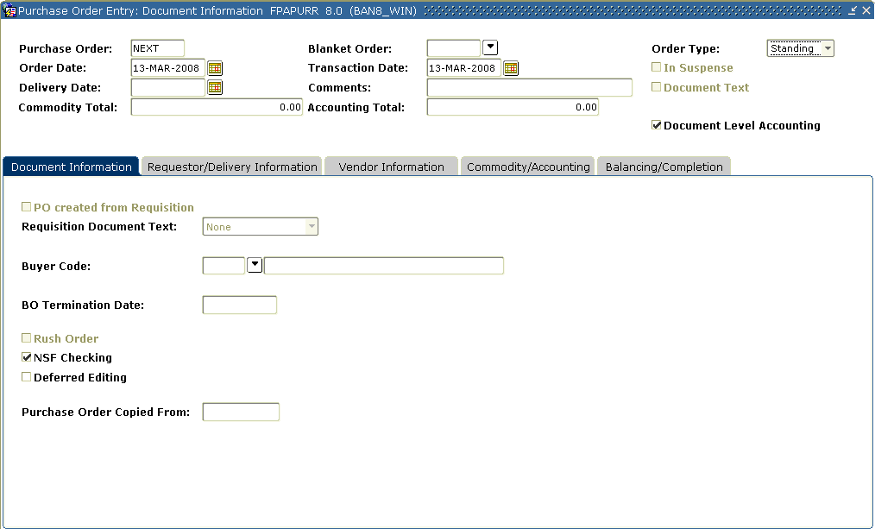
Steps
Follow these steps to create a standing purchase order with a system generated number that uses document level accounting.

- Access the Purchase Order Form (FPAPURR).
- Enter NEXT in the Purchase Order field to create a system generated number.
- Perform a Next Block function.
- Tab to the Type field.
- Select Standing from the drop down list.
- Change the order date if today’s date is not appropriate.
- Change the transaction date if today’s date is not appropriate.
- Enter a delivery date in the Delivery Date field.
Note: The delivery date must be the same as or later than the order date.
- Tab to the Buyers Code field.
- Enter in a buyer code or click on the Search icon to find one.
- Check the Deferred Editing and NSF Checking fields if appropriate.
- Select the Requestor/Delivery Information tab.
Note: If set up, FOMPROF will default in the values for Requestor and Ship to information.
- Enter the requestor in the Requestor field, if appropriate.
- Select a chart of account in the COA field, if appropriate.
- Select an organization in the Organization field, if appropriate.
- Enter a shipping address in the Ship To field, if appropriate.
Note: When you select a shipping address the Address, Phone, Contact, and Attention fields will be filled in if the information was built on the Ship to Address Maintenance Form (FTMSHIP).
- Select the Vendor Information tab.
- Select a vendor in the Vendor field.
Note: Once a vendor is selected, the remaining fields will be filled in for you, if the Procurement address exists for the vendor. If you need to create a vendor or add address information for the vendor, use the Vendor Maintenance Form (FTMVEND).
- Enter a discount code in the Discount field.
- Enter an FOB code in the FOB Code field.
- Enter a tax group in the Tax Group field, if tax processing is on.
Note: Tax groups entered in the purchase order override the settings on the System Control Form (FOASYSC) and the Vendor Maintenance Form (FTMVEND).
- Select a Purchase Order Classification code in the Class Code field.
- Enter a Purchase Order Shipping Carrier code in the Carrier field.
- If the order is in a foreign currency, enter the currency code in the Currency field or click the Search icon to select one.
Note: If your institution does not maintain accounts in foreign currency, and has specified on the Currency Maintenance Form (GUACURR) that a disbursing agent exchanges the funds and makes the actual foreign currency payment, Banner checks the Disbursing Agent box.
- Select Document Text from the Options menu.
- Enter in a Modify Clause or click the Search icon to select one.
- Perform a Next Block function.
- Enter This is training purchase order.
- Click the Save icon.
- Click the Exit icon.
- Select the Commodity/Accounting tab.
Note: Although some fields are different, how one navigates this form is the same as in creating a regular purchase order.
- Select a commodity in the Commodity field.
- Select EA in the U/M field to enter in a unit of measure.
- Tab to the Amount field and enter 10 for the amount to be requested.
- Tab to the Discount field.
Result: Notice the extended price has been filled in by Banner.
Note: The Discount field is automatically calculated based on the discount code previously entered. If you have not specified a discount code, you may enter a discount amount into this field.
- Tab to the Additional field. Enter $15 for the freight charges of this item.
Note: The Tax field is automatically populated based on the tax group you’ve identified on this commodity record.
- Tab to the Commodity field.
- Perform a Next Record function and repeat steps 32 – 37 if additional commodities are to be added to this requisition.
- When finished, perform a Next Block function.
- Select your chart of account in the COA field.
Note: Fiscal year will default in based on the transaction date.
- Click the Search icon for Fund and select fund 1110.
- Click the Search icon for Orgn and select 11102.
- Click the Search Icon for Acct and then select 7210.
- Click the Search Icon for Prog and then select 10.
- Enter the amount to be charged to this accounting distribution in the USD extended field.

Note: the discount and additional amounts are populated automatically.
- If additional accounting distributions were to be charged after entering the amount charged, tab to the COA field, perform a Next Record function, and repeat steps 40 -45.
- When finished, select the Balancing/Completion tab.
- Review the Header, Commodity, and Accounting amounts.
- If these amounts are in balance, click the Complete button

Copying Information to a New Purchase Order
Introduction
You can use the copy feature on the Purchase Order Form (FPAPURR) to copy the information form one PO to a new purchase order.
Note: The PO number that is being copied is identified in the Purchase Order Copied From field.
Banner form
Steps
Follow these steps to complete the process.

- Access the Purchase Order Form (FPAPURR).
- Enter NEXT in the Purchase Order field to create a system generated number.
- Click the Copy icon.
- Enter in the purchase order number to copy from or click the Search icon to find one.
- Verify the vendor information.
- Click the OK button
Note: If you change your mind and do not wish to use the Copy Purchase Order window, click Cancel.
Result: The requestor, vendor, commodity, and accounting information are carried forward to the new document. All suspense flags are set to Y. You must navigate through the new purchase order to remove the document from suspense and complete it.
Warning: The copy functionality will not check or update available balance until you navigate through the form.
- Change the order date if today’s date is not appropriate.
- Change the transaction date if today’s date is not appropriate
- Enter a delivery date in the Delivery Date field.
Note: The delivery date must be the same as or later than the order date.
- Tab to the Buyers Code field.
- Enter in a buyer code or click the Search icon to find one.
- Check the Deferred Editing and NSF Checking fields if appropriate.
- Select the Requestor/Delivery Information tab.
Note: If your FOMPROF is set up the Requestor and Ship to information will default in.
- Enter the requestor in the Requestor field; if appropriate.
- Enter a chart of account in the COA field.
- Enter an organization in the Organization field.
- Select a shipping address in the Ship To field, if appropriate.
Note: When you select a shipping address the Address, Phone, Contact, and Attention fields will be filled in if the information was built on the Ship to Address Maintenance Form (FTMSHIP).
- Select the Vendor Information tab.
- Confirm this is the correct vendor and vendor address to be used.
- If the information is not correct, to update the vendor, click the Search icon in the Vendor field, and enter a vendor.
Note: Once a vendor is selected, the remaining fields will be filled in for you, if the Procurement address exists for the vendor. If you need to create a vendor or add address information for the vendor, use the Vendor Maintenance Form (FTMVEND).
- Change a discount code in the Discount field or click the Search icon to select one, if appropriate.
- Change the FOB in the FOB Code field or click the Search icon to select one, if appropriate.
- Change the tax group in the Tax Group field by entering a code or clicking the Search icon to select one, if appropriate.
Note: Tax groups entered in the purchase order override the settings on the System Control Form (FOASYSC) and the Vendor Maintenance Form (FTMVEND).
- Change the class code in the Class Code field by entering the code or clicking the Search icon to select one, if appropriate.
- Change the carrier in the in the Carrier field by entering the code or by clicking the Search icon to select one, if appropriate.
- If the order is in a foreign currency, enter the currency code in the Currency field or click the Search icon to select one.
Note: If your institution does not maintain accounts in foreign currency, and has specified on the Currency Maintenance Form (GUACURR) that a disbursing agent exchanges the funds and makes the actual foreign currency payment, Banner checks the Disbursing Agent box.
- Select Document Text from the Options menu.
- Enter in a Modify Clause or click the Search icon to select one.
- Perform a Next Block function.
- Enter This is a training purchase order.
- Click the Save icon.
- Click the Exit icon.
- Select the Commodity/Accounting tab.
- Review the commodity and accounting information and make changes if necessary.
- Click the Save icon.
- Click the Exit icon.

Creating a Blanket Order
Introduction
The Blanket Order Form (FPABLAR) is used to track quantities and dollar amounts expended for a contract with a specific vendor. It is not used to encumber monies from which to draw down; use the standing purchase order (FPAPURR) if you want to encumber funds.
Banner form

Once you have entered a vendor, perform a Next Block function to access the rest of the form.
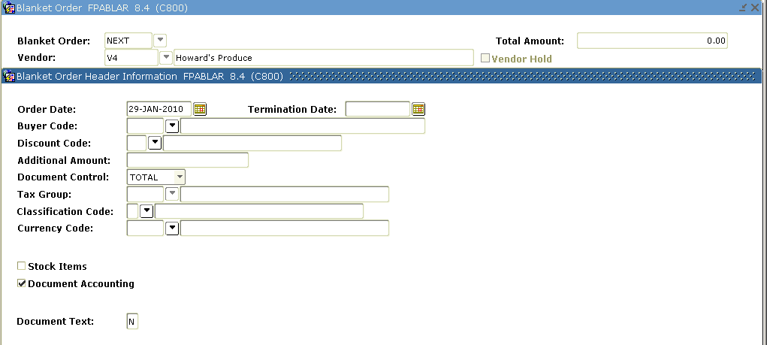

Steps
Follow these steps to complete the process.

- Access the Blanket Order Form (FPABLAR).
- Enter Next in the Blanket Order field, or enter a number of your own.
- Tab to the Vendor field and select the vendor code.
- Perform a Next Block function.
- Change the date in the Order Date field, if appropriate.
- Enter the date the blanket order will be terminated in the Termination Date field.
- Enter the buyer code in the Buyer Code field.
- Enter the discount code in the Discount Code field.
- Enter any freight charges in the Additional Amount field.
- Select the appropriate option from the Document Control field pull-down list.
Note: This field indicates whether the system tracks and controls the blanket order at the entire document level (Document Control at TOTAL) or the commodity level (Document Control at ITEM). Total document tracking is less restrictive because any one commodity can consume all of the remaining balance for the entire blanket order. Commodity level tracking applies a dollar limit to each item as specified on the blanket order. Once you complete the blanket order, you cannot change the control method.
- Enter a code in the Class Code field or click the Search icon from the Purchase Order Classification List (FTMPCLS).
- Enter a code in the Currency Code field or click the Search icon from the Currency Code Maintenance Form (GUACURR), if applicable.
- Check the Stock Items box if you want the items covered by the blanket order to be stock items using the Banner Finance Stores Inventory module.
- Select Document Text from the Options menu.
- Enter in a Modify Clause or click the Search icon to select one.
- Perform a Next Block function.
- Enter This is a training Blanket Order.
- Click the Save icon.
- Click the Exit icon.
- Select Shipping Information from the Options menu.
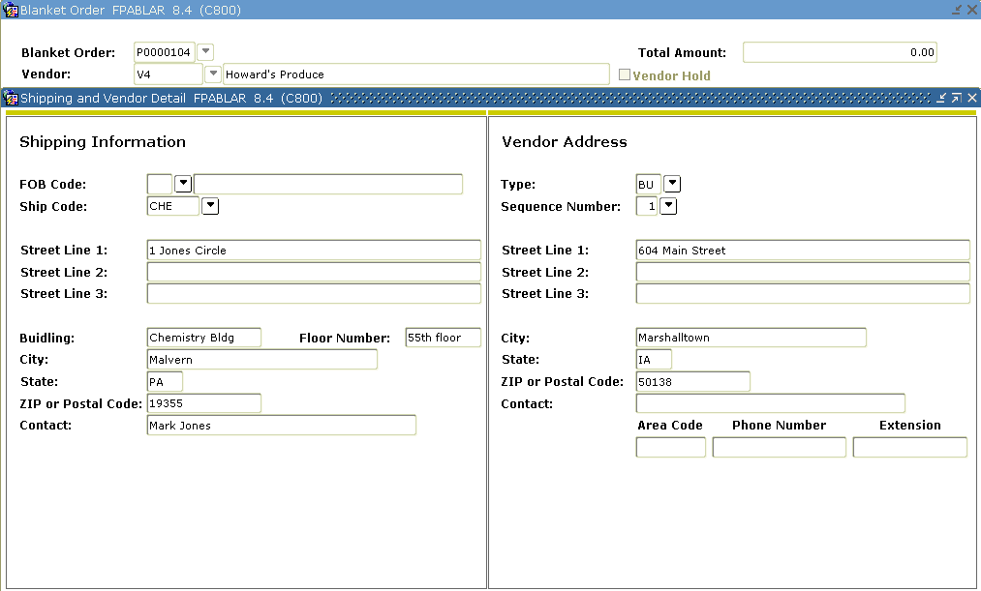
- Select a code in the FOB Code field.
- Select a ship to address in the Ship Code field.
- Perform a Next Field function.

- Verify the defaulted vendor address or select a different one.
- Perform a Next Block function.
Result:
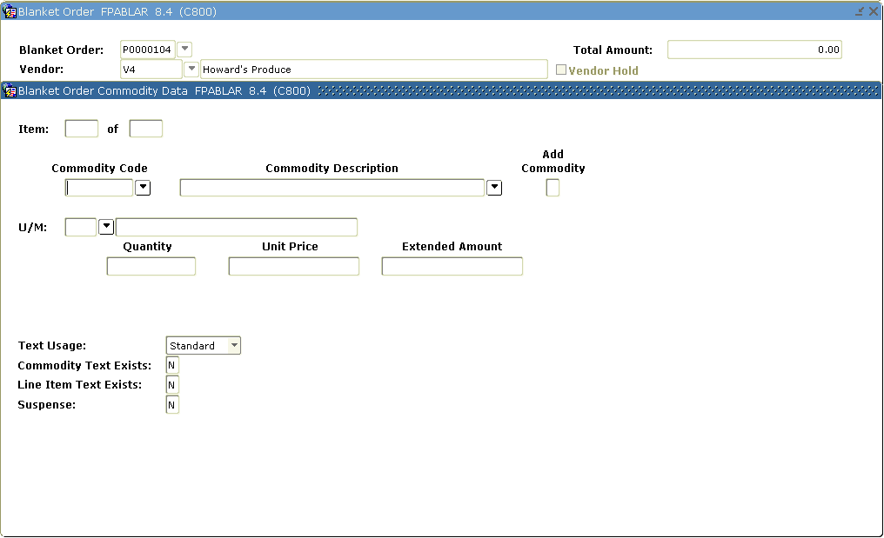
- Enter the commodity code in the Commodity field, or enter the commodity’s description in the Commodity Description field.
- Select the unit of measure for this blanket order.
- Note: If an agreement exists for the vendor specified on this blanket order, the information becomes available. Select Commodity Agreement Information from the Options menu to view the details of the vendor agreement.
- Tab to the Quantity field and enter the desired quantity.
- Tab to the Unit Price field and enter in the unit price, if necessary.
- If the Commodity Text indicator is Y (Yes), select View Commodity Text from the Options menu to view the text.
- Select Line Item Text from the Options menu to create customized text for this blanket order commodity.
- Perform a Next Block function.
- Enter in the text commodity Text One.
- Click the Save icon.
- Click the Exit icon.
- If the blanket order is in a foreign currency, select Currency Information from the Options menu to view conversion information.
- Perform a Next Block function.
- Click Complete.

Creating a Regular Order from a Blanket Purchase
Introduction
When it is time to place an order against a Blanket Purchase Order you create a Regular Purchase Order inPurchase Order Form (FPAPURR) and references the Blanket purchase order number. The Regular Purchase Order may use document level accounting or commodity level accounting Purchase orders referencing a Blanket PO cannot be standing purchase orders. Note: When using a Blanket Order the BO Termination Date field shows the termination date of the blanket order you have referenced.
Banner form
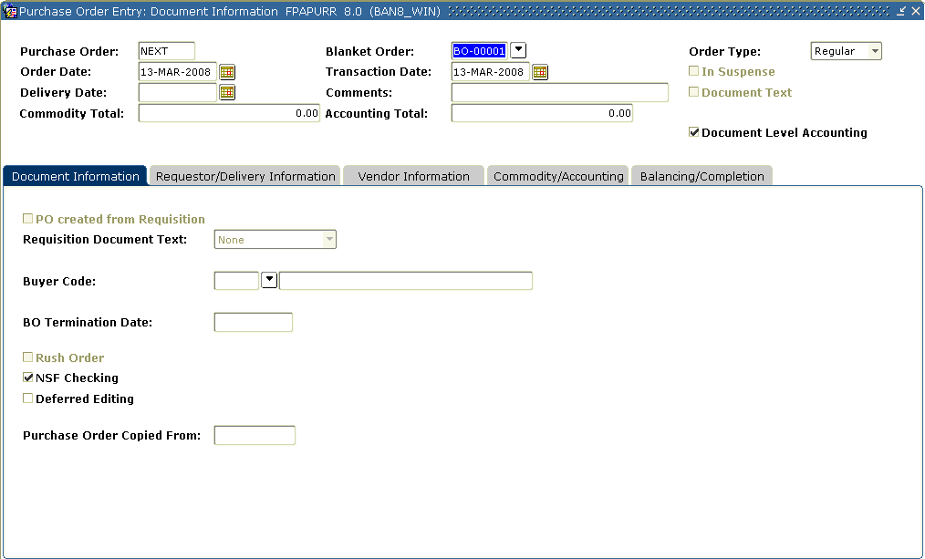
Steps
Follow these steps to complete the process.

- Access the Purchase Order Form (FPAPURR).
- Enter NEXT in the Purchase Order field to create a system generated number.
- Perform a Next Block function.
- Tab to the Blanket Order field
- Enter in the blanket order or click the Search icon to select one.
- Change the order date if today’s date is not appropriate.
- Change the transaction date if today’s date is not appropriate
- Enter a delivery date in the Delivery Date field.
- Tab to the Buyers Code field
- Enter in a buyer code or click on the Search icon to find one.
- Check the Deferred Editing and NSF Checking fields if appropriate.
- Select the Requestor/Delivery Information tab.
Note: If FOMPROF is setup, the Requestor and Ship to information will default in.
- Enter the requestor in the Requestor field.
- Enter a chart of account in the COA field.
- Select an organization in the Organization field.
- Click the Search icon, and enter a shipping address in the Ship To field, if appropriate.
Note: When you select a shipping address the Address, Phone, Contact, and Attention fields will be filled in if the information was built on the Ship to Address Maintenance Form (FTMSHIP).
- Select the Vendor Information tab.
- Select a vendor in the Vendor field.
Note: Once a vendor is selected, the remaining fields will be filled in for you, if the Procurement address exists for the vendor. If you need to create a vendor or add address information for the vendor, use the Vendor Maintenance Form (FTMVEND).
- Enter a discount code in the Discount field.
- Enter an FOB code in the FOB Code field.
- Enter a tax group in the Tax Group field, if tax processing is on.
Note: Tax groups entered in the purchase order override the settings on the System Control Form (FOASYSC) and the Vendor Maintenance Form (FTMVEND).
- Enter a Purchase Order classification code in the Class Code field.
- Select a Purchase Order shipping carrier code in the Carrier.
- If the order is in a foreign currency, enter the currency code in the Currency field or click the Search icon to select one.
Note: If your institution does not maintain accounts in foreign currency, and has specified on the Currency Maintenance Form (GUACURR) that a disbursing agent exchanges the funds and makes the actual foreign currency payment, Banner checks the Disbursing Agent box.
- Select Document Text from the Options menu.
- Enter in a Modify Clause or click the Search icon to select one.
- Perform a Next Block function.
- Enter This is a training purchase order.
- Click the Save icon.
- Click the Exit icon.
- Select the Commodity/Accounting tab.
Note: The Purchase Order Selection form appears with the commodities from the Blanket Order defaulted in.
- Check mark each commodity using the ADD checkbox to select the commodities to be used in this purchase order.
- Click the Save icon.

- Click the Exit icon.
Result: The Commodity/Accounting window shows, with the commodities selected from the Purchase Order Selection window displayed.
- Review the first commodity; make changes, if necessary, in the Commodity and Description fields.
- Review the unit of measure. If changes are necessary, click the Search icon in the U/M field and enter a unit of measure.
- Tab to the Quantity field and enter in the quantity desired.
- Tab to the Unit Price field and review the unit price; change if appropriate.
- Tab to the Discount field.
Result: The extended price has been filled in by Banner.
Note: The Discount field is automatically calculated based on the discount code previously entered. If you have not specified a discount code, you may enter a discount amount into this field.
- Tab to the Additional field. Enter $15 for the freight charges of this item.
Note: The Tax field is automatically populated based on the tax group you’ve identified on this commodity record.
- Tab to the Commodity field.
- If additional commodities defaulted in, perform a Next Record function and repeat steps 35-41.
- When finished, perform a Next Block function.
- Select your chart of accounts in the COA field.
Note: Fiscal year will default in based on the transaction date.
- Click the Search icon for Fund and select 1110.
- Click the Search icon for Orgn and select 11102.
- Click the Search icon for Acct and select 7210.
- Click the Search icon for Prog and select 10.
- Enter the amount to be charged to this accounting distribution in the USD extended field.

Note: the discount and additional amounts are populated automatically.
- If additional accounting distributions were to be charged after entering the amount charged, tab to the COA field, perform a Next Record function, and repeat steps 44-49.
- When finished, select the Balancing/Completion tab.
- Review the Header, Commodity, and Accounting amounts.
- If these amounts are in balance, click the Complete button.

Monitoring Blanket Order Activity
Introduction
The Blanket Order Activity Form (FPIBLAR) is used to monitor various activities against a blanket order. This includes purchase orders, change orders, invoices, and credit memos.
Banner form
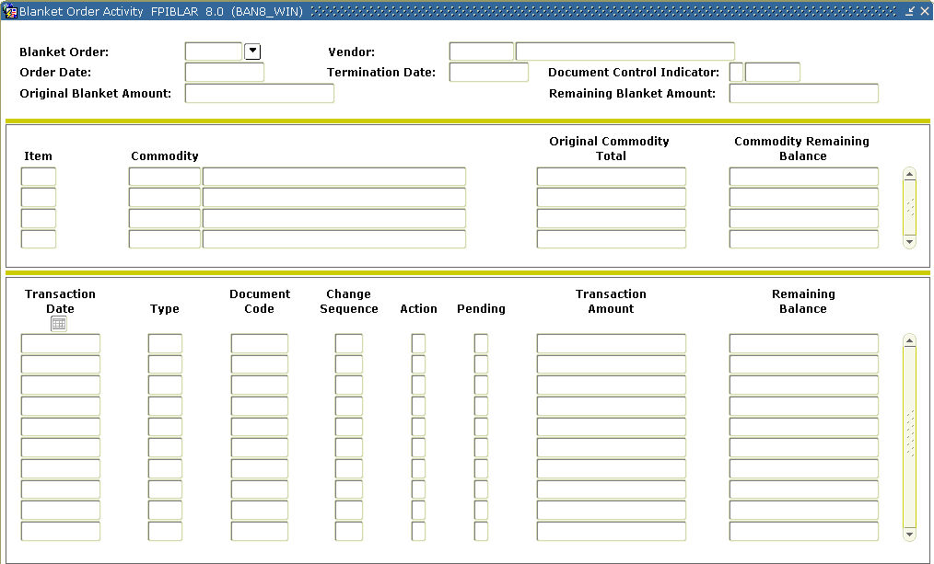

Steps
Follow these steps to complete the process.

- Access the Blanket Order Activity Form (FPIBLAR).
- Enter a blanket order code in the Blanket Order field or view the available records on the Blanket Order Validation Form (FPIBORD).
- Perform a Next Block function.
Note: The commodity’s item number, code, and/or description, original commodity amount, and commodity remaining balance values are automatically populated into the appropriate fields
- Scroll through the commodity records for this blanket order using the scroll bar to the right.
Note: The detail block shows the documents that you issued against the blanket order for this specific commodity. You can scroll through the documents using the bottom scroll bar. You can also query the Transaction Date, Type, Document Code, or Change Sequence to specify which transactions to view.
The Action field reflects the direction in which the transaction affects the Remaining Balance field (+ for increases; - for decreases).
The Pending field indicates Y (Yes) when the document is awaiting posting.
- Click the Exit icon.

Canceling a Purchase/Blanket Order
Introduction
The Purchase/Blanket Order Cancel Form (FPAPDEL) is used to permanently cancel purchase orders and blanket orders that have been previously completed, approved, and posted within the Banner system.
The original purchase orders will be reversed, if all change orders have been cancelled. Canceling an order will prevent any further activity against the document.
Banner form
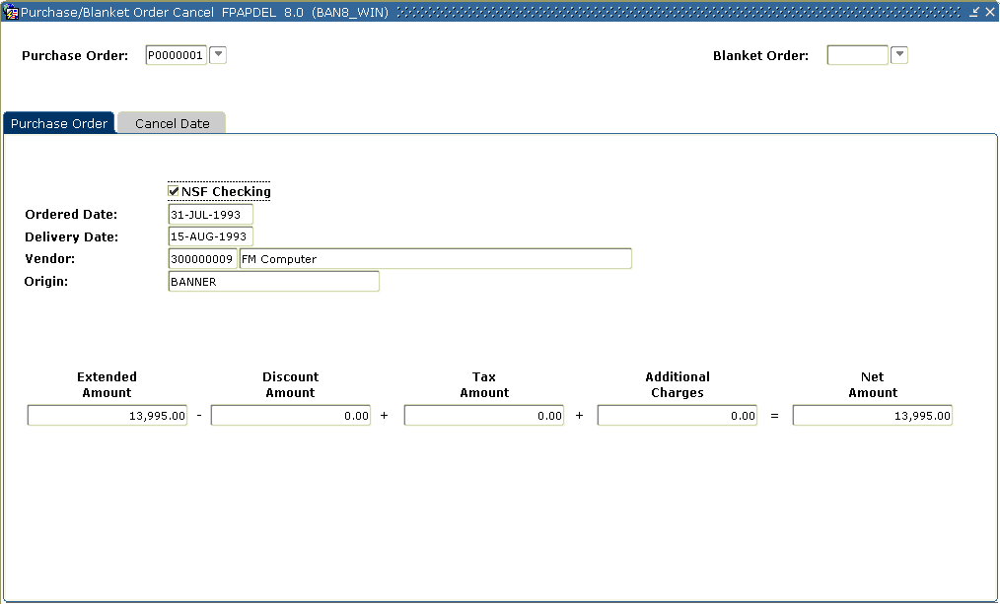

Steps
Follow these steps to complete the process.

- Access the Purchase/Blanket Order Cancel Form (FPAPDEL).
- Enter the purchaser order number in the Purchase Order or click the Search icon to select one.
- Perform a Next Block function.
Note: Banner displays the purchase order/blanket order information for you to verify that you have selected the right document.
- Click the Cancel Date tab.
- Enter any date that is in an open accounting period or accrual period in the Cancel Date field.
Rule: The date must be after the original transaction date.
Note: The Cancel Date field defaults to the current date.
- Tab to the Reason Code field.
- Double-click in the Reason Code field to select a reason for why the Purchase order is being canceled.
- Select Document Text from the Options menu.
- Perform a Next Block function.
- Enter This Purchase Order was created in Error.
- Click the Save icon.
- Click the Exit icon.
- When you are ready to complete the cancellation, select the Process Cancellation option from the Options menu to permanently cancel the purchase order or blanket order.
- Click the Exit icon.

Printing a Purchase Order
Banner form
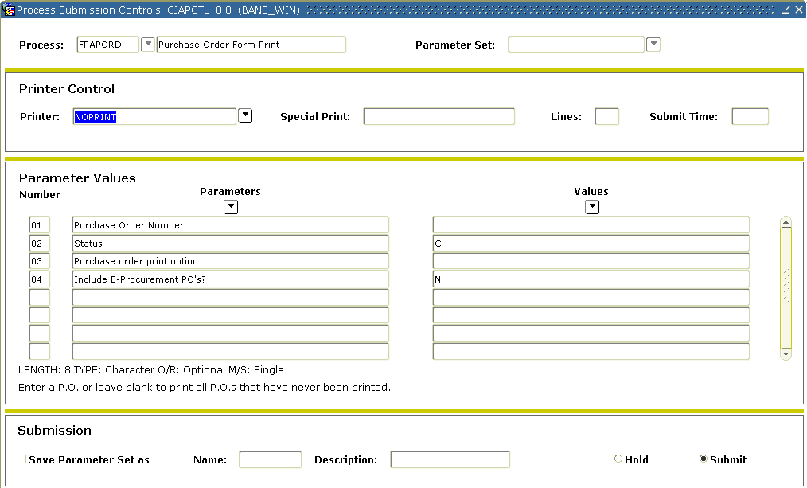
Steps
Follow these steps to print a purchase order.

- Access the GJAPCTL form simply by entering FPAPORD in the Go To field.
- Perform a Next Block Function.
- Enter DATABASE in the Printer Field.
- Perform a Next Block Function.
- Enter into parameter 01 the number of a purchaser order you created. If left blank, all previously unprinted PO’s will print.
Note the help information below the parameters for each parameter in this process.
- You can select current or prior versions of a changed PO with parameter 02.
- If parameter 01 is left blank, you can select Standing, Regular or Both PO’s with parameter 03.
- Parameter 04 can be used to print e-Procurement PO’s.
- Perform a Next Block Function.
- Click the Save icon.
- Review the output.
- Click the Exit icon.
Creating a Change Order
Introduction
The Change Order Form (FPACHAR) is used to revise header, commodity, and accounting information on a completed, approved, and posted purchase order or blanket order. You cannot change the following: the Vendor, the Currency code, the document type (i.e., regular versus standing), and the Document Accounting indicator. You can change the monetary amounts of the distributions and add new ones.
Banner form
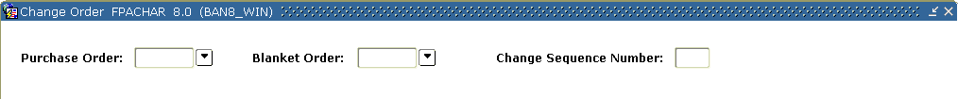
Steps
Follow these steps to complete the process.
- Access the Change Order Form (FPACHAR).
- Perform one of these actions.
- Enter the purchase order in the Purchase Order field or click the Search icon to select one.
- Enter a Blanket Purchase Order in the Blanket Order field or click the Search icon to select one.
Note: If you enter a purchase order number that is associated with a blanket order, the blanket order number displays in the Blanket Order field. If you want to revise a blanket order, leave the Purchase Order field blank.
- Enter NEXT in the Change Sequence Number field to generate a change sequence number. If you want to access an incomplete change order, enter that change sequence number.
Note: You cannot generate a new change order sequence number until you complete, approve, and post the previous change order sequence number.
- Perform a Next Block function.
Note: Information entered on the Purchase Order Form (FPAPURR) is also presented here. However, there is additional information and functionality available on the Change Order Form (FPACHAR).
- Check the Change Accounting Only checkbox.
Note: Only changes to the accounting distribution can now occur. If this checkbox is left unchecked it enables you to change all the permitted fields.
- Verify the option selected in Original Document Text pull-down list, change if necessary.
Note: The Original Document Text pull-down list allows you to decide how you want to handle that document text. The options are: Copy Document Text, Ignore Document Text, and None (if there is no preexisting text).
- Select Document Text from the Options menu to create document text or modify the current document text as noted by the checkmark displayed in the Document Text field.
- Enter in a Modify Clause or click the Search icon to select one.
- Perform a Next Block function.
- Enter text.
- Click the Save icon.
- Click the Exit icon.
- Note: The Document Text field should now have a check in the checkbox.
By adding new text, the Original Document Text field has been reset to Ignore Document Text and is grayed out. This prevents the form from copying text from the original purchase order to the change order multiple times.
- Change the buyer code entered in the Buyer Code field if desired.
- Verify the Purchase Order Type, BO Termination Date (if the purchase order being changed references a blanket order), Rush Order, NSF Checking, and Deferred Editing field settings.
- Select the Requestor/Delivery Information tab.

- Verify the Requestor, COA, Organization, Email, Phone, Fax, Ship To, and Attention To fields. Make changes if necessary.
Note: Information such as the Ship To code and the Delivery Date also affect the commodity records; updating this information will cause all commodity records to be included in the change order, whether or not you specifically include them. Use the Commodity Supplemental Information window to change Ship To or Delivery Date by line item.
Note: When creating a change order for a blanket order, some fields in the Requestor/Delivery window will require entry, even though they were not required for the original blanket order.
- Select the Vendor Information tab.
- Verify the vendor information and change, if necessary.
Note: You cannot change the vendor on a purchase order, but you can update the address code and sequence number.
- Verify the Contact, Email, Discount, FOB Code, Tax Group, Class Code, and Carrier fields. Make changes if necessary.
Note: You cannot change the Currency code that was used on the original purchase order.
- Select the Commodity/Accounting Information tab.
Note: The Purchase Order Item Selection Form (FPQCHAP) allows you to select specifically which items on the purchase order you would like to change.
- To change all items, select the Change All checkbox.
Note: The Change All function is a method for copying all of the commodities on the original purchase order (plus any change orders) to the commodity page of the change order.
- To change specific items, perform a Next Block function.
Note: If you do not choose the "Change All" function, the items and their amounts are still included in this change order; they are just not visible. However, their totals will be included in the Remaining Commodity Amount
- Click the Add checkbox to indicate which items you would like to change on this change order.
- Click the Save icon.
- Click the Exit icon to return to the Change Order: Commodity/ Accounting window.
Note: All of the commodity and accounting information that you have selected will be carried forward and populated on the Change Order Form (FPACHAR). You can still add new items to the order by either entering a commodity code in the Comm field, or by not entering a commodity code and entering just a description in the Desc field. Note that you can still overwrite the commodity description on this form. If you navigate using the Next Field function back through the Commodity and Description fields, you may notice a pop-up box. This feature allows you to see the original commodity description if you have overwritten the original description. This would assist you in identifying whether the Commodity code is appropriate in case additional information has been entered in the Description field.
- Change the Quantity and/ or Unit Price (or Amount on a standing purchase order) so that the extended amount is the correct or revised amount that you want to order.
- Perform a Next Block function.
Note: As in the purchase order, if you are using commodity level or document level accounting and you have the Distribute checkbox checked, the form will automatically distribute your commodity changes in the appropriate manner. To make changes manually, uncheck the Distribute checkbox.
- Make the necessary changes to the accounting distributions.
Note: Although you cannot delete existing accounting distributions from the change order (because they have already been posted by the original purchase order and any subsequent change orders), you can zero out the existing distributions, which will reverse the accounting behind them. You can also change existing distributions with a new monetary amount or add new accounting distributions.
- Select the Balancing/Completion tab.
- Review the Header, Commodity, and Accounting amounts.
- If these amounts are in balance, click the Complete button.

Canceling a Change Order
Introduction
The Change Order Cancel Form (FPACDEL) is used to permanently cancel change orders. You cannot cancel change orders until after they have been completed, approved, and posted.
Banner form
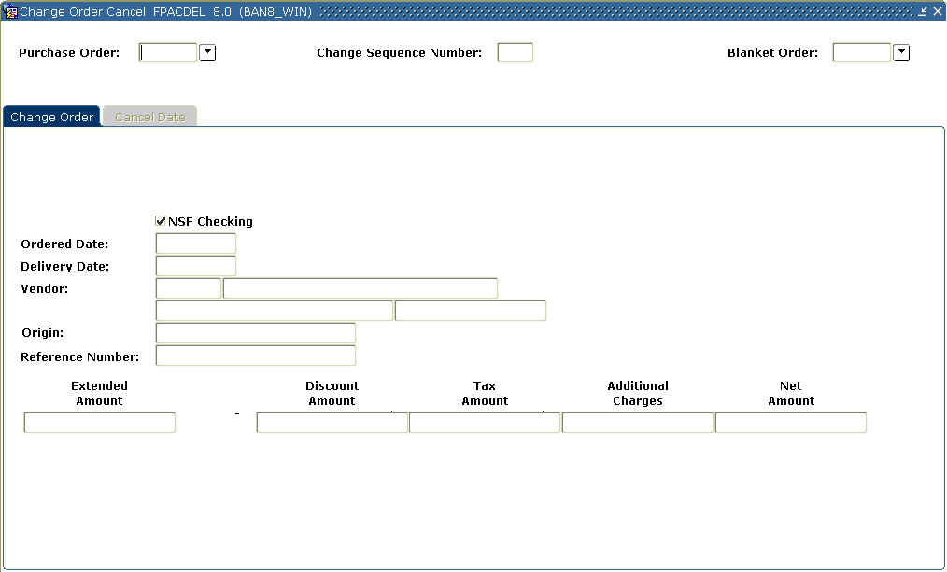
Steps
Follow these steps to complete the process.

- Access the Change Order Cancel Form (FPACDEL).
- Enter the purchase order in the Purchase Order field or click the Search icon to select one, or enter a blanket purchase order in the Blanket Order field.
- Enter the latest change order sequence number in the Change Sequence Number field.
- Perform a Next Block function.
Note: The change order detail is displayed.
- Click the Cancel Date tab.
- Enter any date that is in an open accounting period or accrual period in the Cancel Date field; however, the date must be after the original transaction date.
Note: The Cancel Date field defaults to the current date.
- Tab to the Reason Code field.
- Double-click in the Reason Code field to select a reason for why the change order is being canceled.
- Select Document Text from the Options menu.
- Perform a Next Block function.
- Enter This change order was created in Error.
- Click the Save icon.
- Click the Exit icon.
- When you are ready to complete the cancellation, select Process Cancellation from the Options menu to permanently cancel the purchase order or blanket order.
- Click the Exit icon.

Printing a Change Order
Banner form
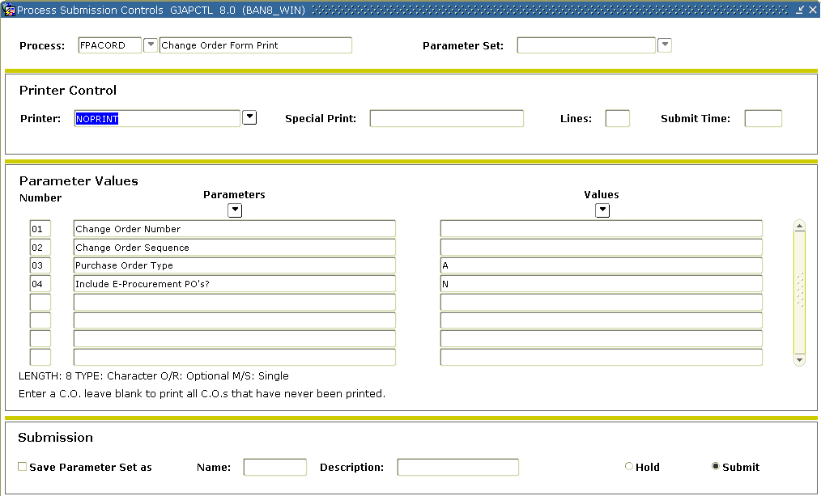
Steps

- Access the GJAPCTL form simply by entering FPACORD in the Go To field.
- Perform a Next Block Function.
- Enter DATABASE in the Printer Field.
- Perform a Next Block Function.
- Enter into parameter 01 the number of a change order you created. If left blank, all previously unprinted PO’s will print. Note the help information below the parameters for each parameter in this process.
- You can select a particular version (sequence) of a change order with parameter 02.
- If parameter 01 is left blank, you can select Standing, Regular or Both PO’s with parameter 03.
- Parameter 04 can be used to print e-Procurement PO’s.
- Perform a Next Block Function.
- Click the Save icon.
- Review the output.
- Click the Exit icon.

Creating a Purchase Order Quickly
Introduction
The Rush Order Form (FPARORD) is used to reserve a purchase order number quickly without having to complete all of the information required to enter a purchase order. You can complete all of the information later using the Purchase Order Form (FPAPURR). This form does not create a budget encumbrance.
Banner form
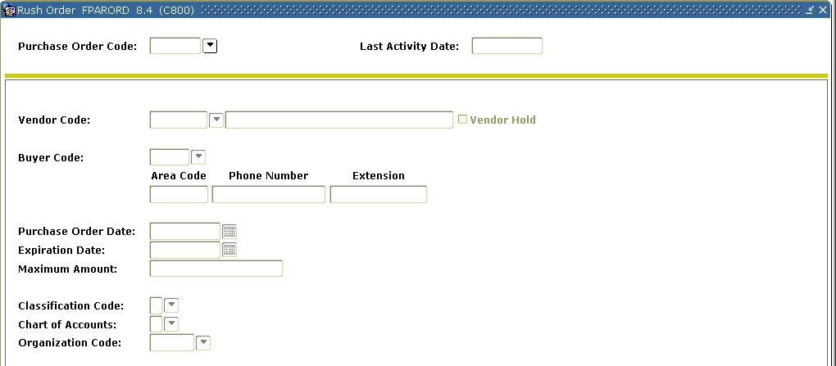
Steps
Follow these steps to complete the process.
Note: The Classification Code, Chart of Accounts, and Organization Code fields are optional, but will be displayed on FPAPURR.
- Access the Rush Order Form (FPARORD).
- Enter NEXT In the Purchase Order Code field
- Perform a Next Block function.
- Enter a vendor code in the Vendor Code field or click the Search icon to select one.
Note: This is an optional field. One-time vendor information cannot be saved with a rush order. If you enter a name without entering a code, Banner does not display the name on the Purchase Order Form (FPAPURR) when you complete the rush order.
- Tab to the Buyer Code field and enter a valid buyer or double-click the Buyer Code field to select one.
Result: After selecting a buyer code, the buyer’s name and information displays in the Phone Number and Extension fields from FTMBUYR.
- Change the purchase order date in the Purchase Order Date field if necessary.
Note: The system date is defaulted in.
- Tab to the Expiration Date field, and enter the date when the rush order is no longer valid.
Note: this field can be left blank if necessary.
- Enter a maximum amount for the resulting purchase order (not the rush order) in the Maximum Amount field.
Note: If you exceed this amount when you complete the purchase order, Banner displays a warning message. This is an optional field.
- Enter a classification code in the Classification Code field or double click in the field to select one.
- Enter in the chart of accounts in the Chart of Accounts field, or double click in the field to select one.
- Enter in an organization in the Organization Code fields, or double click in the field to select one.
- Click the Save icon.
- Click the Exit icon.
- Once the items are bought from the rush purchase order, go to the Purchase Order Form (FPAPURR) and use the purchase order number just recreated on the Rush Order Form (FPARORD) to add the commodities and accounting distribution. The rush purchase order has now been converted into a regular purchase order.

Querying Completed and Approved Purchase/Blanket/ Change Orders
Background
In previous exercises, you created and modified purchase orders, blanket orders, and change orders using the Purchase Order Form (FPAPURR), Blanket Order Form (FPABLAR), and Change Order Form (FPACHAR). Because you completed and approved these documents, you cannot review them from these forms.
Banner form
You can query the orders you created from the Purchase/Blanket Order Inquiry Form (FPIPURR) at any stage of completion.
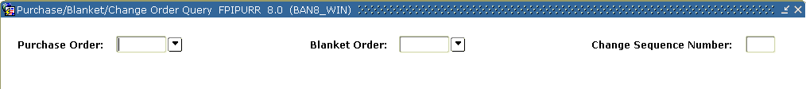
Steps
Follow these steps to complete the process.

- Access the Purchase/Blanket Order Inquiry Form (FPIPURR).
- Enter the purchase order in the Purchase Order field, or click the Search icon to select one, or enter a blanket purchase order in the Blanket field.
- Enter change number in the Change Sequence Number field if you want to review a specific change order. If not, leave the field blank.
- Perform a Next Block function, or select Document Information from the Options menu to go to the Document Information window.
- Perform a Next Block function or select Requestor/Delivery Information from the Options menu to view the requestor and the ship to address
- View the document text, if it exists, by selecting Document Text from the Options menu.
Result: This will display the Procurement Text Entry Form (FOAPOXT).
- Perform a Next Block function or select Vendor Information from the Options menu to show the current vendor information.
- Select Commodity/Accounting Information from the Options menu to access the Commodity/Accounting window.
Note: This window shows the commodity and accounting information entered on any of the three order creation forms. This window also includes the Original Commodity Description pop-up window, which allows you to see the commodity description as defined for the code, even if the description has been overwritten.
Warning: Important! Reviewing a change order that has been posted will only display changes that were made to the items. Any items that were not changed will not be displayed. You can also see the amount the change order has been changed by; whereas when you entered the change order, you entered the amount you wanted the purchase order to be changed to. Make a note of this so you are aware of the differences in display.
- Note: The Commodity Supplemental Data window is displayed when you select Commodity Supplemental Information from the Options menu, and shows additional information regarding this commodity.
It displays the Delivery Date and Ship To fields entered on the requisition, as well as the Assigned Buyer, Bid Assigned (if applicable), Assigned to PO, and PO Item Number fields.
- Click Close to close this window.
- Click the Exit icon to exit the form.

Additional Purchase Order Queries
Introduction
Besides FPIPURR, there six other helpful inquiry forms related to purchase orders. The table below lists the additional inquiry forms.

Form Description | Banner Name
Open Purchase Orders by Buyer | FPIOPOB
Open Purchase Orders by Vendor | FPIOPOV
Open Purchase Orders by FOAPAL | FPIOPOF
Purchase Order Validation | FPIPOHD
Purchase Order Suspense List | FPIPORS
Rush Order Validation | FPIRORD
Querying Document History
Introduction
The Document History Form (FOIDOCH) displays the processing history of purchasing and payment documents. It identifies related documents and provides the status of all documents that are in the processing stream for the queried document.
Banner form
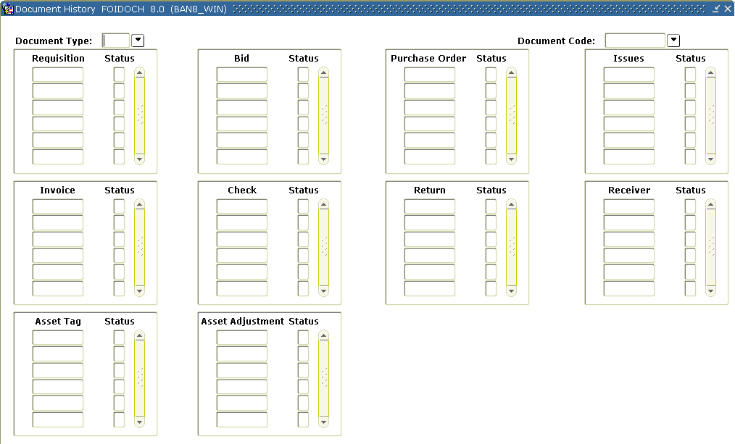
Steps
Follow these steps to complete the process.

- Access the Document History Form (FOIDOCH).
- Enter the type of document in the Document Type field or double-click to retrieve one from the existing document types.
- Go to the Document Code field and enter a document code or retrieve one from the existing documents for the selected document type.
- Perform a Next Block function.
Note: The cursor goes to the block that corresponds to the Document type and code selected. The following are the query forms associated with each of the blocks.
Block | Associated Query Form
Requisition | Requisition Inquiry Form (FPIREQN)
Bid | Request for Bid List Validation Form (FTIBIDS)
Purchase Order | Purchase/Blanket Order Inquiry Form (FPIPURR)
Issues | Stores Issues/Return Query Form (FSIISSQ)
Invoice | Invoice/Credit Memo Query Form (FAIINVE)
Check | Check Payment History Form (FAICHKH)
Return | Returned Goods Validation List Form (FPIRTRN)
Receiver | Receiving Goods Query Form (FPIRCVD)
Asset Tag | Fixed Asset Master Query Form (FFIMAST)
Asset Adjustment | Fixed Assets Adjustment Query Form (FFIADJF)
Note: You can also use the Direct Access function for the following document types.
- Bid - Request for Bid List Validation Form (FTIBIDS)
- Check - Check Payment History Form (FAICHKH)
- Return - Returned Goods Validation List Form (FPIRTRN)
Note: Selecting Status on the Options menu will give an explanation of the status code on the document.
- When finished viewing the history, click the Exit icon.

Opening/Closing Encumbrances
Introduction
The Encumbrance Open/Close Form (FPAEOCD) is used to re-open closed purchase orders at either the document or commodity item level and to close requisitions or purchases orders at either the document or commodity item level. Documents created against either Operating Ledger or General Ledger accounts may be closed with this form. Use of this form will not affect any related systems such as Fixed Asset records or Stores Inventory "on order" quantities.
Closing all commodity items will also close the requisition or purchase order document.
Banner form
Steps – Procedure 1 – closing a purchase order
Follow these steps to complete the process.

- Access the Encumbrance Open/Close Form (FPAEOCD).
- Enter NEXT in the Document Number field, to create a system-generated number or, if you have previously begun an open/close document, enter the document number, or click the Search icon and select an incomplete document from the Encumbrance Open/Close List Form (FPIEOCL)
Note: The first character of this type of document is an asterisk (*).
Warning: Do not enter the requisition or Purchase Order number of the document you want to open/close in this field.
- Perform a Next Block function.
- Select Close PO document or commodity.
- Tab to the Document Transaction field and change the date if necessary.
Result: Today’s date defaults in.
- Perform a Next Block function.
- Enter the purchase order in the Purchase Order Number field or click on the Search icon to select one.
Note: The PO Transaction Date, Vendor, and PO Text Exist indicator will default in from the document.
- Click on the Close All Items and Change Accounting boxes.
Note: The option to close all items will not automatically close all items; it signals the system to default a close indicator for all open commodity items on the document.
Note: The Change Accounting checkbox must be checked for the Close Options to complete the document.
- Select Commodity/Accounting Information tab.
Result: All of the commodity line item information will appear in the Commodity Information section.
- Verify that the items you want to close have a checkmark in the Close box.
- Perform a Next Block function
- Enter the amount in the Adjust By column from the appropriate Current Encumbrance column for the total of all the commodity items being closed.
Note: Data entry is always assumed as a positive entry.
- Select the Complete option from the Options menu to complete the document.
Note: A message will appear in the Auto-Hint Help line that identifies the document number and says that the document has been forwarded to the Posting process.

Steps – Procedure 2 – closing a requisition
Follow these steps to complete the process.

- Access the Encumbrance Open/Close Form (FPAEOCD).
- Enter NEXT in the Document Number field, to create a system-generated number or, if you have previously begun an open/close document, either enter the document number, or click the Search icon and select an incomplete document from the Encumbrance Open/Close List Form (FPIEOCL)
- Note: The first character of this type of document is an asterisk (*).
Warning: Do not enter the requisition or Purchase Order number of the document you want to open/close in this field.
- Perform a Next Block function.
- Select Close Requisition or commodity from the pull-down menu
- Tab to the Document Transaction field and change the date if necessary.
Note: Today’s date defaults in.
- Perform a Next Block function.
- Enter the requisition number in the Requisition Number field or click the Search icon to select one.
Note: The Requisition Transaction Date, Vendor, and Requisition Text Exist indicator will default in from the document.
- Click the Close All Items and Change Accounting boxes.
Note: The option to close all items will not automatically close all items; it signals the system to default a close indicator for all open commodity items on the document.
Note: The Change Accounting checkbox must be checked for the Close Options to complete the document.

- Perform a Next Block function or select Commodity/Accounting Information from the Options menu.
Result: All of the commodity line item information will appear in the Commodity Information section.
- Verify that the items you want to close have a checkmark in the Close checkbox.
- Perform a Next Block function
- Enter the amount in the Adjust By column from the appropriate Current Encumbrance column for the total of all the commodity items being closed.
Note: Data entry is always assumed as a positive entry.
- Select the Complete option from the Options menu to complete the document.
Note: A message will appear in the Auto-Hint Help line that identifies the document number and says that the document has been forwarded to the Posting process.
Steps – Procedure 3 – opening a purchase order
Follow these steps to complete the process.

- Access the Encumbrance Open/Close Form (FPAEOCD).
- Enter NEXT in the Document Number field, to create a system-generated number or, if you have previously begun an open/close document, either enter the document number, click the Search icon and select an incomplete document from the Encumbrance Open/Close List Form (FPIEOCL)
- Note: The first character of this type of document is an asterisk (*).
Warning: Do not enter the requisition or Purchase Order number of the document you want to open/close in this field.
- Perform a Next Block function.
- Select Open PO Document or commodity from the pull-down menu
- Tab to the Document Transaction field and change the date if necessary.
Note: Today’s date defaults in.
- Perform a Next Block function.
- Enter the purchase order in the Purchase Order Number field or click on the search icon to select one.
Note: The PO Transaction Date, Vendor, and PO Text Exist indicator will default in from the from the document
- Click on the Open All Items and Change Accounting boxes.
Note: The option to open all items will not automatically open all items; it signals the system to default an open indicator for all closed commodity items on the document.
- Perform a Next Block function or select Commodity/Accounting Information from the Options menu to navigate to the Commodity/Accounting window.
Result: All of the commodity line item information will appear in the Commodity Information section.
- Verify that the items you want to be open have a checkmark in the Open checkbox.
- Perform a Next Block function
- Enter the amount in the Adjust By column from the appropriate Original Encumbrance column for the total of all the commodity items being opened.
Note: Data entry is always assumed as a positive entry.
- Select the Complete option from the Options menu to complete the document.
Note: A message will appear in the Auto-Hint Help line that identifies the document number and says that the document has been forwarded to the Posting process.

Closing Purchase Orders in Batch
Introduction
The PO Batch Close Process (FPPPOBC) is used to closed purchase orders in mass. This report is helpful in closing purchase orders in a certain range or purchase orders under a specified dollar amount. What the process will not do is close general encumbrance or requisitions. If the process is unable to close a purchase order it will list the purchase order number in an unable to be closed section at the end of the report.
Banner form
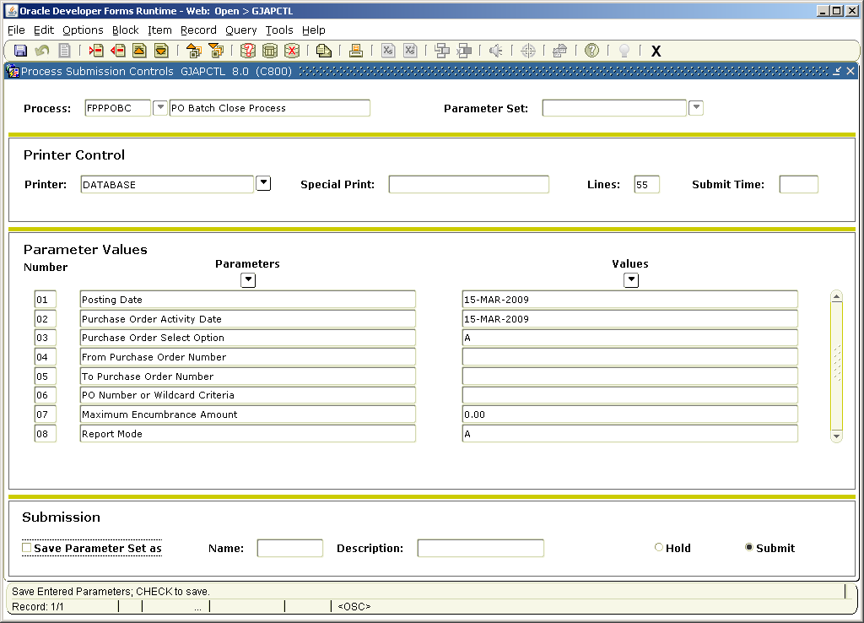
Steps

- Access the GJAPCTL form simply by entering FPPPOBC in the Go To field.
- Perform a Next Block Function.
- Enter DATABASE in the Printer Field.
- Perform a Next Block Function.
- Enter the date, today’s date, to post the closing encumbrance transaction into parameter 01.
Note: you can backdate this date if running during month-end or year-end.
- Enter the date, today’s date, to review all posted purchase orders.
Note: you can change this date to only select purchase orders up to a specific point in time.
- Enter A for Parameter 03.
Note: If you enter R in Parameter 03 you need to fill out a range in Parameter 04 and 05. If you enter S or W in Parameter 03 you need to complete Parameter 06.
- Parameter 04 through 06 will be left blank.
- Enter 0.00 in Parameter 07.
Note: Only open purchase orders for zero dollars would be closed.
- Enter A (audit mode) for Parameter 08.
- Perform a Next Block Function.
- Click the Save icon.
- Review the report.
- Run the report in update mode (U) to process the closing encumbrance entry.
- Click the Exit icon.
Receiving Purchased Goods
Introduction
The receiving process enables you to enter receipt information for items ordered through the purchase order process. You can receive goods based on the quantity identified on a regular purchase order or based on the dollar amount identified on a standing purchase order. Invoices against standing orders will be posted regardless if receiving occurred, since standing orders by-pass the receiving/matching process. In addition, the Accounts Payable department can complete receiving on the Invoice/Credit Memo Form (FAAINVE); however, receiving completed on FAAINVE will not generate a receiving document in the Receiving Goods Form (FPARCVD).
Banner form
Receiving Goods Form (FPARCVD).
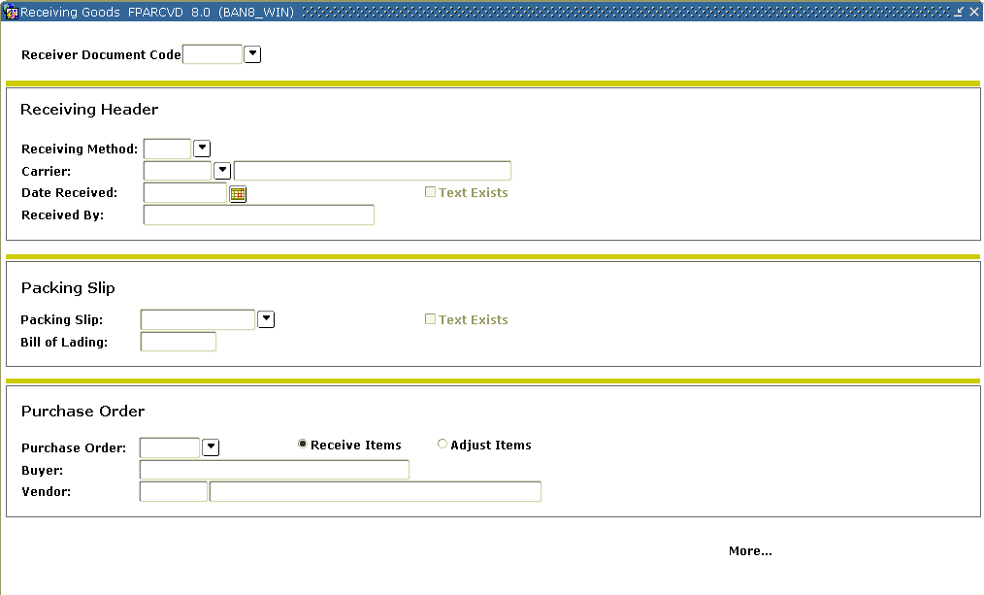

Fields
The table shows fields and checkboxes you should know when completing the exercise that follows.

Field or Checkbox | Description
Receiving Method | This optional field corresponds to the Receiving Method Maintenance Form (FTMRCMT) and contains a user-defined list of receiving methods.
Carrier | Vendors are classified as carriers when either Domestic Carrier or Foreign Carrier is activated from the Vendor Header Additional Information window on the Vendor Maintenance Form (FTMVEND).
Date Received | The Date Received field displays the system date. You can override it.
Received By | Banner controls the Received By field and enters the document creator’s User ID upon completion.
Receive Items and Adjust Items | The radio buttons allow you to process an original receiving document or an adjustment to an existing receipt transaction. An adjustment is basically a negative receiver, and allows you to correct or update completed receipt documents.

Steps – Procedure 1 –original receipt
Follow these steps to enter an original receipt.

- Access the Receiving Goods Form (FPARCVD).
- Enter NEXT In the Receiver Document Code field to allow the system to generate number or click the Search icon to have the system select an incomplete document.
- Double-click in the Receiving Method field to select a receiving method.
- Click the Search icon to select a Carrier (optional).
- Tab to the Date Received field, if necessary. Override the date displayed in the Date Received field, if appropriate.
- Select View Receiving Text from the Options menu to create or modify text associated with a receiver document, and use the General Text Entry Form (FOATEXT) to enter text.
- When completed, click the Save icon.
- Click the Exit icon.
Result: A checkmark in the Text Exists field indicates that receiving text exists.
- Enter the packing slip number in the Packing Slip field.
Note: If the packing slip encompasses the receipt of more than one purchase order, click the Search icon to select the packing slip number entered with a different purchase order number. Packing slips need to be unique to a receiving document. You may add a letter to the end of the packing slip number to create more than one receiver on a packing slip. This is a required field; if you do not have a packing slip number you can enter the initial and date of receiver.
- Tab to the Bill of Lading field and enter the bill of lading number (optional).
- Enter the Purchase Order code for your receipt in the Purchase Order field or click the Search icon to select the completed Purchase Order.
Note: The Buyer and Vendor fields are automatically populated from the purchase order.
- Tab to the Receive Items radio button and verify that it is selected.
- Select Purchase Order Items from the Options menu.
Result: this option this will bring you to the FPCRCVP form/screen that will list all the commodity items listed on the related purchase order.
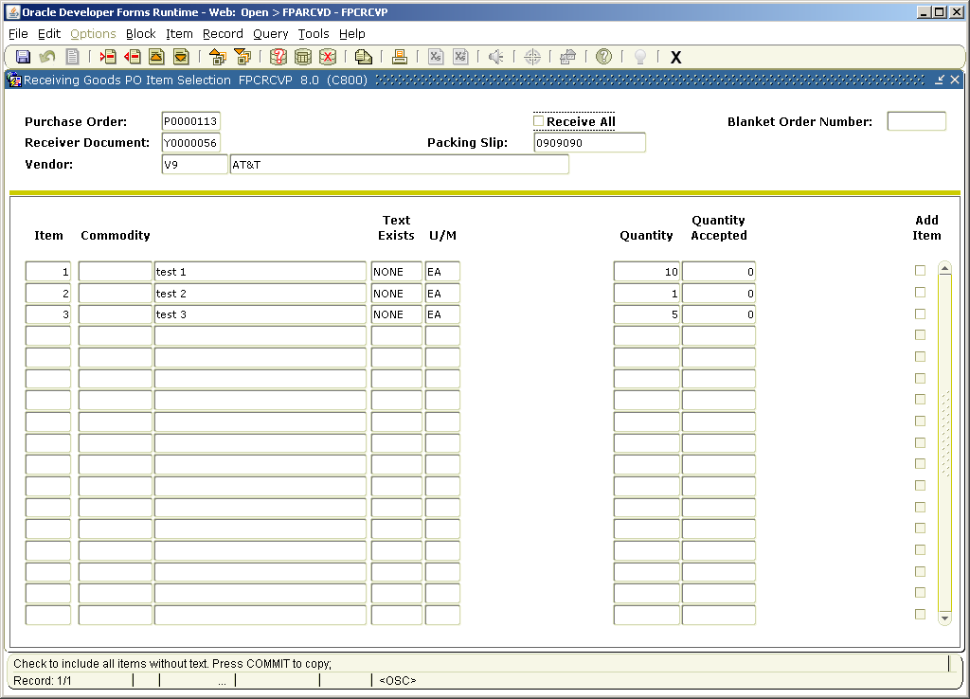
- If all items listed on the purchase order match the packing slip you can select the Receive All option listed at the header of the FPCRCVP form or using the packing slip or invoice copy click to place a check mark in the add box next to the commodity line matching the packing slip/invoice copy.
- When completed, click the Save icon.
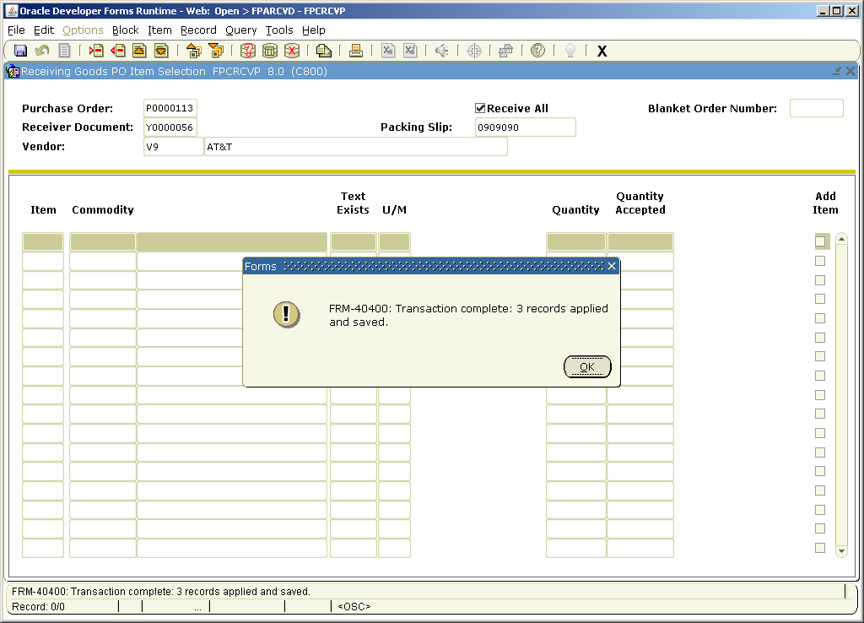
- Click the OK button in the pop-up window.
- Click the Exit icon.

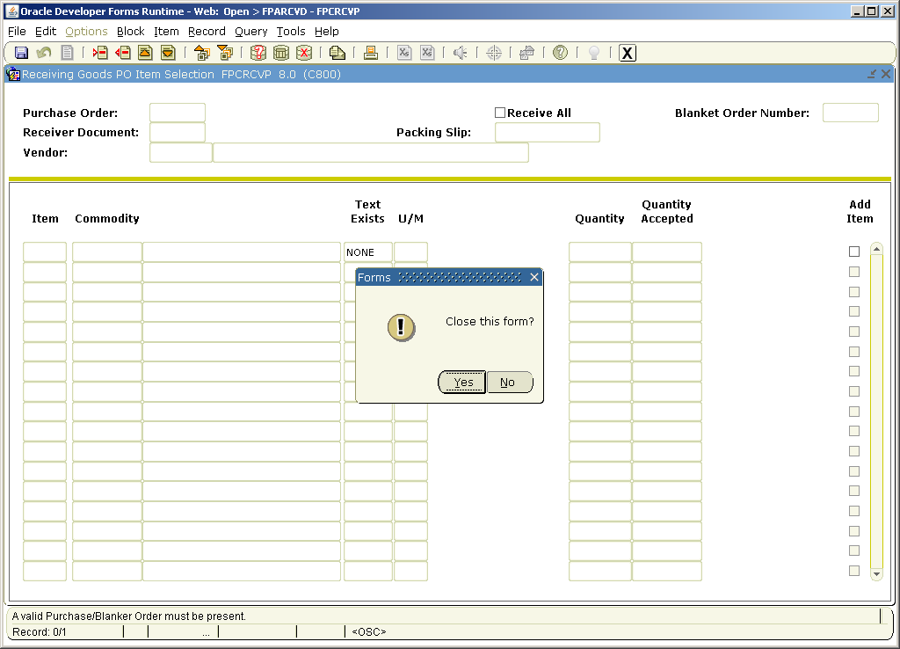
- Click the Yes button to close the form.
Result: you are now at the header page of the receiving document.
- Perform a Next Block function.
Note: The commodity information defaults from the purchase order.
- Did you receive all the goods for each commodity?
- If yes, leave the Final Received? checkbox checked.
- If no, uncheck the Final Received? checkbox.
- For a regular purchase order, go to the Current Quantity Received field and enter the quantity of goods received for this item.
Note: If this document is a standing order, you will not see this field; you will see the Current Amount Received field. You receive standing orders in dollar and cent increments.
- The U/M field from the purchase order is displayed with the commodity. Enter the receiving unit of measure in the U/M field if the U/M is different than the purchase order.
Note: For a regular purchase order, Banner converts the quantity into the purchase order's unit of measure as long as an equivalency record exists in the Equivalency Maintenance Form (FTMEQUL).
- Use the scrollbar to review the rest of the commodity information and repeat steps 15 - 17.
- Do you want to return to the Packing Slip block?
If yes, go to steps 25 -29. If no, go to step 30.

- Perform two Previous Block functions.
- Select View Packing Slip Text from the Options menu.
- Enter free form text to associate with the packing slip.
- Click the Save icon.
- Click the Exit icon.
- Perform two Next Block functions.
- Select Access Completion from the Options menu to go to the Completion window.
- Click Complete to complete the receiving document.
Result: Once you complete the document, the Receiver Document number will be displayed on the Auto-Hint Help line and the cursor will rollback to allow you to enter another receiver.
- Click the Exit icon.
Note: You cannot make further changes to the Receiver Document at this point. If you need to make adjustments, go to Procedure 2.
Steps – Procedure 2
If you need to make adjustments, you can create a new Receiver Document using the same packing slip and purchase order used in Procedure 1. Follow these steps to enter a receipt adjustment.

- Access the Receiving Goods Form (FPARCVD).
- Enter Next In the Receiver Document Code field to allow the system to generate number or click the Search icon to have the system select an incomplete document.
- Double-click in the Receiving Method field to select a receiving method.
- Click the Search icon to select a Carrier (optional).
- Tab to the Date Received field, if necessary. Override the date displayed in the Date Received field, if appropriate.
- Select View Receiving Text from the Options menu to create or modify text associated with a receiver document, and use the General Text Entry Form (FOATEXT) to enter text.
- When completed, click the Save icon.
- Click the Exit icon.
Result: A checkmark in the Text Exists field indicates that receiving text exists.
- Click the Search icon to select the packing slip number used in Exercise 1.
- Tab to the Bill of Lading field and enter the bill of lading number (optional).
- Click the Search icon to select the Purchase Order used in Exercise 1.
Note: The Buyer and Vendor fields are automatically populated from the purchase order.
- Select the Adjusted Items radio button.
- Select Select Purchase Order Items from the Options menu.
Result: This will take you to the Receiving Goods PO Item Selection Form (FPCRCVP).
- Perform a Next Block function.
- Click the Add Item checkbox for the commodities that need to be adjusted.
- Click the Save icon.
- Click the OK button in the pop-up window.
- Click the Exit icon.
- Click the Yes button to close the form.
Result: you are now at the header page of the receiving document.
- Perform a Next Block function.
- For a regular purchase order, go to the Adjustment Quantity Received field and enter the quantity of goods adjusted for this item.
Note: The adjustment must be a negative quantity.
- The U/M field from the purchase order is displayed with the commodity. Enter the receiving unit of measure in the U/M field if the U/M is different than the purchase order.
Note: For a regular purchase order, Banner converts the quantity into the purchase order's unit of measure as long as an equivalency record exists in the Equivalency Maintenance Form (FTMEQUL).
- Use the scrollbar to review the rest of the commodity information and repeat steps 21 - 22.
- Perform a Next Block function.
- Click Complete to complete the receiving document.
Result: Once you complete the document, the Receiver Document number will be displayed on the Auto-Hint Help line and the cursor will rollback to allow you to enter another receiver.
- Click the Exit icon.
Receiving Goods Query
Introduction
Receiving documents that have been completed can only be viewed in FPIRCVD. Anyone with access to this form can view receiving documents entered in Banner.
Banner form
Receiving Goods Query Form (FPARCVD).
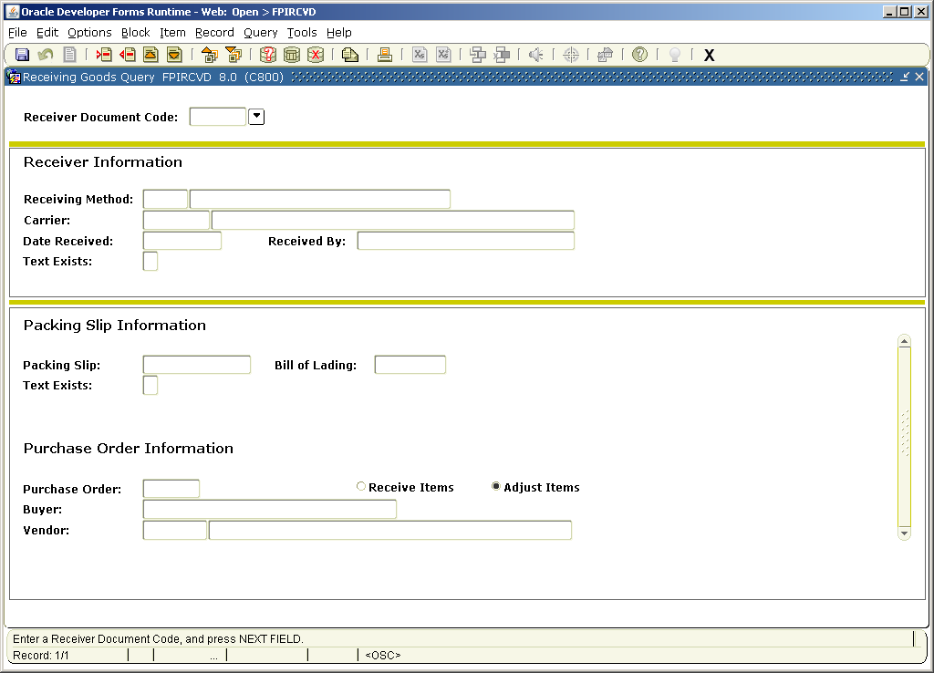

Steps
Follow these steps to review a receiving document.

- Access the Receiving Goods Query Form (FPIRCVD).
- Enter the receiving document in the Receiver Document Code field or click the Search icon select an receiving document from the Receiver/Packing Slips Validation (FPIPKSL).
- Perform a Next Block function to view the data on the header.
- Perform a Next Block function to move to the packing slip section.
- Perform a Next Block function to view the items on the receiving document.
- Click the Exit icon.
Returning Purchased Goods
Introduction
The Returned Goods Form (FPARTRN) is used to identify returned goods for items ordered with a regular purchase order.
Note: Both the Returned Goods Form (FPARTRN) and an adjustment entered on the Receiving Goods Form (FPARCVD) update the Accepted field in the Invoice/Credit Memo Form (FAAINVE). Do not enter the same return in both forms.
Banner form
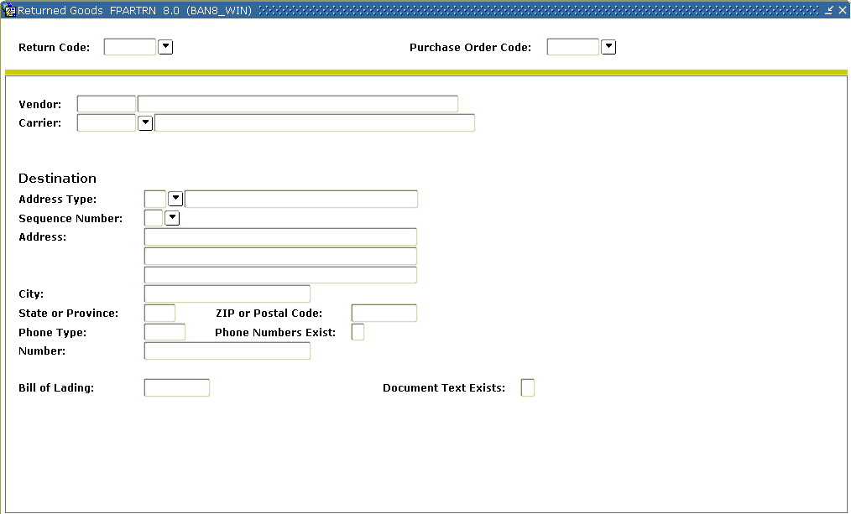

Steps
Follow these steps to complete the process.

- Access the Returned Goods Form (FPARTRN).
- Enter NEXT in the Return Code field or click the Search icon to select an incomplete return.
- Tab to the Purchase Order Code field.
- Enter the Purchase Order code that the goods have been received on or click the Search icon to find a purchase order that the goods have been received on.
- Perform a Next Block function.
Result: The vendor and address information will default from the purchase order.
- Select a different vendor address using the Sequence Number field, if necessary.
- Tab to the Bill of Lading field and enter the bill of lading number for the return of goods (optional).
- Perform a Next Block function or select Returned Goods Information from the Options menu to navigate to the Returned Goods window.
- Enter the purchase order line item number to be returned in the Item field.
Result: The commodity information automatically populates from the purchase order.
- Tab to the Reason field and enter the reason code for this return or double-click in this field to select the return reason.
- Enter the quantity returned for this item in the Quantity Returned field.
Note: The system updates the Quantity To-Date Returned when the return document is saved. The Quantity To-Date Received-Rejected field shows information from data entry on the Receiving Goods Form (FPARCVD).
- Click the Save icon.
- Click the Exit icon.

Summary
Let’s review
As a result of completing this workbook, you have
- created, canceled, and queried requisitions
- assigned a buyer to a requisition
- used the bid process from the request through award stages
- created, canceled and queried purchase orders
- received and returned purchase goods.

Next step
The next step is to complete the Accounts Payable workbook.

Self Check
Directions
Use the information you have learned in this workbook to complete this self check activity.
Question 1
What form is used to create a requisition?
Question 2
The copy function will automatically update the available balance for a copied requisition.
True or False
Question 3
Once you complete a requisition, you can query the information using the Requisition Form (FPAREQN).
True or False
Question 4
You cannot change any information for a completed requisition on the Requisition Inquiry Form (FPIREQN).
True or False
Question 5
Which form is used to cancel requisitions from Banner?
Question 6
Before a requisition can be cancelled, it must first be completed, approved, and posted.

True or False
Question 7
The Buyer Assignment Form (FPAABUY) is used to assign procurement requests to buyers on the basis of internal policies and procedures

True or False
Question 8
What are the two methods to assign a buyer to a requisition?
Question 9
What are the two ways to start the Bid Process?
Question 10
What form is used to combine commodities from different requisitions?
Question 11
Which form is used to produce an external request for the purchase of goods or services from a vendor?
Question 12
Document level accounting assigns one accounting distribution to each commodity ordered.

True or False
Question 13
Documents of different Accounting types (document or commodity level) cannot be combined at any time in any way.
True or False
Question 14
The Blanket Order Form (FPABLAR) is used to encumber monies which can be drawn down by subsequent purchases.
True or False
Question 15
The Blanket Order Activity Form (FPIBLAR) can be used to view just purchase orders against a blanket order, excluding invoices.
True or False

Question 16
The Purchase/Blanket Order Cancel Form (FPAPDEL) is used to permanently cancel purchase orders and blanket orders that have been previously completed, approved, and posted within the Banner system.
True or False
Question 17
Which form is used to revise header, commodity, and accounting information on a completed, approved, and posted purchase order or blanket order?
Question 18
You cannot change the Vendor code, the Currency code, the Document Accounting Level indicator, or the order type using the Change Order Form (FPACHAR). However, you can change the monetary amounts of the distributions and add new ones.
True or False
Question 19
A change order can be cancelled at anytime.
True or False
Question 20
The Rush Order Form (FPARORD) creates an encumbrance.
True or False
Question 21
Purchase orders, blanket orders, and change orders can be queried using the Purchase/Blanket Order Inquiry Form (FPIPURR).
True or False
Question 22
When reviewing an order using FPRPURR, the Commodity/Accounting window only displays items it changes that were made to those items. Any items that were not changed are not displayed.
True or False
Question 23
The Document History Form (FOIDOCH) can only be used when processing history begins with purchasing.
True or False
Question 24
Documents charged against General Ledger accounts may be closed with the Encumbrance Open/Close Form (FPAEOCD).
True or False
Question 25
Which form is used to receive purchased goods?
Question 26
The Returned Goods Form (FPARTRN) can be used with Standing purchase orders.
True or False

Answer Key for Self Check
Question 1
What form is used to create a requisition?
The Requisition Form (FPAREQN)
Question 2
The copy function will automatically update the available balance for a copied requisition.
False. The copy functionality will not check or update available balance until you navigate through the form.
Question 3
Once you complete a requisition, you can query the information using the Requisition Form (FPAREQN).
False. Once completed, you review it using the Requisition Inquiry Form (FPIREQN).
Question 4
You cannot change any information for a completed requisition on the Requisition Inquiry Form (FPIREQN).
True. The Requisition Inquiry Form (FPIREQN) is used to review completed requisitions. You cannot change any information on the FPIREQN form.
Question 5
Which form is used to cancel requisitions from Banner?
The Requisition Cancel Form (FPARDEL) is used to delete requisitions from Banner.
Question 6
Before a requisition can be cancelled, it must first be completed, approved, and posted.
True. Also, if the request has subsequent activity (e.g., Bid, PO, Delivery Receipt, etc.), you cannot delete it.
Question 7
The Buyer Assignment Form (FPAABUY) is used to assign procurement requests to buyers on the basis of internal policies and procedures
True
Question 8
What are the two methods to assign a buyer to a requisition?
Manual Buyer Assignment and Automatic Buyer Assignment
Question 9
What are the two ways to start the Bid Process?
Create bids from requisitions using the Bid Creation Form (FPACTBD), or create bids using the Bid Header Form (FPABIDH).
Question 10
What form is used to combine commodities from different requisitions?
The Purchase Order Assignment Form (FPAPOAS)
Question 11
Which form is used to produce an external request for the purchase of goods or services from a vendor?
The Purchase Order Form (FPAPURR)
Question 12
Document level accounting assigns one accounting distribution to each commodity ordered.
False. Commodity level accounting assigns one accounting distribution to each commodity ordered. Document level accounting assigns one accounting distribution (which can be one or more FOAPAL lines) to the collective total of all commodities ordered.
Question 13
Documents of different Accounting types (document or commodity level) cannot be combined at any time in any way.
True
Question 14
The Blanket Order Form (FPABLAR) is used to encumber monies which can be drawn down by subsequent purchases.
False. It is not used to encumber monies from which to draw down; use the Standing Purchase Order (FPAPURR) if you want to encumber funds.
Question 15
The Blanket Order Activity Form (FPIBLAR) can be used to view just purchase orders against a blanket order, excluding invoices.
True. Enter a query with "PO" in the Type field to view purchase orders only.
Question 16
The Purchase/Blanket Order Cancel Form (FPAPDEL) is used to permanently cancel purchase orders and blanket orders that have been previously completed, approved, and posted within the Banner system.
True
Question 17
Which form is used to revise header, commodity, and accounting information on a completed, approved, and posted purchase order or blanket order?
The Change Order Form (FPACHAR)
Question 18
You cannot change the Vendor code, the Currency code, the Document Accounting Level indicator, or the order type using the Change Order Form (FPACHAR). However, you can change the monetary amounts of the distributions and add new ones.
True
Question 19
A change order can be cancelled at anytime.
False. You cannot cancel change orders until they have been completed, approved, and posted. You must also cancel change orders in the reverse order that they were created.
Question 20
The Rush Order Form (FPARORD) creates an encumbrance.
False
Question 21
Purchase orders, blanket orders, and change orders can be queried using the Purchase Blanket Order Inquiry Form (FPIPURR).
True
Question 22
When reviewing an order using FPRPURR, the Commodity/Accounting window only displays items it changes that were made to those items. Any items that were not changed are not displayed.
True

Question 23
The Document History Form (FOIDOCH) can only be used when processing history begins with purchasing.
False. The Document History Form (FOIDOCH) applies to all document types listed regardless of origin.
Question 24
Documents charged against General Ledger accounts may be closed with the Encumbrance Open/Close Form (FPAEOCD).
True
Question 25
Which form is used to receive purchased goods?
The Receiving Goods Form (FPARCVD)
Question 26
The Returned Goods Form (FPARTRN) can be used with Standing purchase orders.
False

Appendix

Forms Job Aid

Form | Full Name | Use this Form to...
FOACLAU | Clause Entry | create standard clauses to be used on requisitions and/or purchase orders.
FOMPROF | User Profile Maintenance | establish fund/organizational security for users by user ID.
FPAABUY | Buyer Assignment | assign procurement requests to buyers on the basis of internal policies and procedures.
FPAAGRD | Agreement Processing | create vendor agreements on specific commodity codes to be used on requisitions and/or purchase orders.
FPABAWD | Bid Award | assign a vendor for each commodity and to assign a purchase order number.
FPABIDE | Bid Entry | enter vendor pricing data to make bid comparisons.
FPABIDH | Bid Header | establish a bid for items that you request.
FPABLAR | Blanket Order | contract to order a certain dollar amount of goods from a specific vendor.
FPACDEL | Change Order Cancel | cancel a change order which you previously completed and posted.
FPACHAR | Change Order | create a change order to modify a completed and approved purchase order.
FPACTBD | Bid Creation | consolidate existing requisitions into a single bid.
FPAEOCD | Encumbrance Open/Close | Enter information to close a purchase order or commodity, open a purchase order or commodity, or close a requisition or commodity.
FPAPDEL | Purchase/Blanket Order Cancel | cancel a posted purchase order or a completed blanket order.
FPAPOAS | Purchase Order Assignment | consolidate and/or assign completed and approved requisitions to a purchase order.
FPAPRBD | Prospective Bidders | identify bidders who participate in the bid process.
FPAPURR | Purchase Order | enter information to create or modify purchase orders.
FPARCVD | Receiving Goods | enter or view receipt information from a packing slip or receiving document.
FPARDEL | Requisition Cancel | cancel a requisition document.
FPAREQN | Requisition | initiate the procurement process and to define the requestor, vendor, commodity, and accounting information.
FPARORD | Rush Order | enter basic summary purchase data for a rush order entry.
FPARTRN | Returned Goods | create a return transaction code number or modify existing return transaction information.
FPIBIDC | Bid Comparison | view an online display of comparative vendor data.
FPIBLAR | Blanket Order Activity | check the various activities against a blanket order, including purchase orders, change orders, invoices, and credit memos.
FPIEOCD | Encumbrance Open/Close List | List all encumbrance open or close documents, complete or incomplete.
FPIOPOB | Open Purchase Orders by Buyer | list all open purchase orders by a particular buyer code.
FPIOPOF | Open Purchase Orders by FOAPAL | list all open purchase orders by FOAPAL elements.
FIPOPOV | Open Purchase Orders by Vendor | list all open purchaser orders by a particular vendor.
FPIORQF | Open Requisition by FOAPAL Query | display open requisitions by FOAPAL elements.
FPIPKSL | Receiver/Packing Slip Validation | display a listing of all the receiving documents created, complete or incomplete.
FPIPOHD | Purchase Order Validation | display all purchase orders created, complete or incomplete.
FPIPORS | Purchase Order Suspense List | view purchase orders that are incomplete and are suspended.
FPIPURR | Purchase/Blanket Order Inquiry | display purchasing requisitions which are completed, approved, closed, cancelled, or in process.
FPIRCVD | Receiving Goods Query | view receiving documents which are completed, approved, or in process.
FPIREQN | Requisition Inquiry | display purchase requisitions which are completed, approved, closed, cancelled, or in process.
FPIREQS | Requisition Suspense List | view requisitions that are incomplete and are suspended.
FPIRORD | Rush Order Validation | list all rush purchase orders created.
FPIVPRD | Vendor Products Query | review vendors that use sell specific commodities.
FTIABID | Bid Alpha Search | search bids by the name in the bid title.
FTIBIDS | Bid List | display a list of bids created.
FTMBCLS | Bid Classification | create categories to identify different types of bids.
FTMBUYR | Buyer Code Maintenance | create and designate buyer definitions and restrictions.
FTMCOMM | Commodity Maintenance | create and maintain commodity codes and default account relationships.
FTMCRSN | Cancellation Reason Code Maintenance | maintain a list of codes that indicate why orders for goods were cancelled.
FTMEQUL | Equivalency Maintenance | access a cross-reference between the requisition unit of measure, the purchase order unit of measure, and the receiving unit of measure.
FTMFOBS | FOB Code Maintenance | create, maintain, and query the freight-on-board (FOB) codes you use on procurement forms.
FTMPCLS | Purchase Order Classification Maintenance | define criteria for additional classification of a purchase order.
FTMRCMT | Receiving Method Maintenance | create and maintain method-of-receipt codes for goods and services.
FTMRRSN | Return Reason Maintenance | create and maintain reason codes for returns on received goods.
FTMSHIP | Ship to Address Maintenance | establish departmental or central routings for deliveries.
FTMUOMS | Unit of Measure Maintenance | create and maintain a uniform set of unit of measure codes to facilitate the purchase and receipt of goods.
FTMVEND | Vendor Maintenance | add, change, or terminate vendor information.
FTMVPRD | Vendor Products Maintenance | link vendors with commodities to create an electronic catalog.
FTMVTYP | Vendor Type Code Maintenance | add, change, or delete vendor type designations.

Terminology
Bid process
This occurs when potential vendors compete for a contract to produce a good or provide a service.
Commodity
The good or service that is being purchased. In Banner, commodities can be either user-defined, or the NIGP (National Institute of Governmental Purchasing) code may be used.
Commodity level accounting
A way of processing requisitions or purchase orders in which each "line" (commodity) of the requisition will have its own accounting distribution. Supplies and equipment can still be ordered on one requisition.
Document level accounting
A way of processing requisitions or purchase orders in which the accounting distribution entered on the requisition applies to the whole requisition.
Encumbrance
This is the encumbering of funds against budget for a specific purchase order. The encumbrance is established when a purchase order is approved. The encumbrance is reduced or eliminated when invoice is approved, or when the encumbrance is cancelled.
Fixed Asset
Property or item of a lasting nature owned by the institution for its day-to-day operations. Fixed assets are assets that cannot be instantly liquidated. Examples of fixed assets include real estate and equipment.
Purchase order
A commercial document used to request someone to supply a good or service in return for payment.
Purchase orders can be of these three types.
- Regular Purchase Order – Will encumber funds in Banner. All commodities have quantity and a unit price.
- Standing Purchase Order – Will encumber funds in Banner. Commodities have dollar values assigned to them. This type of PO is useful when you are paying for contracts, services or travel.
- Blanket Purchase Order – Does not encumber funds in Banner. Commodities will be assigned quantity and unit prices to them.
Requestor
A person asking for certain goods or services.
Requisition
A written request to purchase something.
Reservation
A reservation is created when a requisition is complete. It represents an internal request for expenditures against budget. A reservation is liquidated when a PO is created. An encumbrance is established by the PO.
Stock Item
A commodity that is in stores inventory. For example, copier paper can be a stock item in stores inventory.
Vendor
A person or company selling goods or providing services to your institution. Typically, Banner Finance requires a vendor record for anyone to whom a check is sent.

