Regular and Substantive Interation Best Practices

These standards have been adapted using the Quality Matters rubric used by New Mexico State University, which effectively incorporate Regular and Substantive Interaction in online courses. Below are the standards with examples for online courses and are recommended to be included as best practices in all Mississippi University for Women online courses.
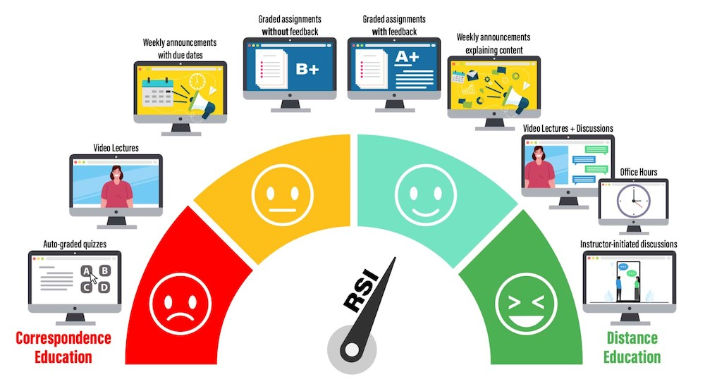
Source: https://oscqr.suny.edu/rsi/

Practice 1: Provide meaningful, instructor-initiated feedback on assignments.
- Individual feedback should be given on every assignment unless multiple assignments are given in a week and then individual feedback will be provided on at least one assignment.
- When publisher material, also referred to as “courseware” (Cengage Mindtap, McGraw Hill Connect, My Lab and Mastering, etc.) is utilized, instructors should still provide individual feedback to each student on assignments. This feedback should be visible to students and should be provided along with any automated feedback or grades provided to the students by the courseware. If no tools for feedback are provided in the courseware, instructors should provide feedback in Canvas using the posted assignment.

Practice 2: Feedback on assignments should be regular and follow an established schedule.
- Best practices suggest that providing feedback within 1 week of an assignment due date, but should be established by the instructor per the requirements of the course.
- Timely feedback is important in order for students to improve and progress through a course and it is recommended that instructors include a syllabus statement that communicates when students should expect to receive feedback on assignments.
- For summative assessments or projects, students should receive timely feedback to allow for them to make appropriate changes based on feedback.
- Not all assignments can be graded in a single week; this is dependent upon the size of the class and the complexity of the assignment. However, an instructor can give meaningful feedback in a timely manner which may include announcements on how grading is progressing, reasons for delayed grading, and general feedback to the entire class explaining common misconceptions or errors that instructors have noticed while assessing student work.
Practice 3: Demonstrate an active presence in the course by communicating information of an academic nature to the entire class weekly.
- This communication must demonstrate that the instructor is communicating live and not using pre-recorded or pre-written communication. Communication should be current and relevant to each course. This communication can include general course information, but to meet the HED standards, it must also include information of an academic nature.
- Examples acceptable to use in your course:
  - Weekly announcements or overviews of important information and concepts that will be covered
  - Summarizing the discussion board weekly
  - Posting weekly instructor tips on the help forum
  - Pre-recorded lectures created by the instructor for the current course
- Examples that do not meet the communication standard:
  - Pre-recorded lectures or overview videos not generated by the instructor
  - Announcements that have been imported from previous courses
  - Simply reminding students of upcoming due dates and not including other relevant academic information.
Practice 4: Clearly communicate expectations for student – instructor communication, and the timeline and method should be clearly stated in the syllabus of the course.
- Quality Assurance practices suggest that instructors respond to student email within 48 hours during the scheduled workweek for a full-term course or with 24 hours of any short-term course.
- It is understood that faculty have non-traditional work hours, especially adjunct faculty. The goal of this standard is flexibility, but consistency and clarity.
Practice 5: Instructors should clearly state how to best contact the instructor to answer questions, or utilize a “help” forums by encouraging student use. It is best practice to respond within 48 hours during the scheduled work week for a full-term course or with 24 hours of any short-term course.
- Best practice for online instruction encourages the use of “help” forums, “question and answer” forums and other forms of open, threaded discussion. These forums can be helpful for both students and instructors, as often students answer questions for each other. Regular participation in a “help” discussion by the instructor can mediate many forms of course questions as well as notify an instructor when something in the LMS has not worked as expected. This equates to in-class question/answer sessions. Students ask open questions to an instructor and all students have access to that question as well as the answer. It can also help with community-building in the course by supporting a student-centered approach.
- If an instructor decides to provide a “help” forum for students, It is imperative the instructor encourage participation in these help forums and establish guidelines for use in the course syllabus. By providing a forum to students, instructors are obligated to regularly monitor and utilize the forum in the event that clarification or correction is needed for student responses.
- Examples:
  - If a student emails a question that is general in nature, copy and paste to the help forum with your response so all students can take advantage of the information.
  - Require students to post to the help forum about a topic that was unclear. This gets them to post, which will hopefully then lead to more postings.
  - Give extra credit points to students who posted in the help forum and to those who respond to the postings of others to provide help.
Practice 6: Encourage regular interaction between students
- It is impossible to replicate the kind of interaction students experience in a face-to-face class in an online environment; however, attempts should be made to create student-to-student interaction. Interaction among students can support learning objectives, create meaningful exchange of ideas, and provide an enriched experience for students as they work through course material. Student-to-student interaction can come in the form of threaded discussion, peer review, team projects, and open forums.
- If discussions are provided in the course for student-to-student interaction, syllabi or assignments should clearly state that students are required to reply to other student posts. Students typically do not participate when the activity is optional or does not have weighted value.
- The instructor must take an active role in encouraging students to participate. Some examples of this include:
  - talking about discussions in weekly announcements,
  - writing discussion summaries, or
  - using synchronous course tools.

Practice 7: Grades must be kept in Canvas and updated weekly
Online students should have access to their grades at all times. Since the course is housed in the Canvas LMS, the grades must be posted in the Canvas LMS. If outside publisher resources are used and assignments are scored on the publisher site, then either integrate so the grades automatically post to Canvas or move the grades from the publisher LMS to Canvas weekly. If not already given, the individual feedback required in Delivery Standard 1 should also be provided
Practice 8: Communicate in a constructive and supportive manner.
Constructive and supportive communication can be provided in discussion forums, in open help forums, in announcements, in MUW emails, as well as in feedback given to students. Best practice encourages multiple forms of communication within a course, and this communication should be professional, constructive, and supportive.

References:
Adapted from New Mexico State University Alamogordo. Online Delivery Standards (2022) https://alamogordo.nmsu.edu/files/docs/Online-Delivery-Standards-Update-9-11-22.pdfcit
*Regular and Substantive Interaction documentation taken/adapted from the WCET Policy Playbook
**The RSI graphic illustration and some content has been adapted and is used with the permission of the SUNY Online Team.
***Retrieved from Regular and Substantive Interaction: Regulatory & Pedagogical Implications presentation by WCET

