

The welcome screen has been modified recently. Although it looks different, the concept is the same.

BANNER 9

BUSINESS/FINANCE

LOGGING IN BANNER 9


TO ACCESS BANNER SCREENS:
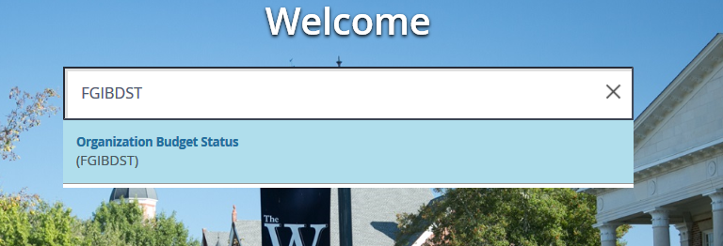

Type in the Banner page you are wishing to work in. Once typed, click enter.

FGIBDST
ORGANIZATIONAL BUDGET STATUS FORM
This screen will be the most helpful in keeping up with your department’s budget. The purpose of the Organizational Budget Status Form (FGIBDST) is to provide a query of the budget availability by organization code. Cumulative, fiscal year-to-date budget and expenditure activity will be displayed by account code. Form FGIBDST, associated forms can be accessed for additional detail.
Organization: Enter
your six digit org code
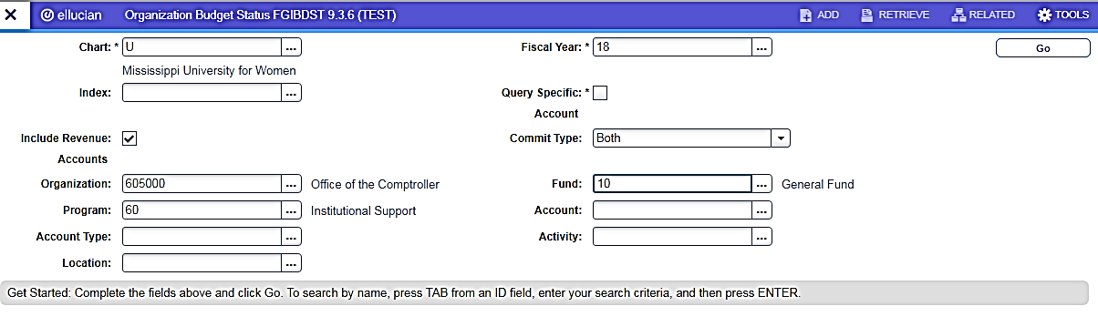
Chart: Should always
be "U" (University)
Fiscal Year: Defaults current fiscal year. It can be changed to whatever fiscal year you are looking for.

Fund & Program: Will populate after the TAB button is pressed once the org is entered.
Be sure the default code that appears is correct, if not, enter the correct code or leave it blank

*If you uncheck Include Revenue Accounts, your budget’s available balance will be calculated. Note – if you have revenue accounts within your budget, check Include Revenue and search for revenue codes (all revenue codes will be 3 digit account numbers)

Once the required information is entered, click GO or ALT page down to display the budget detail information

FGIBDST
ORGANIZATIONAL BUDGET STATUS FORM
Adjusted Budget: This is the amount the organization is given at the beginning of each fiscal year with any budget adjustments that have been made as well.
*Amounts will only be in the “parent” accounts (1000; 2000; 3000; 4000; 5000; 6000; 8100; 8200; 9010)

YTD Activity: Total expenses to date for FY entered. These amounts are expenses that a check has been cut and payment made.

Account: These are the Chart of Account numbers.

Commitments: Outstanding Purchase Orders

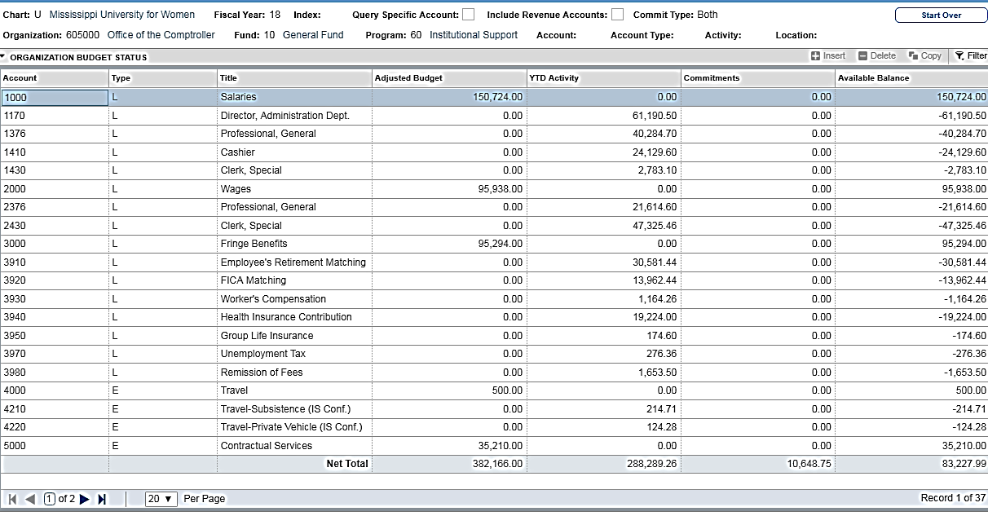
Available Balance:
Adjusted Budget – YTD Activity – Commitments = Available Balance

*All expense accounts will fall under a “parent” account.
For Example: 3000 is the parent account for all fringe accounts. Any 4 digit account that starts with a “3” will fall under the 3000 parent account. The 3000 account would be your budget amount and the accounts 3910, 3920, etc. would be expenses subtracted from that amount. The same would go for all the other parent and expense accounts.

FGIBDST
ORGANIZATION BUDGET STATUS FORM
How to perform a query
With any screen in Banner, you can create a query to search for information you are looking for. Below is an example of how to create a query to get the available balance for a particular account (Contractual, Commodities, Etc.). You will need to be in the FGIBDST screen and have pulled up the information covered in the previous pages. The information for all the accounts will need to be cleared out to enter a query. To do this, use the F7 key. This will populate the Basic Filter bar above your budget information.
Include Revenue Accounts: should be unchecked
Follow the steps below to perform the query:
F7 key will bring up the Account block.
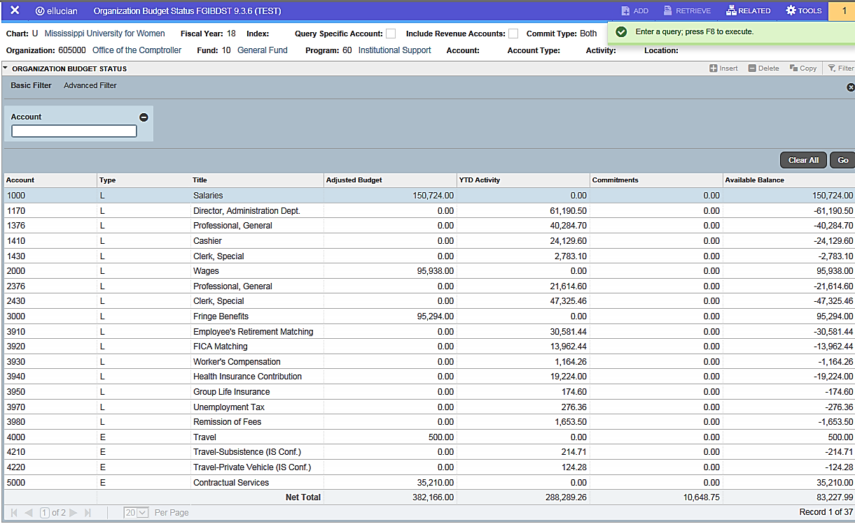

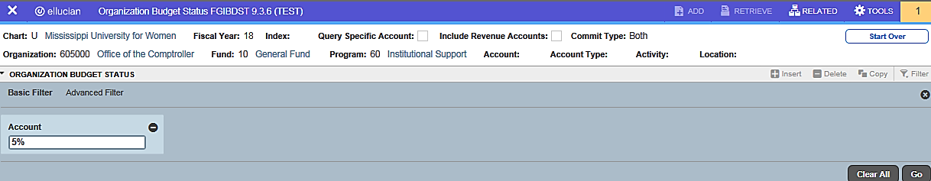

For Example: enter a 5 for Contractual Services followed by a %.
F8 or GO to execute the query. This will pull up the information and balance for that particular account

FGIBDST
ORGANIZATION BUDGET STATUS FORM
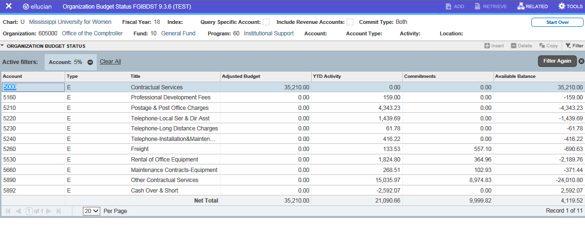
How to perform a query

Using this type of query will give you a quick balance for each category.

The F7/F8 query can be used on many different screens within Banner.
Remember the % is the “wild card”. You can look up amounts, names, PO#s, etc. An example, if you were wanting to look up Office Depot but you were not sure how it was entered into Banner, within the appropriate line search for a vendor you could put in %Office%. This would bring up any vendor with the word Office in it. If you keyed %Office Depot% the query would pull up any vendor with Office Depot in the name.
To return to the original screen with all the information, key F7, delete what may be in the Account field from your query search, then press F8.

FGITRND
DETAIL TRANSACTION ACTIVITY FORM

Details a Specific Account – This can form can be accessed through the FGIBDST screen covered in the previous pages.

*Perform the instructions from page 1 to begin the FGITRND process. Once you have pulled up that information, follow the steps below

On the FGIBDST screen, move the cursor to the Account you
Wish to review (5660, 6130) then click on RELATED to open page options. Select Transaction Detail Information (FGITRND) third option.
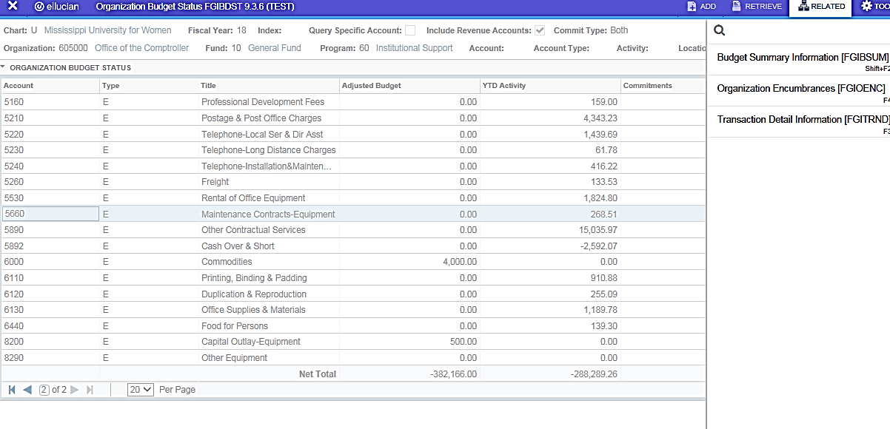

FGITRND
FGITRND gives a detailed version of a particular account
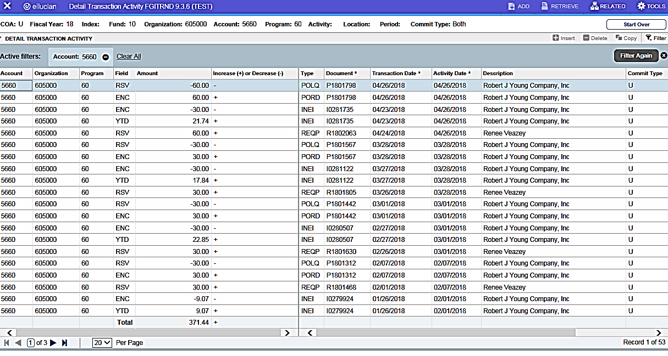
DETAIL TRANSACTION ACTIVITY FORM

Perform a query to clear out all the other acronyms to focus on the YTD amounts.
F7 will pull up the Filter Box. Tab over to the Field column to look up a particular field. To perform the query, click Go or F8.
The Field column will display different acronyms (showing the creation of the requisition and POs)
The amounts that make up the total at the bottom are the amounts that have YTD (year to date) in the field column. These are payments that have been made.

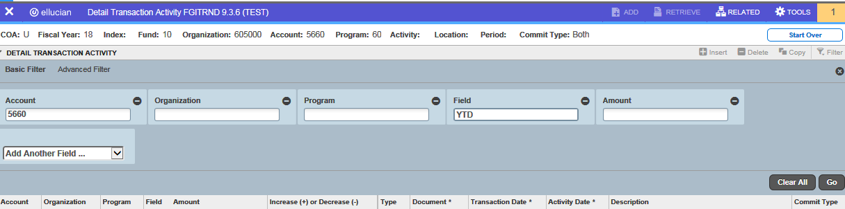

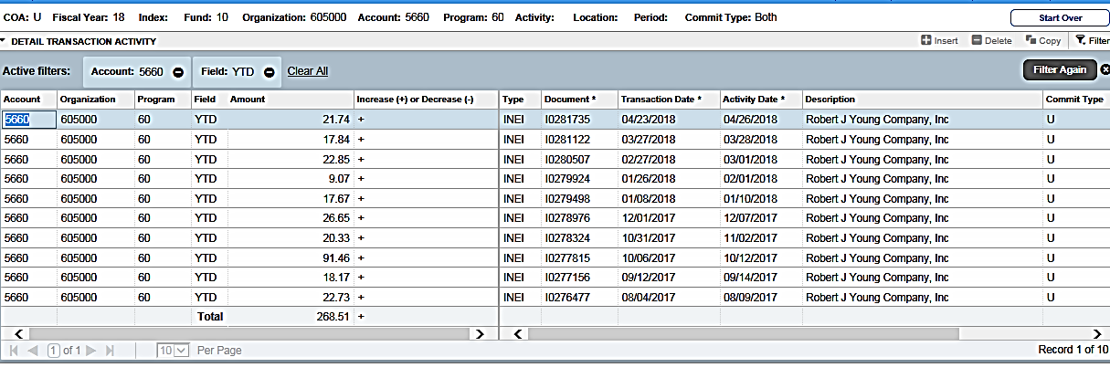

FAIINVE
DOCUMENT QUERY
This form can be accessed through the FGITRND Screen covered in the previous pages.
The Document Query form is used to view documentation related to a particular expenditure or commitment
Highlight the transaction you want to research. Click RELATED then select Query Document by Type

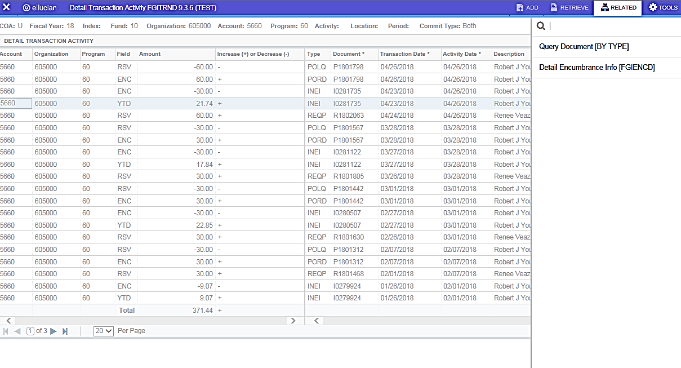

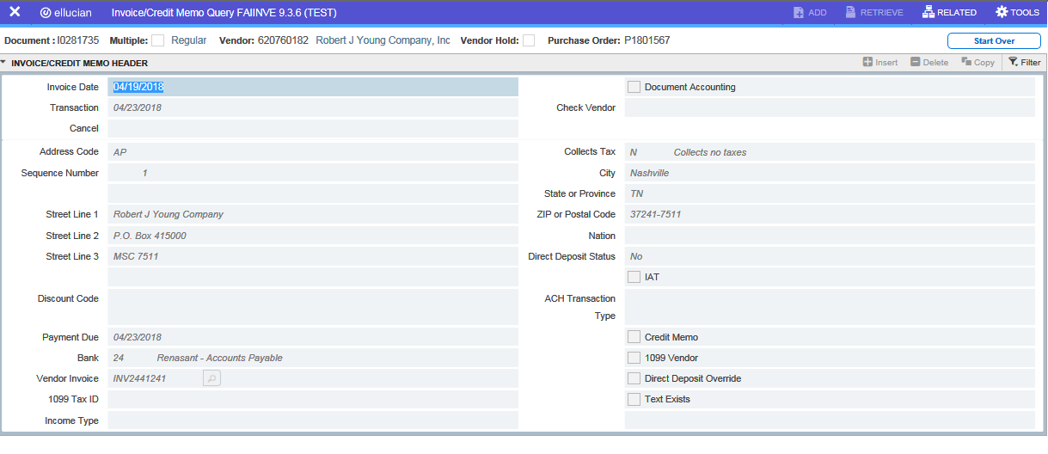
Following the steps above will bring you to the FAIINVE page.

To navigate through this screen use alt+page down. This will provide detailed information about the charge.
Listed will be the mailing address, vendor ID number, description, what the payment is for, amount, etc.

FGIOENC
ORGANIZATION ENCUMRANCE LIST
This form can be accessed through the FGIBDST Screen
The Organization Encumbrance List gives a complete listing of all open encumbrances for an organization.
While on the FGIBDST screen – select the RELATED TAB to highlight Organization Encumbrances (FGIOENC)

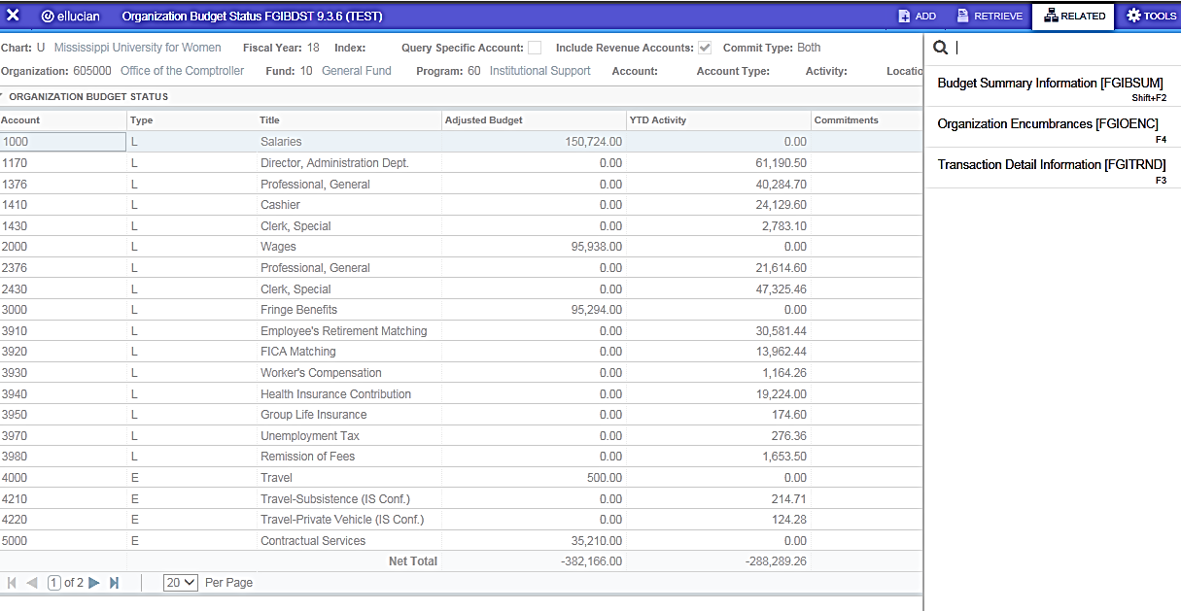

If a PO is not closed, it could be that a payment was never made.
In order for University Accounting to issue a check, we must have a signed receiving report and invoice. Be sure to send all receiving reports to UA in a timely manner.
If you have turned in all information and the PO remains open, contact Accounts Payable (7212) for more information.
If the full amount of a PO is not used, be sure to inform AP by indicating “final” on the receiving report. This will enable AP to close the PO. Remaining funds will be put back to available balance.

Budget Managers should review this form to make sure all POs that should be closed are closed.

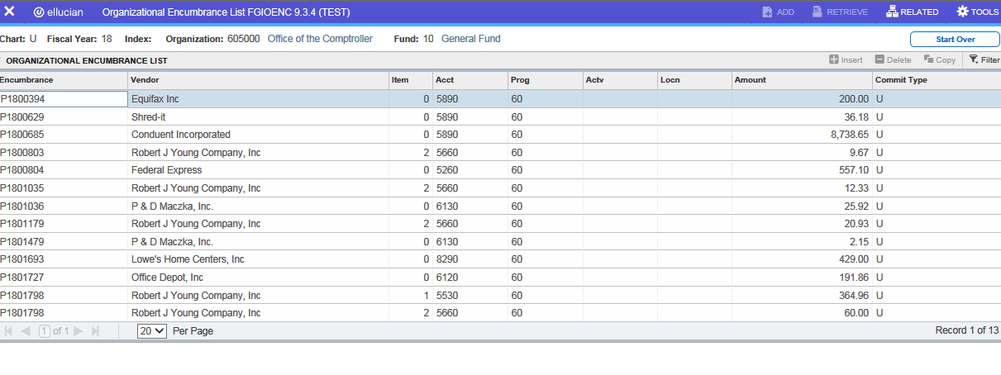

FGRBDSC
ORGANIZATION BUDGET STATUS REPORT
The Organization Budget Status Report gives you an up to date summary on budget and expenditures/commitments for each budget category with a particular organization.
Line Number 01 – Put in Fiscal Year for the report to run in. MUW FY run from July 1 – June 30. (EX: FY19 runs from July 1, 2018 to June 30, 2019)
Printer – key in DATABASE
Line 02 – U for chart of Accounts
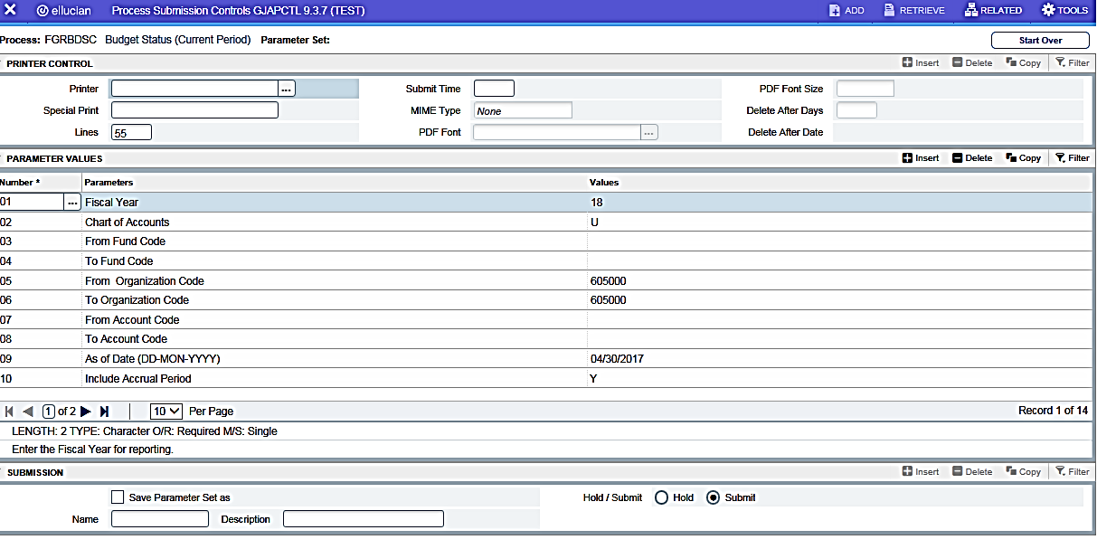

Line 05/06 – List the organization number wanting to review
Line 09 – Key in the date for the report to run through

Save Parameter Set As – check this box if you want all the parameters above saved (the information will be there then next time you log into this screen)
*All other lines leave blank. All lines after 09 leave as default. Once all information has been entered, the save button (not in view) is located at the bottom right of the FGRBDSC page
Click F-10 to save report – this is a MUST or the report will not generate correctly

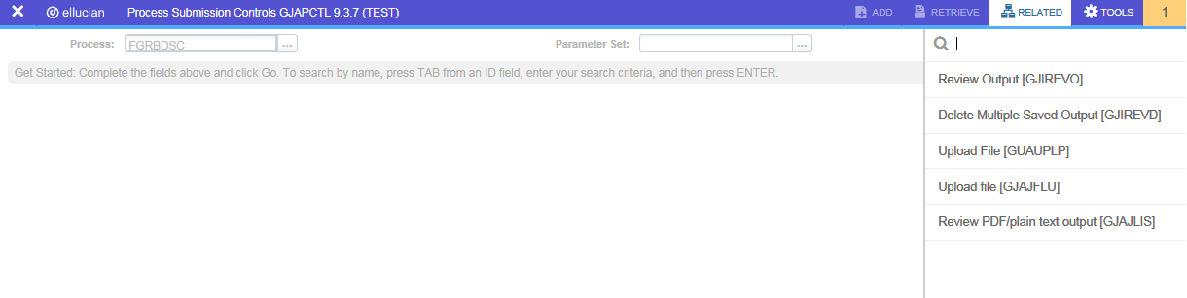

Once saved, the screen below will populate. Click Related and select Review Output.

FGRBDSC
ORGANIZATION BUDGET STATUS REPORT – continued from previous page
After selecting Review Output click on the … following File Name to bring up the reports

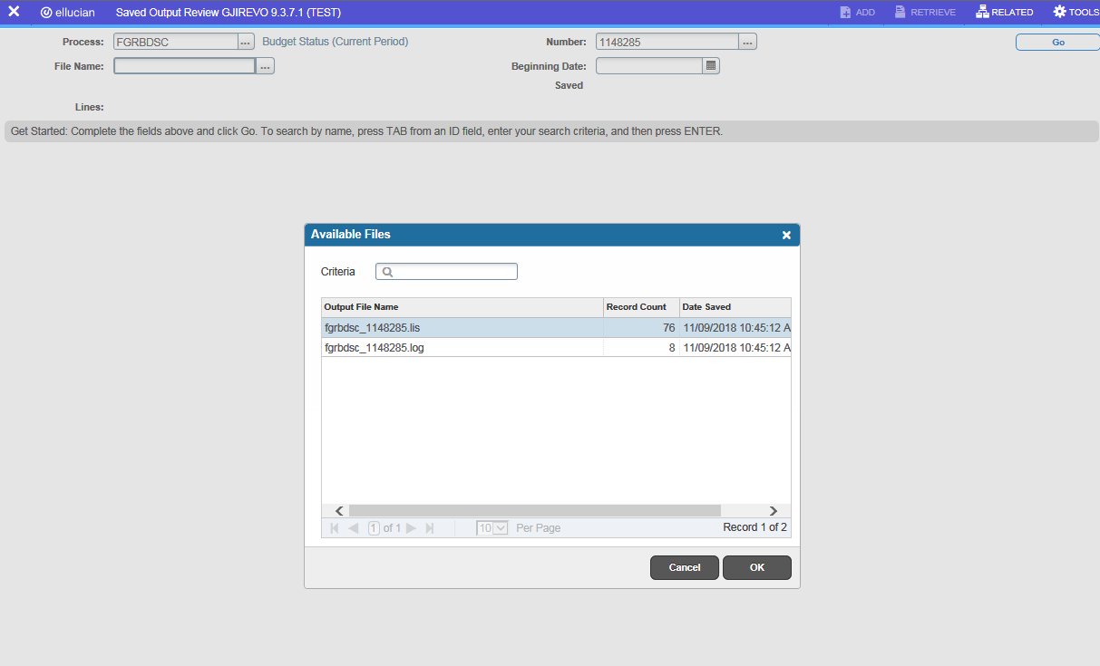

Select the report with the most data. Click OK

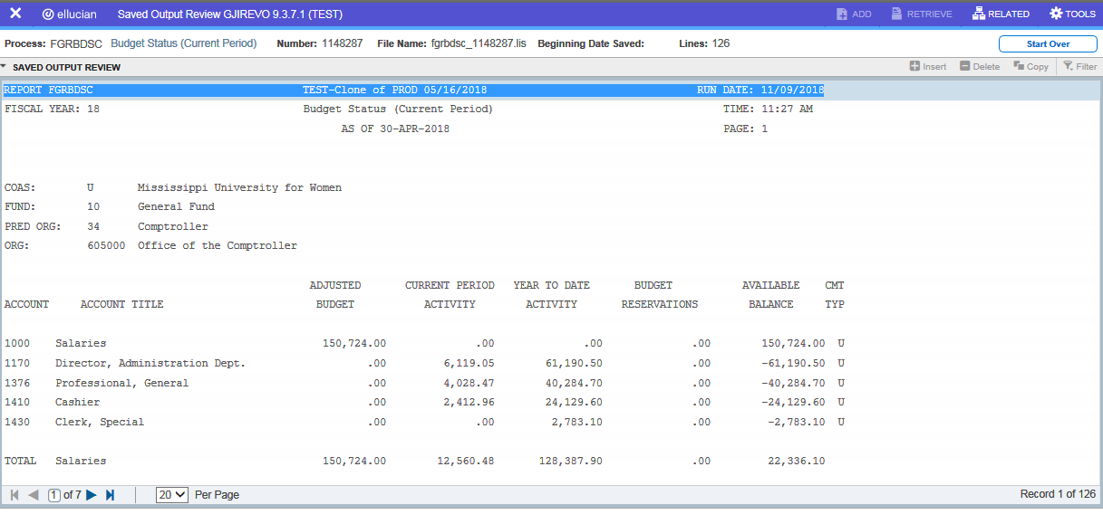

The file can be saved and printed using the TOOLS tab.

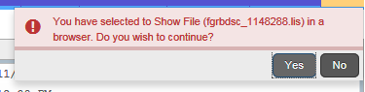

From Tools, select Show Document to save and print
Click yes to show and print file

FGRODTA
ORGANIZATION DETAIL ACTIVITY REPORT
The Organization Detail Activity Report gives a line-by-line detail of the activity within an organization’s budget for a particular period of time.
The report format of Banner page FGITRND
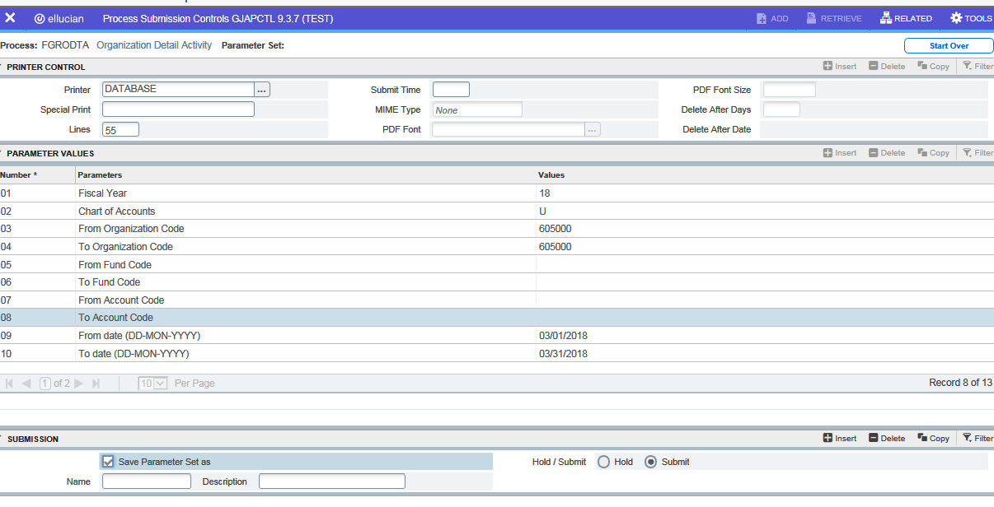
Key in DATABASE for the Printer field

01 – FY for report
02 – U for University
03/04 – Organization required
09/10 – Date range for report. This report can run a whole FY at a time.
Click to Save Parameters
Click F-10 to save report – this is a MUST or the report will not generate correctly

Follow the steps on page 12 to save and print the report

Saving from webpage only allows report saved in text file which won’t pull up to view. Right click to copy report (from web page). Open word document and paste report. Changing font and page orientation will help to view all information.

FOIDOCH
DOCUMENT HISTORY
FOIDOCH is used to view requisitions, invoices, checks and purchase orders.

Type in the document type in order to research a check, requisition, invoice or purchase order
TYPES:
REQ – Requisition
PO – Purchase Order
INV – Invoice
CHK – Check

Enter the Document Type and the Document Code.
(Document Code would be the Check number, Invoice number, PO number or Requisition number.)

Enter information in both fields and click Go or F10.

If Document Code is not known, type in the Document Type and click on the … beside the Document Code

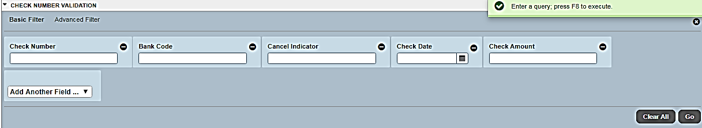

A more detailed filter will open to narrow down the Search. Fill in and click Go. A filter like the one above works with all Document Types.

FOIDOCH
INVOICE/CHECK

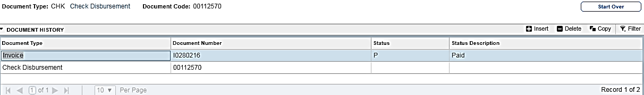
Enter Document Type, Document Code and click Go

Document History results will show the invoice number and the check number that was distributed.

Invoice Status:
Blank – Not Yet Paid
P – Paid
R – Receiving is incomplete
S – Invoice Suspended
X – Invoice Cancelled

The status codes used for checks
Blank – Newer check, not yet generated
F – Check finalized
X – Check voided

FGIBAVL
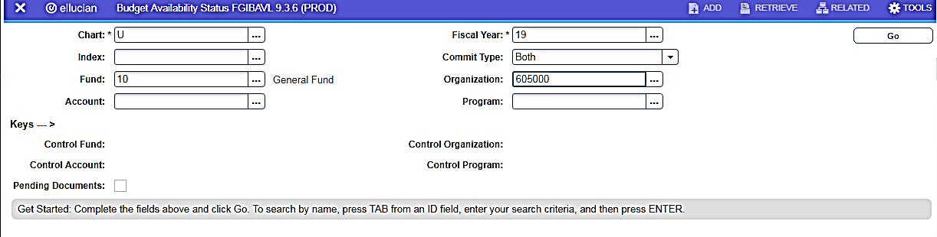
Budget Availability Status Form

Cannot be left blank

Enter in the accounting information for the Organization you wish to view, click Go
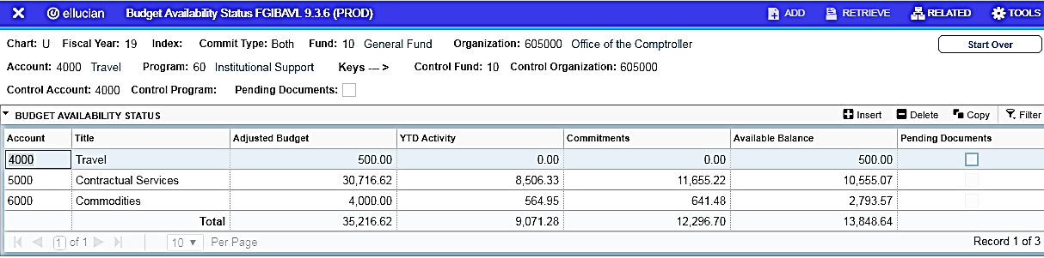

FGIBVAL – is the form used in Banner to check Non-Sufficient Funds (NSF)
The available balance in FGIBAVL is reduced by complete, incomplete, suspended and unapproved transactions (requisitions, POs, invoices and journal entries)

FAIVNDH
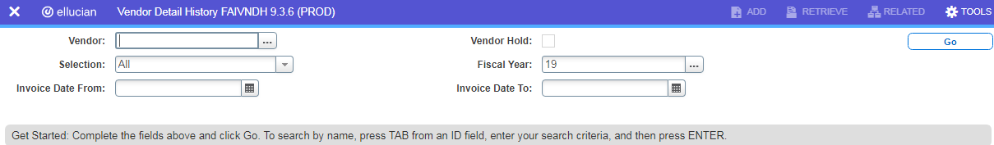
VENDOR HISTORY

Enter the Vendor ID number if known (9501/9502 number or AP vendor ID). If unknown click the … to search.
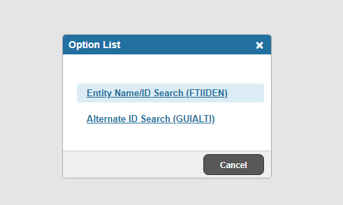
Search Box – click Entity Name/ID Search (FTIIDEN)

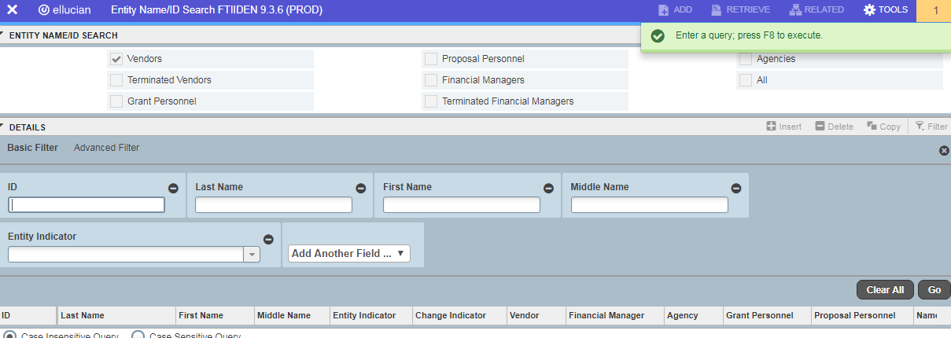
Advanced filter to search for Vendor

Type in the Vendor Name which is case sensitive then Click Go

FAIVNDH
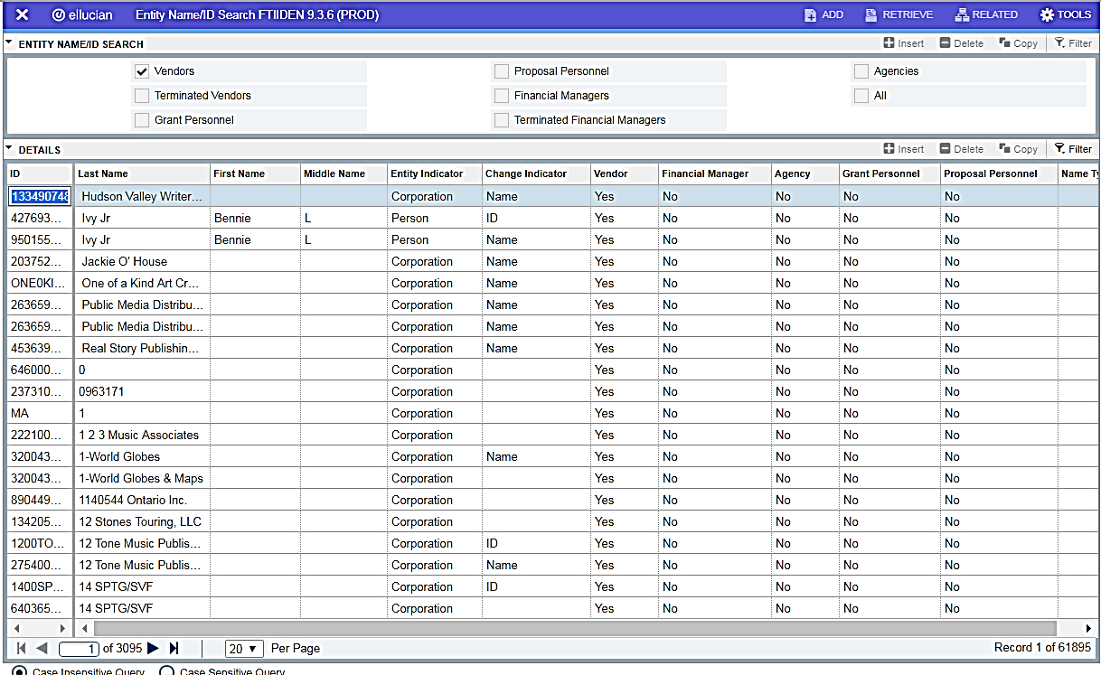
VENDOR HISTORY

Double click on the Vendor you are looking up. Use the navigation arrows to move through Banner pages to find vendor.
Once you double click on Vendor, Banner will take you back to FAIVNDH with the Vendor Number listed
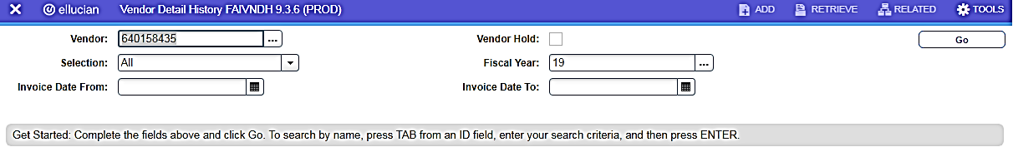

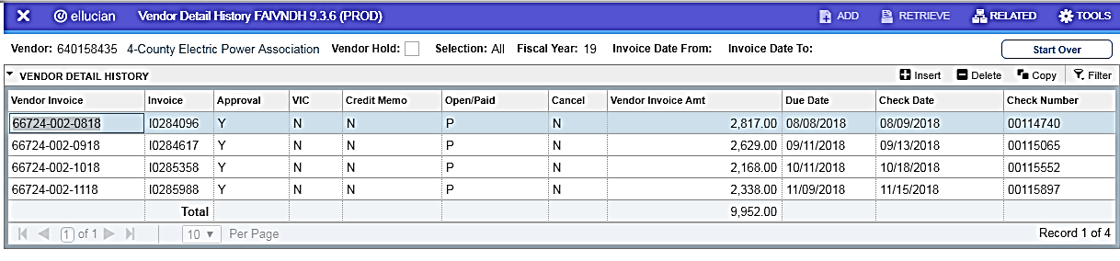
Click GO to pull up detailed Vendor history. Shows Invoices, approval status, payment status, amount of invoice, date invoice was keyed in Banner, date of check and check number.

