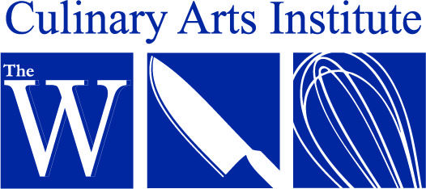

Fall 2017 Cooking Class Schedule & Registration Form

The Culinary Arts Institute at The W is now offering cooking classes that require no MUW enrollment. Each class is offered individually and do not have to be taken in connection with any others. Feel free to sign up for one or all of them, we’d love to have you!

- Biscuits & Scones $50 – September 16th 9am – noon SOLD OUT

- Fresh Pasta Workshop $50 – September 30th 9am – noon SOLD OUT

- Cookie Swap $25 – October 28th 9am – noon

- Holiday Breads $50 – November 4th 9am - 2 pm

.
To mail in your registration, complete the registration form below, and include your check made payable to Culinary Arts Institute.

Mail to:
Culinary Arts Institute
Attention: Cheryl Brown
1100 College Street, MUW-1639
Columbus, MS 39701-5800

Call:
662-241-6286 or 662-241-7472

E-Mail:
Feel free to email mhhawkins@muw.edu if you have any questions.

Drop Off:
Bring completed registration form along with check made payable to Culinary Arts Institute. MUW Culinary Arts Institute / Shattuck Hall / 1100 College Street / Columbus, MS 39701.

NAME ___________________________________________________________________

PHONE NUMBER__________________________________________________________

ADDRESS _________________________________________________________________

CITY _____________________________ STATE ________ ZIP CODE _______________

E-MAIL ADDRESS _________________________________________________________

CLASS NAME_____________________________________________________________

CLASS NAME_____________________________________________________________

CLASS NAME_____________________________________________________________

CLASS NAME_____________________________________________________________

CLASS NAME_____________________________________________________________

Amount Enclosed $___________________
Refund Policy: No refunds will be given for cancellations made less than two (2) weeks prior to the class date.

