GRADE: 6
Unit Title: RATIO AND PROPORTIONAL RELATIONSHIPS  Lesson Title: Ratios, Rates, Proportions and Unit Rates  Estimated Duration: 2 DAYS |  | Real-World Purpose:  - How are rates and unit rates used in the real world?  - How is a unit rate similar to and different from a ratio?  - When you bake a pineapple upside-down bundt cake, what is the ratio of the water to the number of cups of flour?  - What is the cost of an egg if a dozen cost $1.99?  - We can understand which is a better buy during shopping or doing groceries by using ratios, proportions and unit rates.  - ________
I Can:

6.RP.1 Understand the concept of a ratio and use ratio language to describe a ratio relationship between two quantities. For example, “The ratio of wings to beaks in the bird house at the zoo was 2:1, because for every 2 wings there was 1 beak.” “For every vote candidate A received, candidate C received nearly three votes.”

6.RP.2 Understand the concept of a unit rate a/b associated with a ratio a:b with b 􀁺 0, and use rate language in the context of a ratio relationship. For example, “This recipe has a ratio of 3 cups of flour to 4 cups of sugar, so there is 3/4 cup of flour for each cup of sugar.” “We paid $75 for 15 hamburgers, which is a rate of $5 per hamburger.”

6.RP.3b Use ratio and rate reasoning to solve real-world and mathematical problems, e.g., by reasoning about tables of equivalent ratios, tape diagrams, double number line diagrams, or equations.
b. Solve unit rate problems including those involving unit pricing and constant speed. For example, if it took 7 hours to mow 4 lawns, then at that rate, how many lawns could be mowed in 35 hours? At what rate were lawns being mowed?

Performance Objective: (Evidence of Learning)

- Students will be able to identify vocabulary or meanings of words related to ratios, proportions and unit rates by completing classwork and homework exercises independently with 75% accuracy.
- The students will be able to understand unit rates by solving problems given guided practice with 75% accuracy.
- The will be able to apply ratios, rates and unit rates in the real world by making a simple math problem that they encounter in real-world situations.

Prerequisite Skills:

Across-Grade Coherence: Content Knowledge from Earlier Grades
- 4.NF.A.1: Explain why a fraction $\frac{a}{b }$is equivalent to a fraction $\frac{(n × a)}{(n × b) }$ by using visual fraction models, with attention to how the number and size of the parts differ even though the two fractions themselves are the same size. Use this principle to recognize and generate equivalent fractions.

- 5.NF.B.4: Apply and extend previous understandings of multiplication to multiply a fraction or whole number by a fraction.

Within-Grade Coherence: Content from Other Standards in the Same Grade that Provide Reinforcement
- 6.RP.A.1: Understand the concept of a ratio and use ratio language to describe a ratio relationship between two quantities.

Materials/Resources:  - Whiteboard  - Post-it-notes  - 4-function calculator  - Sort cards  - Chart paper  - Document camera  - Flashcards  - Fraction tiles  - Attachments (Total: 4) |  | Key Vocabulary:  - Ratio  - Proportion  - Unit rate  - Equivalent ratios  - Greatest common factor  - Factor trees  - Fraction  - Ratio table  - Scale
Elements of Rigor:
- Conceptual understanding of key concepts
- Procedural skill and fluency
- Rigorous application of mathematics in real-world contexts
Lesson Introduction
How will you introduce the lesson?

One student will be asked to count how many students are there in the classroom. Then ask them to group themselves according to gender. Girls will stay on the right side of the room, and boys will stay in the left side of the room. Ask a representative in the girls group to count how many girls are there in the group. Then ask a representative in the boys group to count how many boys are there in the group. Write their answers on a post-it-note and make the number big. Discuss with the students that when they compare two groups by using ratios, it can be part-whole, an example of which is the ratio of the number of boys (PART) to the number of students in the classroom (WHOLE). It can also be part-part, for example, the ratio of the number of girls (PART) to the number of boys (PART). This will be further discussed on the student exploration activity Chart 1.

STUDENT EXPLORATION ACTIVITY

Ratio/Rate Cards Sort – Put students in groups of two or three. Ask students to sort cards (Attachment #1) into categories (do not give them any guidance, such as titles, amount of categories, etc.)
- Have students explain their categorization.
- Is there evidence of knowledge of part-part, part-whole, and “other”?

- Discuss this CHART 1:
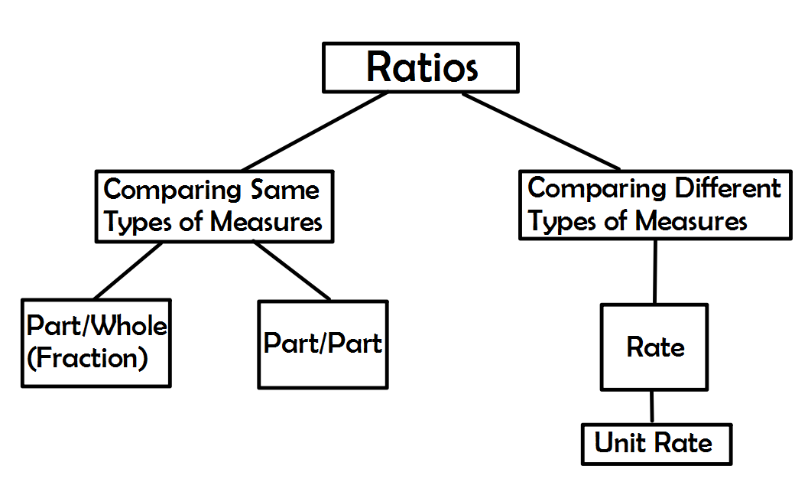
Reference: Adapted from Van de Walle, Teaching Student-Centered Mathematics, grades 5-8, volume 3, pg. 155

- Ask:
- Would you change the arrangement of your card sort given this new information? Why or why not?
- What do you notice about the rate cards?
Possible answer: They use different types of measures.
- What other real life examples of rates can you give?

- Invite student volunteers to explain the definition of unit rate, and guide student responses into a broader discussion:
- A unit rate is a special ratio with a denominator of one that compares different types of measures. It represents a rate with a denominator of 1 in fraction form. Rates are usually expressed in per unit form. Examples include: miles per hour, pizza slices per person, inches per foot, heartbeats per minute, cost per pound, etc.
- Students will view the video on Unit Rates and determine which is a better buy. http://youtube_________

- Return to the card sort. Which rate cards are rates and which are unit rates?
- Review your original sticky notes and classify (or re-classify, if necessary) students’ authentic life examples.
Lesson Activities
Finding the unit rate using equivalent ratios.
- Show two examples:
Example #1:
15 hamburgers for $75. How much per hamburger? (Note to teacher: Make sure students are solving using equivalent ratios.)

$\frac{\$75}{15}$ = $\frac{x}{1}$ $\frac{\$75 ÷15 }{15÷15}$ = $\frac{\$5}{1}$

What is the unit rate? Answer: $5 per hamburger
Example #2: Four movie tickets cost $52. How much does it cost for each ticket?

$\frac{\$52}{4}$ = $\frac{x}{1}$ $\frac{\$52 ÷4}{4÷4}$ = $\frac{\$13}{1}$

What is the unit rate?
Answer: $13 per movie ticket

Use this video to show an example of comparing prices. www.BrainPop.com/math/dataanalysis/comparingprices/

- Which is the better buy? (Rate application)
Use this video to show example
- Compare the prices for various sizes of popcorn sold at the local movie theater.
Mega Bag $10.24 for 32 oz.
Giant Bag $6.00 for 24 oz.
Medium Bag $4.48 for 16 oz.
Kid’s Bag $2.40 for 8 oz.

- What is the unit price per ounce for each bag of popcorn? Show your equivalent ratios.
$\frac{10.24}{32}$ = $\frac{?}{\begin{aligned}1 \\ \\ \\ \\ \end{aligned}}$ $\frac{10.24 32}{32 32}$ = $\frac{.32}{1}$ $\frac{6.00}{24}$ = $\frac{?}{1}$ $\frac{6.00 24}{24 24}$ = $\frac{.25}{1}$

$\frac{4.48}{16}$ = $\frac{?}{1}$ $\frac{4.48 16}{16 16}$ = $\frac{.28}{1}$ $\frac{2.40}{8}$ =$\frac{?}{1}$ $\frac{2.40 8}{8 8}$ = $\frac{.30}{1}$

- What size popcorn is the best buy? Explain your reasoning. Answer: The giant bag the best buy because it cost less per ounce than the other three kinds.

- Have the students work in twos and try the eight problems posted around the room (Attachment #2). Have students go to at least 4 problems to find the unit rate or best buy. Provide a capture sheet for each student (Attachment #3).
Lesson Closure
- Students will need to determine which scenario is correct and justify their reasoning.  - Put 2 pictures of grocery ads of two brands of the same thing side by side on the document camera. Have the students individually determine which brand is the better buy.  - Student will be instructed that they can upload their homework by signing in their accounts at http://frontrow.com  - Students can also be given exit tickets. |  | Essential Questions:  - How can determining unit rates, ratios and proportions be used to represent and understand real-world, and mathematical problems?
Standards for Mathematical Practice (select all that apply)
- Make sense of problems and persevere in solving them.
- Reason abstractly and quantitatively.
- Construct viable arguments and critique the reasoning of others.
- Model with mathematics.
- Use appropriate tools strategically.
- Attend to precision.
- Look for and make use of structure.
- Look for and express regularity in repeated reasoning.

Supplemental Activities
Intervention  - http://buzzmath.com Intervention #1: Ratios and Proportions  - Intervention #2. For students who are struggling on getting the basic ratios and proportions, go to http://www.ixl.com:ratios, proportions, and unit rates  - Intervention #3: Ratios, Rates, and Unit rates. For students who are struggling with vocabularies or understanding meanings of words related on unit rates, go to http://quizlet.com. Review the flashcards and answer the Match test.  - For Students with Disabilities/Struggling Learners, provide calculator for students who need it. When you work in groups, make sure you pair these students with someone who can help them.  - For ELL students, front load vocabulary (ratio, rate, unit rate). They can also go to http://mathtv.com and watch the video on Unit Rates in Spanish. |  | Enrichment  - Have student explore how to use cross-multiplication to get ratios and proportions.  - Changing fractions to decimals using hand or a calculator.  - Show a video on how to solve ratios, proportions and unit rates.  - Give student guidance in dividing the total by the number of items to get the unit rates.  - Have the students (for gifted or advanced students) play this game. www.mathsisfun.com/measure/unit-price-game.html  - Have students look for misleading ads based on unit pricing.
Performance Based Assessment Task
Math Task  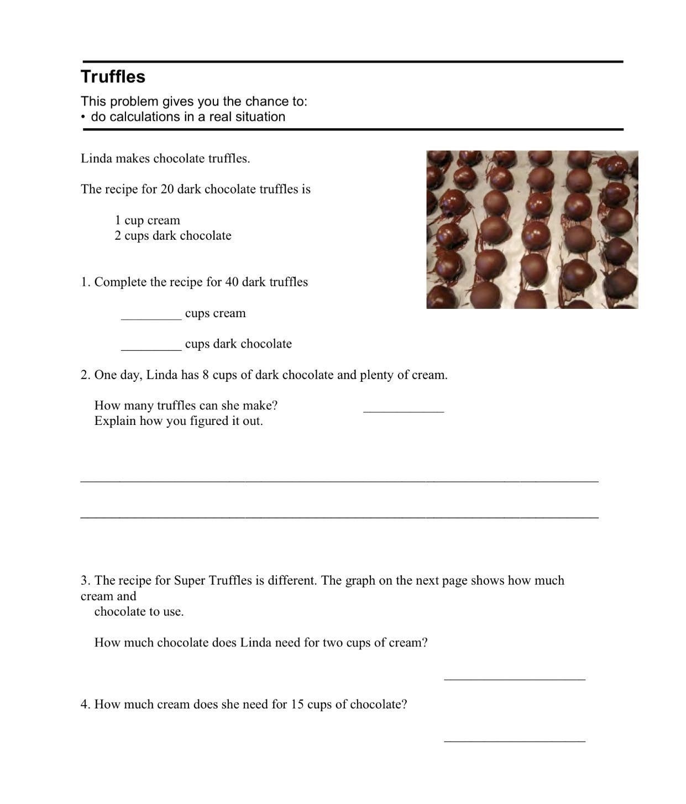  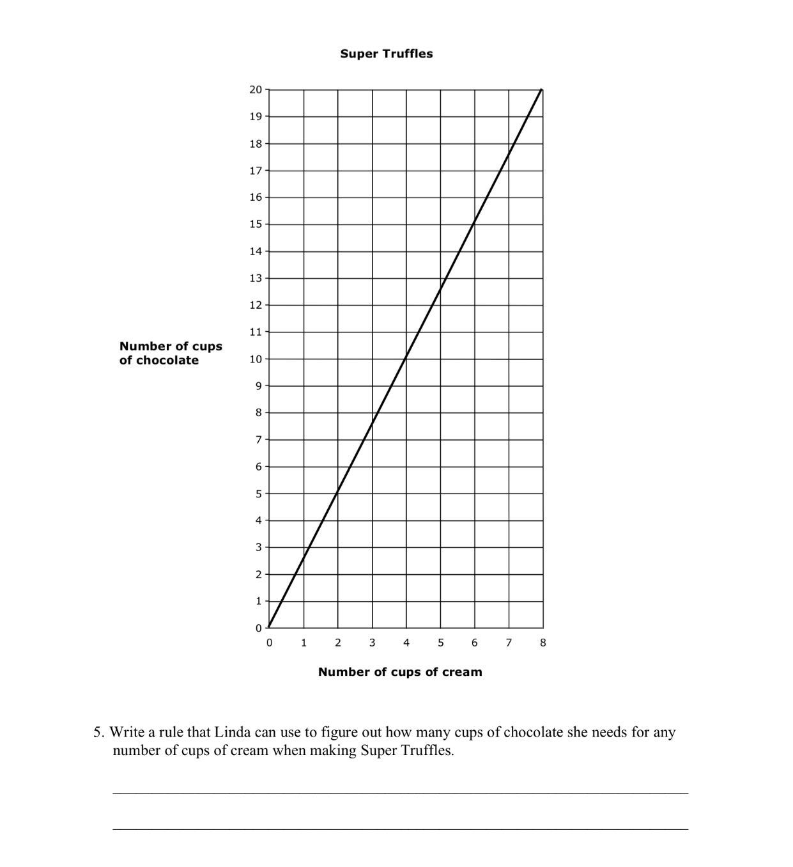 | Rubric/ Plausible Student Response(s)  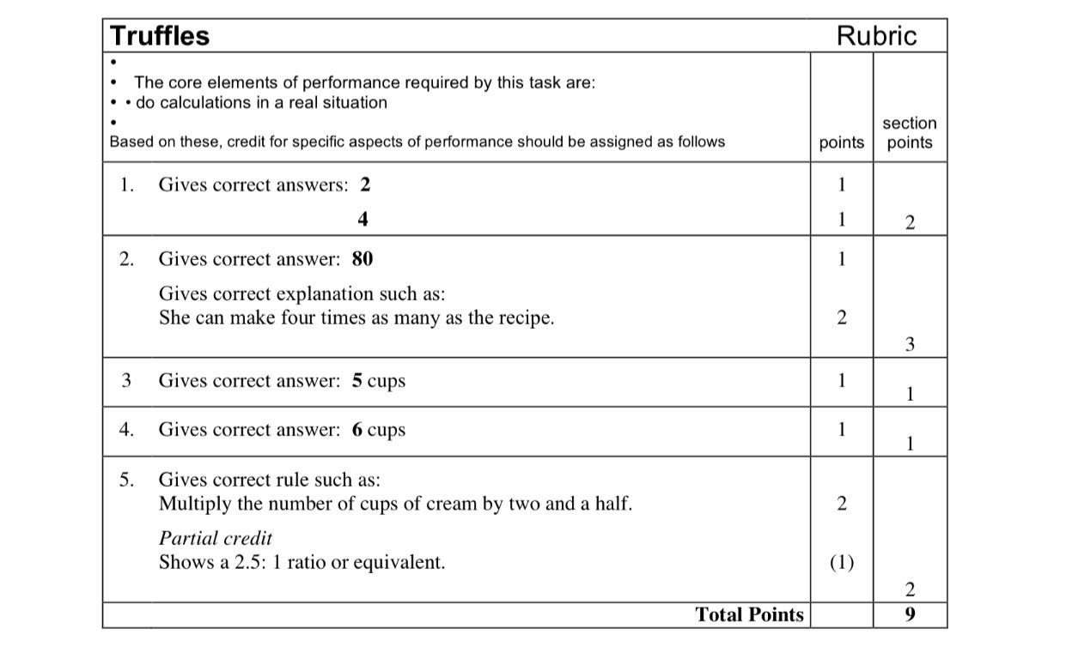  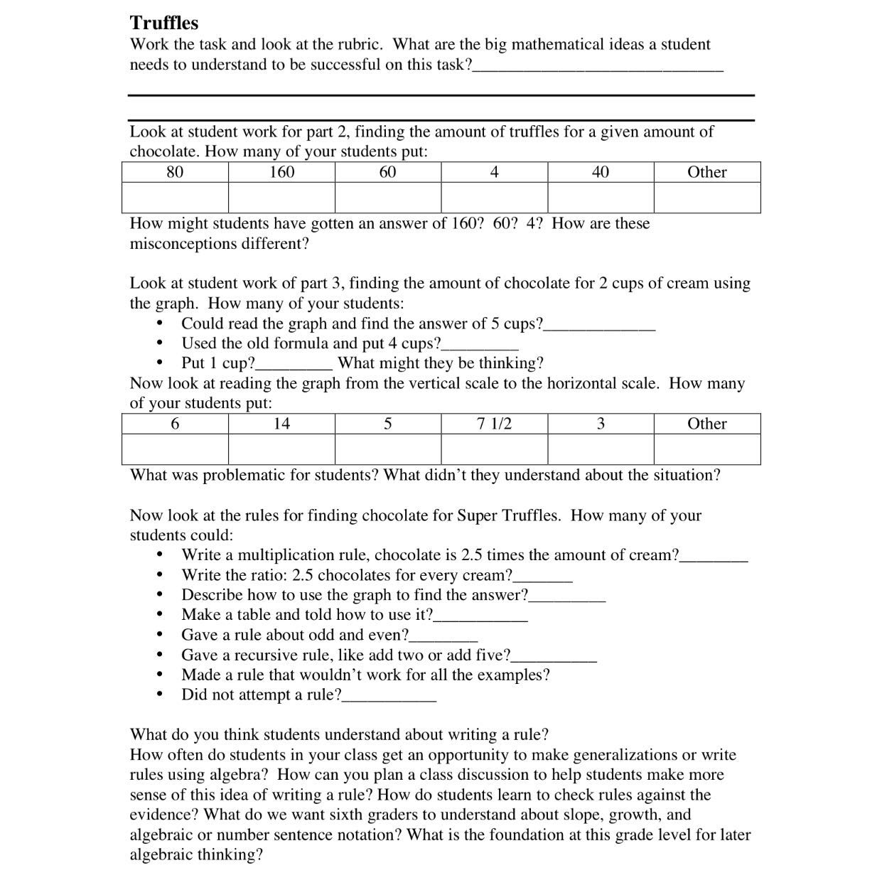

Attachment #1: Graphics for Part/Part and Part/Whole Ratios

GRAPHIC A
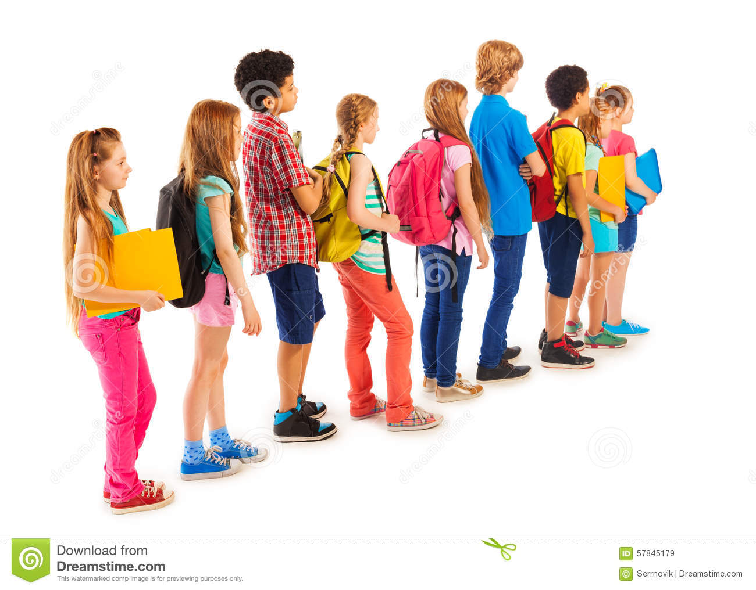

Attachment #1: Graphics for Part/Part and Part/Whole Ratios

Graphic B

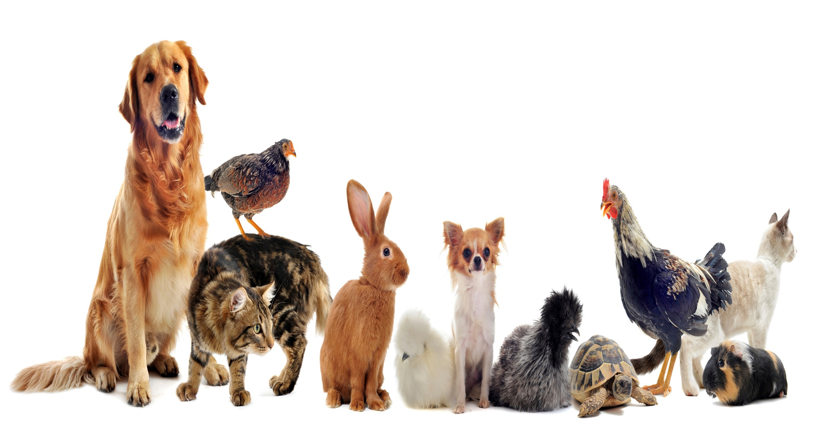

Attachment #1: Graphics for Part/Part and Part/Whole Ratios

Graphic C
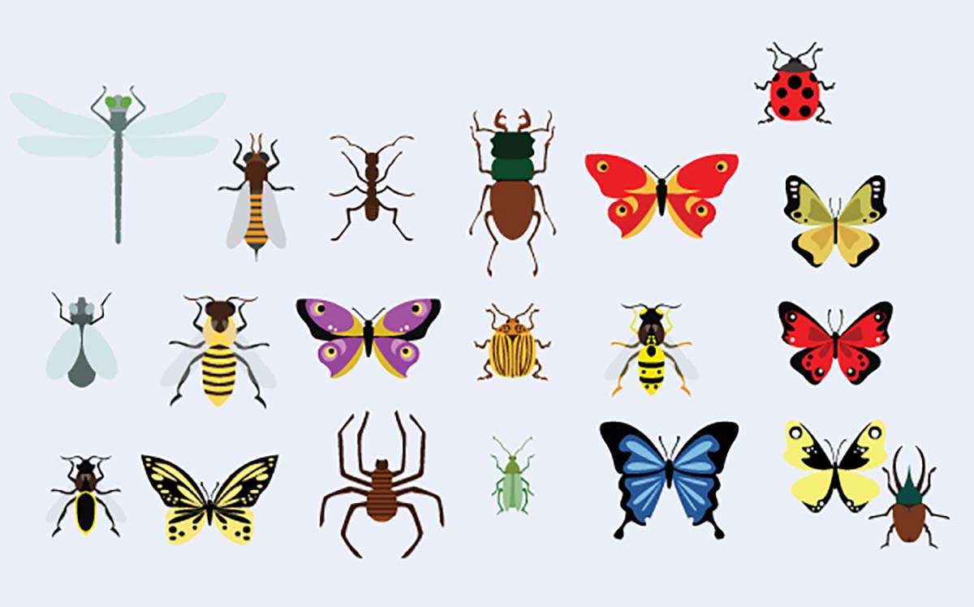

Ratio/Rate Card Sort

Attachment #2:

Number of red roses to number of flowers in bouquet  $\frac{6}{24}$ | Number of red roses to number of yellow roses  6 to 18 | Number of roses per bouquet  12 to 1 | Number of baseballs to number of bats in supply room  $\frac{25}{11}$ | Number of footballs to number of soccer balls  5 to 8
Number of footballs per class  5 : 5  or  1 : 1 | Number of points earned per pupil  $\frac{1140}{15}$ or $\frac{76}{1}$ | Number of points earned to number of possible points  $\frac{80}{100}$ | Number of points earned to number of points not earned  80 : 20 | Probability of getting a head with one coin toss  $\frac{1}{2}$
Probability of getting a head with one coin toss  1 to 2 | Number of heads in 10 tosses  6 to 10 | Number of green M&Ms to total candies in bag  $\frac{5}{23}$ | Number of miles per gallon  $\frac{23}{1}$ | Cost of cereal per ounce  $$\frac{.27}{1}$$
Number of heart beats per minute  67 : 1 | Number of pizza slices per person  3 : 1 | Number of boys to number of girls in same class  11 to 13 | Number of girls to total number students in class  13 : 24 | Cost of bananas per pound  $1.20 : 1
Number of apples to number of oranges  5 : 7 | Number of blue socks to total number of socks in the drawer  6 to 14 | Number of miles per hour  67 : 1 | Number of gallons in 4 minutes  12 : 4 | Number of songs to cost of songs  20 : $5.00

Attachment #2: Ratio/Rate Card Sort - Answer Sheet

Number of red roses to number of flowers in bouquet  $\frac{6}{24}$  ratio | Number of red roses to number of yellow roses  6 to 18  ratio | Number of roses per bouquet  12 to 1  unit rate | Number of baseballs to number of bats in supply room  $\frac{25}{11}$  rate | Number of footballs to number of soccer balls  5 to 8  ratio
Number of footballs per class  5 : 5  or  unit rate  1 : 1 | Number of points earned per pupil  $\frac{1140}{15}$ or $\frac{76}{1}$  unit rate | Number of points earned to number of possible points  $\frac{80}{100}$  ratio | Number of points earned to number of points not earned  80 : 20  ratio | Number of heads with one coin toss  $\frac{1}{2}$  ratio
Number of tails with one coin toss  1 to 2  ratio | Number of heads in 10 tosses  6 to 10  ratio | Number of green M&Ms to number candies in bag  $\frac{5}{23}$  ratio | Number of miles per gallon  unit rate  $$\frac{23}{1}$$ | Cost of cereal per ounce  unit rate  $$\frac{.27}{1}$$
Number of heart beats per minute  67 : 1  unit rate | Number of pizza slices per person  3 : 1  ratio  unit rate | Number of boys in class to number of girls in class  11 to 13 | Number of girls to total number students in class  13 : 24  ratio | Cost of bananas per pound  $1.20 : 1  unit rate
Number of apples to number of oranges  ratio  ratio  5 : 7 | Number of blue socks to total number of socks in the drawer  6 to 14 | Number of miles per hour  67 : 1  unit rate | Number of gallons in 4 minutes  12 : 4  rate | Number of songs to cost of songs  20 : $5.00  ratio

Attachment #3: Number 1

Which is the Better Buy?

2 liters of juice at $3.80
or
1.5 liters of juice at $2.70

Attachment #3: Number 2

Which is the Better Buy?

10 pencils for $4.00
or
6 pencils for $2.70

Attachment #2: Number 3

Which is the Better Buy?

10 fl.oz. of shampoo at $3.60, or
20 fl.oz. of shampoo at $7.10, or 30 fl.oz. of shampoo at $9, or
50 fl.oz. of shampoo at $14.50

Attachment #2: Number 4

Which is the Better Buy?

½ pint of milk at $0.52, or
1 pint of milk at $0.99, or
1 quart of milk at $2.10, or
½ gallon of milk at $4.00

Attachment #2: Number 5

Which is the Better Buy?

500 g of minced beef at $6, or
700 g of stewing beef at $8.68, or
1 kg of beef steak at $14.50, or
1.6 kg of beef roast at $20.80

Attachment #2: Number 6

What is the Speed?

Maria drove to her mother’s house, which is 204 miles away. If it took her 3 hours, what was her average speed?

Attachment #2: Number 7

What is the Cost?

Four gallons of gasoline cost $16.80. What is the price per gallon?

Attachment #2: Number 8

Which is the Better Buy?

3 cans of soda for $1.27
or
5 cans of soda for $1.79

Attachment # 3

PROBLEMS
#1 Which is the Better Buy? 2 liters of juice at $3.80 or 1.5 liters of juice at $2.70
#2 Which is the Better Buy? 10 pencils for $4.00 or 6 pencils for $2.70

#3 Which is the Better Buy? 10 fl.oz. of shampoo at $3.60, or 20 fl.oz. of shampoo at $7.10, or 30 fl.oz. of shampoo at $9, or
50 fl.oz. of shampoo at $14.50

#4 Which is the Better Buy?½ pint of milk at $0.52, or 1 pint of milk at $0.99, or 1 quart of milk at $2.10, or ½ gallon of milk at $4.00.

#5 Which is the Better Buy? 500 g of minced beef at $6, or 700 g of stewing beef at $8.68, or 1 kg of beef steak at $14.50, or
1.6 kg of beef roast at $20.80.

#6 What is the Speed? Maria drove to her mother’s house, which is 204 miles away. If it took her 3 hours, what was her average speed?
#7 Which is the Better Buy? 2 liters of juice at $3.80 or 1.5 liters of juice at $2.70

#8 Which is the Better Buy? 3 cans of soda for $1.27 or 5 cans of soda for $1.79

Attachment #4 Answers
1. 1.5 liters at $2.70
2. 10 pencils for $4.00
3. 50 fl. oz. of shampoo at $14.50
4. 1 pt. of milk at $0.99
5. 500 g of minced beef at $6.00
6. 68 miles per hour
7. $4.20
8. 5 cans of soda for $1.79

