GRADE: 9th
Unit Title: Representing Relationships Mathematically  Lesson Title: Interpreting Different Representations of the Same Information  Estimated Duration:  94 minutes | Real-World Purpose:  Students will learn that information can be expressed in a variety of ways and still mean the same thing. A real world example of this is when a person is comparing cell phone plans and they are written differently. The person is going to want to know which cell phone is better, so they are going to need to know how to interpret the information
I Can:
Standard(s):__F-IF.9______I can compare two functions that are each represented differently (graphs, tables, equations, verbal descriptions).

Standard(s): _A-CED.2_______I can write and graph equations that represent relationships between two variables or quantities.
Standard(s): N-Q.1 __________ can choose, apply, and interpret the units for multistep problems when using formulas, graphs, and other data display

Performance Objective: (Evidence of Learning)
My students will show understanding of how functions can be represented in multiple way by rotating through centers discussing and answering questions about multiple representations. They will show evidence of learning by answering questions after we have discussed their answers to the centers as a group by answering questions about the lesson by writing their answers on the whiteboard. The expectation is that seventy-five percent of students will answer correctly.
Prerequisite Skills:
- Graphing lines
- Writing equations from a graph
- Plotting points on a graph
- Creating equations from a word problem
Materials/Resources:  handouts  PowerPoint | Key Vocabulary:  linear function coordinate plane  equations dependent variable  domain function notation  range  Quizlet
Elements of Rigor:
- Conceptual understanding of key concepts
- Procedural skill and fluency
- Rigorous application of mathematics in real-world contexts
Lesson Introduction
How will you introduce the lesson?
Student Exploration Activity
The centers are a way to pre-assess the students on their knowledge of functions and how to represent data or information in a different form. Each station has a different representation of a function. The goal of this activity is to see if student have the knowledge to write an equation from the representation they are given.

- -TTW set up three centers of linear relationships represented in different ways.
- -TTW setup each center such that it can accommodate sets of 3 students working in pairs.
- -TTW ensure that the student analysis of each function is occurring in pairs.
- TTW have students pictorially represent the scenario.

- -SW have 8 minutes at each station.
- SW write an equation and answer the following questions about each station.

• Center 1: Graphic Representation - Gallons of Gas Scenario At this center, students will be given a graph of how much gas a person used and how many miles they could drive. SEE Attachment 1
• Center 2: Written Representation - Cell Phone Scenario At this center, students are given a written representation to explain Eric’s cell phone bill and they have to figure out how to come up with an equation telling how much Eric’s bill will be for the number of texts he makes or receives. See attachment 2
• Center 3: Table Representation - Pizza Topping Scenario See attachment 3

1. What does the input represent in this scenario?
2. What does the output represent in this scenario?
3. What does the rate of change represent in this scenario?
4. What does the initial value represent in this scenario?
5. Write one sentence to describe the connection between the input and output value in this scenario.

Lesson Activities
Guided Practice
- TW post vocabulary words for the lesson on the whiteboard.
- TW use a vocabulary/writing strategy to introduce key vocabulary. (Frayer Model)
- TW have the students connect each vocabulary term to the real-world scenarios.
After Vocabulary

- TTW model how to write an equation in function notation given a table, verbal description, and graph. (handout See attachment 4, Parking Garage)
- TTW model how to interpret key parts of a function.
- TTW model how to interpret multiple representations of a function.
- TTW tie vocabulary into lesson in the form of a question.
- TTW and SW work on sample problem together ( handout See attachment 5, Monthly Cellphone Bill)
- TTW and SW interpret key parts of a function.
- TTW and SW interpret multiple representations of a function.
Independent practice
- SW work in pairs and create equations using function notation and graph the function for the following real-world scenarios: See Attachment 6.
To check for understanding
- SW work in pairs and rotate around the classroom. ( 15 min each rotation)
- TTW place pieces of butcher paper around the classroom. Each piece of butcher paper will have a different representation of a function. Each group will rotate and add a representation that is not already on the butcher paper.
- SW make sure when they add their representation, it matches the information from the original representation.
- TTW and SW have a discussion about the information students added to the butcher paper

Lesson Closure
1. TTW have the students finalize their independent practice and hand it in as an exit ticket | Essential Questions:  • What is the distinction between independent and dependent variables in a functional relationship?  • What is the connection between the independent and dependent variables and the domain and range of a function?  • What is the relationship between the graph of an equation in two variables and its respective solution set?
Standards for Mathematical Practice (select all that apply)
- Make sense of problems and persevere in solving them.
- Reason abstractly and quantitatively.
- Construct viable arguments and critique the reasoning of others.
- Model with mathematics.
- Use appropriate tools strategically.
- Attend to precision.
- Look for and make use of structure.

- Look for and express regularity in repeated reasoning.
Supplemental Activities
Intervention  - SW will practice labelling a coordinate plane and plotting points on a graph to help the students understand how to draw a graph of a function.  - SW practice understanding of independent and dependent variables to help student to understand where the information will be place on the graph.  - SW practice completing a table to help the students understand the how the information moves along the graph. | Enrichment  - Let students draw a card and construct the multiple representations for that card
Performance Based Assessment Task
Math Task: Dream Salary (See attachment )  Task is attached; also sent to all students via Edmodo  http://www.cfn107.org/uploads/6/1/9/2/6192492/  math_sample_performance_assessment.pdf | Rubric/ Plausible Student Response(s)  How are you measuring success?  To meet expectations for the lesson, student must be able to:  - Remember all types of representations of a function  - Be able to Identify a function from at least 2 multiple representations  - Be able to construct a different representation of a function  Questions to be answered  - What are the 4 types of representation of a function?  - How can you tell that two representations are the same or different?  - What important details are needed to construct a representation?  Possible student answers  - Table, equation, graph, written representation  - Look at the variables and see if the information matches  - Starting point, rate of change

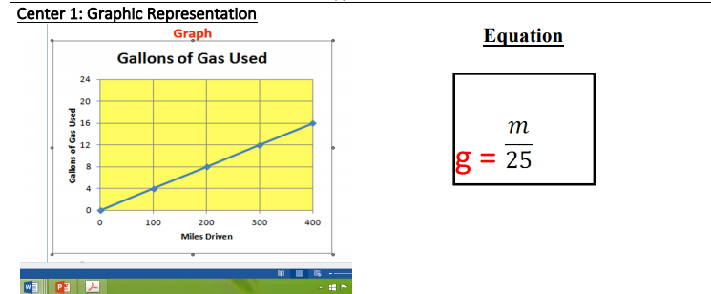
Attachment 1

Attachment 2

Center 2: Written Representation
Description:
Eric’s monthly cell phone bill is a fixed charge of $50 plus 10 cents for every text message text he sends or receives.

Equation

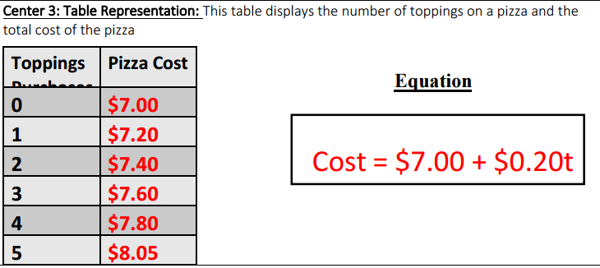
Attachment 3

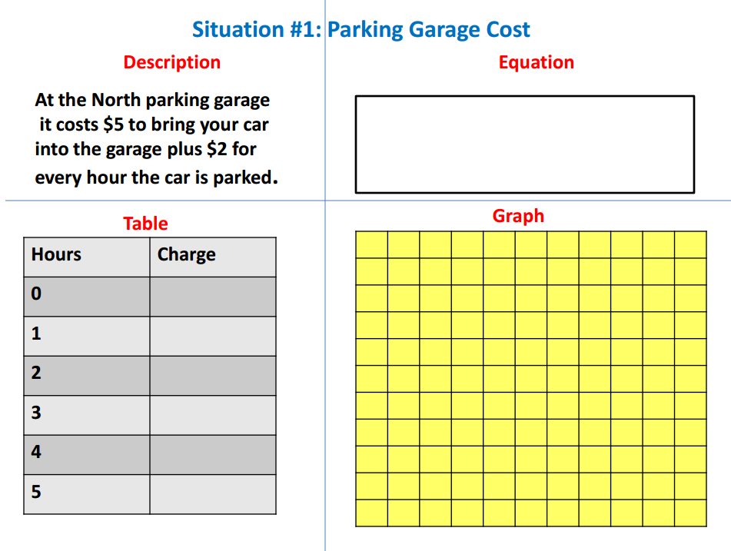
At the north parking garage, it costs $5 to bring your car into the garage plus $2 for every hour the car is parked.

Attachment 4
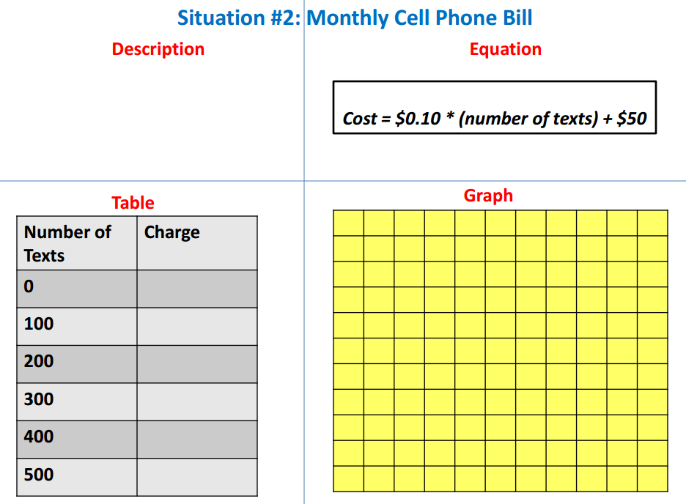
Attachment 5
Attachment 6
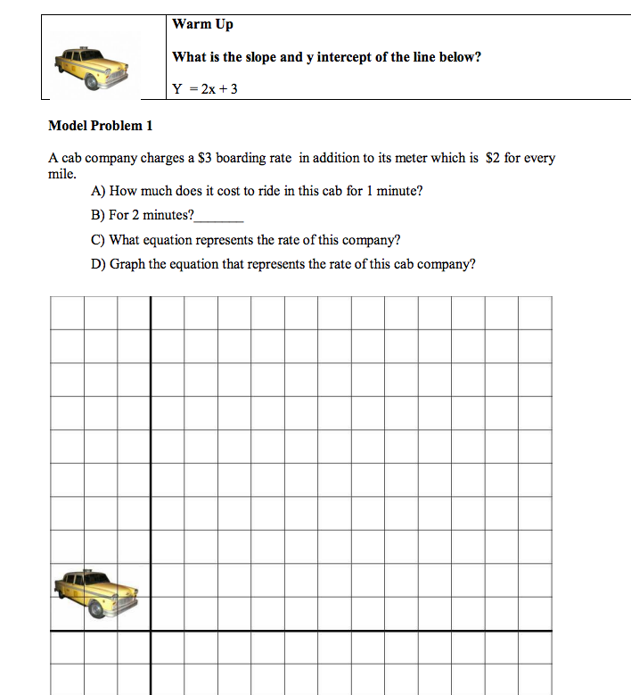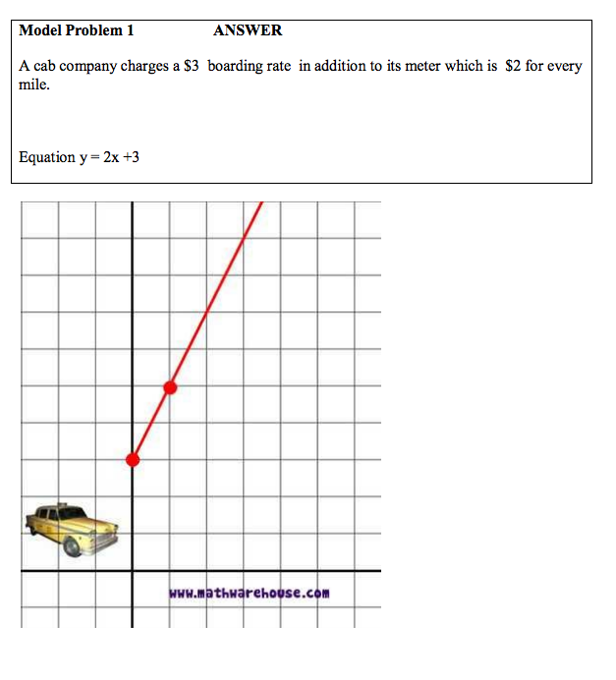
Attachment 6

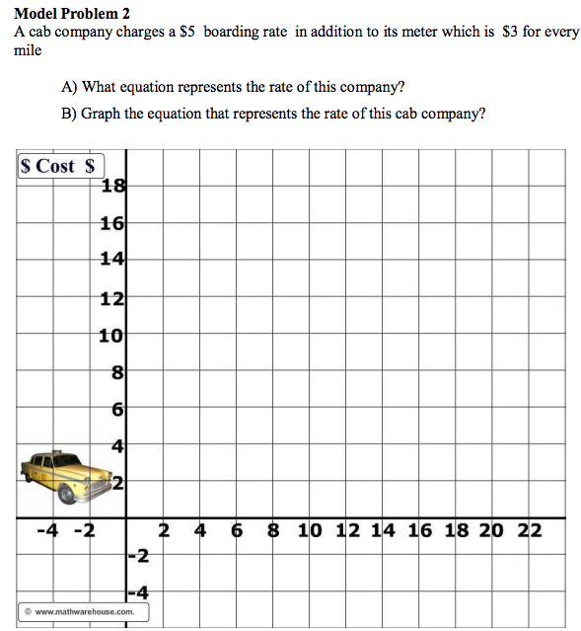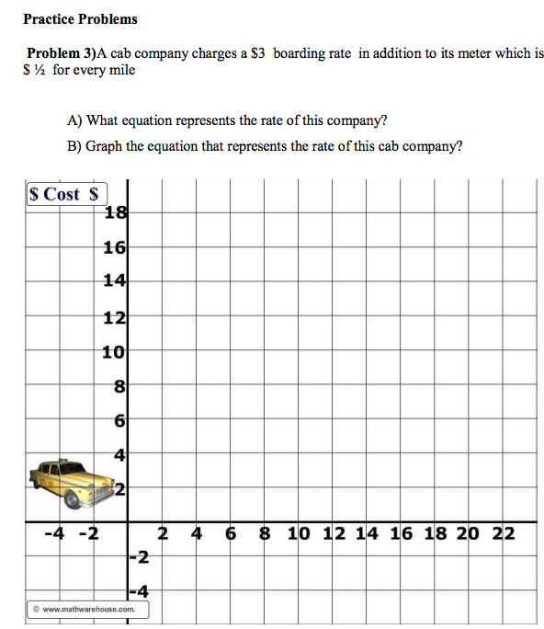
Attachment 6 continued

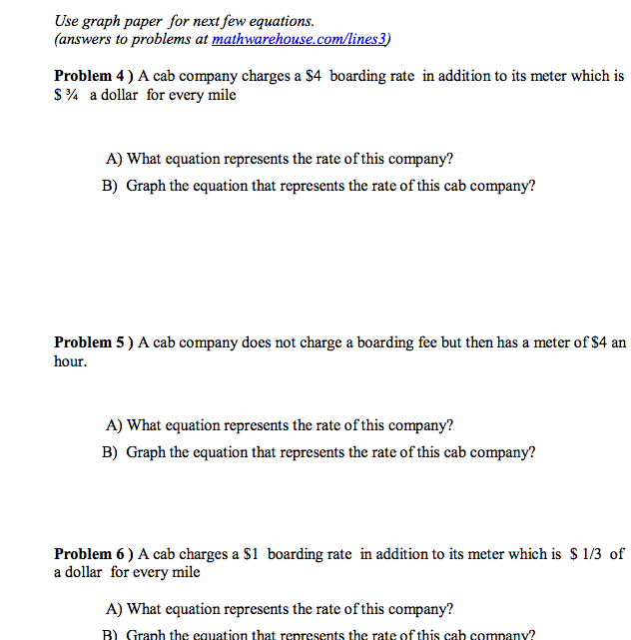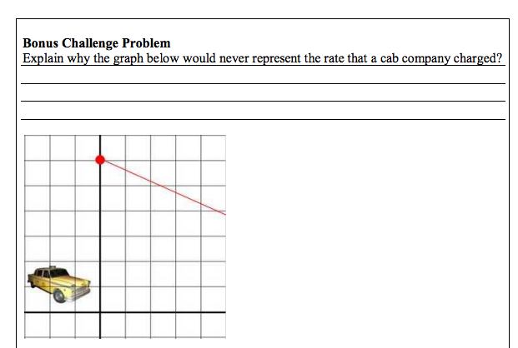

Attachment 7

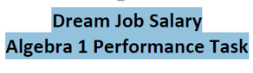

Instructions: The following task contains 4 parts. We are interested in all of your mathematical thinking so please be sure to show your work and read the situation carefully. If at any time you get stuck, feel free to try another part of the task. Relax. Be creative. Good Luck.

