GRADE:
Unit Title: Foundations for Geometry  Lesson Title: Midpoint and distance in a coordinate plane  Estimated Duration: 1 day | Real-World Purpose:  Major League baseball fields are laid out according to strict guidelines. Once you know the dimensions of a field, you can use a coordinate plane to find the distance between two of the bases.
I Can:
Standard(s): CCSS.MATH.CONTENT.HSG.CO.C.9
Prove theorems about lines and angles. Theorems include: vertical angles are congruent; when a transversal crosses parallel lines, alternate interior angles are congruent and corresponding angles are congruent; points on a perpendicular bisector of a line segment are exactly those equidistant from the segment's endpoints.
CCSS.MATH.CONTENT.HSG.CO.D.12
Make formal geometric constructions with a variety of tools and methods (compass and straightedge, string, reflective devices, paper folding, dynamic geometric software, etc.). Copying a segment; copying an angle; bisecting a segment; bisecting an angle; constructing perpendicular lines, including the perpendicular bisector of a line segment; and constructing a line parallel to a given line through a point not on the line.
CCSS.MATH.CONTENT.HSG.GPE.B.4
Use coordinates to prove simple geometric theorems algebraically. For example, prove or disprove that a figure defined by four given points in the coordinate plane is a rectangle; prove or disprove that the point (1, √3) lies on the circle centered at the origin and containing the point (0, 2).
CCSS.MATH.CONTENT.HSG.GPE.B.6
Find the point on a directed line segment between two given points that partitions the segment in a given ratio.
CCSS.MATH.CONTENT.HSG.GPE.B.7
Use coordinates to compute perimeters of polygons and areas of triangles and rectangles, e.g., using the distance formula.*

Performance Objective: (Evidence of Learning) TSW to calculate midpoint and distance from two endpoints of a line segment both on and off the coordinate plane with 75% accuracy.

Prerequisite Skills:
• know the parts of a right triangle and create and identify a right triangle.
• be able substitute values into a formula and evaluate.
• know how to solve equations.
• know the Pythagorean Theorem.
• know how to use the midpoint and distance formulas.
• know how to plot points and write an ordered pair for a point on a graph.
• be operating on Analysis level on Bloom’s Taxonomy with respect to solving equations and using formulas.
Materials/Resources:  - Markers  - Activity sheet  - Assessment sheet  - Colored pencils  - Straightedges  - Calculator | Key Vocabulary:  - Congruent segments  - Construction  - Between  - Midpoint  - Coordinate  - Distance  - Length  - Bisect  - Segment bisector  I
Elements of Rigor:
- Conceptual understanding of key concepts
- Procedural skill and fluency
- Rigorous application of mathematics in real-world contexts
Lesson Introduction
How will you introduce the lesson?
- To introduce the task, students will be asked to define what distance and midpoint means to them.
- To help the students with the task, ask the following questions:
- Give an example of when it is helpful to find a distance. How can we use distance to help make other calculations, such as how much gas to buy?
- Give an example of when it is helpful to know midpoints.
- What do you need to use the midpoint and distance formula?

Student Exploration Activity

Lesson Activities
TTW remind students how to find the average of two numbers. Connect average, a measure of central tendency, to the idea of midpoint.
TTW review how to subtract positive and negative numbers to avoid subtracting errors in the Distance Formula. When finding midpoints and distances on a coordinate plane, relate your instruction to finding distances and midpoints on a number line.

TSW investigate midpoint to find a location and the distance formula to find how far someone traveled.

TSW complete the Activity worksheet using think/pair/share strategy. However, they will think with a partner, pair with another group of two and share with the class as a whole. The students will complete the assessment on their own.

The Activity worksheet is for the students to work with a partner to explore the use of midpoint and distance through a real-world problem. After working on the assignment for 20 minutes the students will share their results with another group and finish what had not been completed. After completing the task, groups will be asked to share their results with the class. The students are to complete the assessment on their own. The teacher needs to walk around and help students with questions they may have. The teacher is to direct the students and not give answers.
Monitoring Student Responses
• Students will communicate their new knowledge with the class by presenting about a question that is assigned.
• If students are having difficulties with expressing their thoughts, the teacher is to use questions to prompt the students.

• After completing activity 2, the teacher will lead the students through a series of questions to pull everything together. The students will then complete the assessment.
♣ What are the distance and midpoint formulas?
♣ How did these formulas come about?
♣ What do we need to know to be able to use these formulas?
♣ How would you find the total distance traveled when going to two different locations?

Lesson Closure
*TTW reiterate topics and concepts covered in today’s lesson including  * distance and midpoint  * How distance and midpoint are applied in real-life situations  *TTW explain the importance of knowing how to, when, and why distance and midpoint would need to be calculated.  *TTW have students complete the following “Exit Questions”  1. What did you know about distance and midpoint before being taught this lesson?  2. What did you learn about distance and midpoint that you did not already know?  3. In what “real-world” ways can you justify having to calculate distance and midpoint?  4. Is there any part of this lesson “calculating distance and midpoint” that you did not fully understand or may need additional information on? | Essential Questions:  - Can you exchange the coordinates ($x_{1}$, $y_{1}$) and ( $x_{2, }{ y}_{2}$ ) in the Midpoint Formula and still find the correct midpoint? Explain.  - A right triangle has side lengths of r, s, and t. Given that  $s^{2}$ + $t^{2}$ = $r^{2}$ , which variables represent the lengths of the legs and which variable represents the length of the hypotenuse?
Standards for Mathematical Practice (select all that apply)
Make sense of problems and persevere in solving them.
Reason abstractly and quantitatively.
- Construct viable arguments and critique the reasoning of others.
Model with mathematics.
- Use appropriate tools strategically.
Attend to precision.
- Look for and make use of structure.

Look for and express regularity in repeated reasoning

Supplemental Activities
Intervention –  *Students will be paired Low-High and peer tutoring will take place so that high students can help low students understand concepts that they may struggle with.  *One-on-one instruction will be provided for those students who struggle to understand the concepts.  Khan Academy Video Lesson https://www.khanacademy.org/math/geometry/analytic-geometry-topic/cc-distances-between-points/v/midpoint-formula 4 Part Videos Series on the Polygons with 2 Part Quiz  Free Distance and Midpoint Calculator http://www.mathportal.org/calculators/analytic-geometry/distance-and-midpoint-calculator.php Free Calculator!  Free Math Help http://www.freemathhelp.com/distance-formula.html Good examples of distance formula!  YouTube Video https://youtu.be/Z1BjPATzFXA Song to help memorize the formulas! | Enrichment  .  TSW complete a Dot-to-Dot Distance Enrichment Worksheet where they will have to follow steps dealing with distance to create a shield for a geometry club logo.  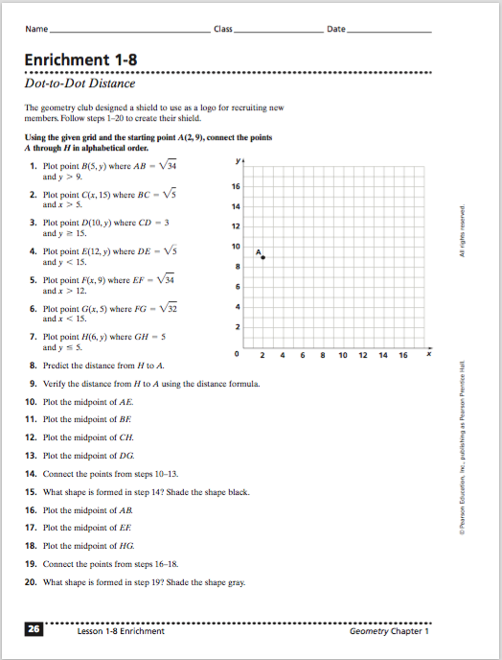
Performance Based Assessment Task
Math Task | Rubric/ Plausible Student Response(s)

