_______________________________________________________________________________________________

Banner Human Resources

Calendar Year-End Processing

Training Workbook

Release 8.6.1 – December 2011

Updated 12/15/2011

Prepared by: Ellucian

4375 Fair Lakes Court

Fairfax, Virginia 22033

United States of America

Customer Support Center website

<http://connect.ellucian.com>

Distribution Services e-mail address

[distserv@ ellucian.com](mailto:distserv@sungardhe.com)

Other services

In preparing and providing this publication, Ellucian is not rendering legal, accounting, or other similar professional services. Ellucian makes no claims that an institution's use of this publication or the software for which it is provided will insure compliance with applicable federal or state laws, rules, or regulations. Each organization should seek legal, accounting and other similar professional services from competent providers of the organization's own choosing.

Trademark

Banner®, Colleague®, PowerCAMPUS®, Luminis® and Datatel® are trademarks of Ellucian or its affiliates and are registered in the U.S. and other countries. Ellucian, Advance, Recruiter, and Open Digital Campus are trademarks of Ellucian or its affiliates. Other names may be trademarks of their respective owners.

Revision History Log

|  |  |
| --- | --- |
| Publication Date | Summary |
| 4/30/08 | New version that supports Human Resources Banner 8.0 software. |
| 12/15/2010 | Updated and made corrections |
| 12/30/2010 | New version that supports 8.4 and 8.4.1 |
| 12/15/2011 | New version that supports 8.6.1 for 2011 year end. |

Notice of rights

Copyright © Ellucian 2004-2012.

This document is proprietary and confidential information of one or more of the Ellucian companies and is not to be copied, reproduced, lent, displayed used or distributed except under license from Ellucian.  Third party copy centers are advised that clients of Ellucian that have licensed the underlying technology associated with this documentation have a valid license to copy and use this documentation in accordance with that underlying license.

green

Table of Contents



Introduction 3

Process Introduction 3

Calendar Year-End Processing 3

Process Introduction 3

Identifying Reportable/Taxable Wages 3

Setting the W-2 Recipient Name 3

Setting the Address Hierarchy 3

Performing Tax Reporting 3

Running the US W-2 Reporting PXRW2xx 3

Verifying W-2 Consent and Display Year 3

Creating an Electronic File 3

Adjusting Laser Print File if W-2s Need Realignment 3

Creating W-2 Corrections 3

Generating U.S. W2c EFW2C Electronic file 3

Generating Puerto Rico W-2 3

Setting up and Creating Data for W-2PR 3

Entering a Different Name 3

Setting Up Address Hierarchy for W-2PR 3

Process and Generate 1099-R Forms 3

Running the 1099-R Load Process 3

Running the 1099-R Print Process 3

Appendix 3

Reports 3

Terminology 3

Forms Job Aid 3

Introduction



Course goal

The goal of this course is to provide you with the knowledge and practice to accurately process your year-end tax reports.

Course objectives

In this course you will learn how to

* identify reportable/taxable wages
* define an address hierarchy
* run 941 detail report
* run W-2 reconciliation report

This is the same as the 941 report verify W-2 consent and display year

* create United States W-2 report
* create file to send to SSA
* adjust the laser print file
* generate W-2s for Puerto Rico
* create W-2 corrections

Intended audience

Payroll Office Administrators and Staff.

Prerequisites

To complete this course, you should have

* completed the Education Practices computer-based training (CBT) tutorial *Banner 8 Fundamentals*, or have equivalent experience navigating in the Banner system
* administrative rights to create and perform the necessary set up in Banner
* completed the *Human Resources Overview* training workbook
* completed the *Employment Compensation* Administration training workbook
* completed the *Time Entry Payroll Processing* training workbook
* administrative rights to create the rules and set the validation codes in Banner.

Process Introduction



Introduction

The Calendar Year-End Processing module is designed to accommodate a more efficient process for quarterly and year-end tax reports.

The forms and reports were developed to

* identify reportable/taxable wages
* define an address hierarchy
* reconcile payroll taxes within a quarter.

Flow diagram

This diagram highlights the processes used to produce W-2 files electronically within the overall Human Resources process.

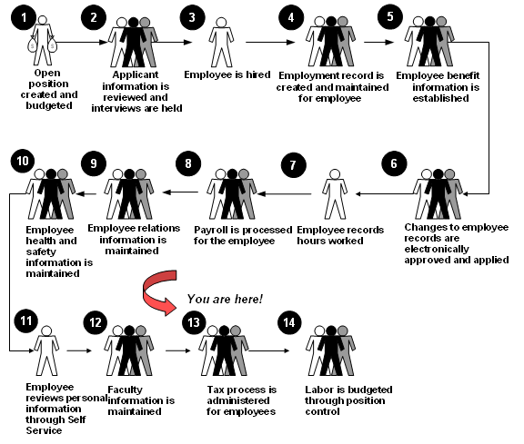

About the process

Employees complete W-4 form.

* Payroll enters tax withholding information into Banner.
* Payroll runs payroll.
* Payroll completes quarterly tax reconciliations.
* Payroll creates year end files for tax reporting and sends them to the SSA.
* Payroll mails W-2s to employees.

Calendar Year-End Processing



Section goal

The goal of this section is to provide you with the knowledge and practice to accurately process your year-end tax reports.

Objectives

In this section you will learn how to

* identify reportable/taxable wages
* define an address hierarchy
* adjust the laser print file.

Process Introduction



Process flow diagram

This diagram highlights the processes used to enter a new employee into Banner Human Resources.



What happens

The stages of the process are described in this table.

|  |  |
| --- | --- |
| **Stage** | **Description** |
| 1 | Employees complete W4 form. |
| 2 | Payroll enters tax withholding information into Banner. |
| 3 | Payroll runs payroll. |
| 4 | Payroll completes quarterly tax reconciliations. |
| 5 | Payroll creates year-end files for tax reporting and sends them to the SSA. |
| 6 | Payroll mails W-2s to employees. |

Identifying Reportable/Taxable Wages



Qualifier statement

All information in this section should be verified with a tax accountant. In addition, each year the arrangement of Box Codes could change and it is important to read through the Year End Regulatory Release Guide from SGHE to identify any significant changes from the IRS. You can also look to the W2 Instructions publication at [www.irs.gov](http://www.irs.gov) to verify what should be associated with each box code.

Setting the W-2 Recipient Name



W-2 recipient name

If you want to use a different name than the one appearing on the Identification Form (PPAIDEN) for the W-2 Employee Name on the U.S. W-2 Report, and on the file produced by the PXPW2XX process (where XX equals the calendar year for W2 reporting) then complete the Social Security Name fields on the U.S. Regulatory Information window of the Employee Form (PEAEMPL).

Note: If a name is not specified in the Social Security Name fields on PEAEMPL, the name that prints on the W-2 will be taken from PPAIDEN.

Setting the Address Hierarchy



Introduction

An address hierarchy for tax processing is established to sort and print priorities to different addresses.

The method for creating the W-2, 1099-R, or 1042-S mailing addresses prioritizes the various address types for each recipient entered on the Identification Form (PPAIDEN) through the use of the Crosswalk Validation Form (GTVSDAX). Once the hierarchy of address types is prioritized on GTVSDAX, the year-end processes use this information to determine the recipient’s addresses

For example, if on GTVSDAX (W-2, 1099-R, or 1042-S—whichever you select) the PR (Permanent) address is given the first priority (sequence of 1), and the BU (Business) address is given second priority, (a sequence of 2), then the year-end processes prints (or produces on magnetic tape or diskette) all PR addresses on file for the recipients. If a PR address is not available, then the system uses the BU address.

Banner forms

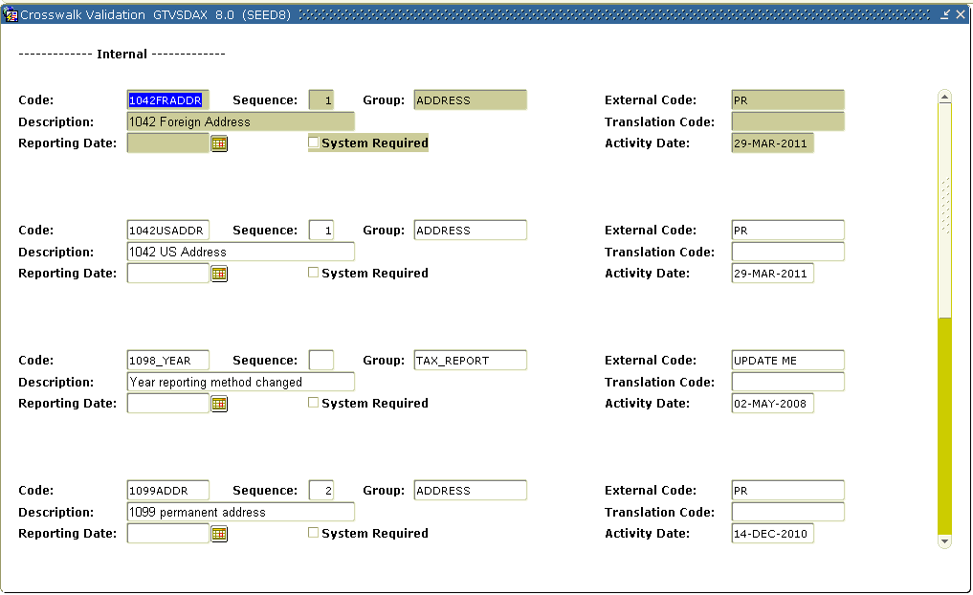

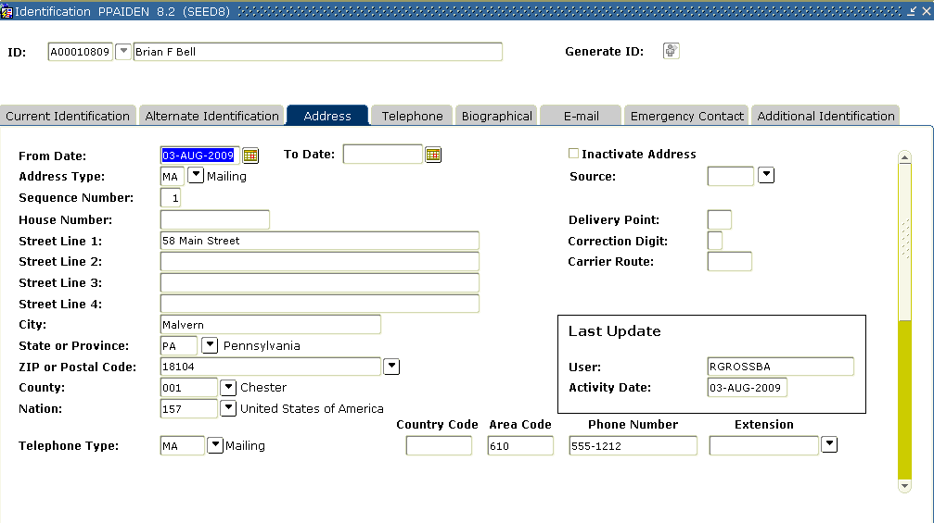

Steps

In order to establish an address hierarchy on the GTVSDAX form, complete the following steps.

1. Access the Crosswalk Validation Form (GTVSDAX).
2. Perform the **Insert Record** function.
3. Enter *W2ADDR*, *1042ADDR*, or *1099ADDR* in the address **Code** field.

Note: Make your choice based on the year-end process for which you want to create the hierarchy.

1. Enter the sequence number of the address type being used for the hierarchy in the **Sequence** field.

Example: If you want the W-2, 1042-S, or 1099-R process to select a MA (Mailing) address type as the secondary address, you would enter *2* in the Internal Seq. field.

1. Enter *ADDRESS* in the **Group** field.
2. Enter the address type in the **External Code** field, such as PR (Permanent).
3. Enter a description, to identify the type of address entered, in the **Description** field.

Example: W2 Address.

1. Click the **Save** icon.
2. Repeat steps 1 through 8 for all address types that are part of the hierarchy used when mailing W-2s, 1099Rs or 1042Ss.
3. Use the Query feature to display existing address information for specific codes. Enter W2ADDR, 1042ADDR, or 1099ADDR to query.

Performing Tax Reporting



Introduction

In order to produce W-2 files, you must set up applicable employer information and box reporting on the Employee Rules Form (PTREMPR).

Banner form

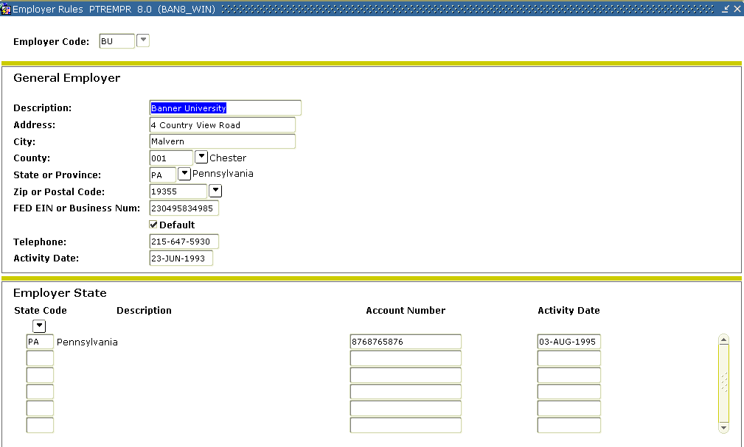

Steps

Follow the steps to set up required employer information.

1. Access the Employer Rule Form (PTREMPR) and complete all fields.
2. Make sure the federal ID number is correct.
3. Create records in the Employer State block for all states that you withhold tax for and specify the correct account number for each state.
4. Access the Magnetic Tape Rule Form (PXAMTAP) and enter values in all necessary fields. Both blocks on the form should be completed.
5. In most cases, the **Transmitter Name** and **Address** fields will be the same as the **Organization Name** and **Address** fields.
6. Access the MMREF-1 Electronic Filing Form (PXAMMEF) and enter values in all necessary fields. Complete all three areas of the form (Submitter Information, Company Information, and Employer Information).
7. Complete the **Third Party FIT Withheld** field in the Employer Information area if applicable. In most cases, the **Submitter Name and Address** fields will be the same as the **Company Name and Address** fields.

Banner form

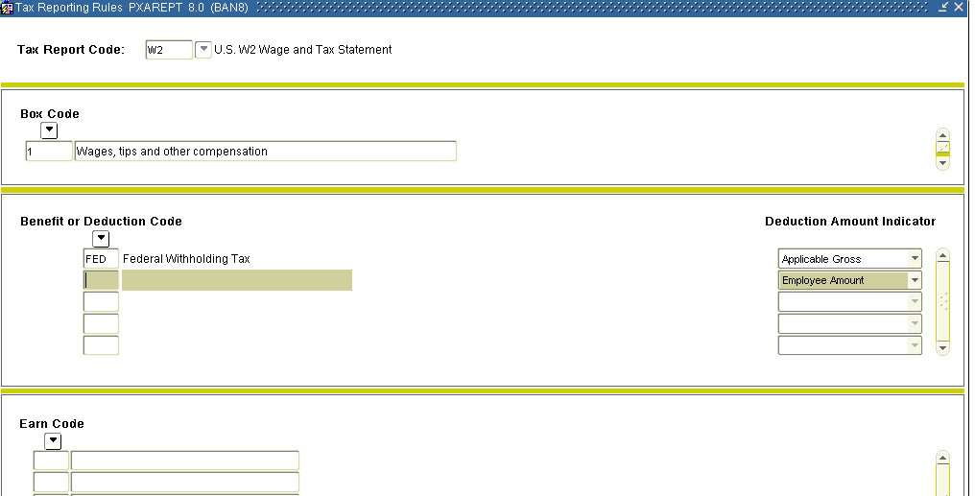

Note: On the PXAREPT form, you must remove any Benefits/Deductions or Earn Codes from Box 9 Earned Income Credit as that box has been grayed out on the W-2 form and should not be reported.

1. Access the Tax Reporting Rule Form (PXAREPT).
2. In the **Tax Report Code** field, enter *W2*.
3. Select the **Next Block** function to move to the Box Identification block.ote: Each record in this area corresponds to a specifically identified box on the W-2 form. All data in this block, except for boxes 16 and 17, are supplied by SunGard Higher Education and should not be modified without consulting SunGard Higher Education. For specific instructions on what to include in each box refer to the IRS Form W2 Instructions Publication.
4. In the **Box Code** field, for box # 16 & 17, enter the box number followed by the two-character state code, as illustrated in the following example:

|  |  |
| --- | --- |
| **Box** | **Description** |
| 16NJ | New Jersey state wages |
| 16OH | Ohio state wages |
| 16PA | Pennsylvania state wages |
| 17NJ | New Jersey State tax withheld |
| 17OH | Ohio State tax withheld |
| 17PA | Pennsylvania State tax withheld |
| 12EE | A new 12EE box code has been added for use with the tax report code of W2. The box code 12EE, description Roth contributions to 457b, allows the user to assign a benefit/deduction to report 457(b) Roth contributions in Box 12 on the W-2 for 2011. |
| Box 9 | Reporting of Advance EIC payments has been blanked out. |
| 12DD | relates to the proposed 2011/2012 reporting of employer sponsored health care costs. This code was delivered with the 8.4.1 release for 2010 year-end. |

Note: You must set up Box 16 and Box 17 for each state for which you deduct state income tax.  
  
**1042S**Note: Benefit/Deduction codes with a deduction type 21 and 22 captures an employee’s state wages and state tax withheld when associated with foreign treaty limits. Benefits/Deductions code setup up with type 21 should be included on PXAREPT for W2, 1042, and tax depository processing.

1. For each box record in the Box Identification block, you must list the benefit /deduction codes (from the PTRBDCA Benefit/Deduction Code field) and/or the earnings codes (from the PTREARN Earnings Code field) associated with the specified box. This selection is made in the Benefit/Deductions block and the Earnings block as described below.
2. Choose a box and select the **Next Block** function to move to the Benefit/Deduction Code block. The vast majority of W-2 boxes will be specified in the Benefit/Deduction Code block.

Note: Few institutions use the Earnings Code block.

1. In the **Benefit or Deduction Code** field, click the search to retrieve the Benefit/Deduction codes that pertain to the box chosen. Often this will be just one code, but if necessary, you can list more than one.

Note: A box is not usually associated with both a benefit/deduction code and an earnings code.

1. Indicate which of the three amounts (Applicable Gross, Employee Amount, or Employer Amount) should be placed in the box for each Benefit/Deduction code listed in the Deduction Amount Indicator field.   
     
   Note: It is very important not only to list the correct benefit/deduction code(s), but also to specify the right amount indicator(s).

Select the **Next Block** function to move to the Earnings block and list the relevant earnings codes if the box is to contain earnings in the Earn Code field.

|  |  |
| --- | --- |
| **Example 1**: Box 1 Annual Federal Wages, Tips and Other Compensation | |
| FED - Federal Tax | Applicable Gross |
| **Example 2:** Box 4 Social Security Tax withheld | |
| FIOFICA - Old age portion | Employee Amount |

Running the US W-2 Reporting PXRW2xx



Introduction

The year-specific United States W2 Process (PXRW2xx) generates United States W-2 form, Form 6559 totals report, and the error/log report pxrw211.log for tax year 2011 and greater. You can print totals in the .lis file when the Processing Mode parameter is set to T. You can view error messages printed on one line after the name and SSN in the .log file. When W-2 forms are created, the totals will be printed in the .log file.

Note: After you install this release of Banner Human Resources:

* 2010 version for printing U.S. W-2s, namely PXRW210 and PXPW210 can no longer be used for generating U.S. W-2s for years beyond 2010
* PXRW210 and PXPW210 can be used for generating only 2010 U.S. W-2s
* 2011 versions, PXRW211 and PXPW211 can be used for printing U.S. W-2s for the year 2011 and beyond.

In the Banner Human Recourse 8.6.1 release, PXRW211 Total Report has changed to more closely match the W2 print process.

Banner form

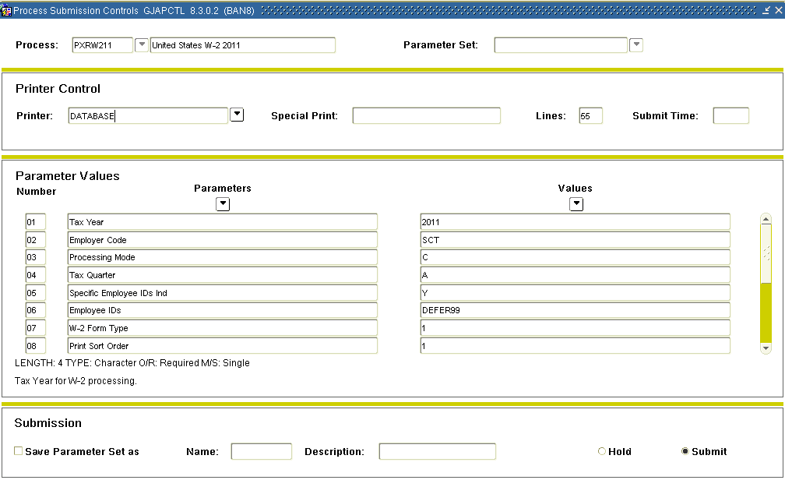

Steps

Follow these steps to generate quarterly and/or full-year tax reports.

1. Access the United States W2 20XX Process (PXRW2XX).

Note: In the screen shot above, it is PXRW211.

1. Double-click in the **Printer** field and select the name of your printer or send it to the database.
2. Enter the tax year in the **Parameter 1** **Tax Year Values** field.
3. Enter the employee code for W-2 processing in the **Parameter 2 Employee Code Values** field.
4. Enter *C* (for Create), *R* (for Reprint Original W-2) *or T* (for Totals Only)in the **Parameter 3** **Processing Mode** **Values** field.   
     
   Note: As of HR 8.4.1 release, you can now print totals in the .lis file of the PXRW209 process when the Processing Mode parameter is set to T. When W-2 forms are created, the totals will still be printed in the .log file.
5. Enter 1, 2, 3, 4 or A (for All) in the **Parameter 4 Tax Quarter Values** field.
6. Enter N (o) or Y (es) to process specific employees **Parameter 5** **Specific Employee ID Ind** **Values** field.
7. Enter the employee ID that you want to process in the **Parameter 6** **Employee IDs** **Values** field if Yes to parameter 06.
8. Enter 1 (Standard 1-up), 2 (Laser 4 up), 3 (Laser pressured sealed), in the **Parameter 7** **W-2 Form Type** **Values** field.
9. Enter 1 (Employee name), 2 (Nation/Zip Code), 3 (Check Distribution Organization) in the **Parameter 8** **Print Sort Type** **Values** field.   
     
   Note: Sort order 2 will now sort by Nation and then Zip Code within Nation. If you want Canada to be grouped together, outside of the U.S., be sure to enter the Nation code for Canada in the address. Anything without a Nation Code will be assumed to be U.S.
10. Enter Y(es) or N(o) in the **Parameter 9** **Zero Out Negative Amounts Values** field.
11. Enter Y(es) or N(o) indicating to print for all employees regardless of consent in the Parameter 10 **Paper Print for W-2 for all Values** field.
12. Enter Y(es) or N(o) indicating if the W-2 is a reissue in the **Parameter 11** **Marked as Reissued W-2** **Values** field.
13. Enter the number of alignment pages that will precede the actual W-2 form in the **Parameter 12** **Number of Alignment Pages** **Values** field.
14. Enter Y(es) or N(o) indicating “All boxes are zero” message in the **Parameter 13** **Suppress Zero W-2 Messages Values** field.
15. Enter Y(es) or N(o) in the **Parameter 14** **Print W-2 with no address** **Values** field.
16. Enter Y(es) or N(o) in the **Parameter 15** **Population Selection Indicator** **Values** field.
17. Enter ID for population in the **Parameter 16** **Population Selection ID Values** field if yes to Population Selection.
18. Enter the creator ID for the population in the **Parameter 17** **Creator ID** **Values** field if yes to Population Selection.
19. Enter the application code for the population in the **Parameter 18** **Application Code** Values field if yes to Population Selection.
20. Click the **Save Parameter Set As** checkbox if you will be using the same printer and date value again.
21. Click the **Save** icon to submit the report.
22. To view the results, click the **Options** menu.
23. Select Review Output [GJIREVO].
24. Click the **File Name** drop-down arrow and select the .lis file.
25. With the .lis file selected, click the **OK** button.
26. The results of the report are displayed.
27. Click the **Exit** icon.

Verifying W-2 Consent and Display Year



Introduction

The Installation Rules Form (PTRINST) can be used to verify specific data related to calendar year-end processing. In particular, PTRINST allows electronic W-2 consent on Employee Termination to be toggled on or off, and specification of which year should be displayed for year-end statements.

Banner form

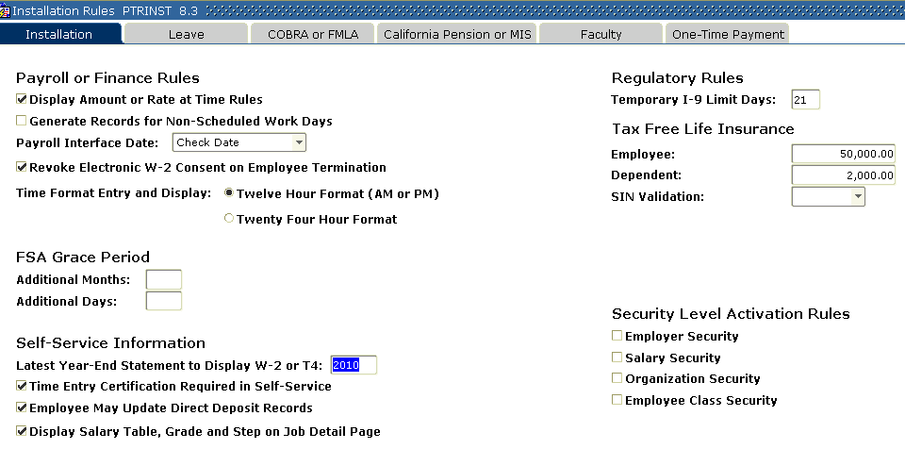

Steps

Follow these steps to verify electronic W-2 consent on employee termination.

1. Access Installation Rules Form (PTRINST).
2. Check or Uncheck the **Revoke Electronic W-2 Consent on Employee Termination** checkbox to toggles consent on terminated employees on or off.

Note: If a year is required, enter a value in the **Latest Year-End Statement to Display W-2 or T4** field.

1. Click the **Save** icon.
2. Click the **Exit** icon.

Creating an Electronic File



Introduction

The W-2 2011 EFW2 File (PXPW211) generates a file (W2REPORT) in EFW2 format for filing United States W-2 information for years 2011 and greater. The .log file of this report also shows all errors.

Detailed specifications of the EFW2 file are available and may be downloaded from the following web site at [www.socialsecurity.gov](http://www.socialsecurity.gov).

After you install this release of Banner Human Resources: 2010 version for filing U.S. W-2s, namely PXRW210 and PXPW210 can no longer be used for generating U.S. W-2s for years beyond 2010:

* PXRW210 and PXPW210 can only be used for 2010 U.S. W-2s
* 2011 versions, namely, PXRW211 and PXPW211 must be used for generating W-2s for years 2011 and beyond
* as of tax year 2008, the process converts special characters in Banner flat files, based on values in the General file gurcnvc.map. Only those characters included or added to this file will be converted. For example: the word “éclair” would not be acceptable to the IRS. Since internationalization functionality was delivered in Banner 8.0, special characters are now recognized in our database
* process checks year-to-date applicable gross for Social Security wages when being run for a quarter. This prevents employees that have reached the SS Old Age maximum from being reported incorrectly as Medicare Qualified Government Employees
* You can report employees who have retirement plans in place of FICA as regular employees and not as MQGE, as allowed by the SSA.

The following records are required in an EFW2 file:

|  |  |  |
| --- | --- | --- |
| **Code** | **Description** | **Required** |
| RA | Submitter Record | Yes |
| RE | Employer Record | Yes |
| RW | Employee Wage Record | Yes |
| RT | Total Record | Yes |
| RF | Final Record | Yes |

You can now report employees who have retirement plans in place of FICA as regular employees and not as MQGE, as allowed by the SSA.

Banner form

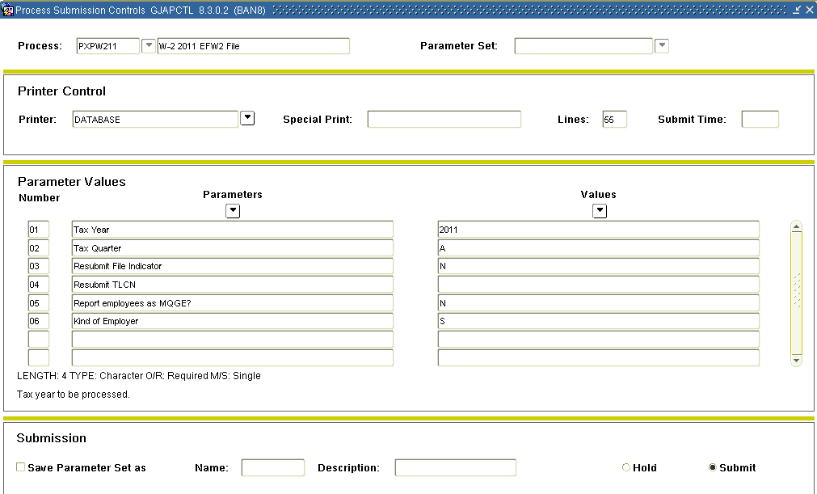

Steps

Follow these steps to create an electronic file.

1. Access W-2 2011 EFW2 File Process (PXPW2xx).

Note: PXRW211 was run in a previous exercise; now, you will complete the process of creating the electronic file by running PXPW2XX.

1. Double-click in the **Printer** field and select the name of your printer.
2. Click the **Next Block** icon.
3. Enter tax year in the **Parameter 01 Tax Year Values** field.
4. Enter tax quarter(s) in the **Parameter 02 Tax Quarter** **Values** field.
5. Enter the (Y)es or (N)o in the **Parameter 03 Resubmit File Indicator Values** field.
6. Enter the TLCN code in **Parameter 04 Resubmit TLCN Values** field.
7. Enter in MQGE Pension Plan Contribution (Employee) code in **Parameter 05 Report employees as MQGE Values** field  
     
   Note: You can now report employees who have retirement plans in place of FICA as regular employees and not as MQGE, as allowed by the SSA.
8. Enter the type of employer in the **Parameter 06 Kind of Employer Values** field.
9. Click the **Next Block** icon.
10. Click the **Save** icon to submit the report.
11. To view the results, click the **Options** menu.
12. Select Review Output [GJIREVO].
13. Click the **File Name** drop-down arrow and select the .lis file.
14. With the .lis file selected, click the **OK** button.
15. The results of the report are displayed.
16. Click the **Exit** icon.

Adjusting Laser Print File if W-2s Need Realignment



Introduction

The instructions below should be followed for making adjustments to the laser print file if your W-2s need some alignment. A person who is familiar with the PostScript language should make modifications to the print file.

Note: SunGard Higher Education supports Moore Laser Printer 4-up forms. Comments made in this section impact these forms.

Default font

The default font chosen for the W-2s is 10 point New Courier, which is a non-proportional typeface. This means that all letters and spaces use the same amount of print space on a horizontal line, regardless of the width of the letter. If a change to the font is required, it can be found at the beginning of the print file. Its form is:

/TextFontCN10 /Courier-New find font 10 scalefont def TextFontCN10 setfont

Postscript printing

In order for a laser printer to recognize a postscript file when running the W-2 Wage and Tax Statement (PXRW2US) Form, the first two characters of the first line must be %! This automatically occurs.

Adjusting horizontal print positions

The print may vary slightly on printers from different manufacturers. Consequently, if horizontal adjustment is required for the entire form, there is an easy way to make the adjustment. Increasing or decreasing the left margin will cause all printed data on the form to sift either left or right. Only very slight adjustments should be necessary.

The applicable parameter can be found at the beginning of the print file and its form is:

/LeftMargin .75 inch def

Adjusting vertical print position

the vertical spacing is somewhat tighter and cannot be accommodated in the same manner as horizontal shifts. A vertical alignment problem will be most noticeable on the lower half of the form. The amount of space between lines is called “leading” and the default values are 9 for single spacing and 18 for double spacing.

If the data is printing over the description of each box on the form, the leading should be increased. If the data is printing over the bottom line of each box, the leading should be decreased. The double space value should always be twice that of the single space value.

Adjustments

When adjusting the leading, increment or decrement use only one number at a time.

Example: Increment single and double spacing from 9 and 18 to 10 and 20.

Moving up or down by one number should be the maximum adjustment necessary for the supported Moore forms. These parameters can be found at the beginning of the print file and their form is:

/LineSpace 9 def

/DoubleSpace 18 def

Printing

If all printed data must be shifted up or down, adjusting the top margin is the best method. The default value can be found in the /TopStart command. If an adjustment is required, it should be very slight. The parameter can be found at the beginning of the print file. Its form is:

/TopStart 10.125inch def (Laser 4-up)

/TopStart 12.325inch def (Laser – Pressure Sealed)

U.S. tax form vendors

This section describes the form vendors that support U.S. year-end tax reporting.

General information about form vendors

The software has been written so that the placement of each of the characters fits accurately in the lines and checkboxes found on the forms supplied by Moore North America (listed below). SunGard Higher Education has selected Moore North America as a recognized and recommended business partner.

If your site elects to use a form vendor other than Moore North America, the placement of the characters may vary since the form may be different. The existence of this restriction does not imply that you must use Moore forms. You may use any vendor that you choose. However, this may require modifications at your site to obtain the proper alignment.

Sample output

Other forms vendors will probably require a sample output that can be obtained from running the tax reports PXR1042, PXR1099, and PXRW2US.

The sample output appears at the beginning of the file and is generated when the tax data exists and the rule forms have been set up correctly in Banner.

Alignment forms

Three alignment forms appear at the beginning of each file generated when running the reports.

W-2

W-2

Form Name Ink Color

Continuous Form 210 5 Part Black

Form Name Ink Color

Continuous Form 104 6 Part Red

Continuous Form 253 6 Part, 5 Forms—Self

Mailer

Mailer

Black

Form Name Ink Color

Continuous Form 200 4 Part Red

Continuous Form 201 6 Part Red

Continuous Form 211 3 Part Red

Continuous Form 212 3 Part Red

Continuous Form 256 6 Part, 5 Forms—Self

Mailer

Mailer

Black

Laser Cut Sheet 275 Employee Copy Black

Laser Cut Sheet 276 Employer Copy Green

Cut Sheet Laser Form 1280Z

(pressure sealed)

N/A Black

Variations

The U.S. Government allows variations in the forms as long as the form is approved by the IRS. Forms supplied by Moore North America are federally approved.

Tax Forms Supported by Moore North America

The following Moore form numbers used for tax processing are supported by Banner:

1042S

1099R

Employee/ employer copies

In order to create an employee and an employer copy for laser printed forms, print the output file twice; once for the employee copies and again for the employer copies. Please note that we do not support an employer form with four employees per page.

Creating W-2 Corrections



Introduction

The W-2 Form (PXAW2CC) allows you to view and print W-2 and W-2c information for an employee. Corrections may be generated after a payroll adjustment has been processed through the Form (PHAADJT). Individual employee copies of a W-2c form may be printed from PXAW2CC. Banner does not support batch printing of W-2c forms, only creation of the electronic file for submittal to the Social Security Administration.

As of Banner Human Resources 8.6.1 release, the PXAW2CC form will allow a Completed status W-2c record to be changed to a Void status. This may be accomplished by using the Option menu to select Void Sequence. Only use the Void status if the PXPWC11 process has not been submitted to SSA. This allows you to control the reporting of the correct Previously Reported values with the newly corrected values in the PXPWC11 process in circumstances where you may have more than one adjustment or W-2c to submit to the Social Security Administration.

The employee will view the W-2c form in Employee Self-Service with a Status of Void on the preview page. If the Void W-2c is printed, ***VOID*** VOID*** VOID*** will print across the top of the form to notify the employee that this specific W-2c is not current. Once the Status on a correction has been changed to Void, you cannot change the Status back to Complete or In-progress. This maintains the history and allows multiple payroll adjustment/corrections to be made with the possibility that a previous W-2c had already been created and completed from a prior adjustment.

Banner form

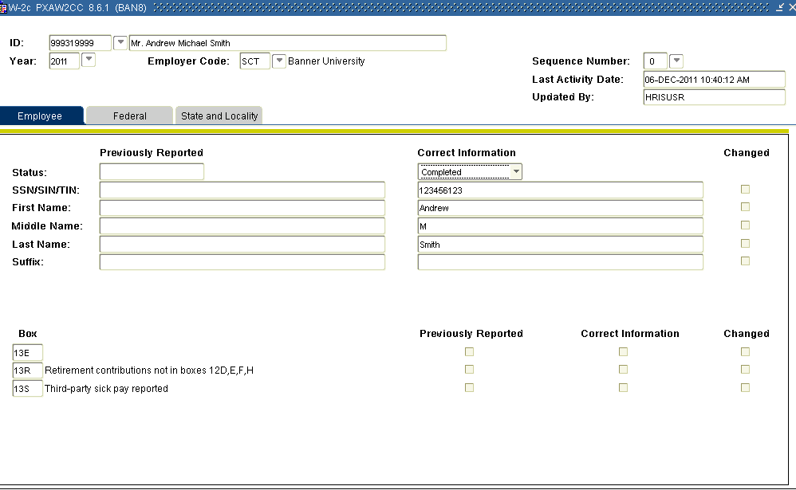

Steps

Follow these steps to make corrections to a W-2c for an employee.

1. First, review, correct and process any adjustments to information previously reported on a W-2 or W-2c.
2. If required, make corrections on the Employee Biographic/Demographic information on the Identification Form (PPAIDEN) and/or the Employee Form (PEAEMPL).
3. If required, make corrections to the Employee’s payroll information on the Payroll Adjustment Form (PHAADJT).
4. If required, make corrections to the previously reported W-2 box code information on the Tax Reporting Rules Form (PXAREPT).
5. Access the W-2c Form (PXAW2CC).
6. Click the **Option** menu.
7. Select **Create New Correction**.
8. Review Previously Reported and Correct Information for accuracy.
9. Once all corrections have been reviewed and confirmed for accuracy, Click the **Status** drop-down arrow and select **Completed**.   
     
   Note: This will release an electronic copy of the form to the employee
10. Click the **Save** icon.

View and print 2011 W-2 information

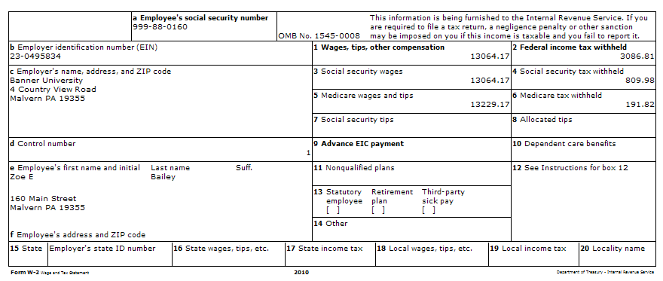

**To view and print a copy of the completed W-2 or W-2c:**

1. Click the **Options** Menu.
2. Select **Display W-2 or W-2c** to display.

Generating U.S. W2c EFW2C Electronic file



Introduction

The U.S. W-2c 2011 EFW2C File Process (PXPWC11), process generates a U.S. W2c EFW2C electronic file (W2CREPORT) for the year 2011 and for future years. The process allows you to send an electronic file of W2c corrections to SSA.

Payroll adjustments may be needed after W-2 submissions if an erroneous amount was reported. The W-2c Corrected Wage and Tax Statement necessary to report these adjustments can be created on the W-2c Form (PXAW2CC). Each time a correction is created on PXAW2CC, a unique Sequence Number is assigned.

Banner form

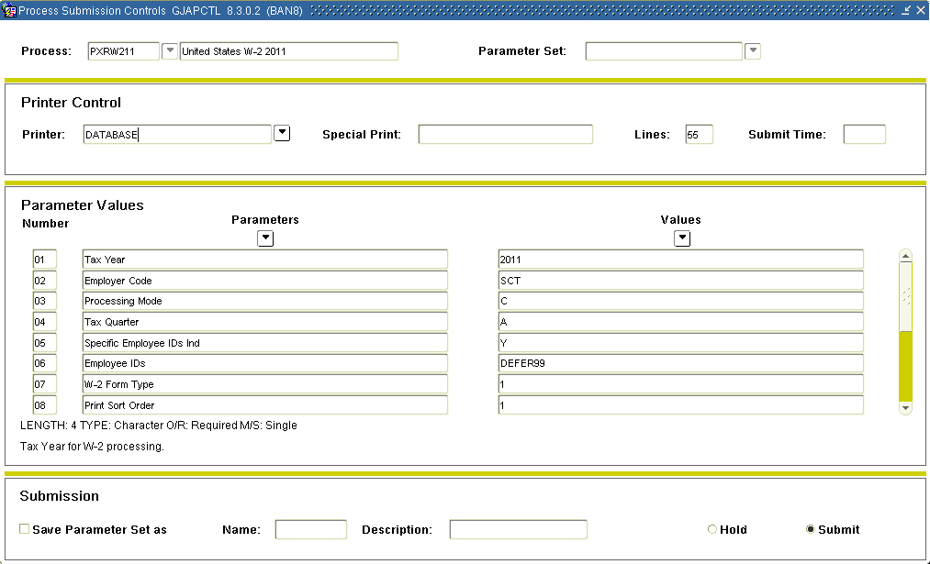

Steps

Following these steps to process generates a U.S. W2c EFW2C electronic file (W2CREPORT).

1. Access U.S. W-2c 2011 EFW2C File Process (PXPWC11),

Note: PXRW210 was run in a previous exercise; now, you will complete the process of creating the electronic file by running PXPW2XX.

1. Double-click in the **Printer** field and select the name of your printer.
2. Click the **Next Block** icon.
3. Enter tax year in the **Parameter 01 Tax Year** **Value** field.
4. Enter tax quarter(s) in the **Parameter 02 Tax Quarter** **Value** field.
5. Enter the (Y)es or (N)o in the **Parameter 03 Resubmit File Indicator Value** field.
6. Enter the TLCN code in **Parameter 04 Resubmit TLCN** **Values** field.
7. Enter in MQGE Pension Plan Contribution (Employee) code in **Parameter 05 Report employees as MQGE** **Values** field.  
     
   Note: You can now report employees who have retirement plans in place of FICA as regular employees and not as MQGE, as allowed by the SSA.
8. Enter Y (es or N(o) for type of employee in the in **Parameter 06 Kind of Employer Values** field.
9. Enter Y (es or N(o) for the employee ID identification indicator in **Parameter 06 Specific Employee id Ind** field.
10. Enter the employee ID in **Parameter 06 Employee IDs Values** field.
11. Enter the W2 form report code in **Parameter 07 W2 Form Type Values** field.
12. Enter the print sort code in **Parameter 08 W2 Print Sort Values** field.
13. Click the **Next Block** icon.
14. Click the **Save** icon to submit the report.
15. To view the results, click the **Options** menu.
16. Select Review Output [GJIREVO].
17. Click the **File Name** drop-down arrow and select the .lis file.
18. With the .lis file selected, click the **OK** button.
19. The results of the report are displayed.
20. To print the report, click **Show Document (Save and Print File)** in the Options menu and print report.
21. Click the **Exit** icon.

Generating Puerto Rico W-2



Section goal

The goal of this section is to provide you with the knowledge and practice to create W-2PR for Puerto Rico employees.

Objectives

In this section, you will learn how to

1. set up required employer information
2. create data for the W-2PR forms
3. create magnetic media containing all required W-2PR information for submission to the government.

Setting up and Creating Data for W-2PR



Introduction

You will set up and create data that is required for Puerto Rico employees W-2PR.

Banner form

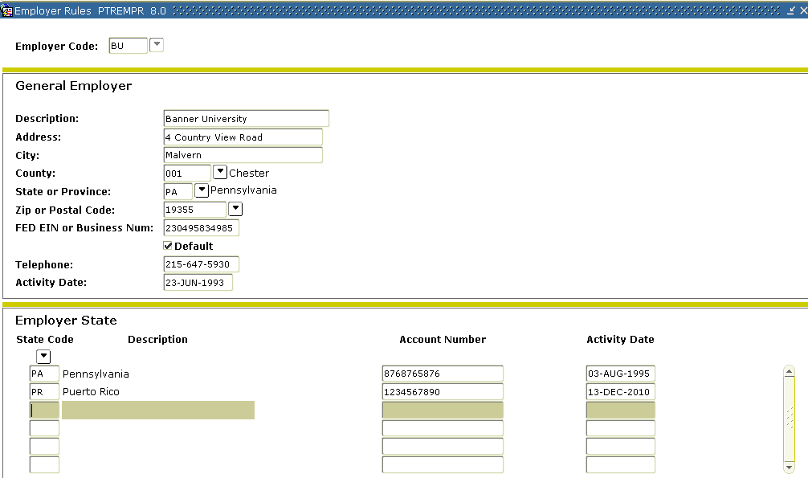

Steps

In this process you will review the necessary forms to set up and create data for W-2PR (Puerto Rico employees W-2s).

1. Access the Employer Rule Form (PTREMPR) and complete all fields.   
     
   Note: Make sure the Federal ID number is correct.
2. Access the Magnetic Tape Rule Form (PXAMTAP) and enter values in all necessary fields. Complete all three areas of the form (Transmitter and Organization).

Note: In most cases, the Transmitter Name and Address fields will be the same as the

1. Access the MMREF-1 Electronic Filing Form (PXAMMEF) and enter values in all necessary fields in the Submitter section.
2. Click the **Save** icon.
3. Click the **Option** menu.
4. Click **Company** and enter values in all necessary fields in the Company section.
5. Click the **Save** icon.
6. Click the **Option** menu.
7. Click **Employer** and enter values in all necessary fields in the Employee section.  
     
   Note: Complete the Third Party FIT Withheld field in the Employer Information area if applicable.

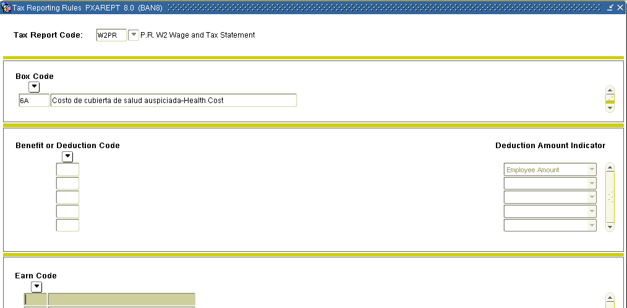

1. Access the Tax Reporting Rule Form (PXAREPT).
2. Enter W2PR in the **Tax Report Code** field.
3. Click the **Next Block** icon.
4. Click in the **Box Code** field.
5. Click the **Next Record** icon to cycle through the available codes.

Note: For each box code, you may select the **Benefit or Deduction Codes** (from the PTRBDCA Benefit or Deduction Code field) and/or the **Earn Codes** (from the PTREARN Earnings Code field) associated with the specified box.

1. Select a box code in the **Box Code** field.
2. Click in the Benefit and Deduction field
3. Select a Benefit and Deduction associated with the box code.
4. Click in the **Earn Code** field.
5. Select an **Earn Code** associated with the box code.  
     
   Note: Few institutions will make use of the Earnings Code block.
6. Click in the **Box Code** field and repeat steps 14 through 20.
7. Click the **Save** icon.
8. Click the **Exit** icon.

Entering a Different Name



Introduction

If you want to use a different name than the one appearing on the Identification Form (PPAIDEN) for the W-2 Employee Name on the W-2 Report, and on the file produced by the PXPW2XX process (where XX equals the calendar year for W2 reporting) then complete the Social Security Name fields on the U.S. Regulatory Information window of the Employee Form (PEAEMPL).

Note: If a name is not specified in the Social Security Name fields on PEAEMPL, the name that prints on the W-2 will be taken from PPAIDEN.

Banner form  
  
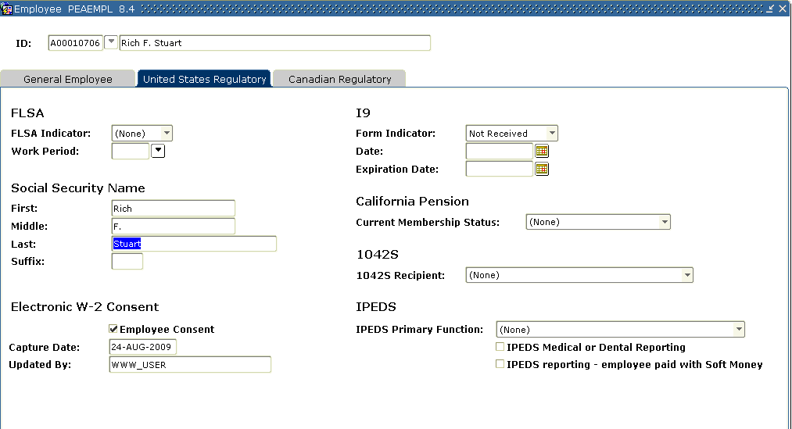

Follow these steps if you want to use a name different than the one appearing on the Identification Form (PPAIDEN) for the W-2 Employee Name on the Puerto Rico W-2 Report (PXRW2PR) and on the files produced by the Puerto Rico W-2 MMREF-1 File (PXPW2MP)

1. Enter the social security in the **Social Security Name** fields in the **U.S. Regulatory Information** tab in the Employee Form (PEAEMPL).

Note: If a name is not specified in the Social Security Name fields on PEAEMPL, the name that prints on the W-2PR will be taken from the Identification Form (PPAIDEN).

Note: The Suffix field on PEAEMPL allows up to four characters for the suffix. The electronic file also allows up to four characters. The first and last name may be truncated, if needed, to print a four character suffix. See the IRS instructions relating to the printing of Name Suffix for more information.

1. Produce both hard copies of Puerto Rico W-2s and data for year-end magnetic processing.
2. Run the Puerto Rico W-2 Report (PXRW2PR) using the W-2 PR parameter.  
     
   Note: The following changes have been made to the W-2PR form for new boxes:

* Box 6A for “Costo de cubierta de salud auspiciada por el patron - Cost of employer-sponsored health coverage” has been added to the form.
* Box 6B for “Donativos Charitable Contributions” has been added to the form.
* Box 16A for “Aportaciones al Programa Ahorra y Duplica tu Dinero – Contributions to the Save and Double your Money Program” has been added to the form.
* Box 24 for “Sueldos y Propinal bajo Ley HIRE de 2010 – Wages and Tips under HIRE Act of 2010” has been removed from the form.

1. Create Magnetic Media Containing W-2PR Information
2. Run the Puerto Rico W-2 MMW2PR-1 File (PXPW2MP) to create magnetic media for Puerto Rico W-2s and populate the MMREF-1 format file (W2REPORT).  
     
   Note: The Comment Form (PPACMNT) is not compatible with MMW2PR-1 reporting requirements.

Note: The Puerto Rico W-2 Process (PXRW2PR) has been modified to print Puerto Rico W-2PRs for 2011.

Setting Up Address Hierarchy for W-2PR



Introduction

The address hierarchy prioritizes the various address types for each recipient entered on the Identification Form (PPAIDEN) using the Crosswalk Validation Form (GTVSDAX).

Banner form

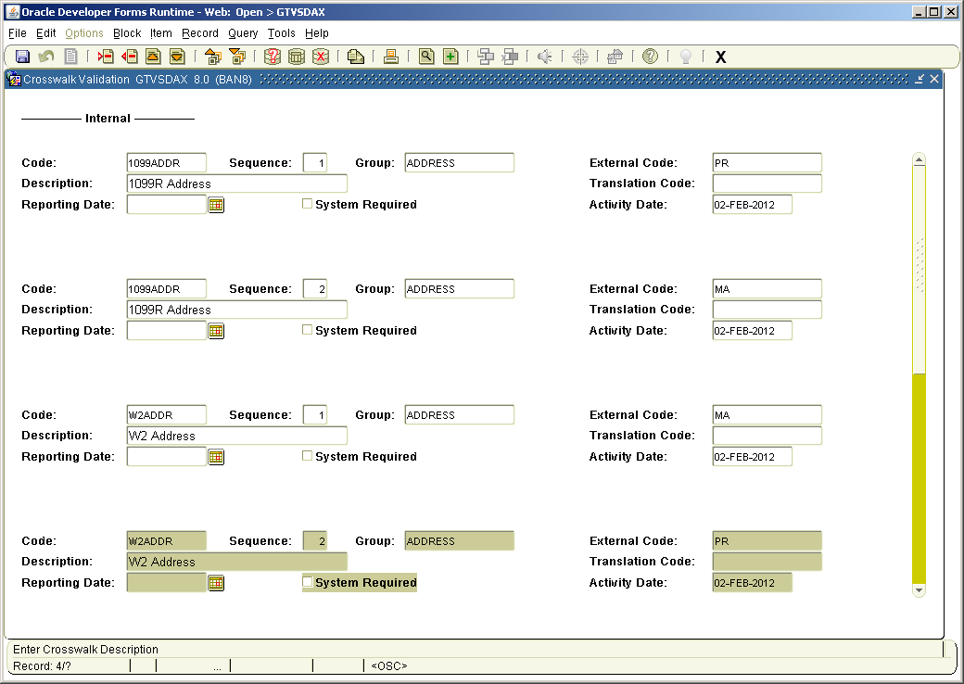

Steps

Follow these steps to create an address hierarchy for the W-2PR.

1. Access the Crosswalk Validation Form (GTVSDAX).
2. Click the **Insert** menu.
3. Click **Record**.
4. Enter *W2ADDR* in the **Code** field.
5. Enter sequence number of the address type in the **Sequence** field.
6. Enter ADDRESS in the **Group** field.
7. Enter description of address type in the **Description** field.
8. Click the **Save** icon.
9. Repeat steps 2 through 8 to enter additional address types
10. Click the **Exit** icon.

Process and Generate 1099-R Forms



Introduction

The HR Banner system utilizes information from several rule forms to produce 1099-R forms for employees.

Banner forms

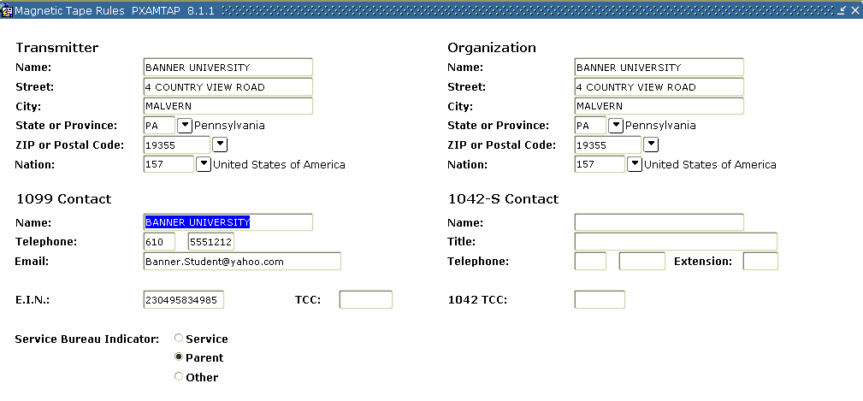

Steps

The following steps are required to process and generate 1099-R forms.

1. Access the Employee Rules Form (PTREMPR) and complete all fields for employee.
2. Access the Magnetic Tape Rule Form (PXAMTAP).
3. Enter the contact name in the **1099 Contact Name** field.
4. Enter the phone number in the **1099 Contact Telephone** field.
5. Click the **Next Block** icon.
6. Enter name control in the **1099 Name Control** field.
7. Access Tax Code Rule Form (PXATXCD).
8. Click drop-down arrow in the **1099-R Indicator** field and select Y(es) or N(o).

Note: The 1099-R Indicator field is only applicable to the state code. It specifies whether the identified state participates in the Combined/Federal State 1099 program.

1. Access 1099-R Distribution Code Validation Form (PTV1099) and review information.   
     
   Note: Lists all the distribution codes to report information for 1099-R forms.
2. Access the Earning Code Rules Form (PTREARN).
3. Click the **Earning Code** Search icon.
4. Click the desired code in the **Code** field.
5. Click the **Select** icon.
6. Click the **Next Block** icon.
7. Click the **Next Block** icon again to access the Regulatory block.
8. Click the **1099-R Code** Search icon and select a code.
9. If the taxable amount cannot be determined for 1099-R processing, click the **Tax Amount not Determined from Earn Code** checkbox.   
     
   Note: When the field is checked, the 1099-R Load Process (PXP1099), will populate Box 2b on the 1099-R.

Banner form  
  
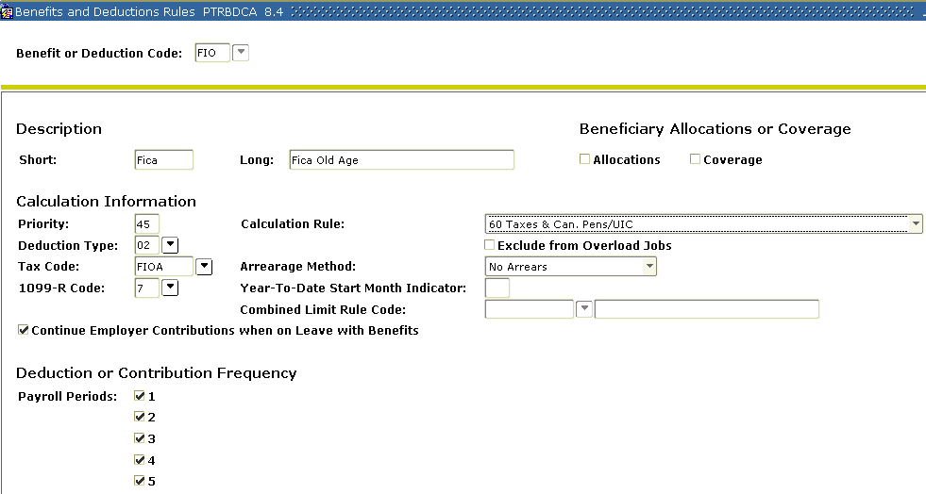

1. Access the Benefits and Deductions Rules Form (PTRBDCA).
2. Enter 1099-R distribution code in the **1099-R Code** field.

Banner form

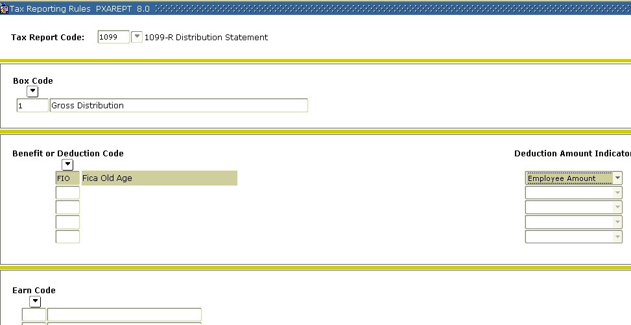

1. Access the Tax Reporting Rules Form (**PXAREPT**).
2. Enter *1099* in the **Tax Report Code** field.
3. Click the **Next Block** icon.
4. Click the **Box Code** Search icon and select a code.
5. Click the **Benefits and Deductions** Code Search icon and select a code.
6. Click the **Next Block** icon.
7. Click the **Earn Code** Search icon and select a code (if it applies).
8. Click in the **Box Code** field.
9. Click the **Next Record** icon.
10. Repeat steps 24 through 27.
11. Click the **Save** icon.
12. Click the **Exit** icon.

Running the 1099-R Load Process



Introduction

You may run the 1099-R Load Process (PXP1099) to populate the PXR1099 table. All records created by this process can be viewed online in the 1099-R Form (PXA1099).

Note: If errors are visible, make the necessary changes on the PXA1099 form.

Banner form

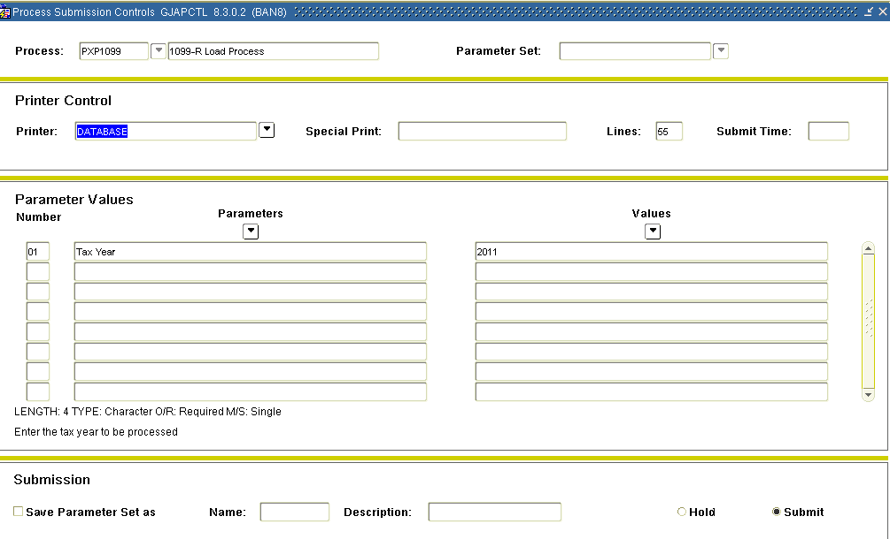

Steps

Follow these steps to complete the 1099-R Load Process.

1. Access the 1099R Load Process (PXP1099).
2. Double-click in the **Printer** field and select the name of your printer.
3. Enter the reporting tax year in the **Parameter 1 Tax Year Values** field.
4. Click the **Save Parameter Set As** checkbox if you will be using the same printer and date value again.
5. Click the **Submit** radio button to process the calculation.
6. Click the **Save** icon to submit the report.
7. To view the results, click the **Options** menu.
8. Select Review Output [GJIREVO].
9. Click the **File Name** drop-down arrow and select the .lis file.
10. With the .lis file selected, click the **OK** button.
11. The results of the report are displayed.
12. Click the **Exit** icon.

Running the 1099-R Print Process



Introduction

You can load 1099-R data into PXA1099 using the 1099-R Load Process (PXP1099). To generate 1099-R forms, run this process followed by PXR1099. (To review and/or revise data after running this process, access PXA1099 before you run PXR1099.)

Banner form

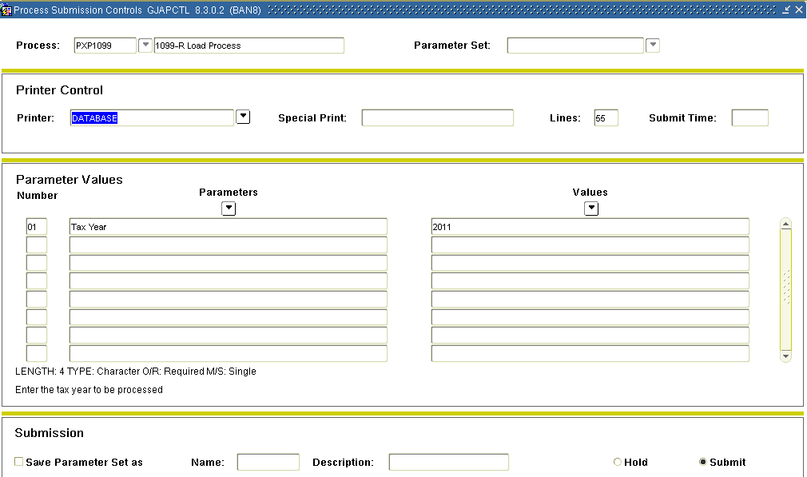

Steps

Follow these steps to complete the 1099R print process.

1. Access the 1099R Print Report Process (PXR1099).
2. Double-click in the **Printer** field and select the name of your printer.
3. Enter the reporting tax year in the **Tax Year** parameter.
4. Enter Y(es) or N(o) to forward to participating states in the **Combined Federal/State Filer** parameter.
5. Enter Y(es) or N(o) to print the report in the **Create the 1099-R Report** parameter.
6. Enter Y(es) or N(o) to create a tape or diskette file in the **Create the Tape/Disk File** parameter.
7. Enter Y(es) or N(o) to mark with a ‘T’ indicating that it is from previous year in the **Transmitted for a Prior Year** parameter.
8. Enter the file type in the **File Type** parameter.
9. If it is applicable, enter replacement alpha characters in the **Replacement Alpha Characters** parameter.
10. If it is applicable, enter the electronic file name in the **Electronic File Name** parameter.
11. Enter Y(es) or N(o) if a cartridge tape is being used in the **Cartridge Tape Filer** parameter.
12. Click the **Save Parameter Set As** checkbox if you will be using the same printer and date value again.
13. Click the **Submit** radio button to process the calculation.
14. Click the **Save** icon to submit the report.
15. To view the results, click the **Options** menu.
16. Select Review Output [GJIREVO].
17. Click the **File Name** drop-down arrow and select the .lis file.
18. With the .lis file selected, click the **OK** button.
19. The results of the report are displayed.
20. Click the **Exit** icon.

Appendix



Section goal  
The purpose of this section is to provide reference materials related to the workbook.

Reports



The following describes the reports that support Calendar Year End Processing. For more specific information about these reports, please refer to the Reports and Processes section, in the Banner Human Resources User Manual.

The following chart lists the report, its Banner name and its functionality.

|  |  |  |
| --- | --- | --- |
| **Report Name** | **Banner Name** | **Functionality** |
| 1099-R | PXR1099 | Generates 1099- R report and magnetic media data |
| 1099-R Load Process | PXP1099 | Loads 1099- R data into PXA1099. To generate 1099- R forms, run this process followed by PXR1099. (To review and/ or  Revise data after running this process, access PXA1099 before you run PXR1099.) |
| 1042-S Report | PXR1042 | Generates Form 1042- S (Foreign Person's U. S. Source Income Subject to Withholding). |
| US. W-2 Wage and Tax Statement | PXRW2XX | Generates United States W- 2 form, totals report, and the error report pxrw2us. Err: The error report generates only when errors exist on the W- 2s. (Note:For instructions on generating W- 2s, refer to the *W- 2 Processing* section of Chapter 8, User Manual. |

|  |  |  |
| --- | --- | --- |
| 1099-R | PXR1099 | Generates 1099- R report and magnetic media data. |
| Tax Table Report | PXRLIST | Produces a report which shows all Tax Table entries. |
| Tax Depository Report | PXRTDEP | Reports on a site's tax liabilities. Provides data for use in determining tax liability to be reported on the Form 8109 (Federal Tax Deposit Coupon) for the tax liability period. Lists all employee tax deductions, employer liability, subject and non subject income, and total income. Supports Form 941 reconciliation, including the 941 Schedule A breakdown of tax liability. You can also use this data in reconciling the quarterly Form 941 by comparing the actual deposits made throughout the reporting quarter to the information generated by the current Form 941 Detail Report (PXRP941). |
| Form 941 | PXRP941 | Detail report of data used to complete the 941 Form. |
| United States W-2 2010 | PXRW210 | generates United States W-2 form, Form 6559 totals report, and the error/log report pxrw210.log for tax year 2010 and greater. You can print totals in the .lis file when the Processing Mode parameter is set to T. You can view error messages printed on one line after the name and SSN in the .log file. When W-2 forms are created, the totals will be printed in the .log file. |
| W-2 2011 EFW2 File | PXPW211 | Processes generate a file (W2REPORT) in EFW2 format for filing United States W-2 information for years 2011 and greater. The .log file of this report also shows all errors. For 2011, modifications have been made to add new field locations for use in the W-2 process. Detailed specifications of the EFW2 file are available and may be downloaded from the following web site: http://www.ssa.gov/employer |
| Puerto Rico Form W-2 Wage and Tax Statement | PXRW2PR | Generates the Puerto Rico W-2PR form and the error report pxrw2pr.err. The error report generates data only when errors exist on the W-2PRs. |
| Puerto-Rico W-2 MMW2PR-1 File | PXPW2MP | Generates a file (W2REPORT) in EFW2 format for use in filing Puerto Rico W-2 information on diskette. PXPW2MP produces an error report to show all address errors. The output filename for the error report is pxpw2mp.err. |

Terminology



941

Employer’s Quarterly Tax Return. Return that indicates what the wages and liabilities are for each quarter within the calendar year. Also indicates what the Tax deposits have been and when they have been deposited.

Applicable gross

The amount of wages associated with the tax.

Constructive receipt

When an individual receives the monies, not when the monies are earned.

*Example:* Pay-period = March 1st to the 15th, pay - day is the 20th. The liability of the employer for taxes is not until the employee actually receives the pay. The employee earned those monies the 1st to the 15th, but they did not receive the monies until the 20th.

Employer ID

The employer ID is a specific Tax ID number issued by the IRS (Internal Revenue service). May also be referred to as “TIN” or Taxpayer ID Number.

Imputed income

The taxable amount of the premium amount for coverage of life insurance over $50,000.00 for an employee.

IRS

Internal Revenue Service, 941 tax returns filed with this agency.

Pre-tax

A deduction that is taken prior to taxes being calculated and deducted. Gross wages less appropriate pre-tax deduction = Applicable gross for that Deductions. Deductions do not always have a pre tax status on all taxes.

*Example:* an employee paid medical deduction (assumption it is a qualified Section 125 under the IRS code) would lower the gross for all taxes, Federal, FICA, Medicare (check with each state as some allow and some don’t). But an employee contribution for a TSA, 403B, or 401K would only reduce the applicable gross for Federal Tax and usually State Tax (check to verify your state).

Quarters

Qtr 1 = Jan, Feb, Mar

Qtr 2 = April, May, June

Qtr 3 = July, Aug, September

Qtr 4 = October, Nov, Dec

SSA

Social Security Administration, W2’s filed with this agency. The SSA makes available to the IRS, W2 totals by SSN and the IRS then compares to the total of the 941’s that were submitted for the year.

Tax deposit

The amount of Tax deposited for the given liability period.

Tax liability

The amount of Tax Due for the given liability period.

Third party sick pay

Disability pay provided to employees by a third party. The insurance company issues the payment checks to the employee’s directly. They also withhold FICA, Medicare and possibly Federal tax. The Insurance provider also makes the deposits and then reports the amounts to the employer usually each month, so as the Employer portion can then be deposited. These amounts are reported on employee’s W2’s at the end of the year. Insurance providers usually send a complete list of the employee’s and the appropriate information to the organization the first part of January.

W4

Form W-4 (Employees Withholding Allowance Certificate). Employees indicate their withholding status and number of exemptions for calculation of Federal tax from wages. Has nothing to do with marital status or number of dependents, is usually based on individuals personal Tax Return (1040).

W2

Annual Wage and Tax statement issued to the employee each year. Employer is required to have W2’s mailed (postmarked) by January 31st each year.

Forms Job Aid



| **Form** | **Full Name** | **Use this Form to...** |
| --- | --- | --- |
| 1042 Magnetic Tape | PXPMT42 | Generates magnetic tape for transmission of 1042-S forms. Run this process following PXR1042. |
| PXRW2xx | United States W-2 Process | generate quarterly and/or full-year tax reports for W-2’s. |
| 1042-S Report | PXR1042 | Generates Form 1042- S (Foreign Person's U. S. Source Income Subject to Withholding). If running on a Dot Matrix printer, you must set the Character Pitch to 12 and Line Spacing to 6 lines per inch. |
| 1099-R | PXR1099 | Generates 1099- R report and magnetic media data |
| 1099-R Load Process | PXP1099 | Loads 1099- R data into PXA1099. To generate 1099- R forms, run this process followed by PXR1099. (To review and/ or  Revise data after running this process, access PXA1099 before you run PXR1099.) |
| GTVSDAX | Crosswalk Validation Form | define records in the Crosswalk Table. Object:Access uses this information to identify the data to be reported in repeating groups and the external codes that should be selected in the Object:Access views. |
| PXAREPT | Tax Reporting Rules Form | define and maintain rules for the data supplied in tax reports (for example, W-2, T4, 1099-R). It identifies the boxes associated with the report and the benefit or deduction codes associated with specified boxes. |
| PXRTDEP | Tax Repository Report | used to submit a Banner job or report for processing. You can specify the print settings and parameter values that control processing. You can run the job or report immediately or hold it for later processing from the operating system. |
| US. W-2 Wage and Tax Statement | PXRW2XX | Generates United States W- 2 form, W- 4 profile, Form 6559 totals report, and the error report pxrw2us. Err: The error report generates only when errors exist on the W- 2s. (Note:For instructions on generating W- 2s, refer to the *W- 2 Processing* section of Chapter 6, User Manual. |