

What can we help you achieve?
HIGHER EDUCATION

Banner Technical
Finance Technical Training Workbook
Release 8.0 - April 2008
Updated 6/23/2011

_________________________________________________________________________________________________________________

SunGard Higher Education
4 Country View Road
Malvern, Pennsylvania 19355
United States of America
(800) 522 - 4827

Customer Support Center website
http://connect.sungardhe.com

Distribution Services e-mail address
distserv@sungardhe.com

Other services
In preparing and providing this publication, SunGard Higher Education is not rendering legal, accounting, or other similar professional services. SunGard Higher Education makes no claims that an institution's use of this publication or the software for which it is provided will insure compliance with applicable federal or state laws, rules, or regulations. Each organization should seek legal, accounting and other similar professional services from competent providers of the organization's own choosing.

Trademark
Without limitation, SunGard, the SunGard logo, Banner, Campus Pipeline, Luminis, PowerCAMPUS, Matrix, and Plus are trademarks or registered trademarks of SunGard Data Systems Inc. or its subsidiaries in the U.S. and other countries. Third-party names and marks referenced herein are trademarks or registered trademarks of their respective owners.
Revision History Log
Publication Date | Summary
4/30/2008 | New version that supports Banner Finance 8.0 software.
6/23/2011 | Minor correction.

Notice of rights
Copyright © SunGard Higher Education 2005-11. This document is proprietary and confidential information of SunGard Higher Education Inc. and is not to be copied, reproduced, lent, displayed or distributed, nor used for any purpose other than that for which it is specifically provided without the express written permission of SunGard Higher Education Inc.


Table of Contents
Introduction 7
Finance Technical Training Overview 8
Banner Applications 9
Product Table Owners 10
Public Synonyms and Views 11
Banner Naming Conventions 12
Banner General Person Tables 13
General Person Table Relationships 14
Vendor Data Relationships 15
Vendor APIs 17
Banner Finance Application 18
System Control Table 19
System Data Validation Table 20
Rule Code Tables 21
Sequence Number Base Tables 22
Document Type Verification Table 23
Prominent Document Types 24
Self Check 25
Self Check - Answer Key 28
Banner 8 Common Enhancements 30
Internationalization Enhancement 31
Partial Data Masking 34
PIN Maintenance 35
Supplemental Data Engine 36
Working with CFOAPAL and Friends 37
Effective Dating 38
Sample Index Structures 39
Typical Query - not Null next change 40
Typical Query - NULL next change 41
Chart of Accounts 42
Fund/Fund Type Structure 43
Account/Account Type Structure 44
Account Type/Control Account Structure 45
Fiscal Years and Periods 46
Activity Dates and User IDs 47
Self Check 48
Self Check – Answer Key 52
Transaction History 55
Banner Ledger Structures 56
Transaction History Table 57
Transaction Detail Table 58
TRNH/TRND Join Criteria 59
Self Check 60
Self Check – Answer Key 64
General Ledger 67
General Ledger 68
FGBGENL/FGBTRND Roadmap 69
FGBGENL Sample Postings 70
Typical GENL/TRND Join Criteria 71
Sample General Ledger View 72
Sample General Ledger View - Query Output 73
Self Check 74
Self Check – Answer Key 76
Operating Ledger 78
Operating Ledger 79
FGBOPAL / FGBTRND Roadmap 81
FGBOPAL Sample Postings 82
Typical OPAL/TRND Join Criteria 83
Sample Operating Ledger View 84
Sample Operating Ledger View - Query Output 85
Self Check 86
Self Check – Answer Key 88
Encumbrance Ledger 90
Encumbrance Ledger 91
FGBENCP / FGBTRND Roadmap 92
Encumbrance Ledger Structures 93
FGBENCP Sample Postings 94
Typical ENCP/TRND Join Criteria 95
Sample Encumbrance Ledger View 96
Sample Encumbrance Ledger View - Query Output 98
Self Check 99
Self Check – Answer Key 101
Grant Ledger 103
Grant Ledger 104
OPAL / GRNT Relationship 106
Sample Grant Ledger view 107
Sample Grant Ledger view - Query Output 108
Self Check 109
Self Check – Answer Key 111
Work with Banner Ledger Structures 113
Banner Ledger Structures - Recap 114
Available Balance Processing 115
Available Balance Processing 116
FGIBAVL 118
Account Pool Examples 119
Self Check 120
Self Check – Answer Key 121
Security and Approvals 122
Finance Application Security 123
User Profiles 124
Rule Group Security 125
Fund / Organization Security 126
Approvals Processing 127
Routing Criteria 128
Document Processing 129
Approvals Processing 130
Common Document Properties 131
Self Check 132
Self Check – Answer Key 134
Purchase Requisitions 136
Purchase Requisitions 137
Typical Requisition Posting 139
Buyer Assignment 140
Purchase Order Assignment 141
Self Check 142
Self Check – Answer Key 145
Purchase Orders 147
Purchase Orders 148
Typical Purchase Order Posting 150
Req to PO 151
Change Orders 152
Self Check 153
Self Check – Answer Key 155
Commodities and Invoices 157
Commodities 158
Receiving 159
Returns 162
Invoices 163
Typical Regular Invoice Posting 165
Req to PO to Invoice 166
Self Check 167
Self Check – Answer Key 169
A/P Checks and Direct Deposits 171
A/P Checks / Direct Deposits 172
A/P Checks 174
A/P Direct Deposits 175
Typical Check Posting 177
Req to PO to Invoice to Check / Direct Deposit 178
A/P Checks - Additional Considerations 179
Self Check 180
Self Check – Answer Key 182
APIs 185
Introduction 186
API Packages 188
Types of APIs Used for Invoicing 194
Miscellaneous Topics 197
Fixed Assets 198
Journal Vouchers 201
Encumbrances 202
Multi-Year Encumbrance Enhancement 204
Banner Finance Interfaces 205
GURFEED Relationships 206
Student Refunds 207
Conversion 208
Daily / Nightly Operations 209
Reporting Strategies 210

Introduction

Course goal
This course provides an overview of the forms, process flows, and database structures of the Banner Finance System. Designed for technical and "power user" staff, this course bridges the gap between application and underlying processes and database objects. The course introduces the technical knowledge necessary to provide implementation support as well as long-term operation and maintenance.
Course objectives
At the end of this course, participants will be able to
- provide implementation and long-term operation and maintenance support for the Banner Finance system.
Intended audience
Programmers, DBAs, and analysts who teach others about Banner tables and processes, perform programming tasks in the Banner environment, facilitate reporting, use any of the Banner Finance System features, or perform analysis on any Banner Finance System module.
Prerequisites
To complete this course, you should have
- completed the Education Practices computer-based training (CBT) tutorial Banner 8 Fundamentals, or have equivalent experience navigating in the Banner system
- administrative rights to create and perform the necessary set up in Banner.

Finance Technical Training Overview
Introduction
This section discusses the foundations of the Banner Finance system.
Objectives
At the conclusion of this system, participants will have a better understanding of:
- Banner applications
- table owners
- major tables in the Finance system
- naming conventions
- table relationships
- vendor data relationships
- prominent document types.

Banner Applications
Diagram
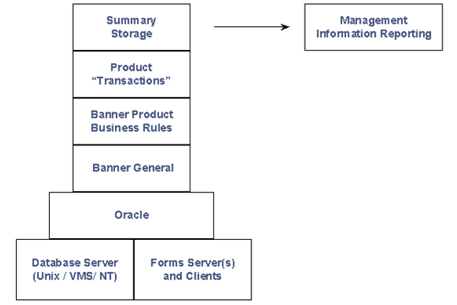
Product Table Owners
Product Table Owners
Product | Table owner
General | GENERAL
General Person | SATURN
Finance | FIMSMGR/FIMSARC
Accounts Receivable | TAISMGR
Position Control | POSNCTL
Payroll | PAYROLL
Student | SATURN
Financial Aid | FAISMGR
Advancement | ALUMNI
Security | BANSECR
Public Synonyms and Views
Diagram
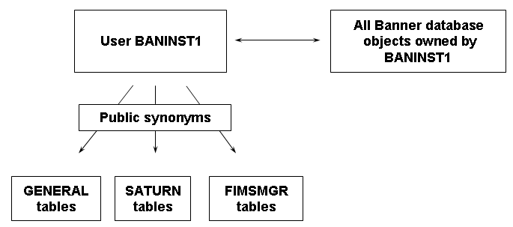
Banner Naming Conventions
Reference
For more information about Banner naming conventions, refer to the Banner Technical Reference - Chapter 1.
- Forms, Reports, Jobs, and Processes
- Tables
- Objects
- Columns
- Indexes
- Constraints
Banner General Person Tables
Table: SPRIDEN
Name data, multiple rows, but only one “active”
Table: SPRADDR
Address data, multiple rows identified by Address types and sequence numbers
Table: SPRTELE
Telephone data, multiple rows, may be related to SPRADDR by Address type
General Person Table Relationships
Person table relationships - diagram
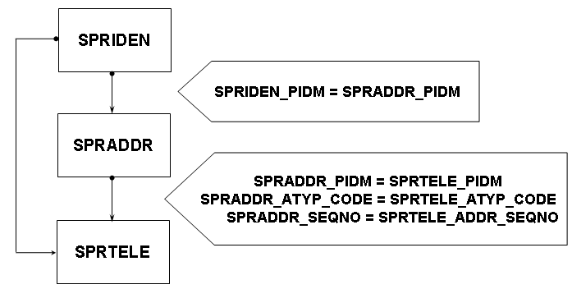
SPRIDEN validation table relationship - diagram
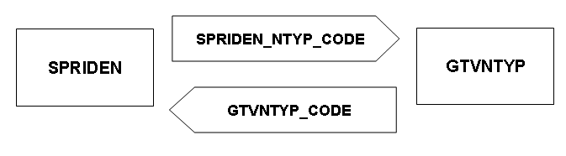
Note: Generally, Banner columns which are named “TABLE”_????_CODE reference validation tables.

Vendor Data Relationships
Considerations
- Using FOAIDEN
- Using FTMVEND
- Common matching system level in GUAINST
- Must be turned on for users to force common matching
- External vendor records created and maintained via Application Programming Interfaces (API's)
Relationships
- SPRIDEN – Person / Non-person ID table
- SPRADDR/SPRTELE/SPBPERS -
Vendor Addresses, Telephone and Tax IDs tables
- FTVVEND – Vendor Validation table
- FAB1099 – Vendor 1099 table
- FTVVENT – Vendor Type table
- FTVVTYP – Vendor Type Validation table
- FTVITYP – Income Type Validation table

Diagram 1
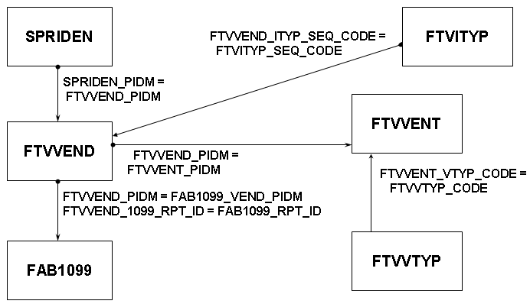
Diagram 2
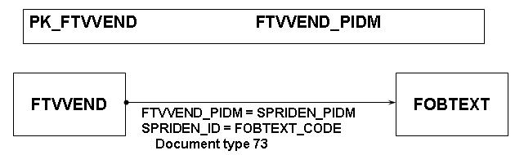

Vendor APIs
APIs
- API Types: Insert, Update, and Delete
- General Person APIs: SPRIDEN, SPRADDR, SPRTELE, SPBPERS, and others
- Vendor APIs: FTVVEND, FTVVENT
- Create user, create date and data origin fields

Banner Finance Application
Finance foundation tables
- Control overall system behavior
- Establish system-wide processing rules
- Define elements which are referenced throughout the Finance System

System Control Table
FOBSYSC / {FOASYSC}
Establishes Finance controls, including:
- Application and Web security indicators
- Available balance processing
- Approvals processing
- Accounting and document level matching controls
- Sponsored research controls
- Fixed assets extract controls

- Should have maintenance access set to the highest security level
- Form controlled by Effective Date process
- Loaded only upon initialization

System Data Validation Table
FTVSDAT/ {FTMSDAT}
- Table of tables
- Features generic table for miscellaneous validation
- Should have maintenance access set to the highest security level
- Defines validation records by:
    - Entity, Attribute, Option 1, Option 2, Level, Chart, Effective date
- Form: FOQSDLV
Rule Code Tables
FTVRUCL, FTVEDIT, FTVRULP / {FTMRUCL}
- Define Posting rules for all documents
- Establish rule edits to apply during processing
- Define process codes used by the Posting process
- Not chart-specific
- Does not use Effective Date processing
- Contain edit and process codes maintained by the System Data Validation Form (FTVSDAT)
- Should have maintenance access set to the highest security level
Diagram
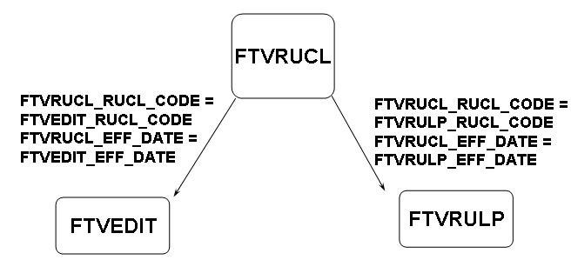

Sequence Number Base Tables
FOBSEQN / {FOASEQN}
- Used to generate Finance document numbers
- Used for other miscellaneous sequence numbers (Commodity codes, Fixed Asset tags, etc.)
- Built before Oracle incorporated sequence objects
- Should have maintenance access set to the highest security level
- Contains a one-character prefix
- Each process uses one of three available columns
FOBFSEQ / {FOMFSEQ}
- Used to generate Finance Feed document number
- Use two-character prefix
- Based on System ID
Note: Typically, all numbers should be set to zero during production setup.

Document Type Verification Table
FTVDTYP / {FTMDTYP}
- Stores all valid document types
- Translates “user” codes into numerics for storage
- Should have maintenance access set to the highest security level
Note: Document types are used extensively to control processing.

Prominent Document Types
Document types
- 1 REQ Requisition
- 2 PO Purchase Order
- 3 INV Invoice/Credit Memo
- 5 CCK Check Cancellation
- 8 CHK Check Disbursement
- 20 JV Journal Document
- 22 RCV Receiving Documents
- 25 ENC Encumbrance
- 60 FAA Fixed Asset Adjustments
- 74 SUM General Ledger Summary

Self Check
Directions
Use the information you have learned in this workbook to complete this self-check activity.
Tables
Banner Finance Vendors and Foundation Tables:
- SPRIDEN
- SPRADDR
- SPRTELE
- FTVVEND
- FOBSYSC
- FTVSDAT
- FTVDTYP
- FOBSEQN
- FOBFSEQ
- FTVRUCL
- FTVRULP
- FTVEDIT
Exercise 1
What are the two owner names of the Finance Tables?

Exercise 2
What is the name of the Owner for all Views?

Exercise 3
What three key tables form the basis of persons and corporations?

Exercise 4
What are the two minimum required tables to create a vendor?

Exercise 5
What field on SPRIDEN indicates most active record, and what is its value?

Exercise 6
What are the two different sequence tables used in Banner Finance for one-up numbering?

Exercise 7
Name the three tables that support rule class codes in Banner Finance.

Exercise 8
Select vendors' records that were inserted or updated by FTMVEND within the last 12 months. The minimum data required is Vendor Name, Type of Vendor (Person or Corporation), Vendor 1099 ID and Vendor Contact Information.

Self Check - Answer Key
Exercise 1
What are the two owner names of the Finance Tables?
FIMSMGR and FIMSARC
Exercise 2
What is the name of the Owner for all Views?
BANINST1
Exercise 3
What three key tables form the basis of persons and corporations?
SPRIDEN, SPRADDR and SPRTELE
Exercise 4
What are the two minimum required tables to create a vendor?
SPRIDEN and FTVVEND
Exercise 5
What field on SPRIDEN indicates most active record, and what is its value?
SPRIDEN_CHANGE_IND, and the value must be NULL
Exercise 6
What are the two different sequence tables used in Banner Finance for one-up numbering?
FOBSEQN and FOBFSEQ
Exercise 7
Name the three tables that support rule class codes in Banner Finance.
FTVRUCL, FTVRULP and FTVEDIT
Exercise 8
Select vendors' records that were inserted or updated by FTMVEND within the last 12 months. The minimum data required is Vendor Name, Type of Vendor (Person or Corporation), Vendor 1099 ID and Vendor Contact Information.

select decode(spriden_entity_ind, 'C',spriden_last_name,
spriden_last_name||', '||spriden_first_name||
' '||spriden_mi)"NAME",
decode(spriden_entity_ind, 'C','CORP','INDV') "TYPE",
ftvvend_1099_rpt_id "TAX ID",
ftvvend_contact "CONTACT",
decode(ftvvend_phone_area, null, null,
'('||ftvvend_phone_area||')')||
decode(ftvvend_phone_number, null, null, ' '
||ftvvend_phone_number)||
decode(ftvvend_phone_ext, null, null,
' EXT. ' ||ftvvend_phone_ext) "PHONE"
from spriden, ftvvend
where spriden_origin = 'FTMVEND'
and spriden_change_ind is null
and spriden_pidm = ftvvend_pidm
and (ftvvend_activity_date > sysdate-365
or spriden_activity_date > sysdate-365);

Banner 8 Common Enhancements
Introduction
This section provides an overview of the enhancements in Banner General 8.0 and Banner Finance 8.0.
Objectives
At the conclusion of this chapter, participants will be able to
- identify enhancements to PIN security
- identify enhancements related to supplemental data
- identify enhancements made for Internationalization purposes
- identify enhancements made for partial data logging
- identify enhancements made for tab-level security.
Internationalization Enhancement
Internationalization
Changes have been made to Banner Finance with the 8.0 release that enable international usage. These changes include the expansion of currency amount, address, phone, and name fields. These Internationalization enhancements will reduce the amount of custom modifications necessary to make Banner usable under those circumstances.
Unicode Support
Banner now supports the Unicode international character set through the character standard UTF8. The Oracle database will be converted to UTF8 as part of the Banner 8.x installation process.
Additional IDs
The Additional Identification Table (GORADID) allows storage of unlimited extra IDs for a person in Banner. Each Additional ID must be assigned an ID type, which is set up on the Additional Identification Type Validation (GTVADID) form and table.
A new Additional ID window on the FOAIDEN form displays Additional ID information.
Refer to the Banner General 8.0 Release Guide for more information on using additional IDs.
Expanded fields
Many fields, including the following, have been expanded on Banner tables and forms so as to accommodate longer data values.
- Name
- Address
- Telephone number
- E-mail address
- ID
- Currency amount
- Currency rate
Currency amounts have been expanded to 17 total characters, including 2 decimal places. This new data length is available for all currency transaction amounts throughout the Banner Finance product, including Research Accounting receivables. A Banner Finance user may enter a maximum of 999,999,999,999,999.99 as a single transaction amount.
Unit price has been expanded to 19 total characters, including 4 decimal places.
Finance 8.0 now uses the expanded Currency Exchange rate in Banner General, which has been expanded to 17 characters, including 7 decimal places.
Finance forms that display the Currency Exchange Rate have been enhanced to display the increased precision of the Currency Exchange Rate.
Affected reports
The following reports have been modified to display larger amounts:
- GL / Subsidiary Control Report (FGRCTRL)
- Trial Balance Exception Report (FGRTBEX)
- Bank I/F Exception Report (FGRBIEX)
- Fixed Asset Orig.Tag Extract Report (FFPOEXT)
- Finance Approvals (FORAPPL)
- Deferred Grant Process (FRRGRNT)
Affected forms
These changes impact a large number of Finance forms, due to the increased capacities for currency fields and/or name, address and phone fields. For a list of all affected forms, please refer to the Banner 8 Finance Release Guide.
Partial Data Masking
Enhancements
The ability to partially mask a field, which was introduced initially in Banner 7.0, has been extended in Banner 8.x to character fields. You can allow a specified number of characters at one side of a field to remain readable while masking the remainder of a value.
To support partial character masking, two new fields (Partial Character Mask and Partial Unmasked Length) have been added to the Data Display Mask Rules Form (GOTDMSK).
Please refer to the Banner General 8.x Release Guide for more information on these changes.
PIN Maintenance
Enhancements
Banner General 8.0 includes enhancements for user PIN (password) security.
- PINs are now stored only in encrypted form
- Institutions can set and enforce standards for strong passwords
- A new, more secure PIN reset mechanism has been established
New forms
- GOAQSTN – PIN Questions Form
Changed forms
- GUAPPFR – Enterprise PIN Preferences Form
- GOATPAC – Third Party Access Form
- GOATPAD – Third Party Access Audit Form
Please refer to the Banner General 8.x Release Guide for more information on these changes.
Supplemental Data Engine
Enhancements
The Supplemental Data Engine allows storage of additional data that are not part of the existing Banner data model. Examples of the types of data affected are comments fields to record miscellaneous notes or data that has been translated into various languages.
No customization of Banner forms or tables is needed to capture and use additional data with SDE. The new data is displayed in a popup window, the Supplemental Data Window, and is stored in a supplemental data table. Because no customization is needed, supplemental data is generally not impacted by Banner upgrades.
Each supplemental data record created through SDE is tied to a specific Banner table, so any forms using that table will be able to access the same data through the Supplemental Data Window. Through SDE you can create additional fields associated with a specific Banner table but stored in a separate table, the Supplemental Data Table.
Although it is natural to think of supplemental data in terms of extra fields on Banner forms, SDE is tied to forms only indirectly.
There are several limitations of SDE, including the following.
- Not all tables, blocks, and forms work with SDE.
- The combination of SDE with Virtual Private Database (VPD) for use in Multi-Enterprise Processing is currently not supported.
- Masking is not currently supported with SDE.
Please refer to the Banner General 8.x Release Guide for more information on these changes.

Working with CFOAPAL and Friends
Introduction
This section discusses CFOAPAL and its applications in the Finance system.
Objectives
At the conclusion of this section, participants will have a better understanding of:
- effective dating
- index structures and queries
- Chart of Accounts
- fund and account types
- fiscal years and periods
- activity dates and user IDs.

Effective Dating
Effective date logic
- Banner records entry and tracks changes to accounting elements
- Effective, Next Change, and Termination dates
- A question of nullability…
    - Null effects upon index usage
    - ALL_TAB_COLUMNS
- Timestamps
- When appearances deceive...
Effective date processing – initial entry
Element Effective Next Chg Term Activity
MYORG 01-JUL-2004 31-DEC-2099 null 15-JUN-2004
Effective date processing – after changes
Element Effective Next Chg Term Activity
MYORG 01-JUL-2004 31-JUL-2004 null 31-JUL-2004
MYORG 31-JUL-2004 30-JUN-2005 null 15-JUN-2005
MYORG 30-JUN-2005 31-DEC-2099 01-JUL-2005 15-JUN-2005

Sample Index Structures
PK_FTVFUND
FTVFUND_COAS_CODE
FTVFUND_FUND_CODE
FTVFUND_EFF_DATE
FTVFUND_NCHG_DATE
PK_FTVTGRP
FTVTGRP_TGRP_CODE
FTVTGRP_EFF_DATE

Typical Query - not Null next change
Query

SELECT ftvfund_title
FROM ftvfund
WHERE ftvfund_coas_code = 'B'
AND ftvfund_fund_code='MYFUND'
AND ftvfund_eff_date <= sysdate
AND ftvfund_nchg_date > sysdate
AND (ftvfund_term_date is Null
OR ftvfund_term_date > sysdate)

Typical Query - NULL next change
Query
SELECT ftvtgrp_non_taxable
FROM ftvtgrp
WHERE ftvtgrp_tgrp_code = 'NT'
AND ftvtgrp_eff_date) <= sysdate
AND (ftvtgrp_nchg_date > sysdate
OR ftvtgrp_nchg_date is Null)
AND (ftvtgrp_term_date is Null
OR ftvtgrp_term_date > sysdate)
Chart of Accounts
CFOAPAL
- Chart of Accounts Validation Form (FTVCOAS)
    - Legal Entity
- Fund Code Validation Form (FTVFUND)
    - Funding Source
- Organization Code Validation Form (FTVORGN)
    - Department
- Account Code Validation Form (FTVACCT)
    - Object / Type of transaction
- Program Code Validation Form (FTVPROG)
    - Functional category
- Activity Code Validation Form (FTVACTV)
    - Type of activity (optional)
- Location Code Validation Form (FTVLOCN)
    - Physical location (optional)
- Account Index Validation Form (FTVACCI)
    - Data entry aid combining elements
- Grants and Contract table (FRBGRNT)
    - Grants and Contracts
- Hierarchical structures
Fund/Fund Type Structure
Diagram
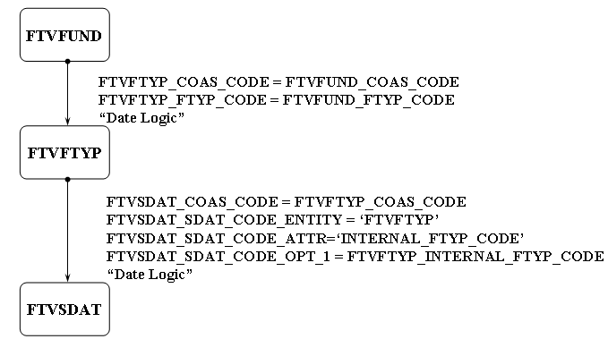

Account/Account Type Structure
Diagram
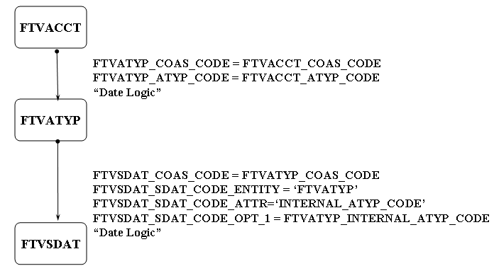

Account Type/Control Account Structure
Diagram
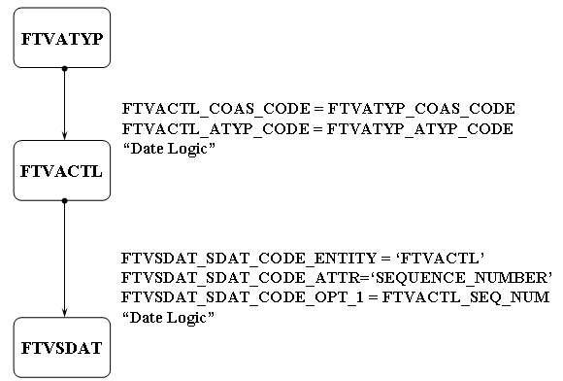

Fiscal Years and Periods
FTVFSYR, FTVFSPD/{FTMFSYR}
- Derive year and period for all posted transactions from FTVFSPD, based upon Transaction date
- Form controls period status:
    - N (Not open)
    - (Open)
    - C (Closed)
- Control record periods 01 through 13 (00 and 14 by the Posting process)
- Should have maintenance access set to the highest security level

Activity Dates and User IDs
Tread lightly
- Most Banner tables contain columns _ACTIVITY_DATE and _USER_ID
- Activity dates normally include full timestamp
- Column values normally reflect the LAST occurrence of data manipulation by forms
- Data manipulation by SQL does not update above fields automatically

Self Check
Directions
Use the information you have learned in this workbook to complete this self-check activity.
Tables
Banner Finance Chart of Accounts, Fiscal Year/Period Tables:
- FTVCOAS
- FTVSDAT
- FTVATYP
- FTVFTYP
- FTVFUND
- FTVORGN
- FTVACCT
- FTVPROG
- FTVACTV
- FTVLOCN
- FTVACTL
- FTVFSYR
- FTVFSPD
- FTVFMGR

Exercise 1
What are the three tables that support the fund structure?

Exercise 2
What are the three tables that support the account structure?

Exercise 3
What is the purpose of the Fiscal Year and Fiscal Period tables?

Exercise 4
What is the purpose of using effective date logic?

Exercise 5
What are the three key functions of the FGRTRNI process?

Exercise 6
Display the codes and titles of all level one fund codes in Chart B.

Exercise 7
Display the account code and its title, account type code and its title, and internal account type code and title for all Chart B accounts.

Exercise 8
Display all organization code rows that have been modified during the current Fiscal Year.

Exercise 9
Display all entities and attributes in the System Data table where chart of account code is set to “B”.

Self Check – Answer Key
Exercise 1
What are the three tables that support the fund structure?
FTVSDAT, FTVFTYP and FTVFUND
Exercise 2
What are the three tables that support the account structure?
FTVSDAT, FTVATYP and FTVACCT
Exercise 3
What is the purpose of the Fiscal Year and Fiscal Period tables?
They work with the transaction date to set the fiscal year code and fiscal period code that the transaction will post to.
Exercise 4
What is the purpose of using effective date logic?
It is important to track auditing changes of accounting elements over time. That way, you will always post with the correct accounting elements based upon the transaction date.
Exercise 5
What are the three key functions of the FGRTRNI process?
- To Interface in Journal entries,
- To perform deferred edits on documents,
- To submit auto journal vouchers
Exercise 6
Display the codes and titles of all level one fund codes in Chart B.

select ftvfund_fund_code “FUND CODE”,
ftvfund_title “FUND TITLE”
from ftvfund
where ftvfund_fund_code_pred is null
and ftvfund_coas_code = ‘B’
and ftvfund_eff_date <= sysdate
and ftvfund_nchg_date > sysdate
and (ftvfund_term_date > sysdate
or ftvfund_term_date is null);
Exercise 7
Display the account code and its title, account type code and its title, and internal account type code and title for all Chart B accounts.

select ftvacct_acct_code “CODE”,
ftvacct_title “TITLE”,
ftvatyp_atyp_code “ATYP CODE”,
ftvatyp_title “ATYP TITLE”,
ftvsdat_sdat_code_opt_1 “INTERNAL ATYP CODE”,
ftvsdat_title “INTERNAL ATYP TITLE”
from ftvacct,ftvatyp,ftvsdat
where ftvacct_atyp_code = ftvatyp_atyp_code
and ftvatyp_internal_atyp_code =
ftvsdat_sdat_code_opt_1
and ftvsdat_sdat_code_entity = 'FTVATYP'
and ftvacct_coas_code = 'B'
and ftvatyp_coas_code = 'B'
and ftvsdat_coas_code = 'B'
and ftvacct_eff_date <= sysdate
and ftvacct_nchg_date > sysdate
and (ftvacct_term_date > sysdate
or ftvacct_term_date is null)
and ftvatyp_eff_date <= sysdate
and ftvatyp_nchg_date > sysdate
and (ftvatyp_term_date > sysdate
or ftvatyp_term_date is null)
and ftvsdat_eff_date <= sysdate
and ftvsdat_nchg_date is null
and (ftvsdat_term_date > sysdate
or ftvsdat_term_date is null);
Exercise 8
Display all organization code rows that have been modified during the current Fiscal Year.
select * from ftvorgn
where ftvorgn_activity_date > to_date
( '20030701','YYYYMMDD');
Exercise 9
Display all entities and attributes in the System Data table where chart of account code is set to “B”.

select distinct ftvsdat_sdat_code_entity “ENTITY”,
ftvsdat_sdat_code_attr “ATTRIBUTE”
from ftvsdat
where ftvsdat_coas_code = ‘B’
and ftvsdat_nchg_date is NULL
order by ftvsdat_sdat_code_entity,
ftvsdat_sdat_code_attr;

Transaction History
Introduction
This section discusses the workings of Transaction History in the Finance system.
Objectives
At the conclusion of this section, participants will be able to
- work with Banner ledger structures
- work with the Transaction history and detail tables.

Banner Ledger Structures
Overview
- FGBTRNH: Transaction History table
- FGBTRND: Transaction Detail table
- FGBENCH: Encumbrance Header table
- FGBENCD: Encumbrance Detail table
- FGBENCP: Encumbrance Period Detail table
- FGBGENL: General Ledger
- FGBOPAL: Operating Ledger
- FRRGRNL: Grant Ledger
General notes
- There are no “open the year/period” processes (tables are populated as needed)
- Tables are manipulated only* by the Finance Posting process (FGRACTG)
* Exceptions: The Encumbrance Header table (ENCH), the
Encumbrance Detail table (ENCD) and FGRGRNL
- Tables form the basis of most reporting requirements
Note: Non-Banner access to tables should be limited to read-only.

Transaction History Table
FGBTRNH
- Contains one row per document posting per accounting distribution
- Allows multiple submissions of a document (change orders, recurring payables, auto jvs)
- Records document cancellation (Reversal indicator)
- Records Transaction date

Transaction Detail Table
FGBTRND
- Contains multiple rows for each row in the Transaction History table (FGBTRNH)
- Derives posting logic from multiple sources (SDAT, Rules, Control Accounts)
- Provides a ledger road map: Each row of the Transaction Detail table (TRND) reflects a single operation upon a single column of a single row within a single ledger
- Grant Ledger exception
Note: Due to Transaction Detail table (TRND) size, queries should be restrictive whenever possible

TRNH/TRND Join Criteria
Diagram
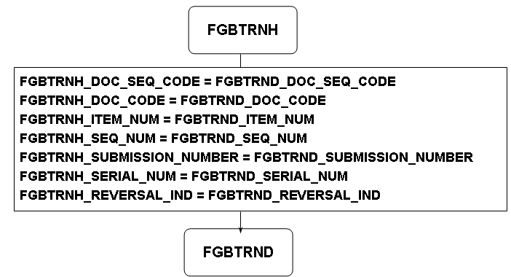

Self Check
Directions
Use the information you have learned in this workbook to complete this self-check activity.
Tables
Banner Finance Transaction History and Detail Tables:
- FGBTRNH
- FGBTRND
Exercise 1
What does the FGBTRNH table represent?

Exercise 2
What does the FGBTRND table represent?

Exercise 3
What ledger table is used most often for research and troubleshooting purposes?

Exercise 4
What are the three valid values of the FGBTRND_LEDGER_IND on FGBTRND table?

Exercise 5
What is the purpose of the FIELD_CODE in FGBTRND table? Provide examples of its purpose.

Exercise 6
What field on FGBTRND indicates the type of document posted?

Exercise 7
Display the Fiscal Year code, Fiscal Period code, Document Type description, and number of each Document type processed in FGBTRNH.

Exercise 8
Display the Document number and Total Document amount for all posted invoices from FGBTRNH.

Exercise 9
Display all possible combinations of the Ledger indicator and Field code that exist in FGBTRND.

Exercise 10
Display the Document numbers and document types of all documents posted between 6PM and 6AM.

Self Check – Answer Key
Exercise 1
What does the FGBTRNH table represent?
Document header information that posted to the ledger.
Exercise 2
What does the FGBTRND table represent?
Document detail information as to what ledger and what field it was posted to.
Exercise 3
What ledger table is used most often for research and troubleshooting purposes?
FGBTRNH and FGBTRND
Exercise 4
What are the three valid values of the FGBTRND_LEDGER_IND on FGBTRND table?
O = Operating Ledger, E = Encumbrance Ledger, G = General Ledger
Exercise 5
What is the purpose of the FIELD_CODE in FGBTRND table? Provide examples of its purpose.
Tells which field in the ledger the amount was posted to.
Example: if the ledger indicator = 'O' and field code =- '03', then the amount was posted to the operating ledger year to date activity amount field
Exercise 6
What field on FGBTRND indicates the type of document posted?
FGBTRND_DOC_SEQ_CODE indicates the type of document posted (using document type sequence number.)
Exercise 7
Display the Fiscal Year code, Fiscal Period code, Document Type description, and number of each Document type processed in FGBTRNH.

select fgbtrnh_fsyr_code “FISCAL YEAR”,
fgbtrnh_posting_period “FISCAL PERIOD”,
ftvdtyp_desc “DOC TYPE”,
count(*) “NO OF DOCS”
from fgbtrnh,ftvdtyp
where fgbtrnh_doc_seq_code = ftvdtyp_seq_num
group by fgbtrnh_fsyr_code,
fgbtrnh_posting_period,
ftvdtyp_desc;
Exercise 8
Display the Document number and Total Document amount for all posted invoices from FGBTRNH.

select fgbtrnh_doc_code "INVOICE NUMBER",
to_char(sum(fgbtrnh_trans_amt*decode (
fgbtrnh_dr_cr_ind,'+','1','-1')),
‘$9999999999.00’) "AMOUNT"
from fgbtrnh
where fgbtrnh_doc_seq_code = 3
group by fgbtrnh_doc_code;

Exercise 9
Display all possible combinations of the Ledger indicator and Field code that exist in FGBTRND.

select distinct fgbtrnd_ledger_ind
"LEDGER INDICATOR",
fgbtrnd_field_code "FIELD CODE"
from fgbtrnd;
Exercise 10
Display the Document numbers and document types of all documents posted between 6PM and 6AM.

select distinct fgbtrnh_doc_code “DOC NUMBER”,
ftvdtyp_desc “DOC TYPE”
from fgbtrnh,ftvdtyp
where fgbtrnh_doc_seq_code = ftvdtyp_seq_num
and (to_char(fgbtrnh_activity_date,'HH24MISS')
>= '180000'
or to_char(fgbtrnh_activity_date,'HH24MISS')
<= '060000');

General Ledger
Introduction
This section discusses the workings of the General Ledger in the Finance system.
Objectives
At the conclusion of this section, participants will be able to
- work with the General Ledger structures

General Ledger
FGBGENL
- Records Assets (10), Liabilities (20), and the Fund balance (40)
- Has control accounts (30) to which other transaction types are posted
- Contains one row per fiscal year / fiscal period / accounting distribution with debit / credit sums
- Does not calculate fiscal period totals cumulatively within a fiscal year
Note: Accounting Distribution consists only of COA, Fund, and Account.

FGBGENL/FGBTRND Roadmap
Which ledger?
FGBTRND_LEDGER_IND = 'G'
Which row?
GENL Primary Key
Which column?
FGBTRND_FIELD_CODE
- '01' - _SUM_PERIODIC_DR
- '02' - _SUM_PERIODIC_CR
What effect?
- FGBTRND_TRANS_AMT = '$'
- FGBTRND_DR_CR_IND = 'D' or 'C'
Note: In all postings, the fiscal year and fiscal period are calculated from the Document Transaction date.

FGBGENL Sample Postings
Diagram
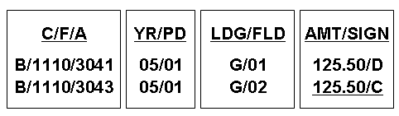
Notice the redundancy of field code and sign in the general ledger postings.
Typical GENL/TRND Join Criteria
Criteria
- FGBGENL_COAS_CODE = FGBTRND_COAS_CODE
- FGBGENL_FSYR_CODE = FGBTRND_FSYR_CODE
- FGBGENL_PERIOD = FGBTRND_POSTING_PERIOD
- FGBGENL_FUND_CODE = FGBTRND_FUND_CODE
- FGBGENL_ACCT_CODE = FGBTRND_ACCT_CODE
- FGBTRND_LEDGER_IND = 'G'
Note: The Normal Balance indicators for accounts and account types define whether the difference between debits and credits should be positive, zero, or negative.
These indicators are stored on the Account Code Validation Form (FTVACCT) and the Account Type Validation Form (FTVATYP).

Sample General Ledger View
Sample view
CREATE OR REPLACE force view aud_genl_fspd
(fsyr,
fspd,
coas,
fund,
acct,
acct_normal_bal,
debits,
credits,
balance,
normal_bal_ind) as
SELECT fgbgenl_fsyr_code,
fgbgenl_period,
fgbgenl_coas_code,
fgbgenl_fund_code,
fgbgenl_acct_code,
ftvacct_normal_bal,
fgbgenl_sum_periodic_dr,
fgbgenl_sum_periodic_cr,
DECODE(ftvacct_normal_bal,
'C', fgbgenl_sum_periodic_cr -
fgbgenl_sum_periodic_dr,
fgbgenl_sum_periodic_dr -
fgbgenl_sum_periodic_cr),
DECODE(sign(decode(ftvacct_normal_bal,
'C', fgbgenl_sum_periodic_cr -
fgbgenl_sum_periodic_dr,
fgbgenl_sum_periodic_dr -
fgbgenl_sum_periodic_cr)),
-1, 'OOB', NULL)
FROM ftvacct, fgbgenl
WHERE ftvacct_coas_code = fgbgenl_coas_code
AND ftvacct_acct_code = fgbgenl_acct_code
AND ftvacct_eff_date <= sysdate
AND ftvacct_nchg_date > sysdate
comment on table aud_genl_fspd is
'Audit Tool: General Ledger totals by CFA/fsyr/fspd';

GRANT SELECT on aud_genl_fspd to public;

DROP public synonym aud_genl_fspd;

CREATE public synonym aud_genl_fspd for aud_genl_fspd;

Sample General Ledger View - Query Output
Query output
FY FP C FUND ACCT A DEBITS CREDITS BALANCE NOR
-- -- - ------ ------ - ---------- ---------- ---------- ---
02 06 B 1110 1090 D 22995.42 1184246.42 -1161251 OOB
02 06 B 1110 2101 C 1627437.93 5839984.27 4212546.34
02 06 B 1110 3011 C 0 400 400
02 06 B 1110 3021 D 5844289.27 470091.93 5374197.34
02 06 B 1110 3023 C 0 900000 900000
02 06 B 1110 3041 D 65712716 6375357.43 59337358.6
02 06 B 1110 3043 C 6375357.43 65712716 59337358.6
02 06 B 1110 3051 C 900000 0 -900000 OOB

Self Check
Directions
Use the information you have learned in this workbook to complete this self-check activity.
Tables
Banner Finance General Ledger Table:
- FGBGENL
Exercise 1
What is the key difference between the operating ledger (FGBOPAL) and the general ledger (FGBGENL) from a database design prospective?

Exercise 2
What type of accounts post to General Ledger?

Exercise 3
Is the General Ledger a signed or unsigned table?

Exercise 4
How can we query on the current balance for a specific fiscal year from the General Ledger?

Exercise 5
Display the Fiscal Year code, Fund, and Fund balance of all funds with a non-zero balance for Chart of Accounts B.

Exercise 6
Display the Fiscal Year code, Account code, Account title, and balance across all funds for Chart of Accounts B.

Self Check – Answer Key
Exercise 1
What is the key difference between the operating ledger (FGBOPAL) and the general ledger (FGBGENL) from a database design prospective?
The operating ledger is in de-normalized form. All periods are on one record. The general ledger is in normal form. Each period is on a separate record.
Exercise 2
What type of accounts post to General Ledger?
Asset = 10, liabilities = 20, control accounts = 30,
fund balance accounts = 40, fund additions = 90, fund deductions = 95
Exercise 3
Is the General Ledger a signed or unsigned table?
The General Ledger is an unsigned table. Only Debits and Credits values exist in the table with positive signs in all cases.
Exercise 4
How can we query on the current balance for a specific fiscal year from the General Ledger?
We need to sum all the periods totals started from period 00 to the current period (using SYSDATE to extract current period number from FTVFSPD) for the given fiscal year.
Exercise 5
Display the Fiscal Year code, Fund, and Fund balance of all funds with a non-zero balance for Chart of Accounts B.

select fgbgenl_fsyr_code “FSYR”,
fgbgenl_fund_code “FUND CODE”,
sum (fgbgenl_sum_periodic_dr -
fgbgenl_sum_periodic_cr) “SUM”
from fgbgenl
where fgbgenl_coas_code = ‘B’
having sum(fgbgenl_sum_periodic_dr -
fgbgenl_sum_periodic_cr) != 0
group by fgbgenl_fsyr_code,
fgbgenl_fund_code;
Exercise 6
Display the Fiscal Year code, Account code, Account title, and balance across all funds for Chart of Accounts B.
select fgbgenl_fsyr_code "FSYR",
fgbgenl_acct_code “ACCOUNT”,
ftvacct_title “TITLE”,
decode(ftvacct_normal_bal, ‘D’,
sum(fgbgenl_sum_periodic_dr –
fgbgenl_sum_periodic_cr),
sum(fgbgenl_sum_periodic_cr –
fgbgenl_sum_periodic_dr)) "BALANCE"
from fgbgenl,ftvacct
where fgbgenl_coas_code = ‘B’
and fgbgenl_acct_code = ftvacct_acct_code
and fgbgenl_coas_code = ftvacct_coas_code
and ftvacct_eff_date <= sysdate
and ftvacct_nchg_date > sysdate
and (ftvacct_term_date > sysdate
or ftvacct_term_date is null)

group by ftvacct_normal_bal,
fgbgenl_fsyr_code,
fgbgenl_acct_code,
ftvacct_title;
Operating Ledger
Introduction
This section discusses the workings of the Operating Ledger in the Finance system.
Objectives
At the conclusion of this section, participants will be able to work with the Operating Ledger structures.

Operating Ledger
FGBOPAL
- Records revenue (50), labor (60), expense (70), and transfers (80)
- Spawns corresponding postings to General Ledger (GENL) control accounts for each Operating Ledger (OPAL) transaction
- Contains separate summary values for budget, budget adjustment, expense, reservation, and encumbrance transactions
- Accounting Distribution consists of COA, Fund, Orgn, Acct, Prog, Actv (optional), and Location (optional)
Denormalized table
- Each row contains one fiscal year
- Each column displays one period (periods 00 through 14)
- Note: Column names contain period designators:
fgbopal_14_ytd_actv
- Each period total is the cumulative sum of activity from period 00 through the current period

Periodic Totals
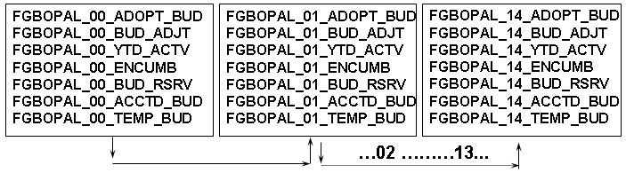
- Series of 15 groups of 7 ledger totals
- Each “bucket” total is year-to-date
- Current period totals calculated
- Remaining budget totals calculated
- An eighth column for grant activity is obsolete
FGBOPAL / FGBTRND Roadmap
Which ledger?
FGBTRND_LEDGER_IND = 'O'
Which row?
OPAL Key Index
Which column? (in each series)
FGBTRND_FIELD_CODE
- '01' - _ADOPT_BUD
- '02' - _BUD_ADJT
- '03' - _YTD_ACTV
- '04' - _ENCUMB
- '05' - _BUD_RSRV
- '06' - _ACCTD_BUD
- '07' - _TEMP_BUD
What effect?
- FGBTRND_TRANS_AMT = '$'
- FGBTRND_DR_CR_IND = '+' or '-'
Note: In all postings, the fiscal year and fiscal period are calculated from the Document Transaction date.

FGBOPAL Sample Postings
Diagram
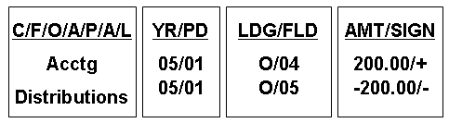

Typical OPAL/TRND Join Criteria
Criteria
FGBOPAL_COAS_CODE = FGBTRND_COAS_CODE
FGBOPAL_FSYR_CODE = FGBTRND_FSYR_CODE
FGBOPAL_FUND_CODE = FGBTRND_FUND_CODE
FGBOPAL_ACCT_CODE = FGBTRND_ACCT_CODE
FGBOPAL_ORGN_CODE = FGBTRND_ORGN_CODE
FGBOPAL_PROG_CODE = FGBTRND_PROG_CODE
FGBOPAL_ACTV_CODE = NVL(FGBTRND_ACTV_CODE,' ')
FGBOPAL_LOCN_CODE = NVL(FGBTRND_LOCN_CODE,' ')
FGBOPAL_CMT_TYPE = FGBTRND_CMT_TYPE
FGBTRND_LEDGER_IND = 'O'

Sample Operating Ledger View
Sample view
CREATE OR REPLACE force view aud_opal_fsyr
(fsyr,
coas,
fund,
orgn,
acct,
prog,
ytd_bud,
ytd_exp,
ytd_rsrv,
ytd_enc,
ytd_bud_remain) AS
SELECT fgbopal_fsyr_code,
fgbopal_coas_code,
fgbopal_fund_code,
fgbopal_orgn_code,
fgbopal_acct_code,
fgbopal_prog_code,
sum(fgbopal_14_adopt_bud +
fgbopal_14_bud_adjt),
sum(fgbopal_14_ytd_actv),
sum(fgbopal_14_bud_rsrv),
sum(fgbopal_14_encumb),
sum(fgbopal_14_adopt_bud +
fgbopal_14_bud_adjt -
fgbopal_14_ytd_actv -
fgbopal_14_bud_rsrv -
fgbopal_14_encumb)
FROM fgbopal
GROUP BY fgbopal_fsyr_code,
fgbopal_coas_code,
fgbopal_fund_code,
fgbopal_orgn_code,
fgbopal_acct_code,
fgbopal_prog_code;
comment on table aud_opal_fsyr is
'Audit Tool: Operating Ledger totals by fsyr/CFOAP ';
GRANT SELECT on aud_opal_fsyr to public;
DROP public synonym aud_opal_fsyr;
CREATE public synonym aud_opal_fsyr for aud_opal_fsyr;

Sample Operating Ledger View - Query Output
Query output
FY ACCT YTD_BUD YTD_EXP YTD_RSRV YTD_ENC YTD_BUD_REMAIN
-- ----- ---------- ---------- ---------- ---------- --------------
02 Acctg 3195000 670000 0 0 2525000
02 Acctg 1462000 215000 0 0 1247000
02 Acctg 1388000 215000 0 0 1173000
02 Acctg 1895000 0 0 0 1895000
02 Acctg 1350000 0 0 0 1350000
02 Acctg 2000000 5000000 0 0 -3000000
02 Acctg 0 75912.2 0 0 -75912.2
02 Acctg 100001 0 0 0 100001
02 Acctg 35000 29166.7 0 0 5833.3
02 Acctg 0 121 0 0 -121
02 Acctg 0 1500 0 0 -1500

Self Check
Directions
Use the information you have learned in this workbook to complete this self-check activity.
Tables
Banner Finance Operating Ledger Table:
- FGBOPAL
Exercise 1
What type of accounts post to Operating Ledger?

Exercise 2
What are the accounting elements that are necessary to post to the operating ledger?

Exercise 3
What is the obsolete column in the Operating Ledger, and why?

Exercise 4
How is the available balance calculated from the operating ledger table?

Exercise 5
How can we query on the current balance for a specific fiscal year from the Operating Ledger?

Exercise 6
Display the Account code and Account title of all data-enterable Direct Expenditure accounts in the Operating Ledger that have never been used on a posted transaction.

Exercise 7
Compute total remaining budget by Fiscal Year and fund for all funds under chart of accounts B.

Self Check – Answer Key
Exercise 1
What type of accounts post to Operating Ledger?
Revenue accounts = 50, labor accounts = 60,
expense accounts = 70, transfers accounts = 80
Exercise 2
What are the accounting elements that are necessary to post to the operating ledger?
Chart of Accounts Code, Fund Code, Organization Code, Account Code and Program Code
Exercise 3
What is the obsolete column in the Operating Ledger, and why?
All Grant Activities “FGBOPAL_**_GRANT_ACTV” columns (where ** represent the period), because the creation of the grant ledger FRRGRNL replaced it.
Exercise 4
How is the available balance calculated from the operating ledger table?
Adopted budget + budget adjustments – year to date activity – encumbrances – budget reservations = remaining budget.
Exercise 5
How can we query on the current balance for a specific fiscal year from the Operating Ledger?
We need to sum period 14 total for the given fiscal year.
Exercise 6
Display the Account code and Account title of all data-enterable Direct Expenditure accounts in the Operating Ledger that have never been used
on a posted transaction.

select ftvacct_acct_code “ACCT”,
ftvacct_title “TITLE”
from ftvacct
where ftvacct_data_entry_ind = 'Y'
and ftvacct_atyp_code in
(select ftvatyp_atyp_code
from ftvatyp
where ftvatyp_internal_atyp_code = '70')
minus
select fgbopal_acct_code “ACCT”,
ftvacct_title “TITLE”
from fgbopal, ftvacct
where ftvacct_acct_code = fgbopal_acct_code
and ftvacct_eff_date <= sysdate
and ftvacct_nchg_date > sysdate
and (ftvacct_term_date > sysdate
or ftvacct_term_date is null);
Exercise 7
Compute total remaining budget by Fiscal Year and fund for all funds under chart of accounts B.

select fgbopal_fsyr_code “FSYR”,
fgbopal_fund_code “FUND”,
sum (fgbopal_14_adopt_bud
+ fgbopal_14_bud_adjt
- fgbopal_14_ytd_actv
- fgbopal_14_encumb
- fgbopal_14_bud_rsrv) “REMN BUD”
from fgbopal
where fgbopal_coas_code = ‘B’
group by fgbopal_fsyr_code,fgbopal_fund_code;

Encumbrance Ledger
Introduction
This section discusses the workings of the Encumbrance Ledger in the Finance system.
Objectives
At the conclusion of this section, participants will be able to work with the Encumbrance Ledger structures.

Encumbrance Ledger
FGBENCP
- Records periodic summaries of encumbrance establishment, adjustment, and liquidation by encumbrance accounting distribution
- Includes all encumbrance activity: Purchase Order, Requisition, Labor, and General
- Related to the Encumbrance Header table (FGBENCH) and the Encumbrance Period Detail table (FGBENCD)
- Does not calculate fiscal period totals cumulatively within a fiscal year
- Stores totals as signed numbers

FGBENCP / FGBTRND Roadmap
Which ledger?
FGBTRND_LEDGER_IND = 'E'
Which row?
ENCP Primary Key
Which column? (in each series)
FGBTRND_FIELD_CODE
- '01' - _ORIG_ENCB_AMT
- '02' - _SUM_ENCB_ADJT
- '03' - _SUM_ENCB_LIQ
What effect?
- FGBTRND_TRANS_AMT = '$'
- FGBTRND_DR_CR_IND = '+' or '-'
Note: In all postings, the fiscal year and fiscal period are calculated from the Document Transaction date.

Encumbrance Ledger Structures
Diagram
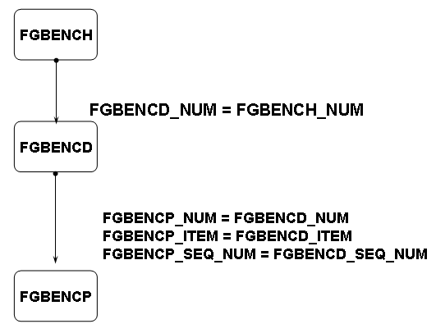

FGBENCP Sample Postings
Diagram
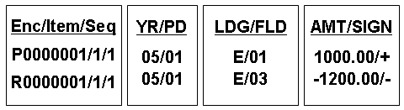
Note: Encumbrance, Item, and Sequence are related to encumbrance columns in the Transaction Detail table (FGBTRND) instead of Document code, item, and sequence.
A single document may create multiple postings to the Encumbrance Period Detail table (ENCP) against separate encumbrances.
In the above, a purchase order results in the establishment of the PO as well as liquidation of the requisition.

Typical ENCP/TRND Join Criteria
Criteria
FGBENCP_NUM = FGBTRND_ENCD_NUM
FGBENCP_ITEM = FGBTRND_ENCD_ITEM_NUM
FGBENCP_SEQ_NUM = FGBTRND_ENCD_SEQ_NUM
FGBENCP_FSYR_CODE = FGBTRND_FSYR_CODE
FGBENCP_PERIOD = FGBTRND_POSTING_PERIOD
FGBTRND_LEDGER_IND = 'E'

Sample Encumbrance Ledger View
Sample view
CREATE OR REPLACE force view aud_encp_open
(enc_num,
enc_item,
enc_seq,
fsyr,
coas,
fund,
orgn,
acct,
prog,
orig_enc,
enc_adjt,
enc_liq,
enc_bal) AS
SELECT fgbencd_num,
fgbencd_item,
fgbencd_seq_num,
fgbencd_fsyr_code,
fgbencd_coas_code,
fgbencd_fund_code,
fgbencd_orgn_code,
fgbencd_acct_code,
fgbencd_prog_code,
sum(fgbencp_orig_encb_amt),
sum(fgbencp_sum_encb_adjt),
sum(fgbencp_sum_encb_liq),
sum(fgbencp_orig_encb_amt +
fgbencp_sum_encb_adjt +
fgbencp_sum_encb_liq)
FROM fgbencp, fgbencd
WHERE fgbencd_status = 'O'
AND fgbencp_num = fgbencd_num
AND fgbencp_item = fgbencd_item
AND fgbencp_seq_num = fgbencd_seq_num
GROUP BY fgbencd_num,
fgbencd_item,
fgbencd_seq_num,
fgbencd_fsyr_code,
fgbencd_coas_code,
fgbencd_fund_code,
fgbencd_orgn_code,
fgbencd_acct_code,
fgbencd_prog_code;

comment on table aud_encp_open is
'Audit Tool: Encumbrance Ledger Details for
Open Encumbrances';

GRANT SELECT on aud_encp_open to public;
DROP public synonym aud_encp_open;
CREATE public synonym aud_encp_open for aud_encp_open;

Sample Encumbrance Ledger View - Query Output
Query output
Enc/Item/Seq FY 'ACCTGDIST ORIG_ENC ENC_ADJT ENC_LIQ ENC_BAL
------------- -- ---------- --------- --------- --------- ---------
P0000156/0/1 02 Acctg Dist 530 0 -380 150
P0000157/0/1 02 Acctg Dist 1038.75 0 -778 260.75
P0000163/0/1 02 Acctg Dist 300 0 0 300
P0000164/0/1 02 Acctg Dist 3750 0 0 3750
P0005555/0/1 02 Acctg Dist 3600 0 0 3600
POOOOO44/0/1 02 Acctg Dist 2350 505 0 2855
PR940001/0/46 02 Acctg Dist 47700 0 -47700 0
PR950001/0/1 02 Acctg Dist 144000 0 -144000 0
PR950001/0/11 02 Acctg Dist 82500 0 -82500 0
PR950001/0/12 02 Acctg Dist 29284.2 0 0 29284.2

Self Check
Directions
Use the information you have learned in this workbook to complete this self-check activity.
Tables
Banner Finance Encumbrance Ledger Table:
- FGBENCP
Exercise 1
What four kinds of encumbrances does the encumbrance ledger support?

Exercise 2
What three key fields on FGBTRND and FGBTRNH support researching an encumbrance?

Exercise 3
Display the Encumbrance number, item, and sequence and posted totals of all encumbrances adjusted during the 1995 Fiscal Year.

Exercise 4
Display the Vendor name, Encumbrance number, and Encumbrance balance for open encumbrances.

Self Check – Answer Key
Exercise 1
What four kinds of encumbrances does the encumbrance ledger support?
Requisitions (budget reservations) Purchase Orders, Labor and General encumbrances.
Exercise 2
What three key fields on FGBTRND and FGBTRNH support researching an encumbrance?
Encd_num, encd_item_num, encd_seq_num
Exercise 3
Display the Encumbrance number, item, and sequence and posted totals of all encumbrances adjusted during the 1995 Fiscal Year.

select fgbencp_num “ENCUM NO”,
fgbencp_item “ITEM NO”,
fgbencp_seq_num “SEQ NO”,
sum (fgbencp_orig_encb_amt
+ fgbencp_sum_encb_adjt
+ fgbencp_sum_encb_liq) “ENCUM TOTAL”
from fgbencp
where fgbencp_fsyr_code = '95'
and fgbencp_sum_encb_adjt > 0
group by fgbencp_num, fgbencp_item,
fgbencp_seq_num;
Exercise 4
Display the Vendor name, Encumbrance number, and Encumbrance balance for open encumbrances.

select decode(fgbench_vendor_pidm,
NULL, ‘No Vendor Attached’,
f_format_name(fgbench_vendor_pidm,
'LFMI')) “VENDOR NAME”,
fgbench_num “ENCUM NO”,
sum (fgbencp_orig_encb_amt
+ fgbencp_sum_encb_adjt
+ fgbencp_sum_encb_liq) “ENCUM BALANCE”
from fgbench,fgbencp
where fgbench_num = fgbencp_num
and fgbench_status_ind = 'O'
group by fgbench_vendor_pidm,fgbench_num;

Grant Ledger
Introduction
This section discusses the workings of the Grant Ledger in the Finance system.
Objectives
At the conclusion of this section, participants will be able to work with the Grant Ledger structures.

Grant Ledger
FRRGRNL
- Records labor, revenue, expense, and transfers
- Keys on grant year rather than fiscal year
- Calculates grant year using grant project start date
- Processes each GRNT transaction as a hybrid OPAL transaction (Transaction is not stored separately in TRND)
- Features Accounting Distribution that consists of coas, grnt, fund, orgn, acct, prog, actv (optional), and location (optional)
- Provides separate summary values for budget, budget adjustment, expense, reservation, and encumbrance transactions
Denormalized table
- A row contains one grant year (fiscal year)
- The grant year total is a sum the current grant year plus all prior grant years
- Each column displays one grant period (periods 00 through 14)
Note: Column names contain period designators.
Each grant period total is the cumulative sum of activity from period 00 through the current period of the current grant year.
Postings
- Postings to the grant ledger occur whenever the FTVFUND_GRNT_CODE has a value in it.
- Activity and Location: if null in the transaction, they are stored as spaces
- Grant year and grant period are calculated from project start date and calendar year using transaction date
Periodic Totals
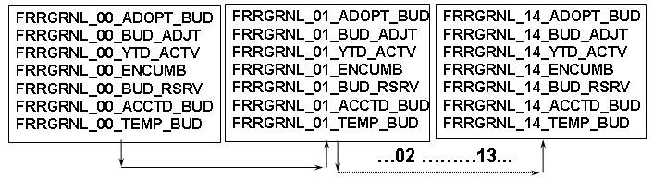
- Series of 15 groups of 7 ledger totals
- Each “bucket” total is inception-to-date
- Transaction period through period 14 ITD accumulated
- Remaining budget totals calculated in the forms

OPAL / GRNT Relationship
Diagram
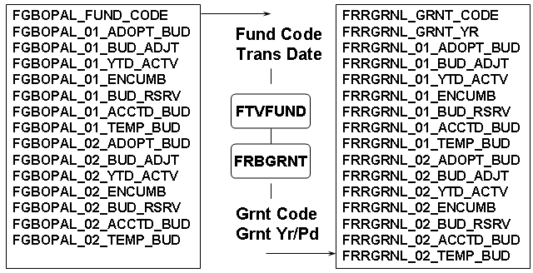

Sample Grant Ledger view
Sample view
CREATE OR REPLACE force view aud_grnt_incept
(grnt,
coas,
fund,
orgn,
acct,
prog,
itd_bud,
itd_exp,
itd_rsrv,
itd_enc,
itd_bud_remain) AS
SELECT m.frrgrnl_grnt_code,
m.frrgrnl_coas_code,
m.frrgrnl_fund_code,
m.frrgrnl_orgn_code,
m.frrgrnl_acct_code,
m.frrgrnl_prog_code,
sum(m.frrgrnl_14_adopt_bud +
m.frrgrnl_14_bud_adjt),
sum(m.frrgrnl_14_ytd_actv),
sum(m.frrgrnl_14_bud_rsrv),
sum(m.frrgrnl_14_encumb),
sum(m.frrgrnl_14_adopt_bud +
m.frrgrnl_14_bud_adjt -
m.frrgrnl_14_ytd_actv -
m.frrgrnl_14_bud_rsrv -
m.frrgrnl_14_encumb)
FROM frrgrnl m
WHERE m.frrgrnl_grnt_yr =
(SELECT max(s.frrgrnl_grnt_yr)
FROM frrgrnl s
WHERE s.frrgrnl_grnt_code =
m.frrgrnl_grnt_code)
GROUP BY m.frrgrnl_grnt_code, m.frrgrnl_coas_code,
m.frrgrnl_fund_code, m.frrgrnl_orgn_code,
m.frrgrnl_acct_code, m.frrgrnl_prog_code;
comment on table aud_grnt_incept is
'Audit Tool: Grant Ledger Year to Date
Inception Balance';

GRANT SELECT on aud_grnt_incept to public;
DROP public synonym aud_grnt_incept;
CREATE public synonym aud_grnt_incept for aud_grnt_incept;
Sample Grant Ledger view - Query Output
Query output
GRNT Bud Exp Rsrv Enc Bal
------ ---------- ----------- ----------- ----------- -----------
215601 1000.00 80.00 .00 .00 920.00
215701 .00 135.00 .00 .00 -135.00
215801 90000.00 8000.00 .00 2000.00 80000.00
215901 180000.00 6600.00 4500.00 2200.00 1667.00

Self Check
Directions
Use the information you have learned in this workbook to complete this self-check activity.
Tables
Banner Finance Grant Ledger Table:
- FRRGRNL
Exercise 1
What field on FGBTRND represents a transaction update in the Grant Ledger?

Exercise 2
What is the key difference between the operating ledger (FGBOPAL) and the grant ledger (FRRGRNL)?

Exercise 3
Assume that encumbrances and reservations should be excluded from balance computations. Display the Grant code, Grant start date, Grant end date and inception-to-date balance for all grants.

Exercise 4
Determine which grants have multiple funding sources.

Self Check – Answer Key
Exercise 1
What field on FGBTRND represents a transaction update in the Grant Ledger?
There is no field in FGBTRND represent a transaction update in the Grant Ledger. The Grant Ledger is a hybrid transaction of the Operating Ledger and the fact that the fund belongs to a grant.
Exercise 2
What is the key difference between the operating ledger (FGBOPAL) and the grant ledger (FRRGRNL)?
Operating ledger is based upon fiscal year, grant ledger is based upon inception to date
Exercise 3
Assume that encumbrances and reservations should be excluded from balance computations. Display the Grant code, Grant start date, Grant end date and inception-to-date balance for all grants.

select a.frrgrnl_grnt_code “GRANT CODE”,
frbgrnt_project_start_date “GRANT START DATE”,
frbgrnt_project_end_date “GRANT END DATE”,
sum (a.frrgrnl_14_adopt_bud
+ a.frrgrnl_14_bud_adjt) “BUDGET”,
sum (a.frrgrnl_14_ytd_actv) “ACTIVITY”,
sum (a.frrgrnl_14_adopt_bud
+ a.frrgrnl_14_bud_adjt
- a.frrgrnl_14_ytd_actv) “BALANCE”
from frrgrnl a, frbgrnt
where a.frrgrnl_grnt_yr = (
select max(fofycnv(b.frrgrnl_grnt_yr))
from frrgrnl b
where b.frrgrnl_grnt_code =
a.frrgrnl_grnt_code)
and a. frrgrnl_grnt_code = frbgrnt_code
group by a.frrgrnl_grnt_code,
frbgrnt_project_start_date,
frbgrnt_project_end_date;
Exercise 4
Determine which grants have multiple funding sources.

select distinct ftvfund_grnt_code “GRANT CODE”,
count(*) “NO OF FUND CODES”
from ftvfund
where ftvfund_grnt_code is not null
and ftvfund_eff_date <= sysdate
and ftvfund_nchg_date > sysdate
and (ftvfund_term_date > sysdate
or ftvfund_term_date is null)
having count(*) > 1
group by ftvfund_grnt_code;

Work with Banner Ledger Structures
Introduction
This section is a brief recap of the relationship between the Banner ledger structures.

Banner Ledger Structures - Recap
Diagram
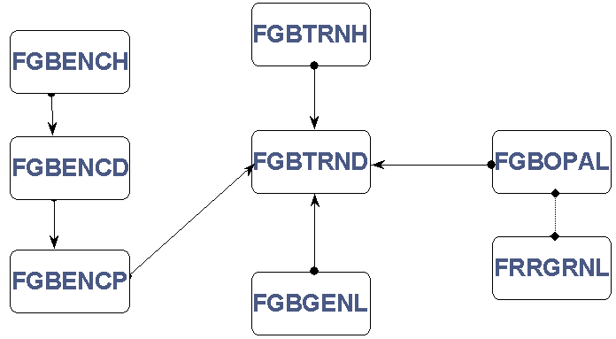

Available Balance Processing
Introduction
This section discusses the workings of Available Balance Processing in the Finance system.
Objectives
At the conclusion of this section, participants will be able to
- describe Available Balance processing
- describe account pool examples.

Available Balance Processing
Purpose
- Occurs immediately after we move to another block or record
- Maintains budget, encumbrance, reservation, and expense totals in FGBBAVL
- Records unposted documents in FGRBAKO
- Incorporates processing methods and stored values that depend on budget control rules
- Involves a rebuild process: FGRBAVL
Control keys
NSF Checking indicators exist in FOBSYSC.
Control keys are found on:
- Chart of Accounts Validation Form (FTVCOAS)
- Fund Code Validation Form (FTVFUND)
- Fund Type Validation Form (FTVFTYP)
Controls
The controls for checking budget availability:
- Define FOAP elements used in NSF checking
- Define control period (Annual, Quarter, Year to Date)
- Define error severity: E (Error), W (Warning)
Budget pooling
Account code: Use the Account Maintenance Form (FTMACCT).
Budgets may also be pooled by fund (FTVFUND) or organization (FTVORGN). We may also use the Hierarchical Budget Maintenance Form (FTMHBUD).

FGIBAVL
Query Form FGIBAVL
- Values stored are control keys rather than transaction elements
- BAVL = OPAL + BAKO
Primary Key
FGBBAVL_COAS_CODE
- FGBBAVL_FSYR_CODE
- FGBBAVL_FUND_CODE
- FGBBAVL_ORGN_CODE
- FGBBAVL_ACCT_CODE
- FGBBAVL_PROG_CODE
- FGBBAVL_PERIOD
- FGBBAVL_CMT_TYPE
Other columns
- FGBBAVL_ACTIVITY_DATE
- FGBBAVL_SUM_UNBUDGET_APPROP
- FGBBAVL_SUM_ADOPT_BUD
- FGBBAVL_SUM_BUD_ADJT
- FGBBAVL_SUM_YTD_ACTV
- FGBBAVL_SUM_ENCUMB
- FGBBAVL_SUM_BUD_RSRV
Account Pool Examples
Budget Entries at expense level
Account Code Pool Acct Data Entry
7000 No
7100 No
7101 7000 Yes
7102 7000 Yes
7200 No
7201 7000 Yes
Budget Entries at pool level
Account Code Pool Acct Data Entry
7000 Budget
7100 No
7101 7000 Yes
7102 7000 Yes
7200 No
7201 7000 Yes
Notes
In each case, ABAL totals stored using account code 7000.
Self Check
Directions
Use the information you have learned in this workbook to complete this self-check activity.
Tables
Banner Finance Budget Availability Tables:
- FGBBAVL
- FGRBAKO
Exercise 1
Explain why you may see different values in the form FGIBDST and FGIBAVL.

Exercise 2
What is the purpose of FGRBAKO?

Exercise 3
What three forms or tables do we set our main Available Balance controls on? In what order does the system look for the controls?

Self Check – Answer Key
Exercise 1
Explain why you may see different values in the form FGIBDST and FGIBAVL.
FGIBDST represents fgbopal table or amounts that have been posted. FGIBAVL represents document amounts that have been both posted and not yet posted.
Exercise 2
What is the purpose of FGRBAKO?
To be able to back out amounts from fgbbavl in the event a document amount is changed or the document itself is deleted from the system.
Exercise 3
What three forms or tables do we set our main Available Balance controls on? In what order does the system look for the controls?
First FTVFUND, then FTVFTYP, last FTVCOAS.

Security and Approvals
Introduction
This section discusses security and approvals processing in the Finance system.
Objectives
At the conclusion of this section, participants will be able to
- understand security in Finance applications, rule groups, funds and organizations
- work with user profiles
- discuss approvals and document processing.

Finance Application Security
Overview
- System control table revisited
- Rule group security
- Fund / Fund type security
- Organization security
- Approvals processing
Diagram
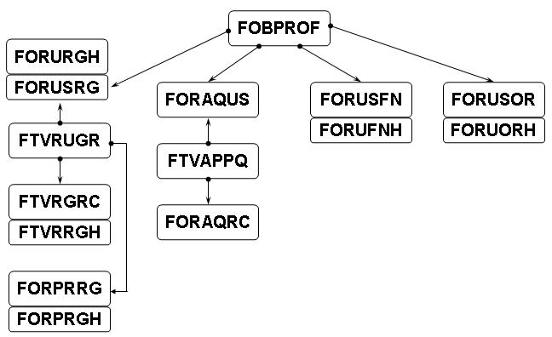

User Profiles
FOBPROF / {FOMPROF}
All users must have a profile.
Prominent settings:
- Default COAS, contacts, Orgn code and budget id
- Master Fund / Orgn Security Ind
- Finance Self Service and Web Budget Access Ind
- Web Budget Master Fund / Orgn Security Ind
- NSF, Exp End Date, Accrual Period, EDI, ACH, PCARD overrides
- Accounts payable overage tolerances
- Invoice restriction, selection and overrides
- Purchasing and receiving defaults and overrides

Rule Group Security
Establish Rule Group / Rule Class Relationships
Rule Group / Rule Class Security Maintenance Form (FOMRGRC)
Tables: FTVRUGR, FTVRGRC, FTVRRGH
Establish Rule Group / Process Relationships
Form / Process to Rule Group Maintenance Form (FOMPRRG)
Tables: FORPRRG, FORPRGH
Establish User / Rule Group Relationships
Rule Group Security Maintenance Form (FOMUSRG)
Tables: FORUSRG, FORURGH

Fund / Organization Security
Characteristics
- Both are hierarchical
- Grants the authority to query, post, or both
- Allows for separate Web Budget security indicators
Establish User / Fund (Fund Type) Relationships
Fund / Fund Type with Web Budget Security:
Form (FOMUSFN)
Tables: FORUSFN, FORUFNH
Establish user / organization relationships
Organization Security with Web Budget Security: Form (FOMUSOR)
Tables: FORUSOR, FORUORH
Approvals Processing
System control table
- Enabled by Document type
- Implicit vs. explicit
Establish user / approval queue relationships
- Establish document approval queues and optionally associate with next queue using FTMAPPQ
- Queue levels
- Next Queue Indicator
- View valid Queue IDs, descriptions, and queue limits with FTVAPPQ
- Users, levels, and level limits on table FORAQUS
- Higher level approvers can override lower levels
- View approvals using FOAUAPP
Establish approval queue routing criteria
Approval Queue Routing Codes Form (FOMAQRC)
Table: FORAQRC
- Rule Group relationships
- Hierarchical considerations
- Routing Process (forappl)
- NSF and Catch-all Queues

Routing Criteria
Criteria priority
Select the queue ID that most closely matches your transaction.
The priority of selection criteria is as follows:
- Fund or ftyp, orgn, acct, atyp, or prog all match.
- Any combination of the above match (if two records have the same number of matches then fund/ftyp outranks orgn, and orgn outranks acct/atyp, acct/atyp outranks prog).
- Fund or ftyp matches.
- Orgn matches.
- Acct or atyp matches. Program matches.
- No matches, but the record that is the least number of levels away from the transaction is considered a match. (If two records are the same number of levels away from the transaction, then the number of levels away of the fund/ftyp outranks orgn, and orgn outranks acct/atyp, acct/atyp outranks prog).
Document Processing
Diagram
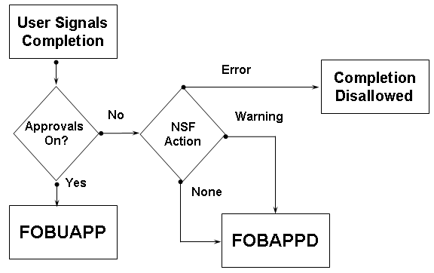
Approvals Processing
Diagram
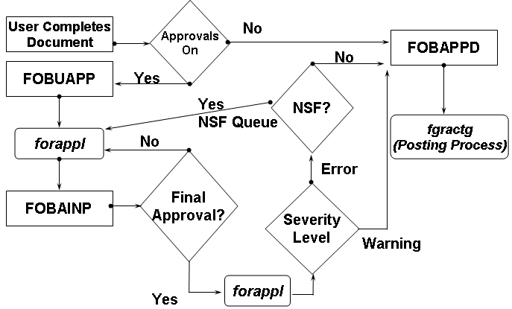
Common Document Properties
Document level accounting
- Multiple commodities
- Multiple accounting not commodity-specific
Commodity (item) level accounting
- Multiple commodities
- Multiple accounting per item
Considerations
- Default can be changed on FTMSDAT (ALL_DOCS, INVOICE, PO, REQS)
- Header, Commodity, and Accounting tables
- Text and clauses
- Document History Form (FOIDOCH) and Document Retrieval Inquiry Form (FGIDOCR)
- Completion, Approval, and Open indicators
- Cancellations
- Multiple one-to-many relationships
- E-Procurement via external systems (FPAEPRC)
- Purchasing APIs
Self Check
Directions
Use the information you have learned in this workbook to complete this self-check activity.
Tables
Banner Finance Security and Approval Tables:
- FORUSFN
- FORUFNH
- FORUSOR
- FORUORH
- FORUSRG
- FORURGH
- FORPRRG
- FTVRGRC
- FTVRRGH
- FTVRUGR
- FTVAPPQ
- FORAQUS
- FORAQRC
- FOBUAPP
- FOBAPPH
- FOBAINP
- FOBAPPD
Exercise 1
What table and or form does the system check first to determine fund orgn security? Second? Then third?

Exercise 2
What is the difference between Implicit and Explicit Approvals?

Exercise 3
What tables tell you the document status (i.e. waiting for approvals or waiting for posting)?

Exercise 4
Display queue ID, name, queue limit, next queue, user level, user ID, and user limit for all approval queues.

Self Check – Answer Key
Exercise 1
What table and or form does the system check first to determine fund orgn security? Second? Then where third?
FOBSYSC (where the security is turned on) FOBPROF to test for master security, then FORUSFN for Funds and FORUSOR for Organizations.
Exercise 2
What is the difference between Implicit and Explicit Approvals?
For Implicit, if you are in the approval queue and you entered the document, by the mere fact that you entered the document, the system assumes that you have approved it.
Explicit means in the same situation that you still must manually approve it on an approval form even though you entered it.
Exercise 3
What tables tell you the document status (i.e. waiting for approvals or waiting for posting)?
FOBAPPD tells if the document is waiting for posting and FOBUAPP tells if the document is waiting for approval.
Exercise 4
Display queue ID, name, queue limit, next queue, user level, user ID, and user limit for all approval queues.

select ftvappq_queue_id “QUEUE ID”,
ftvappq_description “DESC”,
ftvappq_queue_limit "Q LIMIT",
ftvappq_next_queue_id "NEXT Q",
foraqus_queue_level "APPROVER LEVEL",
foraqus_user_id_appr “APPROVER ID”,
foraqus_queue_limit "APPROVER LIMIT"
from ftvappq,foraqus
where ftvappq_queue_id = foraqus_queue_id
and foraqus_eff_date <= sysdate
and foraqus_nchg_date is null
and (foraqus_term_date > sysdate
or foraqus_term_date is null);

Purchase Requisitions
Introduction
This section discusses purchase requisitions in the Banner Finance system.
Objectives
At the conclusion of this section, participants will be able to
- describe purchase requisitions
- describe a typical requisition posting
- discuss buyer and purchase order assignments.

Purchase Requisitions
Characteristics
- Document type 1
- Requisition Form (FPAREQN)
- Normally initiated by end users or E-Procurement, subject to approval
- Assigned to buyers
- Buyers assign to purchase orders
- Vendor options: ID, name, or neither
- Computed totals
- Can be combined with other requisitions on a purchase order
- Process cancellation using the Requisition Cancel Form (FPARDEL)
Tables
- FPBREQH – Request Header table
- FPRREQD – Request Detail table
- FPRREQA – Request Accounting table
- FOBTEXT – Text table
- FOBCLAU – Clause Validation table
- FORCLAU – Clause Text table
- FTVRQPO – Request/PO Verification table
Diagram
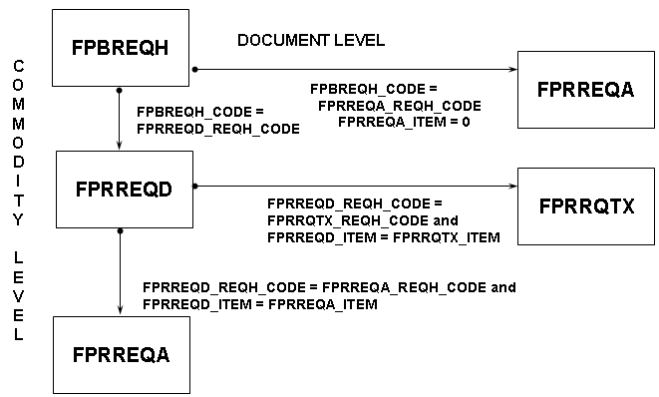
Typical Requisition Posting
Diagram
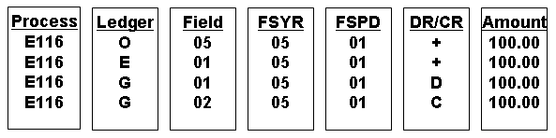
- O posting increases reservation amount in the Operating Ledger (OPAL)
- E posting establishes the requisition encumbrance in the Encumbrance Period Detail table (ENCP)
- G postings are to reservation control accounts in the General Ledger (GENL)

Buyer Assignment
FTMBUYR / {FTVBUYR}
- Buyers Created on FTMBUYR (FTVBUYR, FTVBUYC, FTVBUYO)
- Commodities and/or Organizations may be automatically routed to a specific buyer
- May establish a PO limit for departmental buyers
Buyer Assignment
- Enable automatic buyer assignment on system control
- Organization codes take precedence over commodity codes
- Last assign date used in table for routing
- Manual buyer assignment via FPAABUY form
- Updates FPRREQD_BUYR_CODE
Purchase Order Assignment
FPAPOAS
Purchase Order Assignment Form (FPAPOAS)
- Buyer assigns purchase order - splitting / combining allowed
- Updates FPRREQD_POHD_CODE
- Updates FPRREQD_POHD_ITEM
- Creates record FTVRQPO
- Creates Purchase Order in Incomplete status
Self Check
Directions
Use the information you have learned in this workbook to complete this self-check activity.
Tables
Banner Finance Purchase Requisition Tables:
- FPBREQH
- FPRREQD
- FPRREQA
- FPRRQTX
Exercise 1
What is the difference between commodity level accounting and document level accounting, where in the system can you set up the default, and which fields in the database indicate which type of accounting the document is based upon?

Exercise 2
In General Purchasing Payable tables, what are the three types of record structures used to define a document?

Exercise 3
What table in Banner Finance is used solely for text and comments?

Exercise 4
When is the BUYER CODE field populated on the FPRREQD table?

Exercise 5
When is the purchase order number field populated on the FPRREQD table?

Exercise 6
Display the Transaction date, Vendor name, and Total Purchase amount for all open requisitions.

Exercise 7
Display the Document number, encumbrance amount, and liquidated total of all requisitions by Fiscal Year.

Self Check – Answer Key
Exercise 1
What is the difference between commodity level accounting and document level accounting, where in the system can you set up the default and which fields in the database indicate which type of accounting the document is based upon?
Document level accounting is when the accounting records all share the cost of all the items. Commodity level accounting is when an accounting record does not share the cost of all the items. You can set up the default in FTMSDAT. Single_acctg_ind on the header and item_num = 0 or something else on the accounting record will indicate which type of accounting the document is based upon.
Exercise 2
In General Purchasing Payable tables, what are the three types of record structures used to define a document?
Header, detail and accounting.
Exercise 3
What table in Banner Finance is used solely for text and comments?
FOBTEXT.
Exercise 4
When is the BUYER CODE field populated on the FPRREQD table?
Two instances. On automatic buyer assignment at the completion of the requisition or on the Buyer assignment form FPAABUY.
Exercise 5
When is the purchase order number field populated on the FPRREQD table?
When the PO is assigned on FPAPOAS.
Exercise 6
Display the Transaction date, Vendor name, and Total Purchase amount for all open requisitions.

select fpbreqh_trans_date “TRAN DATE”,
decode(fpbreqh_vend_pidm,
NULL, ‘No Vendor Chosen’,
f_format_name(fpbreqh_vend_pidm, 'LFMI'))
“VENDOR NAME”,
sum (fprreqa_amt
+ nvl(fprreqa_addl_chrg_amt,0)
- nvl(fprreqa_disc_amt,0)
+ nvl(fprreqa_tax_amt,0))
“TOTAL AMOUNT”
from fpbreqh,fprreqa
where fpbreqh_code = fprreqa_reqh_code
and fpbreqh_closed_ind != ‘Y'
group by fpbreqh_trans_date, fpbreqh_vend_pidm;
Exercise 7
Display the Document number, encumbrance amount, and liquidated total of all requisitions by Fiscal Year.

select fgbencp_fsyr_code “FISCAL YEAR”,
fgbencp_num “REQ NO”,
sum (fgbencp_orig_encb_amt
+ fgbencp_sum_encb_adjt)
“ENCUM AMOUNT”,
sum (fgbencp_sum_encb_liq) "TOTAL LIQ"
from fgbench, fgbencp
where fgbench_type = ‘R’
and fgbencp_num = fgbench_num
group by fgbencp_fsyr_code,fgbencp_num
order by fgbencp_fsyr_code,fgbencp_num;

Purchase Orders
Introduction
This section introduces purchase orders in Banner Finance.
Objectives
At the conclusion of this section, participants will be able to
- discuss and describe purchase orders and their characteristics.

Purchase Orders
Characteristics
- Document type 2
- Purchase Order Form (FPAPURR)
- Centralized vs. Distributed
- Standing vs. Regular
- May result from requisition(s), E-Procurement or direct entry
- Vendor options: ID required
- Computed totals
- Multiple Reqs, single PO; single Req, multiple POs
- Cancellation processing: Purchase / Blanket Order Cancel Form (FPAPDEL)
- Close processing: batch process FPPPOBC or the Encumbrance Open/Close form (FPAEOCD)
Tables
- FPBPOHD – PO Header table
- FPRPODT – PO Detail Goods table
- FPRPODA – PO Accounting Detail table
- FOBTEXT – Text table
- FOBCLAU – Clause Validation table
- FORCLAU – Clause Text table
- FPRPOTX – PO Commodity Tax table
- FTVRQPO – Request/PO Verification table
Diagram
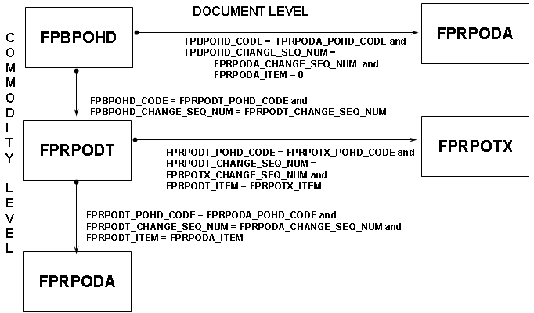
Typical Purchase Order Posting
Diagram
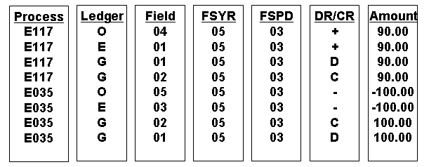
- O postings increase encumbrance and decrease reservation amounts in the Operating Ledger (OPAL)
- E postings establish the PO encumbrance and liquidate the reservation encumbrance in the Encumbrance Period Detail table (ENCP)
- G postings are to reservation and encumbrance control accounts in the General Ledger (GENL)
Req to PO
Diagram
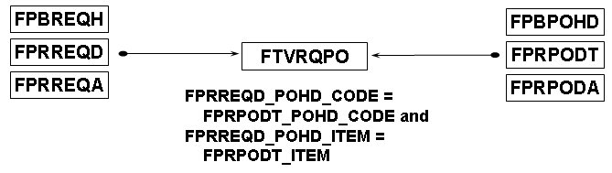
Change Orders
Characteristics
- Allowed even after invoicing
- Normally used to adjust quantity, price, accounting distribution(s)
- Tracked via CHANGE_SEQ_NUM (null value is “current row”, equals sum of prior rows
- Allowed by the Transaction History table (TRNH) through FGBTRNH_SUBMISSION_NUMBER
Self Check
Directions
Use the information you have learned in this workbook to complete this self-check activity.
Tables
Banner Finance Purchase Orders Tables:
- FPBPOHD
- FPRPODT
- FPRPODA
- FPRPOTX
Exercise 1
What other table is populated at time of purchase order assignment to a requisition?

Exercise 2
What is the use of the Change sequence number on the purchase order?

Exercise 3
What is the form that can be used to close Purchase Encumbrances?

Exercise 4
Display the Purchase Order document number, PO item number, PO item description, Purchase Requisition document number, requisition item number, and requisition quantity of all purchase orders created from requisitions.

Exercise 5
Display the Purchase Order document number, PO item number, and associated text for all purchase orders with text references.

Self Check – Answer Key
Exercise 1
What other table is populated at time of purchase order assignment to a requisition?
FTVRQPO
Exercise 2
What is the use of the Change sequence number on the purchase order?
Used to control purchase order changes and the posting of them. Null value record represents sum of all prior orders. 0 presents the original purchase order, a number represents the change order itself with the actual change.
Exercise 3
What is the form that can be used to close Purchase Encumbrances?
FPAEOCD
Exercise 4
Display the Purchase Order document number, PO item numnrt, PO item description, Purchase Requisition document number, requisition item number, and requisition quantity of all purchase orders created from requisitions.

select fprpodt_pohd_code “PO NUMBER”,
fprpodt_item “PO ITEM NUMBER”,
fprpodt_comm_desc “PO ITEM DESC”,
fprreqd_reqh_code “REQ NUMBER”,
fprreqd_item “REQ ITEM NUMBER”,
fprreqd_qty “REQ QUANTITY”
from fprpodt, fprreqd
where fprreqd_pohd_code = fprpodt_pohd_code
and fprreqd_pohd_item = fprpodt_item;
Exercise 5
Display the Purchase Order document number, PO item number, and associated text for all purchase orders with text references.

select fprpodt_pohd_code “PO NUMBER”,
fprpodt_item “PO ITEM”,
fobtext_text “TEXT”
from fprpodt,fobtext
where fobtext_dtyp_seq_num = 2
and fprpodt_pohd_code = fobtext_code
and fprpodt_item = fobtext_item
order by fprpodt_pohd_code,
fprpodt_item,
fobtext_seq_num;
Commodities and Invoices
Introduction
This section discusses commodities and invoices in the Banner Finance system.
Objectives
At the conclusion of this section, participants will be able to work with commodities and invoices in Banner Finance.

Commodities
Characteristics
- Document type 14
- Form FTMCOMM
- Establish Commodities
- Establish as an Asset or a Stock Item
- Establish Estimated Life Years
- May be assigned a default account code
- Used with Request and PO's
- Connected to Stores Master Inventory Control
- Form FTRINVM
Diagram
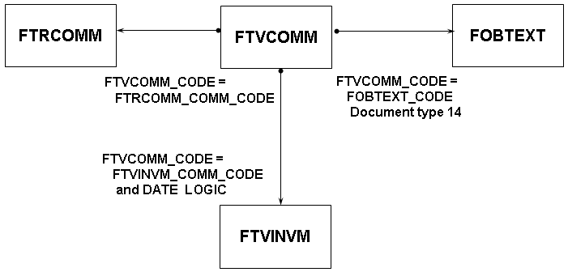

Receiving
Characteristics
- Document type 22
- Receipt of goods form (FPARCVD)
- Centralized or Decentralized
- Receive stock into items into Stores Inventory
- Receipts are available immediately to AP and Invoices
- Receiving may be set to required on FOASYSC
- Allows returns and Adjustments
- Returns Document type 7
- Packing Slip Document type 23
Forms
- FPARCVD – Receiving Goods Form
- FPCRCVP – Receiving Goods PO Item Selection Form
- FPADELV – Delivery Log Form
- FPARTRN – Returned Goods Form
Tables
- FPBRCHD – Receiver Header table
- FPBRCDT – Packing Slip Detail table
- FPRRCDT – Receiving Detail table
- FOBTEXT – Text table
- FPBRTRN – Returns table
- FPRRTRN – Returns Item table
Diagram 1
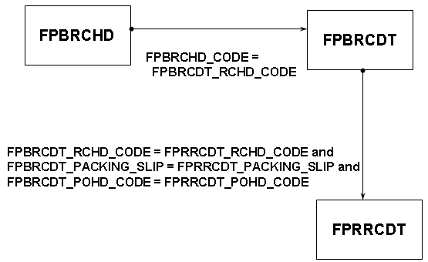
Diagram 2
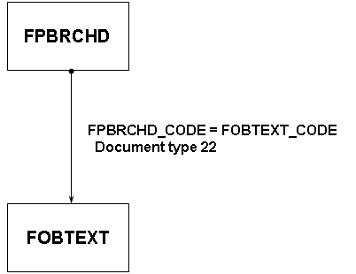
Returns
Diagram
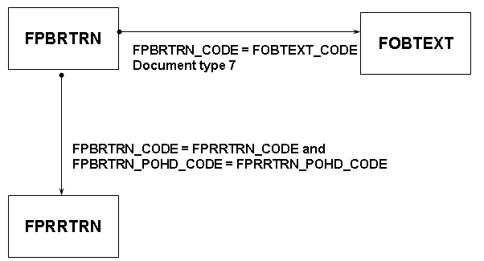
Note: Returns are now obsolete, as they are managed with the new Adjustment feature on the Receiving form.

Invoices
Characteristics
- Document type 3
- Centralized vs. distributed
- Direct pay vs. encumbrance invoice
- Vendor options: ID, one-time, or check vendor
- Computed totals
- Liquidation: partial vs. total
- Single PO - multiple Invoices
Usage
- Use grouping indicator for check processing
- Process cancellations with the Invoice/Credit Memo Cancel Form (FAAINVD)
- Schedule recurring payables (Reusable Invoices)
- Recurring Payables Form (FAARUIV)
- Make payments against grants with indirect cost or cost-share defined
- Can defer these calculations on FOASYSC

Diagram
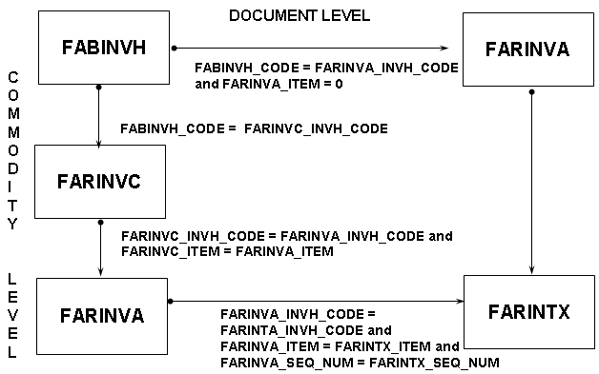
Typical Regular Invoice Posting
Diagram
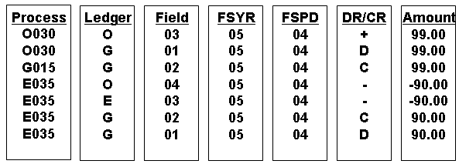
- O postings increase expense and decrease encumbrance amounts in the Operating Ledger (OPAL)
- E postings liquidate the encumbrance in the Encumbrance Period Detail table (ENCP)
- G postings are to accounts payable, encumbrance and expense control accounts in the General Ledger (GENL)

Req to PO to Invoice
Diagram
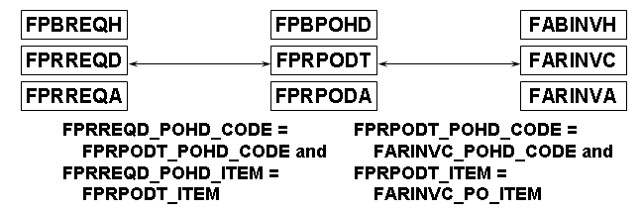
Self Check
Directions
Use the information you have learned in this workbook to complete this self-check activity.
Tables
Banner Finance Invoice Tables:
- FABINVH
- FARINVC
- FARINVA
- FARINTX
Exercise 1
What two fields can you change on the invoice after it has been posted?

Exercise 2
When using the Vendor Invoice consolidation feature, what table stores the details for the vendor invoices?

Exercise 3
Display all unique combinations of requisition to purchase order to invoice.

Exercise 4
Display all open invoices, with document total, for which the payment due date has been reached.

Exercise 5
Display any direct pay invoice that is waiting for approval

Self Check – Answer Key
Exercise 1
What two fields can you change on the invoice after it has been posted?
Payment Due Date and the Hold indicator.
Exercise 2
When using the Vendor Invoice consolidation feature, what table stores the details for the vendor invoices?
FARVINV.
Exercise 3
Display all unique combinations of requisition to purchase order to invoice.

select distinct fprreqd_reqh_code “REQ NUMBER”,
fprpodt_pohd_code “PO NUMBER”,
farinvc_invh_code “INV NUMBER”
from fprreqd,fprpodt,farinvc
where fprreqd_pohd_code = fprpodt_pohd_code
and farinvc_pohd_code = fprpodt_pohd_code;
Exercise 4
Display all open invoices, with document total, for which the payment due date has been reached.

select fabinvh_code “INV CODE”,
fabinvh_pmt_due_date “PAYMENT DUE DATE”,
sum (nvl(farinva_appr_amt,0)
+ nvl(farinva_addl_chrg_amt,0)
+ nvl(farinva_tax_amt,0)
- nvl(farinva_disc_amt,0)) "TOTAL AMT"
from fabinvh,farinva
where fabinvh_pmt_due_date <= sysdate
and fabinvh_open_paid_ind = 'O'
and fabinvh_code = farinva_invh_code
and fabinvh_hold_ind = 'N'
and fabinvh_appr_ind = 'Y'
and fabinvh_complete_ind = 'Y'
group by fabinvh_code,fabinvh_pmt_due_date;
Exercise 5
Display any direct pay invoice that is waiting for approval.

select fabinvh_code “INV NUMBER”
from fabinvh
where fabinvh_invoice_type_ind = 'D'
and exists
(select ‘X’
from fobuapp
where fobuapp_doc_code = fabinvh_code
and fobuapp_seq_num = 3) ;

A/P Checks and Direct Deposits
Introduction
This section discusses A/P checks and direct deposits in the Banner Finance system.
Objectives
At the conclusion of this section, participants will be able to work with A/P checks and direct deposits in Banner Finance.

A/P Checks / Direct Deposits
Characteristics
- Document type 8 (check cancellation is 5)
- Types:
    - Batch Check
    - Online Check
    - Manual Check
    - Direct Deposit
- Initiated by users through the Batch Check Print Form (FAABATC) or the Online Check Form (FAAONLC) , processed via Job Submission
Usage
- Utilizes temporary tables, primarily FATCKNO, FATCKIN, FATCKDT, FARDIRD (permanent table)
- Processes cancellation using the Check Cancellation Form (FAACHKS)
- Run FARINVS for invoice selection report
Batch checks
Requires several processes for batch checks, in order:
- FABCHKS – selects invoices for payment
- FABCHKP - prints the checks
- FABCHKR – prints the check register
- FABCHKA – accounting process
First two processes are combined in fabchk1.shl.
Direct deposit
Requires several processes for direct deposit, in order:
- FABCHKS – selects invoices for payment
- FAPDIRD or FAPCDIR (Canadian) - prints the direct deposit file
- FAPTREG (optional) – prints the transmission register
- FARDIRD (optional) – prints the remittance advices
- FABCHKA – accounting process

A/P Checks
FAABATC and FAAONLC
- Initiates Processing
FATCKNO
- Contains starting check number
FABCHKS
- Selects items for payment, populates temporary tables FATCKIN/FATCKDT with invoice information
FATCKIN / FATCKDT
- Contain check-to-invoice cross reference and check print details
FABCHKP
- Prints checks, can be rerun using “restart mode”
- Populates FABCHKS/FABINCK and ending check number in FATCKNO
FABCHKR
- Prints check register
FABCHKA
- Submits checks for posting and populates FABCHKA. This is the point of no return!!!

A/P Direct Deposits
FAABATC
- Initiates Processing
FATCKNO
- Contains starting direct deposit number
FABCHKS
- Selects items for direct deposit, populates temporary tables FATCKIN/FATCKDT
FATCKIN/ FATCKDT
- Contains direct deposit-to-invoice cross reference data
FABCHKP
- Modified to not select direct deposit invoices – not run
FAPDIRD or FAPCDIR
- Populate the FARDIRD Direct Deposit Table
FARDIRD
- Contains temporary direct deposit data
FAPTREG
- Creates summary control totals register for bank/clearing house
FARDIRD
- Prints direct deposit remittance advices (optional)
FABCHKA
- Submits direct deposits for posting
Diagram
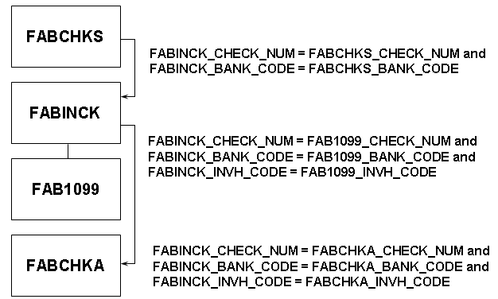

Typical Check Posting
Diagram
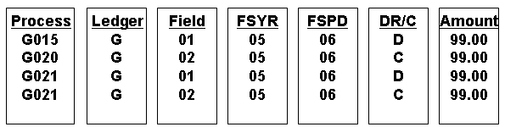
- First posting is debit to accounts payable in the input fund
- Second posting is credit to claim on cash in the input fund
- Third posting is debit to claim on cash in the bank fund
- Fourth posting is credit to cash account in the bank fund

- All of this accounting is defined on table GXVBANK

Req to PO to Invoice to Check / Direct Deposit
Diagram
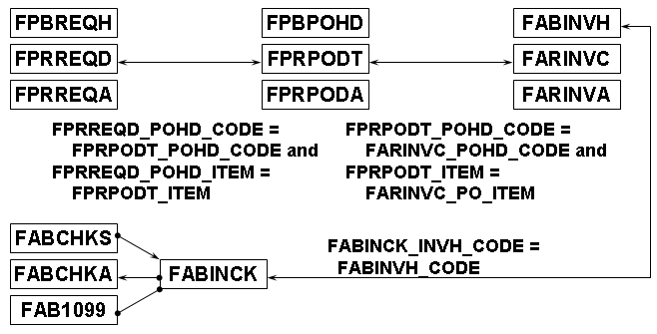
A/P Checks - Additional Considerations
Considerations
- 1099 Processing: FAB1099 and FAM1099
- Printer selection (GTVPRNT)
- Bank reconciliation
    - Table: FABBKTP
- Bank Tape Reconciliation Form (FAABREC)
    - Process: FARBREC
    - Student refunds
    - Distributed processing

Self Check
Directions
Use the information you have learned in this workbook to complete this self-check activity.
Tables
Banner Finance A/P Check Tables:
- FABCHKS
- FABINCK
- FABCHKA
- FABBKTP
- FAB1099
Exercise 1
What are the names of the temporary tables used to support checks processing?

Exercise 2
Display Vendor name, Check date, and Payment amount ordered by descending amount.

Exercise 3
For cases of extreme befuddlement, develop a process to purge a batch check run.

Exercise 4
Display Check number, Check date, amount, and Vendor name of all non-batch checks.

Self Check – Answer Key
Exercise 1
What are the names of the temporary tables used to support checks processing?
FATCKNO, FATCKIN, FATCKDT
Exercise 2
Display Vendor name, Check date, and Payment amount ordered by descending amount.

select decode(fabinvh_vend_pidm,
NULL, fabinvh_one_time_vend_name,
f_format_name(fabinvh_vend_pidm,
'LFMI')) “NAME”,
fabinck_check_date "CHECK DATE",
fabinck_check_num “CHECK NUMBER”,
sum(fabinck_net_amt) “AMOUNT”
from fabinvh, fabinck
where fabinck_invh_code = fabinvh_code
group by fabinvh_one_time_vend_name,
fabinck_check_date,
fabinvh_vend_pidm,
fabinck_check_num
order by NAME desc;
Exercise 3
For cases of extreme befuddlement, develop a process to purge a batch check run.

Delete from fabinck
where fabinck_check_num between
(select fatckno_check_num
from fatckno
where fatckno_check_type = ‘S’)
and (select fatckno_check_num
from fatckno
where fatckno_check_type = ‘E’)
Delete from fabchks
where fabchks_check_num between
(select fatckno_check_num
from fatckno
where fatckno_check_type = ‘S’)
and (select fatckno_check_num
from fatckno
where fatckno_check_type = ‘E’)

Delete fatckno;

Delete fatckdt;

Delete fatckin;
Exercise 4
Display Check number, Check date, amount, and Vendor name of all non-batch checks.

select distinct fabchks_check_num "CHECK NUM",
fabchks_check_date "CHECK DATE",
fabchks_check_amt “AMOUNT”,
decode(fabinvh_vend_pidm,
NULL, fabinvh_one_time_vend_name,
f_format_name(fabinvh_vend_pidm,
'LFMI')) “NAME”,
decode (fabchks_check_type_ind,
'M','Manual','O','Online')
“CHECK TYPE”
from fabchks, fabinck, fabinvh
where fabchks_check_type_ind in ('M','O')
and fabchks_check_num = fabinck_check_num
and fabinck_invh_code = fabinvh_code;

APIs
Introduction
This section lists the APIs used in Banner Finance.

Introduction
Introduction
Application Programming Interfaces (APIs) enhance processing and simplify code.
The API is actually a program comprised of four different packages:
- a primary package containing query functions and create, update, and delete procedures
- a Rules package containing subprograms that support the primary package
- a Strings package containing error messages
- an associated DML package that performs the actual database maintenance of the edited data.
In addition to the API packages, other supporting package types include the following:
- Support - Contains supporting programs that may be called by other APIs and error messages related to these edits.
- Validation - Contains standard functions and procedures for a specific validation table.
For additional information, refer to the API Technical Documentation available via the Customer Support Center.
APIs and Supporting Packages used in Banner
Banner Finance currently includes two categories of APIs: Procurement APIs and Invoice APIs.
Procurement APIs
Procurement APIs are used by the Purchase Order Form (FPAPURR), Requisition Form (FPAREQN) and the Self-Service Purchase Order page (bwfkpurr.P_PurchaseOrder) to calculate taxes, update the tax table, and display tax calculations.
In addition, the interfaces that enable e-Procurement integration between SciQuest HigherMarkets and Banner perform tax and currency conversion calculations.
Invoice APIs
Invoice APIs are used for the four major invoice tables:
- Invoice Header Table (FABINVH)
- Invoice Commodity Table (FARINVC)
- Invoice Accounting Table (FARINVA)
- Invoice Tax Allocation Table (FARINTX)
These APIs include query functionality, and may be used to create, update, and delete individual rows in the four base invoice tables. The logic in the business entity APIs addressed the edits pertaining to each of these tables individually, but not to the invoice as a whole.
The release of the business process APIs enabled FOAPAL re-defaulting for update, and provided update capability for multiple vendor invoices.
API Packages
API Packages
The following charts identify the API packages and supporting packages used to process Finance data in Banner. The APIs replace the corresponding code in the Banner forms.
All APIs and packages used in Banner Finance will begin with an ‘f,’ followed by an ‘b,’ and an underscore ‘_,’ followed by a verb/noun describing what the API does. If the 2nd letter is a ‘p’ instead of a ‘b,’ then that database package is a Business Process API defining a ‘unit of work’.

Object Name | Entity Name | Task Performed | Associated Tables | Associated Packages
fb_accounting_  element | ACCOUNTING_ ELEMENT | Contains business interface for IFOAPAL information. | FTVCOAS | fb_accounting_element_ rules  Provides supporting subprograms for ACCOUNTING_ ELEMENT.
fb_chart_of_ accounts | CHART_OF_ ACCOUNTS | Contains the standard DML functions for CHART_OF_ ACCOUNTS. | FTVCOAS | fb_chart_of_ accounts_rules Provides supporting subprograms for CHART_OF_ ACCOUNTS.
fb_commodity | COMMODITY | Contains the standard DML functions for COMMODITY. | FTVCOMM | fb_commodity_rules  Provides supporting subprograms for COMMODITY.  fb_commodity_ strings  Provides error messages and error message functions for COMMODITY.
fb_common | COMMON | Contains common functions, procedures, and variables for Finance. | N/A | fb_common_strings  Provides error messages and error message functions for COMMON.
fb_invoice_ header | INVOICE_ HEADER | Contains the common business interface for INVOICE_HEADER. | FABINVH | fb_invoice header_rules  Provides supporting subprograms for INVOICE_HEADER. fb_invoice_header_strings  Provides error messages and error message functions for INVOICE_HEADER.  dml_fabinvh  Provides the procedures to insert, update, and delete from various Banner tables.

Object Name | Entity Name | Task Performed | Associated Tables | Associated Packages
fb_invoice_ item | INVOICE_ ITEM | Contains the common business interface for INVOICE_ITEM. | FARINVC | fb_invoice_item_rules  Provides supporting subprograms for INVOICE_ITEM. fb_invoice_item_strings  Provides error messages and error message functions for INVOICE_ITEM.  dml_farinvc  Provides the procedures to insert, update, and delete from various Banner tables.
fb_invoice_ acctg | INVOICE_ ACCTG | Contains the Common Business interface for INVOICE_ACCTG. | FARINVA | fb_invoice_acctg_rules  Provides supporting subprograms for INVOICE_ACCTG. fb_invoice_acctg_strings  Provides error messages and error message functions for INVOICE_ACCTG.  dml_farinva  Provides the procedures to insert, update, and delete from various Banner tables.
fb_invoice_ tax | INVOICE_TAX | Contains the Common Business interface for INVOICE_TAX. | FARINTX | fb_invoice_tax_rules  Provides supporting subprograms for INVOICE_TAX. fb_invoice_tax_strings  Provides error messages and error message functions for INVOICE_TAX.  dml_farintx  Provides the procedures to insert, update, and delete from various Banner tables.

Object Name | Entity Name | Task Performed | Associated Tables | Associated Packages
fb_jv_header | JV_HEADER | Contains the Common Business interface for the Journal Voucher Header API (JV_HEADER). | FGBJVCH | fb_jv_header_strings  Provides error messages and error message functions for JV_HEADER.  fb_jv_header_rules  Provides supporting subprograms for JV_HEADER.  dml_fgbjvch  Provides the procedures to insert, update, and delete from various Banner tables.
fb_jv_detail | JV_DETAIL | Contains the Common Business interface for the Journal Voucher Detail API (JV_DETAIL). | FGBJVCD | fb_jv_detail_strings  Provides error messages and error message functions for JV_DETAIL. fb_jv_detail_rules  Provides supporting subprograms for JV_DETAIL.  dml_fgbjvcd  Provides the procedures to insert, update, and delete from various Banner tables.
fb_purchase_ order | PURCHASE_ ORDER | Contains the Common Business interface for PURCHASE_ ORDER. | FPBPOHD FPRPODA FPRPODT | fb_purchase_order_rules  Provides supporting subprograms for PURCHASE_ORDER.
fb_po_tax | PO_TAX | Contains the Common Business interface for the Purchase Order Tax Table (PO_TAX). | FPRPOTX | Purchase Order Form (FPAPURR) Purchase Order Self-Service page (bwfkpurr.P_Purchase Order) dml_fprpotx  Provides the procedures to insert, update, and delete from various Banner tables.
fb_requisition | REQUISITION | Contains the common business interface for REQUISITION. | FPBREQH FPRREQD FPRREQA | fb_requisition_rules  Provides supporting subprograms for REQUISITION.

Object Name | Entity Name | Task Performed | Associated Tables | Associated Packages
fb_req_tax | REQ_TAX | Contains the Common Business interface for the Requisition Tax Table (REQ_TAX). | FPRRQTX | Requisition Form (FPAREQN) dml_fprrqtx  Provides the procedures to insert, update, and delete from various Banner tables.
fb_ship | SHIP | Provides standard DML functions for the FTVSHIP table. | FTVSHIP | fb_ship_rules  Provides supporting subprograms for SHIP.
fb_vendor | VENDOR | Provides the common business interface for VENDOR. | FTVVEND | fb_vendor_rules  Provides supporting subprograms for VENDOR.  fb_vendor_strings  Provides error messages and error message functions for VENDOR.
fb_vendor_type | VENDOR_TYPE | Provides the common business interface for VENDOR_TYPE. | FTVVENT | fb_vendor_type_rules  Provides supporting subprograms for VENDOR_TYPE. fb_vendor_type_strings  Provides error messages and error message functions for VENDOR_TYPE.
fp_invoice | INVOICE | Contains the Common Business interface for the composite entity Invoice (FP_INVOICE). | Invoice Tables: FABINVH FARINVA FARINVC FARINTX | fp_invoice_strings  Provides error messages and error message functions for INVOICE.
fp_journal_ voucher | JOURNAL_ VOUCHER | Process API for Journal Vouchers (JOURNAL_ VOUCHER). | Journal Voucher Tables: FGBJVCH FGBJVCD | fp_journal_voucher_strings  Provides error messages and error message functions for JOURNAL_VOUCHER.

Support Packages
These packages contain supporting programs that may be called by other APIs and error messages related to these edits.
Object Name | Task Performed | Associated Tables
ffkedit | Consolidates the editing and defaulting for Rule Class edits. | FTVEDIT
ffkfoap | Edits codes for the following: chart of accounts, fund, organization, account, program, activity, location, project, and bank. | FTVCOAS  FTVFUND  FTVORGN  FTVACCT  FTVPROG  FTVACTV  FTVLOCN
ffkrulp | Ensures that all data required by the Rule Process Codes associated with the Rule Class Code in the record is present. | FTVRULP
foksels | Contains functions, record types, and cursors to support selection of various Finance information.
foktext | Supports functionality of Finance Document text. | FOBTEXT
fpkpurr | Contains all procedures and functions required to create a purchase order in Banner Finance. | FPBPOHD  FPRPODT  FPRPODA  FPRPOTX
fpkreqn | Contains all procedures and functions required to create a requisition in Banner Finance. | FPBREQH  FPRREQD  FPRREQA  FPRRQTX
fokutil | Contains procedures and functions common to all modules in Banner Finance.
fpkutil | Performs various common routines used by the Finance procurement module.

Validation Packages
These packages contain standard functions and procedures.

Object Name | Task Performed
fb_ftvbuyr | Contains standard functions and procedures for the Buyer Verification Table (FTVBUYR).
fb_ftvcrsn | Contains standard functions and procedures for the Closed Document Reason Code Table (FTVCRSN).
fb_ftvdisc | Contains standard functions and procedures for the Discount Terms Table (FTVDISC).
fb_ftvityp | Contains standard functions and procedures for the Income Type Table (FTVITYP).
fb_ftvtgrp | Contains standard functions and procedures for the Tax Group Validation Table (FTVTGRP).
fb_ftvtrat | Contains standard functions and procedures for the Tax Rate Table (FTVTRAT).
fb_ftvuoms | Contains standard functions and procedures for the Unit of Measure Table (FTVUOMS).
fb_ftvvtyp | Contains standard functions and procedures for the Vendor Type Table (FTVVTYP).
Types of APIs Used for Invoicing
Types of APIs Used for Invoicing
This section describes the types of APIs used for the invoicing function, and provides detailed information about how the create, update, and delete functions within the APIs populate tables and process data.
Two types of APIs are needed to ensure that the API approach is comparable to the actions of a user performing an action, such as completing an invoice in Banner: Business Entity APIs and Business Process APIs.
Business Entity APIs
Banner Business Entity APIs define the following:
- Common operations that the Banner business entity supports, and
- Common types that support data encapsulation requirements so institutions can manipulate the Business Entity data as a whole.
The business entity APIs could be used by a custom interface from an outside source to feed direct pay invoice data to Banner Finance invoice tables.
CREATE/UPDATE APIs
The business entity CREATE and UPDATE APIs populate data in individual invoice tables. These APIs also perform the tasks identified in the following chart.

Validate table values (based on transaction date) | Vendor ID  Vendor address types and sequences  Note: If no vendor ID is present, validate that Vendor Name, Vendor Address (Line 1), City, State and Zip Code are present (at a minimum)  Discount Codes  Tax Group Codes  Commodity Codes  Unit of Measure  COA and FOAPAL values  Open/closed fiscal years and periods  Invoice document has not been previously completed
Enforce | Invoice permissions based on settings in FOMPROF  Fund/Organization security based on the user ID and settings in FOASYSC, FOMPROF, FOMUSFN, FOMUSOR  NSF handling based on the settings in FTMCOAS, FOASYSC, FTMFTYP, FTMFUND
Derive | Appropriate rule classes based on transaction data  Discount amounts based on discount codes  Taxes based on tax rate values in each tax group  Currency amounts for approved amounts, discount amounts, additional amounts, and tax amounts based on percentages  Currency conversion amounts
Populate default values for | Vendor address and sequence number from FTMVEND  Vendor 1099 data from FTMVEND  Vendor invoice/check preferences from FTMVEND (single invoice per check or multiple invoice per check)  Tax groups from settings in FOASYSC and FTMCOMM  FOAPAL defaults (and enforcing override settings) for Account Indexes from FTMACCI  OPAL defaults from FTMFUND  FPAL defaults from FTMORGN  Account code and UOM defaults from FTMCOMM
DELETE APIs
DELETE APIs must be used so that accounting/tax deletions are processed prior to item delete, and accounting/tax and item deletions are processed prior to header delete. Business entity DELETE APIs can be used to perform the following tasks.
- Delete specific accounting sequences, which will also delete any associated tax information from FARINTX, if they exist.
- Delete specific items, if no accounting tax/records exist for the invoice.
- Delete of header records, if no item and accounting tax/records exist for the invoice.
Business Process APIs
Banner Business Process APIs provided in Release 7.3 support business processes that span calls to multiple Banner Business APIs in the context of a single transaction.
The business process APIs are significant because of the role they play in processing wrap up and balancing routines necessary for completion of invoices, and creation of invoice types other than direct pay.
For example, the business process APIs aggregate the rows that were created by the business entity APIs in each of the invoice base tables, evaluate all the data that is required to establish a complete invoice document in Banner Finance, and perform cross-table updates across multiple tables and forms. They provide the data complexity needed to reference a Purchase Order item or General Encumbrance in an invoice.

Miscellaneous Topics
Introduction
This section discusses miscellaneous topics of interest in the Banner Finance system.

Fixed Assets
Characteristics
- Document type 61
- Maintain fixed and moveable assets
- Create Intermediate Origination tags (O-tags) from Procurement and Payables
- Has Automatic Capitalization feature
- Minimum Asset Capitalization value defined on FOASYSC
- Enter assets directly in FFAMAST
- Assign Permanent tags (P-tags)
- Assign attachments (other origination tags)
Usage
- Create and maintain depreciation records
- Maintain custody and location
- Make adjustments to assets
- Fixed asset adjustment (Document type 60)
- Synchronizes Fixed Asset Subsidiary Ledger and General Ledger
Diagram 1
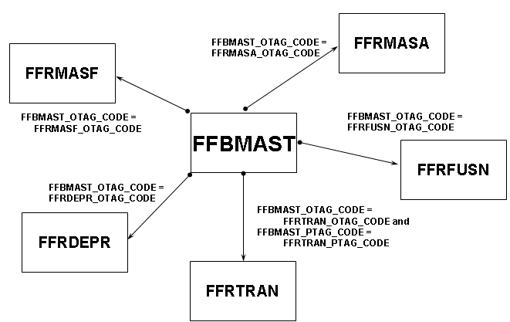
Diagram 2
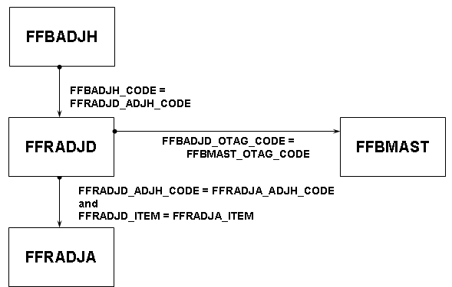

Journal Vouchers
Characteristics
- Document type 20
- Can record all categories of transactions
- Initiated by:
- Users through the Journal Voucher Entry Forms (FGAJVCD or FGAJVCQ)
- Interface batches with errors
- System deletes Journal tables (FGBJVCH / FGBJVCD) after entry is posted
- Contain no “cancellation” mechanism in baseline
- Use deposit numbers and reconciliation
Diagram
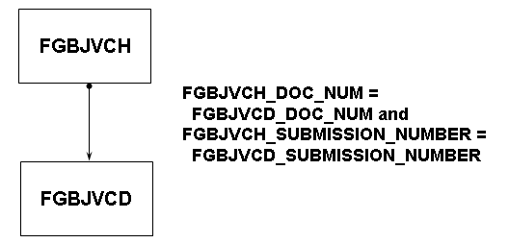

Encumbrances
Characteristics
- Document type 25
- Non-Purchasing encumbrances
- Initiated by:
- Users via the Encumbrance/Reservations Maintenance Form (FGAENCB)
- Interface (Position Control)
- Stored in “pseudo ledger”
- Encumbrance Header table (FGBENCH)
- Encumbrance Detail table (FGBENCD)
- Encumbrance Period Detail table (FGBENCP)
Table maintenance
- Encumbrance Period Detail table (ENCP) table maintained only by the Posting process
- _STATUS vs. _STATUS_IND
    - FGBECNCH_STATUS reflects the status of the document, either null for incomplete or “C” for complete
    - FGBENCH_STATUS_IND reflects the status of the encumbrance, either “O” for open or “C” for closed
Diagram
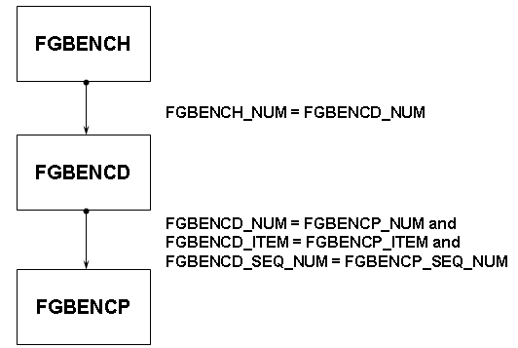
Multi-Year Encumbrance Enhancement
Introduction
The Multi-Year Encumbering enhancement is a collaborative effort among Banner Human Resources, Banner Position Control, and Banner Finance and is the first phase of a multi-phased update planned for grants management. A subsequent phase, planned for delivery with the 8.1 release, will support effort certification and enhanced labor redistribution.
Note: This enhancement applies only to customers who are planning to install Banner HR 8.0, Banner Position Control 8.0, and Banner Finance 8.0. If you do not use HR or Position Control, you can refer to this section for information about Finance objects that changed. 􀂄
The Banner Finance 8.0 Release Guide includes information about the procedural changes delivered with this enhancement, provides a diagram of the process flow, and describes all objects that are new or changed with Banner Finance 8.0.
Banner Finance Interfaces
Overview
- Banner product transactions
- Student refunds
- External interfaces (incoming)
- External interfaces (outgoing)
- Interfacing via API’s for General person, Vendors and Purchasing documents
- Building other API’s using Banner API standards
Interfaces (GURFEED)
- Feature a generic transaction interface
- Represent a normal journal entry
- Work with System IDs defined in the System data table
- Note: Record type 1 emulates FGBJVCH.
Record type 2 emulates FGBJVCD.

GURFEED Relationships
GURFEED Relationships
Product | Process | Source table(s)
Advancement | aapfeed | AABDUES
 |  | AARAJBD
 |  | AARAJIN
 | adpfeed | AGBGIFT
 |  | AGRADGS
 |  | AGRAGIF
Financial Aid | rpblmia | “LMS” file
Position Control | nhpfin2 | NHRFINC
Accounts Receivable | tgrfeed | TBRACCD
 |  | TBRAPPL
 |  | TBRDEPO
 |  | TBRMISD
 |  | TRRACCD
 |  | TRRAPPL

Student Refunds
Characteristics
- Initiated by refund transaction in Accounts Receivable
- Use a process (tgrfeed) to load payable into a table (GURAPAY)
- Involve internal interface that assumes the existence of PIDM
- Interface an offsetting entry to Accounts Payable through GURFEED
- Will generate FTVVEND record if none exists

Conversion
Topics
- Timing
- Beginning balances
- Transaction history / detail
- Unique considerations for grants/projects
- Validation / Rules tables
- Documents
- Accounts Receivable
Conversion methods
- GURFEED
- Conversion within Legacy
- Conversion in Banner (FTVEELT)
- Tools
- SQL*Loader
- PL/SQL
- Pro*C
- Converter Tool
- Other

Daily / Nightly Operations
Operations
- Sleep / Wake (Finance and A/R)
- Interface processing
- Control report (fgrctrl, fgrcash, fgrtbex, fgrglex, tgrrcon)
- Other Finance office reports
- Archival
- Job scheduling
- Monitoring of extents

Reporting Strategies
Strategies
- Advanced reporting strategies
- Baseline Database objects
- Banner Object: Access
- Custom objects
- Data warehousing
- Oracle reports
- Needs analysis and Data security
- Reporting tools and Distribution mechanism(s)
- Data warehouse options
- Web component
- Reporting during implementation

